**DAILY ONLINE ACTIVITIES SUMMARY**

|  |  |  |  |  |  |  |  |  |
| --- | --- | --- | --- | --- | --- | --- | --- | --- |
| **Date:** | **23/06/2020** | | | | | **Name:** | **RACHANA B S** | |
| **Sem & Sec** | **4th Sem B Sec** | | | | | **USN:** | **4AL18CS065** | |
| **Online Test Summary** | | | | | | | | |
| **Subject** | | **Not conducted** | | | | | | |
| **Max. Marks** | | **-** | | **Score** | | | **-** | |
| **Certification Course Summary** | | | | | | | | |
| **Course** | **Cloud Foundations** | | | | | | | |
| **Certificate Provider** | | | **Great Learning** | | **Duration** | | | **5 hours** |
| **Coding Challenges** | | | | | | | | |
| **Problem Statement:1.** [Write a C Program to Sort a stack using a temporary stack](https://github.com/orgs/alvas-education-foundation/teams/2nd-year/discussions/134)  **2**. [Python Program to Split the array and add the first part to the end There is a given an array and split it from a specified position, and move the first part of array add to the end.](https://github.com/orgs/alvas-education-foundation/teams/2nd-year/discussions/135) | | | | | | | | |
| **Status: executed** | | | | | | | | |
| **Uploaded the report in GitHub** | | | | | **yes** | | | |
| **If yes Repository name** | | | | | <https://github.com/bsrachana/lockdown_coding> | | | |
| **Uploaded the report in slack** | | | | | **yes** | | | |

Online Test Details: test was not conducted today.

Certification Course Details:

In today’s session, I learnt about Containers vs VM's Links to an external site.

SNAPSHOT:

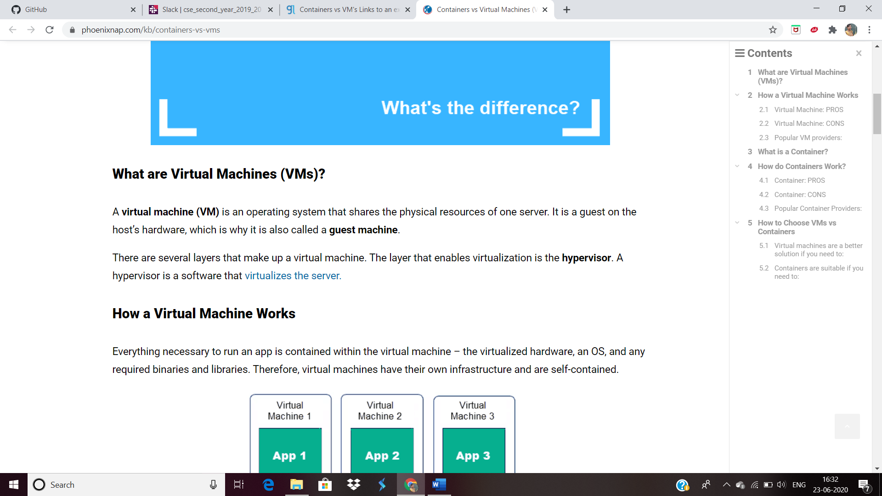

Coding Challenges Details:

Every day we are given with new question of coding related to the language of java and c. it seems interesting how we imbibe ourselves in depth to understand the logic, break it and then code for it.

Today’s question was:

1. [Python Program to Split the array and add the first part to the end There is a given an array and split it from a specified position, and move the first part of array add to the end.](https://github.com/orgs/alvas-education-foundation/teams/2nd-year/discussions/135)

Top of Form

Bottom of Form

|  |
| --- |
| Examples:  Input : arr[] = {12, 10, 5, 6, 52, 36} k = 2 Output : arr[] = {5, 6, 52, 36, 12, 10} Explanation : Split from index 2 and first part {12, 10} add to the end .  Input : arr[] = {3, 1, 2} k = 1 Output : arr[] = {1, 2, 3} Explanation : Split from index 1 and first part add to the end. |

SNAPSHOT:

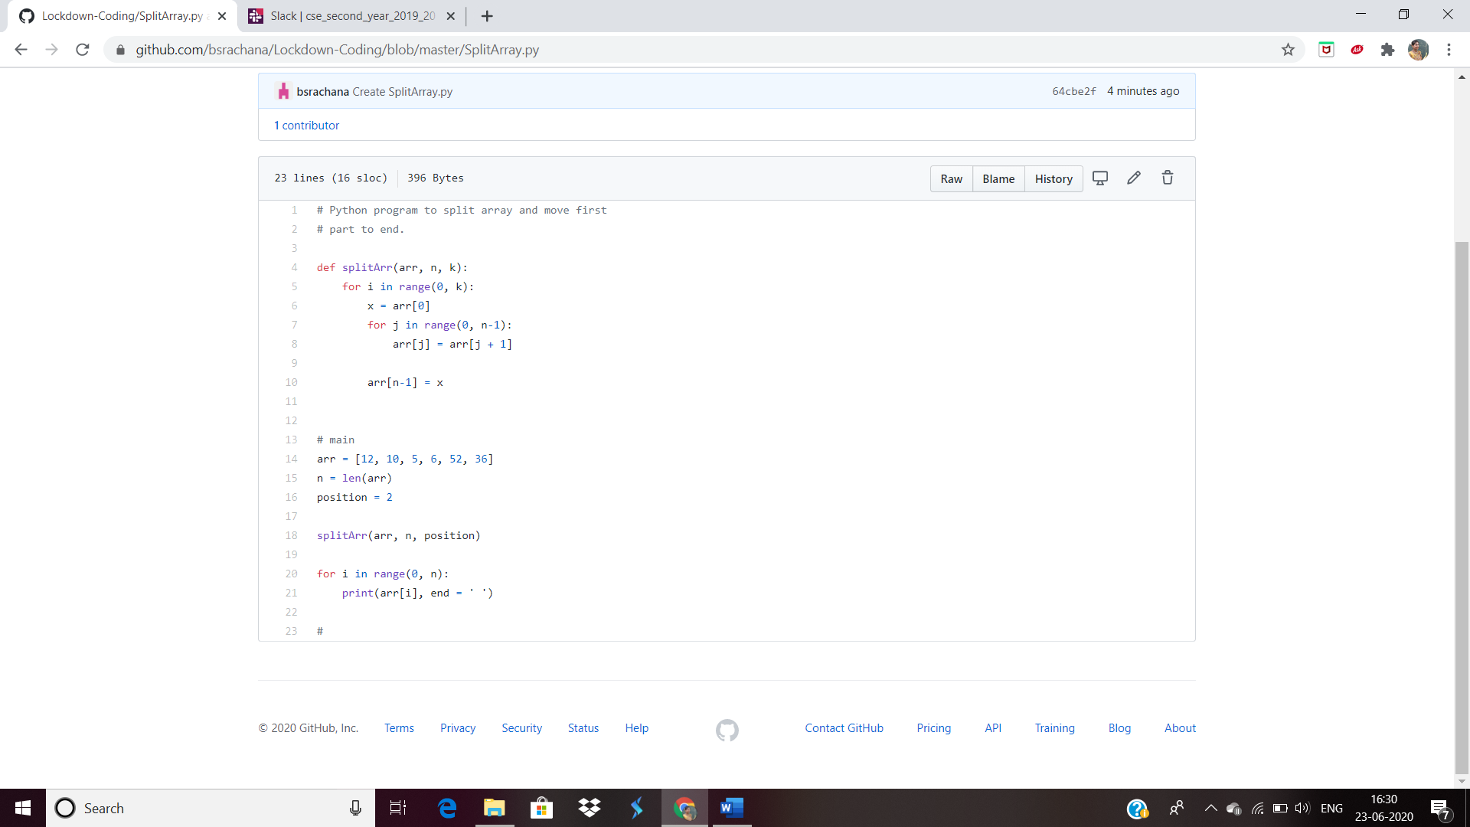

2. [Write a C Program to Sort a stack using a temporary stack](https://github.com/orgs/alvas-education-foundation/teams/2nd-year/discussions/134)

Top of Form

Bottom of Form

|  |
| --- |
| We follow this algorithm.   1. Create a temporary stack say tmpStack. 2. While input stack is NOT empty do this: • Pop an element from input stack call it temp • while temporary stack is NOT empty and top of temporary stack is greater than temp, pop from temporary stack and push it to the input stack • push temp in temporary stack 3. The sorted numbers are in tmpStack |

SNAPSHOT:

