**DAILY ONLINE ACTIVITIES SUMMARY**

|  |  |  |  |  |  |  |  |  |
| --- | --- | --- | --- | --- | --- | --- | --- | --- |
| **Date:** | **25/06/2020** | | | | | **Name:** | **RACHANA B S** | |
| **Sem & Sec** | **4th Sem B Sec** | | | | | **USN:** | **4AL18CS065** | |
| **Online Test Summary** | | | | | | | | |
| **Subject** | | **Not conducted** | | | | | | |
| **Max. Marks** | | **-** | | **Score** | | | **-** | |
| **Certification Course Summary** | | | | | | | | |
| **Course** | **Cloud Foundations** | | | | | | | |
| **Certificate Provider** | | | **Great Learning** | | **Duration** | | | **5 hours** |
| **Coding Challenges** | | | | | | | | |
| **Problem Statement:** [Write a C Program to reverse the rows in a 2d Array](https://github.com/orgs/alvas-education-foundation/teams/2nd-year/discussions/136)  Top of Form  Bottom of Form | | | | | | | | |
| **Status: executed** | | | | | | | | |
| **Uploaded the report in GitHub** | | | | | **yes** | | | |
| **If yes Repository name** | | | | | <https://github.com/bsrachana/lockdown_coding> | | | |
| **Uploaded the report in slack** | | | | | **yes** | | | |

Online Test Details: test was not conducted today.

Certification Course Details:

In today’s session, I learnt about how to build First IoT Application with IBM Watson IoT.

SNAPSHOT:

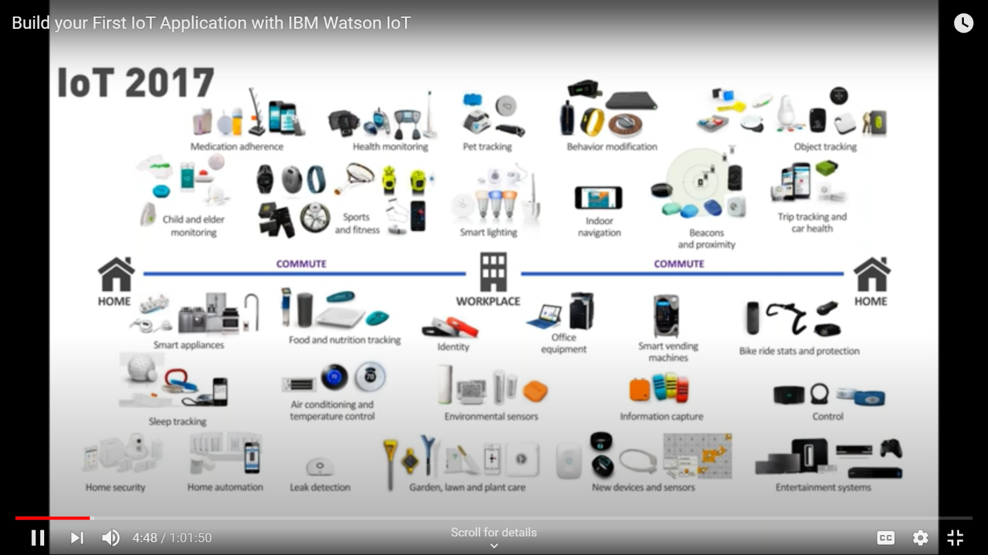

Coding Challenges Details:

Every day we are given with new question of coding related to the language of java and c. it seems interesting how we imbibe ourselves in depth to understand the logic, break it and then code for it.

Today’s question was:

1. [Write a C Program to reverse the rows in a 2d Array](https://github.com/orgs/alvas-education-foundation/teams/2nd-year/discussions/136)

Top of Form

Bottom of Form

|  |
| --- |
| Given a 2D array arr[][] of size M x N integers where M is the number of rows and N is the number of columns. The task is to reverse every row of the given 2D array.  **Example:**  **Input:** arr[][] = { {1, 2, 3}, {4, 5, 6}, {7, 8, 9} } **Output:** 3 2 1 6 5 4 9 8 7  **Input:** arr[][] = { {1, 2}, {4, 5}, {7, 8}, {9, 10} } **Output:** 2 1 5 4 8 7 10 9 |

SNAPSHOT:

