**DAILY ONLINE ACTIVITIES SUMMARY**

|  |  |  |  |  |  |  |  |  |
| --- | --- | --- | --- | --- | --- | --- | --- | --- |
| **Date:** | **26/06/2020** | | | | | **Name:** | **RACHANA B S** | |
| **Sem & Sec** | **4th Sem B Sec** | | | | | **USN:** | **4AL18CS065** | |
| **Online Test Summary** | | | | | | | | |
| **Subject** | | **Not conducted** | | | | | | |
| **Max. Marks** | | **-** | | **Score** | | | **-** | |
| **Certification Course Summary** | | | | | | | | |
| **Course** | **Cloud Foundations** | | | | | | | |
| **Certificate Provider** | | | **Great Learning** | | **Duration** | | | **5 hours** |
| **Coding Challenges** | | | | | | | | |
| **Problem Statement:** [Given start and end of a range, write a Python program to print all negative numbers in given range.](https://github.com/orgs/alvas-education-foundation/teams/2nd-year/discussions/137) | | | | | | | | |
| **Status: executed** | | | | | | | | |
| **Uploaded the report in GitHub** | | | | | **yes** | | | |
| **If yes Repository name** | | | | | <https://github.com/bsrachana/lockdown_coding> | | | |
| **Uploaded the report in slack** | | | | | **yes** | | | |

Online Test Details: test was not conducted today.

Certification Course Details:

In today’s session, I learnt about PGP in Cloud Computing.

SNAPSHOT:

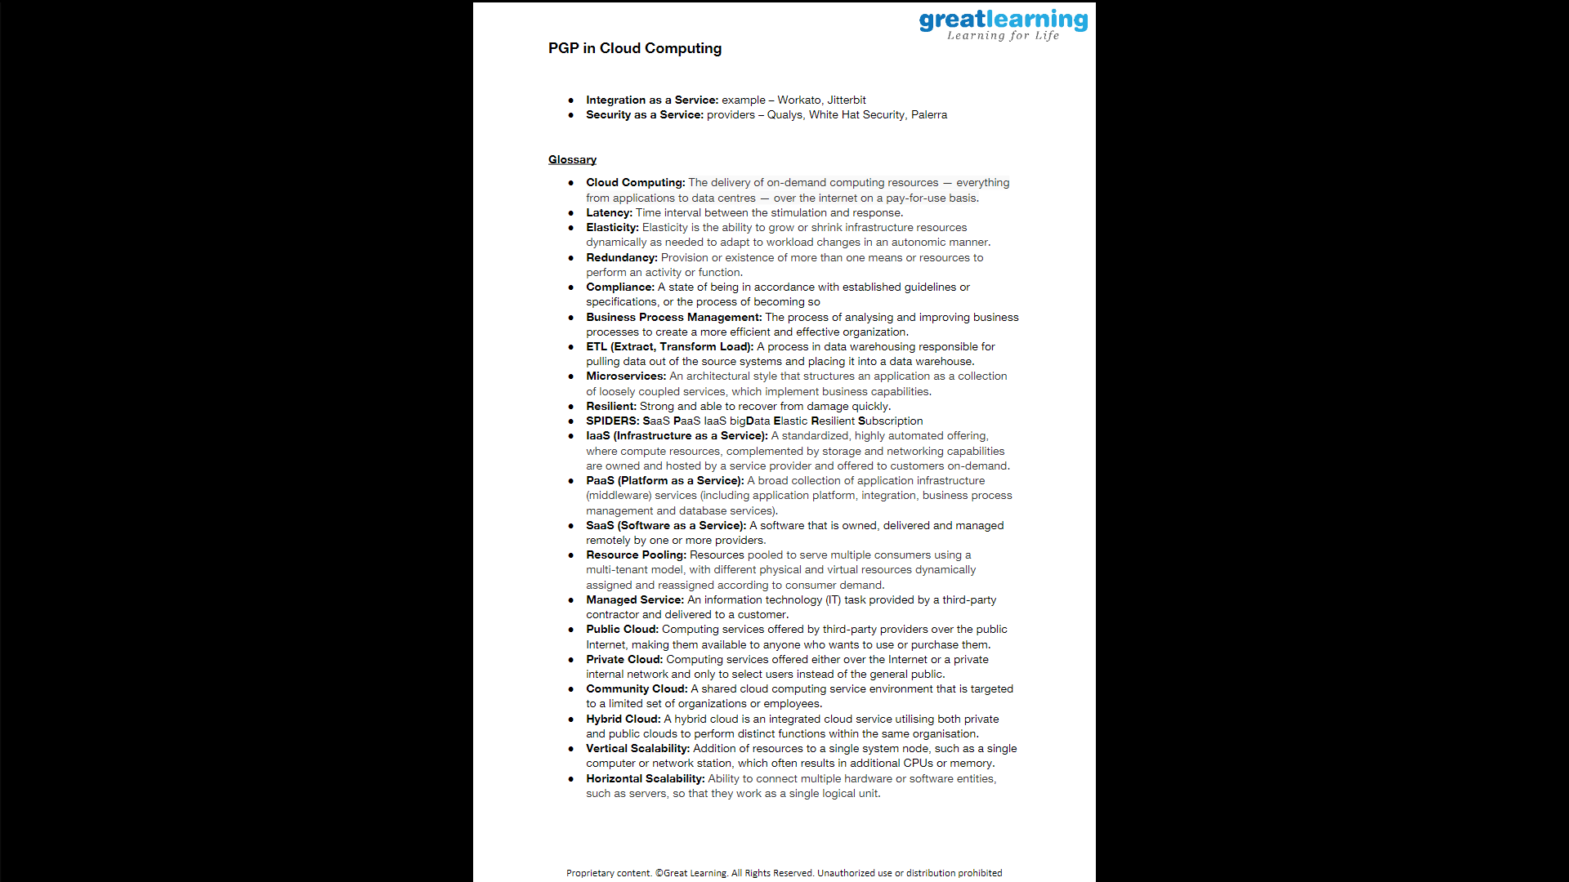

Coding Challenges Details:

Every day we are given with new question of coding related to the language of java and c. it seems interesting how we imbibe ourselves in depth to understand the logic, break it and then code for it.

Today’s question was:

1. [Given start and end of a range, write a Python program to print all negative numbers in given range.](https://github.com/orgs/alvas-education-foundation/teams/2nd-year/discussions/137)

Top of Form

Bottom of Form

|  |
| --- |
| Example: Input: start = -4, end = 5 Output: -4, -3, -2, -1 Input: start = -3, end = 4 Output: -3, -2, -1 |

SNAPSHOT:

