**DAILY ONLINE ACTIVITIES SUMMARY**

|  |  |  |  |  |  |  |  |  |
| --- | --- | --- | --- | --- | --- | --- | --- | --- |
| **Date:** | **27/06/2020** | | | | | **Name:** | **RACHANA B S** | |
| **Sem & Sec** | **4th Sem B Sec** | | | | | **USN:** | **4AL18CS065** | |
| **Online Test Summary** | | | | | | | | |
| **Subject** | | **Data Communication** | | | | | | |
| **Max. Marks** | | **30** | | **Score** | | | **28** | |
| **Certification Course Summary** | | | | | | | | |
| **Course** | **Data Science** | | | | | | | |
| **Certificate Provider** | | | **Great Learning** | | **Duration** | | | **2 hours** |
| **Coding Challenges** | | | | | | | | |
| **Problem Statement:1**. [Write a C program to print kth digit](https://github.com/orgs/alvas-education-foundation/teams/2nd-year/discussions/138)  Top of Form  Bottom of Form  Top of Form  Bottom of Form   |  | | --- | | **Examples:**  Input: U = 250  Output: 3500  **Explanation:**  Charge for the first 100 units – 10100 = 1000Charge for the 100 to 200 units – 15100 = 1500 Charge for the 200 to 250 units – 20*50 = 1000 Total Electricity Bill = 1000 + 1500 + 1000 = 3500 | | | | | | | | | |
| **Status: executed** | | | | | | | | |
| **Uploaded the report in GitHub** | | | | | **yes** | | | |
| **If yes Repository name** | | | | | <https://github.com/bsrachana/lockdown_coding> | | | |
| **Uploaded the report in slack** | | | | | **yes** | | | |

Online Test Details:

Today I attended internals of Data Communication where the test was for 30 marks. 30 questions of 1 mark of the time limit was 30 mins. I scored 28/30

SNAPSHOT:

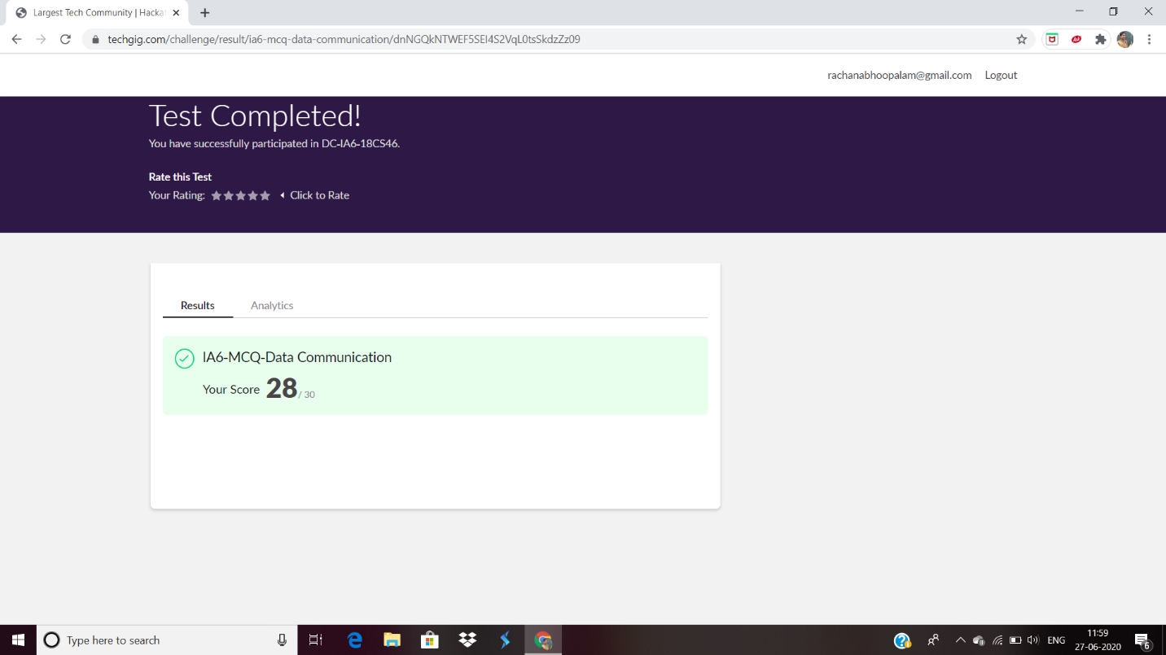

Certification Course Details:

Explanation about Introduction to Visualization Libraries.

SNAPSHOT:



Coding Challenges Details:

Every day we are given with new question of coding related to the language of java and c. it seems interesting how we imbibe ourselves in depth to understand the logic, break it and then code for it.

Today’s question was:

1. [Write a C program to print kth digit](https://github.com/orgs/alvas-education-foundation/teams/2nd-year/discussions/138)

Top of Form

Bottom of Form

|  |
| --- |
| Given two numbers a and b, find kth digit from right of a^b.  Input:  The first line of the input contains T denoting the number of test cases.Each of the next T lines contains three space separated positive integers denoting the value of a , b and k respectively.  Output:  For each test case, output the kth digit from right of a^b in new line.  Constraints:  1<=T<=100 1<=a , b <=15 1<=k<=|totaldigits in a^b|  Example:  Input: 2 3 3 1 5 2 2  Output: 7 2  Hint Output: 1 Explanation 3^3 = 27 for k = 1. First digit is 7 in 27 Output : 2 Explanation 5^2 = 25 for k = 2. First digit is 2 in 25 |

Top of Form

Bottom of Form

|  |
| --- |
|  |

SNAPSHOT:

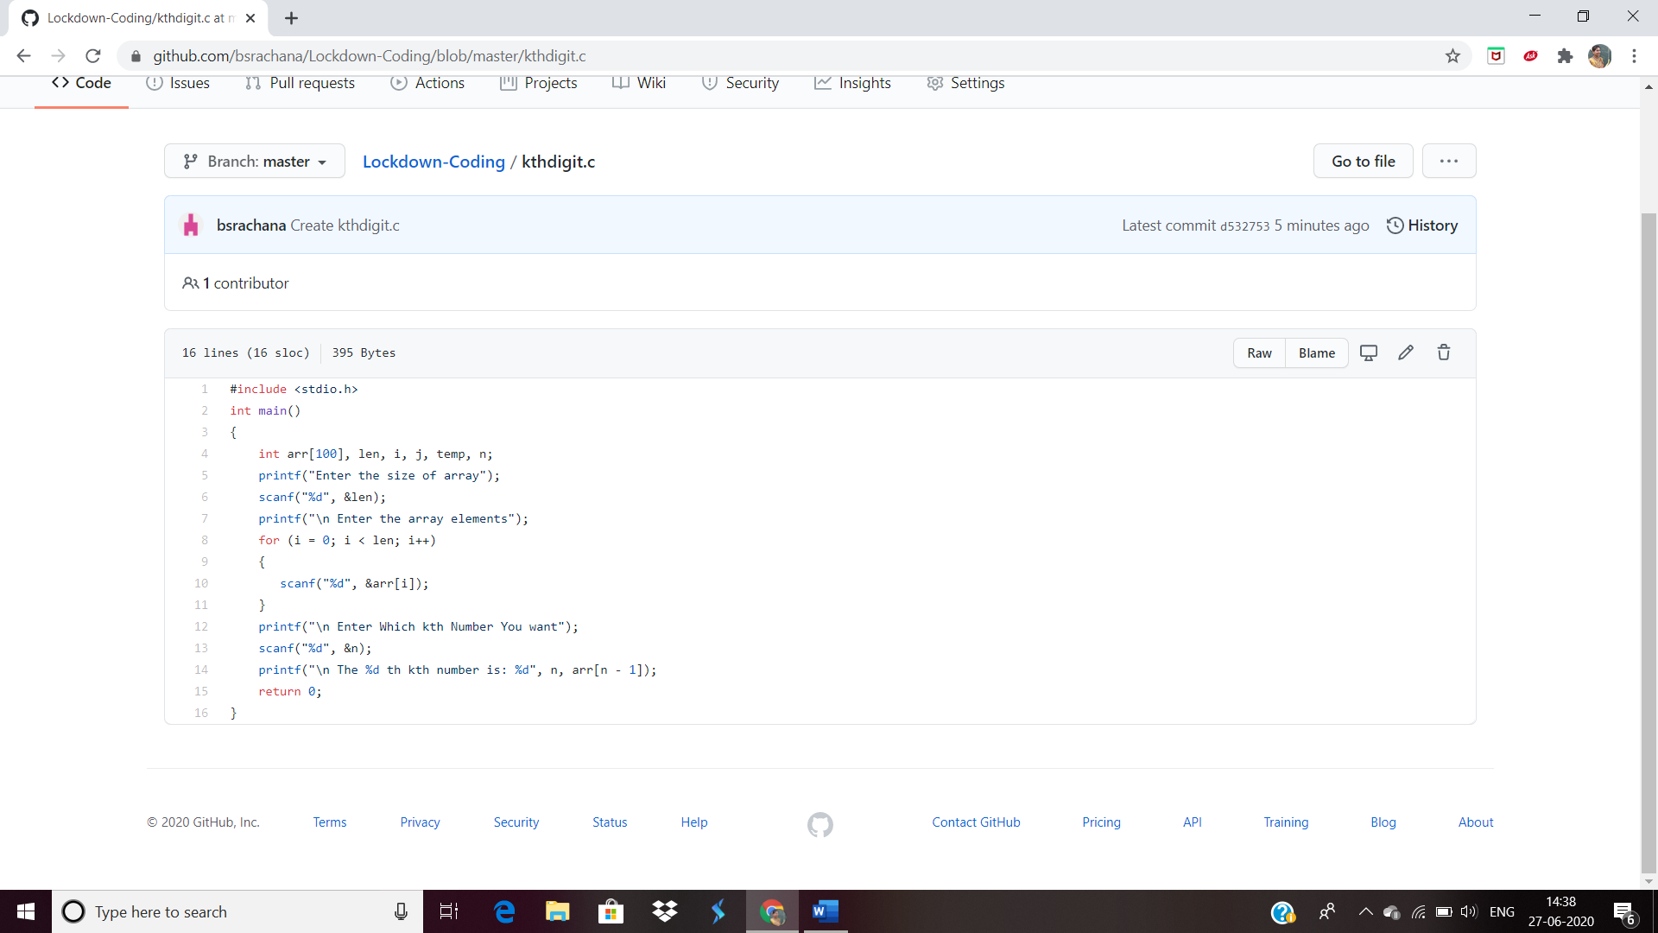

Top of Form

Bottom of Form