**DAILY ONLINE ACTIVITIES SUMMARY**

|  |  |  |  |  |  |  |  |  |
| --- | --- | --- | --- | --- | --- | --- | --- | --- |
| **Date:** | **29/06/2020** | | | | | **Name:** | **RACHANA B S** | |
| **Sem & Sec** | **4th Sem B Sec** | | | | | **USN:** | **4AL18CS065** | |
| **Online Test Summary** | | | | | | | | |
| **Subject** | | **Not conducted** | | | | | | |
| **Max. Marks** | | **-** | | **Score** | | | **-** | |
| **Certification Course Summary** | | | | | | | | |
| **Course** | **Virtual Internship on Data Science [Program Preview]** | | | | | | | |
| **Certificate Provider** | | | **Great Learning** | | **Duration** | | | **2 hours** |
| **Coding Challenges** | | | | | | | | |
| **Problem Statement:** [Given a list of numbers, write a Python program to count Even and Odd numbers in a List.](https://github.com/orgs/alvas-education-foundation/teams/2nd-year/discussions/139) | | | | | | | | |
| **Status: executed** | | | | | | | | |
| **Uploaded the report in GitHub** | | | | | **yes** | | | |
| **If yes Repository name** | | | | | <https://github.com/bsrachana/lockdown_coding> | | | |
| **Uploaded the report in slack** | | | | | **yes** | | | |

Online Test Details: test was not conducted today.

Certification Course Details:

In today’s session, I learnt about Line Plot.

SNAPSHOT:

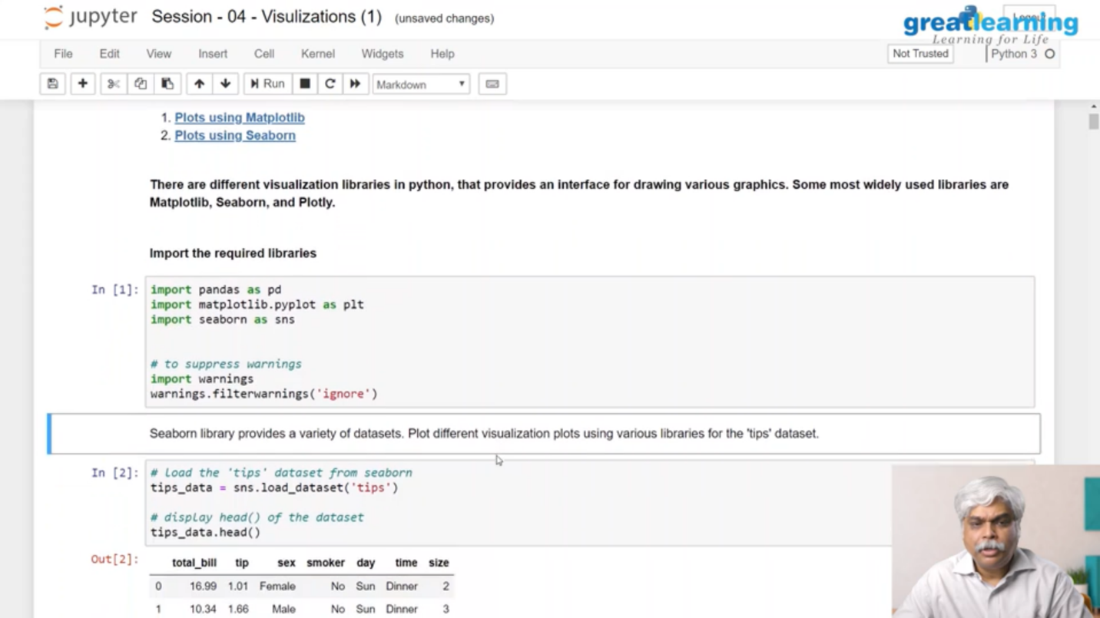

Coding Challenges Details:

Every day we are given with new question of coding related to the language of java and c. it seems interesting how we imbibe ourselves in depth to understand the logic, break it and then code for it.

Today’s question was:

1. [Given a list of numbers, write a Python program to count Even and Odd numbers in a List.](https://github.com/orgs/alvas-education-foundation/teams/2nd-year/discussions/139)

Top of Form

Bottom of Form

|  |
| --- |
| Example: Input: list1 = [2, 7, 5, 64, 14] Output: Even = 3, odd = 2 Input: list2 = [12, 14, 95, 3] Output: Even = 2, odd = 2 Example 1: count Even and Odd numbers from given list using for loop Iterate each element in the list using for loop and check if num % 2 == 0, the condition to check even numbers. If the condition satisfies, then increase even count else increase odd count. |

SNAPSHOT:

