**DAILY ONLINE ACTIVITIES SUMMARY**

|  |  |  |  |  |  |  |  |  |
| --- | --- | --- | --- | --- | --- | --- | --- | --- |
| **Date:** | **30/06/2020** | | | | | **Name:** | **RACHANA B S** | |
| **Sem & Sec** | **4th Sem B Sec** | | | | | **USN:** | **4AL18CS065** | |
| **Online Test Summary** | | | | | | | | |
| **Subject** | | **Not conducted** | | | | | | |
| **Max. Marks** | | **-** | | **Score** | | | **-** | |
| **Certification Course Summary** | | | | | | | | |
| **Course** | **Virtual Internship on Data Science [Program Preview]** | | | | | | | |
| **Certificate Provider** | | | **Great Learning** | | **Duration** | | | **2 hours** |
| **Coding Challenges** | | | | | | | | |
| **Problem Statement: 1.** [Write a C++ Program to Move all zeroes to end of array using Two-Pointers](https://github.com/orgs/alvas-education-foundation/teams/2nd-year/discussions/140)  **2.** [Write a C Program to check whether the number is Ugly or not.](https://github.com/orgs/alvas-education-foundation/teams/2nd-year/discussions/141) | | | | | | | | |
| **Status: executed** | | | | | | | | |
| **Uploaded the report in GitHub** | | | | | **yes** | | | |
| **If yes Repository name** | | | | | <https://github.com/bsrachana/lockdown_coding> | | | |
| **Uploaded the report in slack** | | | | | **yes** | | | |

Online Test Details: test was not conducted today.

Certification Course Details:

In today’s session, I learnt about Bar Plot.

SNAPSHOT:

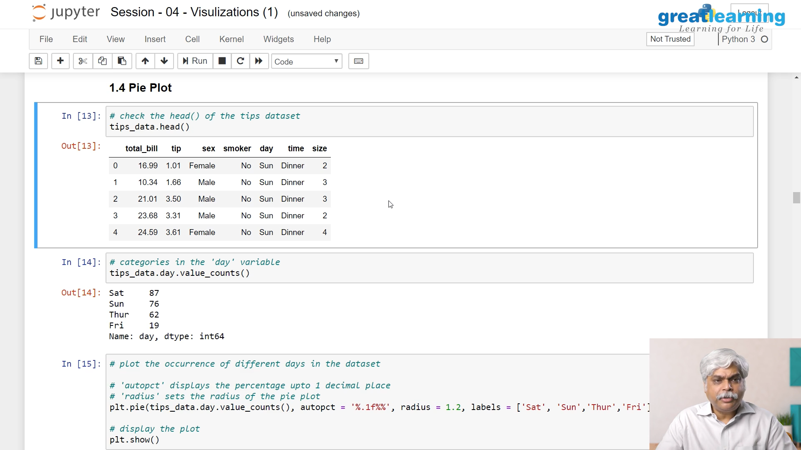

Coding Challenges Details:

Every day we are given with new question of coding related to the language of java and c. it seems interesting how we imbibe ourselves in depth to understand the logic, break it and then code for it.

Today’s question was:

1. [Write a C++ Program to Move all zeroes to end of array using Two-Pointers](https://github.com/orgs/alvas-education-foundation/teams/2nd-year/discussions/140)

Top of Form

Bottom of Form

|  |
| --- |
| Given an array of random numbers, Push all the zero’s of the given array to the end of the array. For example, if the given arrays is {1, 0, 2, 6, 0, 4}, it should be changed to {1, 2, 6, 4, 0, 0}. The order of all other elements should be the same.  Examples:  Input: arr[]={8, 9, 0, 1, 2, 0, 3} Output: arr[]={8, 9, 1, 2, 3, 0, 0} Explanation: Swap {0 ,1} -> Resulting array {8, 9, 1, 0, 2, 0, 3} Swap {0 ,2} -> Resulting array {8, 9, 1, 2, 0, 0, 3} Swap {0 ,3} -> Final array {8, 9, 1, 2, 3, 0, 0}  Input: arr[]={4, 5, 0, 0, 0, 0, 6, 7} Output: arr[]={4, 5, 6, 7, 0, 0, 0, 0} |

SNAPSHOT:

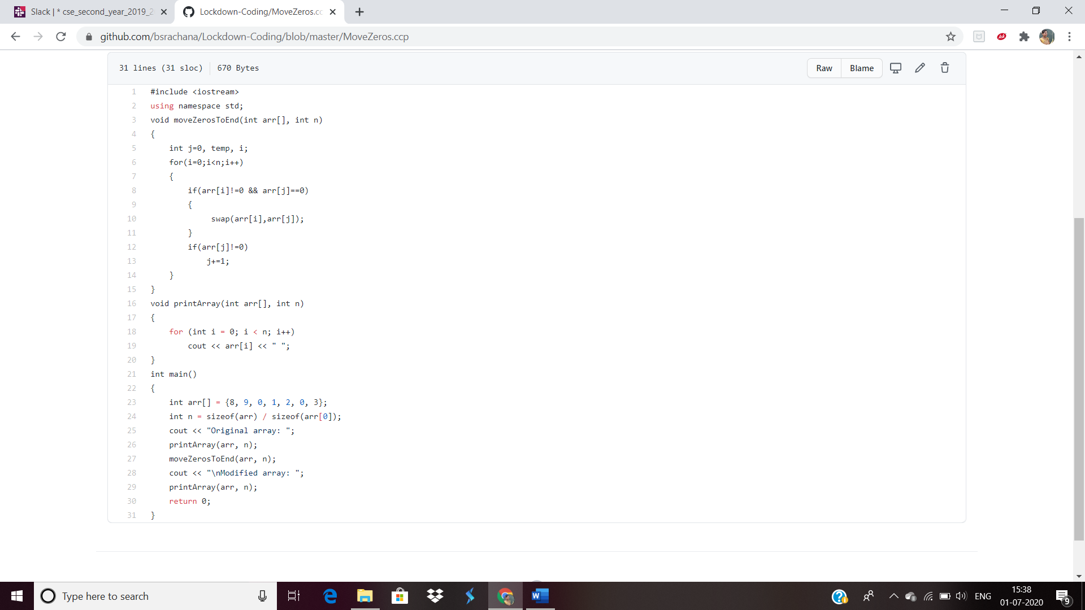

2. [Write a C Program to check whether the number is Ugly or not.](https://github.com/orgs/alvas-education-foundation/teams/2nd-year/discussions/141)

Top of Form

Bottom of Form

|  |
| --- |
| Ugly numbers are those number whose prime factors are 2, 3 or 5. From 1 to 15, there are 11 ugly numbers 1, 2, 3, 4, 5, 6, 8, 9, 10, 12, 15. The numbers 7, 11, 13 are not ugly because they are prime. The number 14 is not ugly because in its prime factor the 7 will come. |

SNAPSHOT:

