1.a $\int_{-∞}^{+∞}{}$ $\int_{-∞}^{+∞}{}$ $sin(2πα_{1}x)cos(2πα_{2}y)dxdy$

$⇒ \int_{-∞}^{+∞}{}sin(2πα_{1}x)dx ⋅\int_{-∞}^{+∞}{}cos(2πα_{2}y)dy$

$⇒$ $\int_{-∞}^{+∞}{}\frac{{(e}^{i2πα_{1}x} - e^{-i2πα_{1}x})}{2i}e^{-i2πux}dx ⋅\int_{-∞}^{+∞}{}\frac{{(e}^{i2πα_{2}y} + e^{-i2πα_{2}y})}{2}e^{-i2πvy}dy$

$⇒ \frac{1}{2i}\left[\int_{-∞}^{+∞}{}e^{i2πα_{1}x - i2πux}dx - \int_{-∞}^{+∞}{}e^{-i2πα_{1}x - i2πux}dx\right] ⋅ \frac{1}{2}\left[\int_{-∞}^{+∞}{}e^{i2πα_{2}y - i2πvy}dy +\int_{-∞}^{+∞}{}e^{-i2πα_{2}y - i2πvy}dy\right]$

$⇒ \frac{1}{2i}\left[ δ(u-α_{1}) - δ(u+α_{1}) \right] ⋅ \frac{1}{2}\left[ δ(v-α_{2}) + δ(v+α_{2}) \right]$

$⇒ \frac{1}{4i}$ $\left[ δ(u-α_{1}) - δ(u+α_{1}) \right] ⋅ \left[ δ(v-α_{2}) + δ(v+α_{2}) \right]$

1.b $\int_{-∞}^{+∞}{}$ $\int_{-∞}^{+∞}{}$ $cos(2π(α_{1}x + α_{2}y))dxdy$

$⇒$ $\int_{-∞}^{+∞}{}$ $\int_{-∞}^{+∞}{}$ $cos(2πα_{1}x +2πα_{2}y)dxdy$

$⇒$ $\int_{-∞}^{+∞}{}$ $\int_{-∞}^{+∞}{}$ $cos(2πα_{1}x)⋅cos(2πα_{2}y) - sin(2πα_{1}x)⋅sin(2πα_{2}y) dxdy$

$⇒ \int_{-∞}^{+∞}{}$ $\int_{-∞}^{+∞}{}$ $cos(2πα_{1}x)⋅cos(2πα_{2}y)dxdy - \int_{-∞}^{+∞}{}\int_{-∞}^{+∞}{}sin(2πα_{1}x)⋅sin(2πα_{2}y) dxdy$

$⇒ \int_{-∞}^{+∞}{}$ $cos(2πα_{1}x)dx⋅\int_{-∞}^{+∞}{}cos(2πα_{2}y)dy - \int_{-∞}^{+∞}{}sin(2πα_{1}x)dx ⋅\int_{-∞}^{+∞}{}sin(2πα_{2}y)dy$

$⇒ \frac{1}{2}\left[ δ(u-α_{1}) + δ(u+α_{1}) \right] ×\frac{1}{2} \left[ δ(v-α_{2})+ δ(v+α_{2}) \right] - \frac{1}{2i}\left[ δ(u-α_{1}) - δ(u+α_{1}) \right] × \frac{1}{2i}\left[ δ(v-α_{2}) - δ(v+α_{2}) \right]$

$⇒ \frac{1}{4}\left[ δ(u-α_{1}) + δ(u+α_{1}) \right] × \left[ δ(v-α_{2})+ δ(v+α_{2}) \right] + \frac{1}{4}\left[ δ(u-α_{1}) - δ(u+α_{1}) \right] × \left[ δ(v-α_{2}) - δ(v+α_{2}) \right]$

$⇒ \frac{1}{4}\left[\left[ δ(u-α_{1}) + δ(u+α_{1}) \right] × \left[ δ(v-α_{2})+ δ(v+α_{2}) \right] +\left[ δ(u-α_{1}) - δ(u+α_{1}) \right] × \left[ δ(v-α_{2}) - δ(v+α_{2}) \right]\right]$

$⇒ \frac{1}{4}$ [$δ(u-α_{1})⋅δ(v-α_{2}) +δ(u-α_{1})⋅δ(v+α_{2}) + δ(u+α_{1})⋅δ(v-α_{2})+δ(u+α_{1})⋅δ(v+α_{2})$ $+δ(u-α_{1}) ⋅ δ(v-α_{2}) - δ(u-α_{1}) ⋅δ(v+α_{2})-δ(u+α_{1})⋅δ(v-α_{2})+δ(u+α_{1})⋅δ(v+α_{2})$]

$⇒ \frac{1}{2}\left[ δ(u-α_{1})⋅δ(v-α_{2})+δ(u+α_{1})⋅δ(v+α_{2}) \right]$

2. $x[n] = \{-1, 2,-1\}$

$h[n] = \{1, 2, 3, 4\}$

From the equation of convolution, the output signal *y*[n] will be

$y[n] = \sum_{k}{}x[k]⋅h[n-k]$

Let's compute the values of $y[0]$, $y[1]$, $y[2]$, $y[2], y[3], y[4], y[5]$….

$y[0] =\sum_{k=-∞}^{+∞}{}x[k]⋅h[0-k]$

$=x[0]⋅h[0-0]+x[1]⋅h[0-1]+x[2]⋅h[0-2] + x[3]⋅h[0-3]+ ....$

$=x[0]⋅h[0]$

$= -1 ⋅1$

$= -1$

$y[1] =\sum_{k=-∞}^{+∞}{}x[k]⋅h[1-k]$

$=x[0]⋅h[1-0]+x[1]⋅h[1-1]+x[2]⋅h[1-2] + x[3]⋅h[1-3]+. ...$

$=x[0]⋅h[1]+x[1]⋅h[0]$

$= -1 ⋅2+2⋅1$

$= 0$

$y[2] =\sum_{k=-∞}^{+∞}{}x[k]⋅h[2-k]$

$=x[0]⋅h[1-0]+x[1]⋅h[1-1]+x[2]⋅h[1-2] + x[3]⋅h[1-3]+ ....$

$=x[0]⋅h[2]+x[1]⋅h[1] + x[2]⋅h[0]$

$= -1 ⋅3+2⋅2-1⋅1$

$= 0$

$y[3] =\sum_{k=-∞}^{+∞}{}x[k]⋅h[3-k]$

$=x[0]⋅h[3-0]+x[1]⋅h[3-1]+x[2]⋅h[3-2] + x[3]⋅h[3-3]+ ....$

$=x[0]⋅h[3]+x[1]⋅h[2] + x[2]⋅h[1]$

$= -1 ⋅4+2⋅3-1⋅2$

$= 0$

$y[4] =\sum_{k=-∞}^{+∞}{}x[k]⋅h[4-k]$

$=x[0]⋅h[4-0]+x[1]⋅h[4-1]+x[2]⋅h[4-2] + x[3]⋅h[4-3]+ ....$

$=x[1]⋅h[3]+x[2]⋅h[2]$

$= 2⋅4-1⋅3$

$= 5$

$y[5] =\sum_{k=-∞}^{+∞}{}x[k]⋅h[3-k]$

$=x[0]⋅h[5-0]+x[1]⋅h[5-1]+x[2]⋅h[5-2] + x[3]⋅h[5-3]+ ....$

$=x[2]⋅h[3]$

$= -1 ⋅4$

$= -4$

$y[n] = \{-1,0,0,0,5,-4\}$

3.a

The correct answer is **option (B)**, since in this plot of spectral output *(y-axis)* against wavelength *(x-axis)*, the value of spectral output is non-zero for a single wavelength – corresponding to the wavelength of the monochromatic light – and zero for all other wavelengths.

3.b

Given $P(λ) = 1$

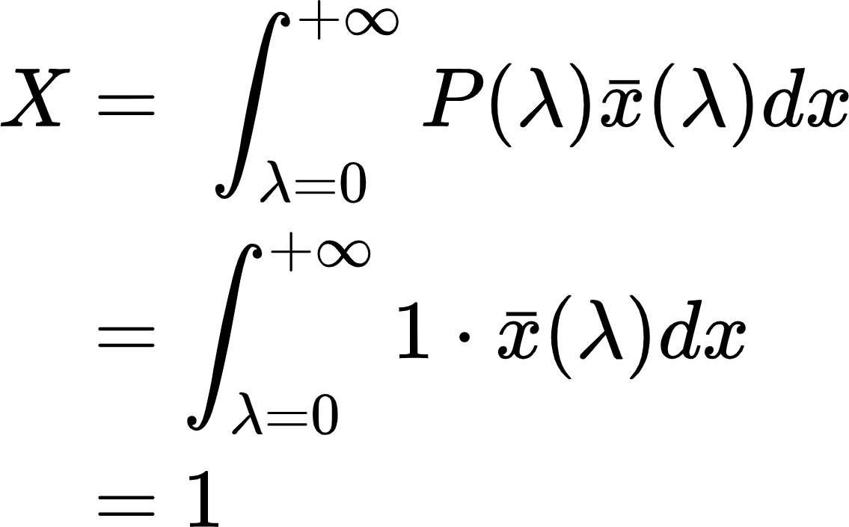

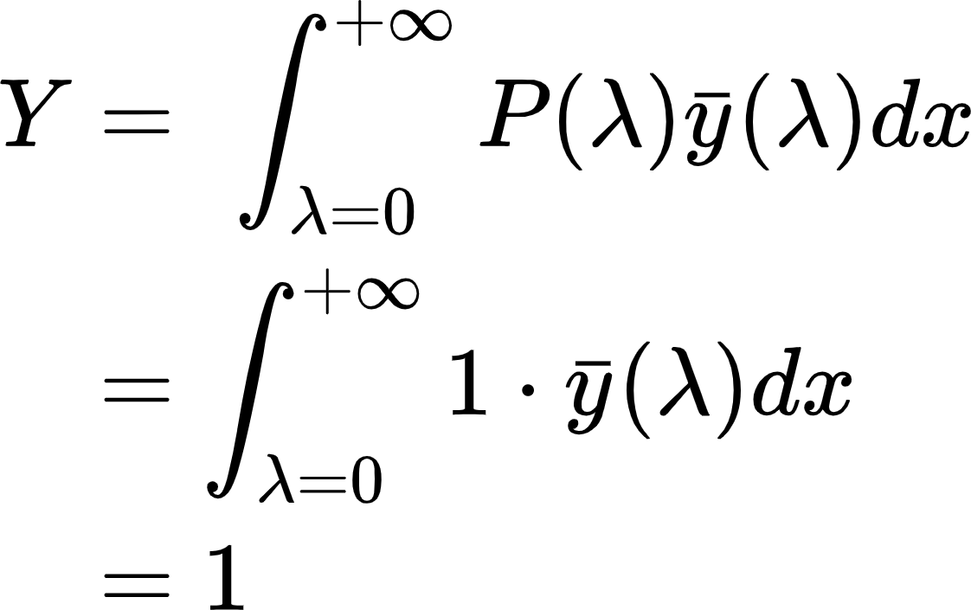

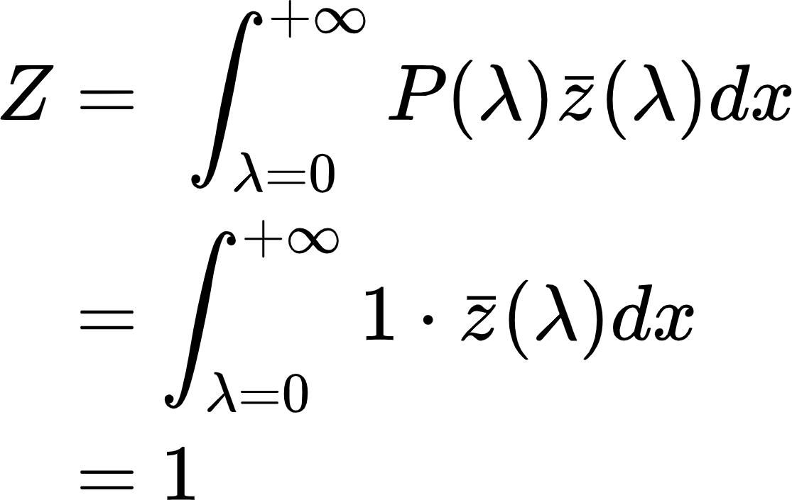

Now calculating $x,y,z$ from $X,Y,Z$

$x = \frac{X}{X+Y+Z}=\frac{1}{1+1+1}=\frac{1}{3}$

$y = \frac{Y}{X+Y+Z}=\frac{1}{1+1+1}=\frac{1}{3}$

$z = \frac{Z}{X+Y+Z}=\frac{1}{1+1+1}=\frac{1}{3}$

$(x,y,z)⇒(0.33,0.33,0.33)$

3.c

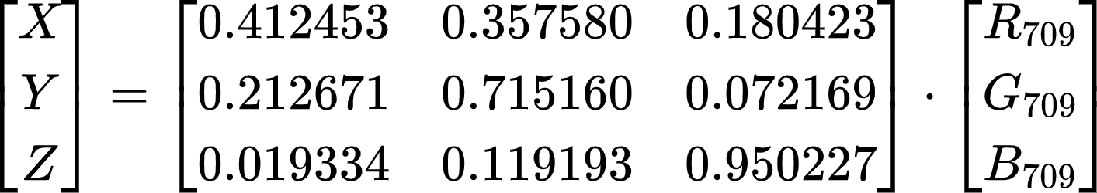

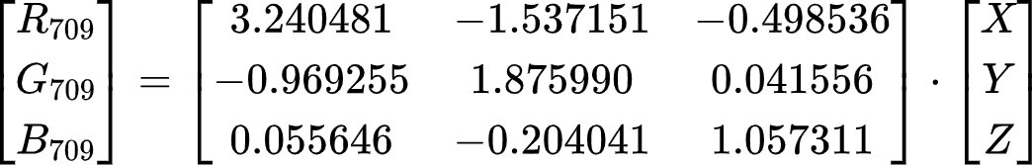

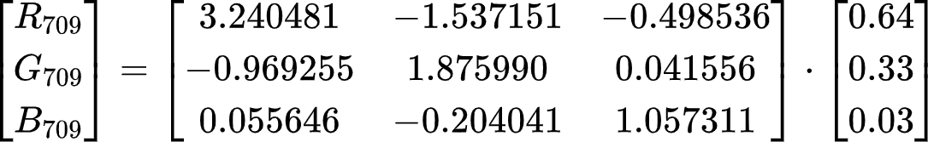

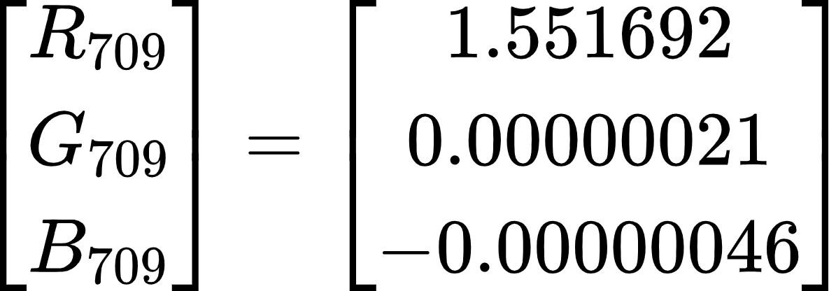

4.

Color contrast in terms of luminance is the relationship between the luminance of a brighter area of interest and that of an adjacent darker area. *Luminance* is the intensity of light emitted from a unit area surface in a given direction. Mathematically, it can be formulated as:

$C_{w}= \frac{L - L_{b}}{L}$

where,

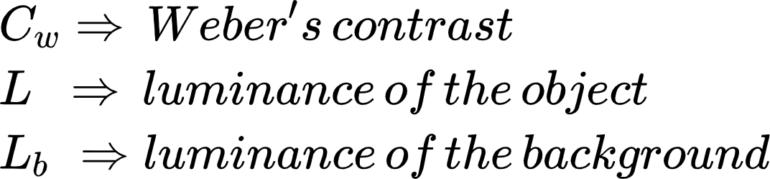

This definition is also called **Weber Contrast**, and is the most commonly useful one in the context of lighting.

5.

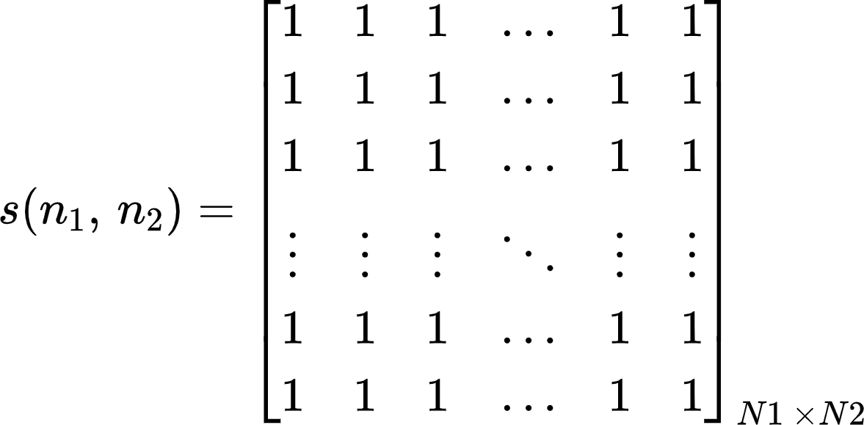

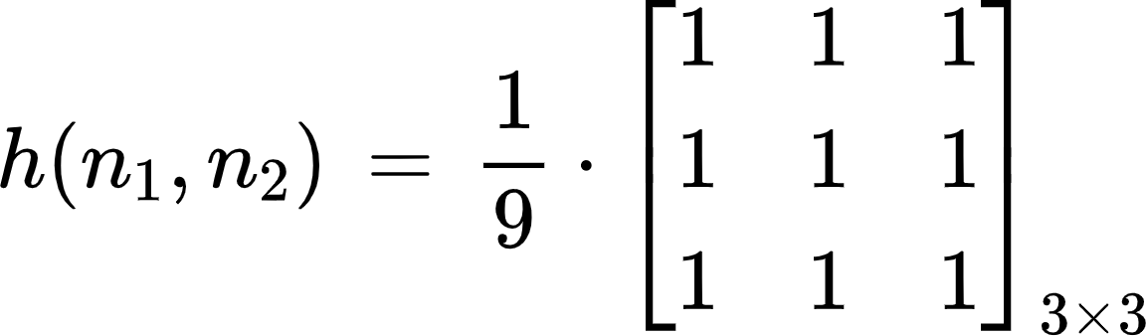

Convolving the filter / kernel $h(n1,n2)$ over input $s(n1,n2)$ gives us the following output:

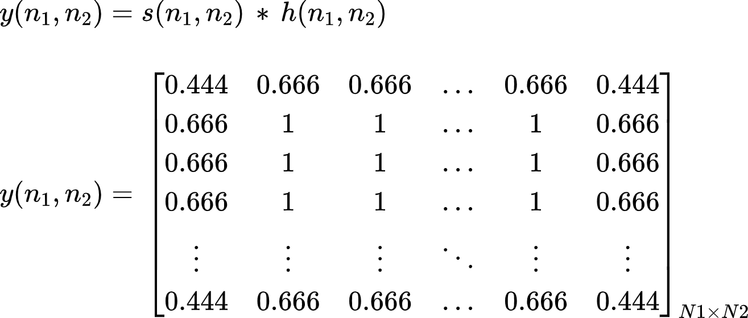

Plotting the frequency response of filter $h(n_{1}, n_{2})$ using *freqz2*

