PROJECT REPORT
Implement Client Script & UI Policy
(Incident)
ServiceNow Micro Project | UI Policy | Client Scripts
Prepared as per the ServiceNow Phasewise Project Report Format
Team ID | SWTID-2026-6539
Team Members | Sri Lekha B (Team Leader), Krish C P, Piraisudar S
Platform | ServiceNow (System UI: UI Policies, Client Scripts)
Date | 30 September 2026

1. Introduction

1.1 Project Overview
This micro project demonstrates how ServiceNow client-side controls, UI Policies and Client Scripts, enforce data integrity on Incident records. The solution works directly on the Incident form and list view to control field behaviour, auto-populate values and block invalid submissions.
When the Impact of an Incident is set to High (1 – High), the UI Policy “High Impact Control” makes the Assignment group mandatory and the Urgency field read-only, and reverses these changes when Impact is no longer High. Three Client Scripts complement the policy: an onChange script sets Urgency to High, an onSubmit script prevents saving without an Assigned To value, and an onCellEdit script blocks State changes made directly in the list.

1.2 Purpose
The purpose of the project is to ensure that Incidents are created with complete and valid information, improving data quality and consistency across the platform. The implementation aims to:
- Dynamically make fields mandatory and control field behaviour based on Impact.
- Auto-populate values, such as Urgency, when a condition is met.
- Prevent record submission when required conditions are not met.
- Prevent unauthorised State changes through list editing.
- Improve reporting accuracy, SLA compliance and overall service quality.
Skills: Incident Management, UI Policy, UI Policy Actions, Client Scripts, Form Validation.

2. Ideation Phase

2.1 Problem Statement
Date | 30 September 2026
Team ID | SWTID-2026-6539
Project Name | Implement Client Script & UI Policy (Incident)
Maximum Marks | 2 Marks

Incident records require consistent and accurate data entry for effective triage, routing and resolution. Relying solely on user awareness and manual checks leads to incomplete, inconsistent or incorrect data, which affects reporting accuracy, SLA compliance and service quality. There is a need to enforce conditional field behaviour and validation directly at the user interface level, controlling field visibility, mandatory status and save-time validation so that Incidents meet defined business rules before they are submitted.
Customer Problem Statement:
Problem Statement (PS) | I am (Customer) | I’m trying to | But | Because | Which makes me feel
PS-1 | A service desk agent / incident manager | Log and route high-impact Incidents correctly | Incidents are saved without an owner or assignment group | Nothing enforces mandatory fields based on Impact | Worried about missed SLAs and delayed resolution
PS-2 | A reporting analyst / process owner | Rely on accurate Incident data for reports and SLA tracking | Impact, Urgency and State values are inconsistent or changed carelessly | Users can edit fields freely, including State from the list view | Frustrated by unreliable data

2.2 Empathy Map Canvas
Date | 30 September 2026
Team ID | SWTID-2026-6539
Project Name | Implement Client Script & UI Policy (Incident)
Maximum Marks | 4 Marks

The empathy map captures the perspective of the service desk agent who creates and updates Incidents, and the process owner who depends on the quality of that data.
SAYS  “Who is this high-impact Incident assigned to?”  “Why is Urgency not matching Impact?”  “Who changed the State from the list?” | THINKS  “The form should stop me from saving incomplete data.”  “High-impact Incidents need an owner immediately.”  “Manual checks are easy to forget.”
DOES  Creates and updates Incidents on the form  Edits fields directly from the list view  Sets Impact and Urgency manually | FEELS  Pressured when handling high-impact issues  Frustrated by rework caused by bad data  Confident when the form guides them
PAINS  Incomplete or inconsistent records  Missing Assigned To / Assignment group  Accidental State changes in lists | GAINS  Mandatory fields enforced automatically  Urgency set consistently for high impact  Clean data and reliable SLA reporting

2.3 Brainstorming
Date | 30 September 2026
Team ID | SWTID-2026-6539
Project Name | Implement Client Script & UI Policy (Incident)
Maximum Marks | 4 Marks

Step 1: Team Gathering, Collaboration and Select the Problem Statement
The team reviewed common data-quality gaps on Incident records and selected the problem: fields are not controlled or validated at the user interface level.
Step 2: Brainstorm, Idea Listing and Grouping
Group | Ideas Listed
UI Policy | Apply extra controls when Impact is High; make Assignment group mandatory; make Urgency read-only; reverse changes when the condition is no longer true
onChange Client Script | Automatically set Urgency to High when Impact becomes High and show an information message
onSubmit Client Script | Block save and show an error on Assigned To when a High-impact Incident has no assignee
onCellEdit Client Script | Block State changes from the list view and direct the user to open the Incident
Testing | Test mandatory enforcement, successful save, reverse condition, list-edit blocking and form-based update

Step 3: Idea Prioritization
Idea | Impact | Effort | Priority
UI Policy “High Impact Control” with Assignment group mandatory and reverse if false | High | Low | 1 – Selected
UI Policy Action making Urgency read-only | Medium | Low | 2 – Selected
onChange script to auto-set Urgency | Medium | Low | 3 – Selected
onSubmit script to require Assigned To | High | Low | 4 – Selected
onCellEdit script to block State edits in list | Medium | Low | 5 – Selected
Server-side Business Rule / Data Policy backup validation | High | Medium | 6 – Future scope

3. Requirement Analysis

3.1 Customer Journey Map
Stage | User Action | Touchpoint | Experience / Pain Point | Opportunity
Create | Opens Incident > Create New | Incident form | Form does not guide the user | UI Policy applies conditional behaviour
Set Impact | Selects Impact = 1 – High | Impact field | Urgency and ownership often forgotten | onChange script sets Urgency; policy makes fields mandatory / read-only
Submit | Clicks Submit / Update | Form save | Incomplete record can be saved | onSubmit script blocks save without Assigned To
Bulk edit | Edits State in the Incident list | List view | State changed without context | onCellEdit script blocks the change
Revise | Changes Impact to Medium | Impact field | Restrictions might remain | Reverse if false restores normal behaviour

3.2 Solution Requirements
Date | 30 September 2026
Team ID | SWTID-2026-6539
Project Name | Implement Client Script & UI Policy (Incident)
Maximum Marks | 4 Marks

Functional Requirements:
FR No. | Functional Requirement (Epic) | Sub Requirement (Story / Sub-Task)
FR-1 | UI Policy on Incident | Create UI Policy “High Impact Control” on table Incident, Active, condition Impact is 1 – High
FR-2 | Mandatory Field Control | UI Policy action: Assignment group mandatory; Reverse if false = true
FR-3 | Field Behaviour Control | UI Policy Action on Urgency: Read-only = true; Visible left unchanged
FR-4 | onChange Client Script | “Auto set urgency for high impact” on Impact: sets Urgency to 1 and shows an info message
FR-5 | onSubmit Client Script | “Prevent save if Assigned To missing”: blocks save for High-impact Incidents without Assigned To
FR-6 | onCellEdit Client Script | “Prevent state change via list edit” on State: shows an alert and cancels the edit
FR-7 | Testing and Verification | Test mandatory enforcement, successful save, reverse condition, list-edit blocking and form-based update

Non-functional Requirements:
NFR No. | Non-Functional Requirement | Description
NFR-1 | Usability | Clear messages guide the user: an information message for Urgency, an error box on Assigned To, and an alert for list edits
NFR-2 | Security | Only administrators or users with configuration access can create or modify the policy and scripts; State is protected from list edits
NFR-3 | Reliability | Rules apply consistently every time the Incident form or list is used; reverse if false undoes changes when conditions no longer apply
NFR-4 | Performance | Lightweight client-side logic that runs instantly in the browser without server round trips
NFR-5 | Availability | Runs on the ServiceNow instance whenever the Incident form or list is available
NFR-6 | Scalability | The pattern can be reused for other tables, fields and conditions

3.3 Data Flow Diagram and User Stories
Date | 30 September 2026
Team ID | SWTID-2026-6539
Project Name | Implement Client Script & UI Policy (Incident)
Maximum Marks | 4 Marks

Data Flow Diagram (Level 0):
User (Incident form / list) | → | Impact change event | → | UI Policy + Client Scripts (browser) | → | Validation decision (allow / block) | → | Incident table record

Data enters when the user edits the Impact field on the Incident form. The UI Policy and onChange script react in the browser, updating field behaviour and Urgency. On submit, the onSubmit script validates Assigned To and either blocks the save or lets the record be written to the Incident table. List edits to State are intercepted by the onCellEdit script before any data is sent.
User Stories:
User Type | Functional Requirement (Epic) | User Story No. | User Story / Task | Acceptance Criteria | Priority | Release
Administrator | UI Policy | USN-1 | As an administrator, I can create UI Policy “High Impact Control” on Incident with condition Impact is 1 – High | Policy is active and saved | High | Sprint-1
 |  | USN-2 | As an administrator, I can make Assignment group mandatory and set Reverse if false to true | Field is mandatory for High impact and reverts otherwise | High | Sprint-1
 |  | USN-3 | As an administrator, I can add a UI Policy Action making Urgency read-only | Urgency is read-only when Impact = High | High | Sprint-1
 | onChange Script | USN-4 | As an administrator, I can create an onChange script on Impact that sets Urgency to High | Urgency = 1 and info message shown | High | Sprint-1
 | onSubmit Script | USN-5 | As an administrator, I can create an onSubmit script that blocks save when Assigned To is empty for High impact | Save blocked with error on Assigned To | High | Sprint-2
 | onCellEdit Script | USN-6 | As an administrator, I can create an onCellEdit script to stop State edits in the list | Alert shown and value unchanged | High | Sprint-2
Service Desk Agent | Form Validation | USN-7 | As an agent, I want High-impact Incidents to require an assignee, and a valid save to succeed once Assigned To is filled | Blocked without Assigned To; saved with it | High | Sprint-2
 |  | USN-8 | As an agent, I want restrictions removed when Impact changes from High to Medium | Urgency editable; save succeeds | Medium | Sprint-2
 | State Control | USN-9 | As an agent, I can still update State on the Incident form even though list editing is blocked | Form update saved successfully | Medium | Sprint-2

3.4 Technology Stack
Date | 30 September 2026
Team ID | SWTID-2026-6539
Project Name | Implement Client Script & UI Policy (Incident)
Maximum Marks | 4 Marks

Table-1: Components and Technologies
S.No | Component | Description | Technology
1 | User Interface | Incident form and Incident list view where users enter and edit data | ServiceNow platform UI (Incident form, list)
2 | Application Logic-1 | Conditional field behaviour (mandatory, read-only) based on Impact | UI Policy and UI Policy Actions (System UI > UI Policies)
3 | Application Logic-2 | Auto-set Urgency and save-time validation | Client Scripts: onChange, onSubmit (System UI > Client Scripts)
4 | Application Logic-3 | Prevent State changes from the list view | Client Script: onCellEdit
5 | Client-side APIs | Read and update form values and show messages | JavaScript, g_form API (setValue, getValue, addInfoMessage, showErrorBox)
6 | Database | Incident records and the configuration records for the policy and scripts | ServiceNow platform database (Incident table)
7 | File Storage / External API / ML Model | Not used in this project | Not applicable
8 | Infrastructure | Configuration performed on the ServiceNow cloud instance | ServiceNow instance

Table-2: Application Characteristics
S.No | Characteristics | Description | Technology
1 | Open-Source Frameworks | Native platform features; no external framework required | ServiceNow client-side scripting
2 | Security Implementations | Configuration limited to admin users; State protected from list edits; mandatory ownership on high-impact Incidents | ServiceNow roles and ACLs
3 | Scalable Architecture | Reusable pattern of condition + action + script that can be applied to other tables | UI Policy and Client Script framework
4 | Availability | Hosted and managed ServiceNow cloud instance | ServiceNow cloud
5 | Performance | Lightweight client-side logic executed in the browser | Client Scripts, UI Policy

4. Project Design

4.1 Problem – Solution Fit
Date | 30 September 2026
Team ID | SWTID-2026-6539
Project Name | Implement Client Script & UI Policy (Incident)
Maximum Marks | 2 Marks

The Problem-Solution Fit confirms that the identified data-quality problem is real and that UI-level controls solve it.
Canvas Element | Description
Customer Segment | Service desk agents, incident managers, process owners and reporting analysts
Jobs to be Done / Problems | Record complete, accurate Incidents and route high-impact Incidents promptly
Triggers | Impact set to 1 – High; user attempts to save; user edits State in a list
Emotions (Before → After) | Worried, frustrated by rework → Confident, guided by the form
Available Solutions | Manual checks and user awareness; unreliable and inconsistent
Customer Constraints | Time pressure during incidents; need for lightweight, easy-to-maintain controls
Behaviour | Users work in the Incident form and list view every day
Solution | UI Policy plus onChange, onSubmit and onCellEdit Client Scripts enforcing business rules at the UI level
Channels | ServiceNow Incident form, Incident list, System UI configuration modules

4.2 Proposed Solution
Date | 30 September 2026
Team ID | SWTID-2026-6539
Project Name | Implement Client Script & UI Policy (Incident)
Maximum Marks | 2 Marks

S.No. | Parameter | Description
1 | Problem Statement (Problem to be solved) | Incident records are submitted with incomplete, inconsistent or incorrect data because nothing enforces business rules at the user interface level.
2 | Idea / Solution description | UI Policy “High Impact Control” (Impact is 1 – High) makes Assignment group mandatory (reverse if false) and an action makes Urgency read-only. Client Scripts auto-set Urgency (onChange), require Assigned To on save (onSubmit) and block State edits in lists (onCellEdit).
3 | Novelty / Uniqueness | Combines declarative UI Policy with targeted scripts across form and list contexts for complete client-side coverage with minimal code.
4 | Social Impact / Customer Satisfaction | Better data quality, faster routing of critical Incidents and higher confidence in reports and SLAs.
5 | Business Model (Revenue Model) | Internal value: less rework, fewer SLA breaches and lower support cost.
6 | Scalability of the Solution | The same approach extends to other fields, tables and conditions (e.g. Priority, Category, Change or Problem records).

4.3 Solution Architecture
Date | 30 September 2026
Team ID | SWTID-2026-6539
Project Name | Implement Client Script & UI Policy (Incident)
Maximum Marks | 4 Marks

The architecture bridges the business problem (poor data quality on Incidents) and the technology solution (client-side rules executed in the browser).
Architecture and data flow:
Incident form: Impact = 1 – High | → | UI Policy: Assignment group mandatory, Urgency read-only | → | onChange script sets Urgency = 1 | → | onSubmit script validates Assigned To | → | Record saved (or blocked)

Layer | Component | Role
Presentation | Incident form and list view | Where users enter data and trigger the rules
Declarative logic | UI Policy “High Impact Control” + UI Policy Action (Urgency) | Mandatory and read-only behaviour, reversed when the condition is false
Scripted logic | onChange, onSubmit, onCellEdit Client Scripts | Auto-populate, save validation, list-edit blocking
Data | Incident table | Stores only validated records

5. Project Planning and Scheduling

5.1 Project Planning
Date | 30 September 2026
Team ID | SWTID-2026-6539
Project Name | Implement Client Script & UI Policy (Incident)
Maximum Marks | 5 Marks

Planning follows an Agile approach: an Epic is broken into Stories, each Story is estimated in Story Points (1, 2, 3, 5) and completed within a fixed-length Sprint. The six configuration tasks and the testing activities are organised into two sprints.
Product Backlog, Sprint Schedule and Estimation
Sprint | Functional Requirement (Epic) | User Story No. | User Story / Task | Story Points | Priority | Team Members
Sprint-1 | UI Policy | USN-1 | Create UI Policy “High Impact Control” with condition Impact is 1 – High | 2 | High | [Name]
Sprint-1 |  | USN-2 | Add Assignment group mandatory action with Reverse if false | 2 | High | [Name]
Sprint-1 |  | USN-3 | Create UI Policy Action making Urgency read-only | 2 | High | [Name]
Sprint-1 | onChange Script | USN-4 | Create onChange script to auto-set Urgency | 3 | High | [Name]
Sprint-2 | onSubmit Script | USN-5 | Create onSubmit script to block save without Assigned To | 3 | High | [Name]
Sprint-2 | onCellEdit Script | USN-6 | Create onCellEdit script to block State list edits | 2 | High | [Name]
Sprint-2 | Testing | USN-7 | Test mandatory enforcement and successful save | 2 | High | [Name]
Sprint-2 |  | USN-8 | Test reverse condition (High to Medium) | 2 | Medium | [Name]
Sprint-2 |  | USN-9 | Test list-edit blocking and form-based State update | 2 | Medium | [Name]

Story Points Summary
Sprint 1 = 2 + 2 + 2 + 3 = 9 story points.
Sprint 2 = 3 + 2 + 2 + 2 + 2 = 11 story points.
Total Story Points = 9 + 11 = 20.
Project Tracker, Velocity and Burndown
Sprint | Total Story Points | Duration | Sprint Start Date | Sprint End Date (Planned) | Story Points Completed | Sprint Release Date (Actual)
Sprint-1 | 9 | 6 Days | [Start date] | [End date] | [Completed] | [Release date]
Sprint-2 | 11 | 6 Days | [Start date] | [End date] | [Completed] | [Release date]

Velocity: Velocity = Total Story Points ÷ Number of Sprints = 20 ÷ 2 = 10 story points per sprint. With a 6-day sprint, average velocity is 10 ÷ 6 ≈ 1.7 story points per day.
Burndown Chart: Remaining work starts at 20 story points and should reach 0 by the end of Sprint 2. Update the chart using the actual completion data in the tracker above.

6. Functional and Performance Testing

6.1 Performance Testing
Date | 30 September 2026
Team ID | SWTID-2026-6539
Project Name | Implement Client Script & UI Policy (Incident)
Maximum Marks | As per template

Testing Scope
- UI Policy “High Impact Control” and its Urgency action
- onChange script (auto-set Urgency)
- onSubmit script (Assigned To validation)
- onCellEdit script (State list-edit blocking)
Testing Environment
URL / Location: ServiceNow instance – [Enter instance URL]. Credentials: [Provided separately; not recorded here].
Test Cases
Test Case ID | Test Scenario | Test Steps | Expected Result | Actual Result | Pass/Fail
TC-001 | Mandatory enforcement | Incident > Create New; set Impact to High; leave Assigned To empty; click Submit | Incident is not saved; error shown on Assigned To; Urgency is set and read-only | [Record] | [Pass/Fail]
TC-002 | Successful save | Fill Assigned To (and other required fields); click Submit | Incident is saved without errors; Urgency auto-set and read-only | [Record] | [Pass/Fail]
TC-003 | Reverse condition | Open a High-impact Incident; change Impact to Medium; click Submit | Assigned To not mandatory; Urgency editable; save succeeds | [Record] | [Pass/Fail]
TC-004 | List edit blocking | Incident > All; double-click State in a list row | Alert displayed; State remains unchanged | [Record] | [Pass/Fail]
TC-005 | Form-based update | Open the Incident; change State; click Update | State change saved; other rules still apply | [Record] | [Pass/Fail]
TC-006 | onChange behaviour | Change Impact to High on the form | Urgency = High and info message “Urgency set to High for High impact incident.” | [Record] | [Pass/Fail]

Bug Tracking
Bug ID | Bug Description | Steps to Reproduce | Severity | Status | Additional Feedback
BG-001 | [Describe issue, if any] | [Step 1, Step 2, Step 3] | [Low/Medium/High] | [Open/In Progress/Closed] | [Comments]

Sign-off
Tester Name | [Name of Tester]
Date | [Date of Test Completion]
Signature | [Tester’s Signature]
Project Manager / Product Owner Sign-off | [Name and date]

7. Results

7.1 Output Screenshots
The implementation was carried out in six tasks. Follow the steps and insert the corresponding screenshot at each placeholder.

Task 1: Create UI Policy on Incident
- Log in to the ServiceNow instance with administrative or configuration access.
- Navigate to System UI > UI Policies and click New.
- Enter Name: High Impact Control; Table: Incident; Active: true.
- In Conditions, set Field: Impact, Operator: is, Value: 1 – High.
- Add the UI Policy action for Assignment group and check Mandatory.
- Set Reverse if false to true, so changes are reverted when the condition is not met.
- Review the configuration and click Submit.
[ Insert screenshot: UI Policy “High Impact Control” form with conditions ]

Screenshot 1: UI Policy – High Impact Control (Impact = 1 – High)
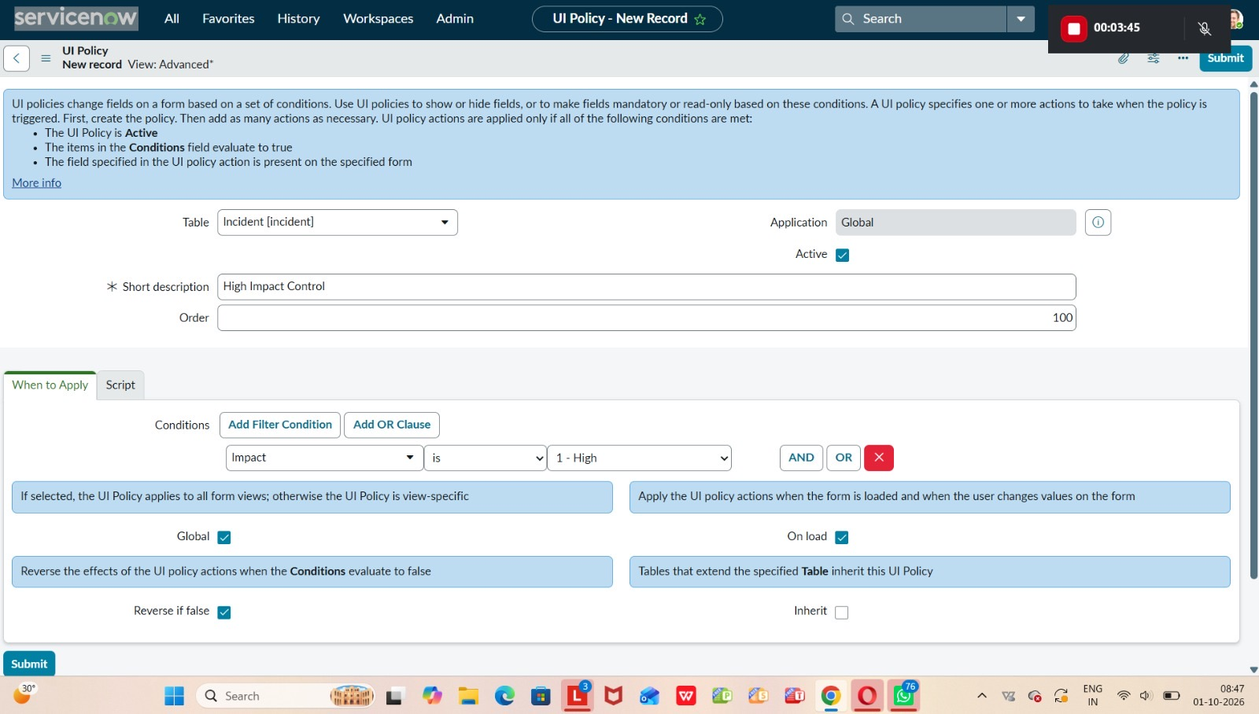
Screenshot 2: UI Policies list
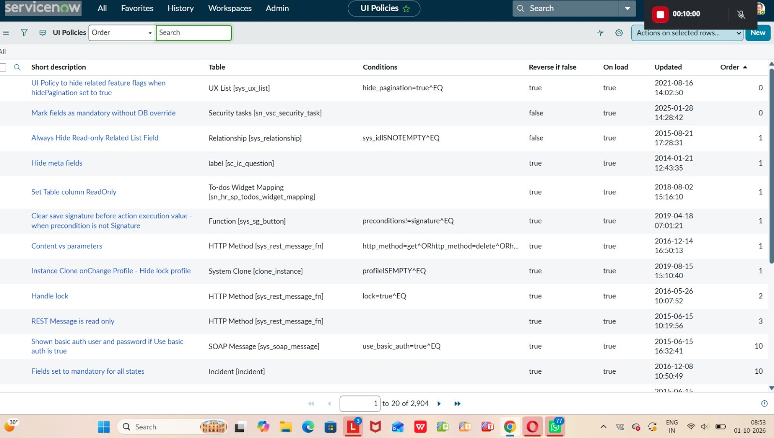

Task 2: Create UI Policy Action – Urgency
- Open the High Impact Control UI Policy and scroll to the UI Policy Actions related list.
- Click New.
- Set Field name: Urgency; Read-only: true; leave Visible unchanged.
- Click Submit.
- Verify: set Impact to High on an Incident and confirm Urgency becomes read-only; change Impact and confirm it reverts.
[ Insert screenshot: UI Policy Action for Urgency (read-only) ]

Screenshot 3: UI Policy Action configuration
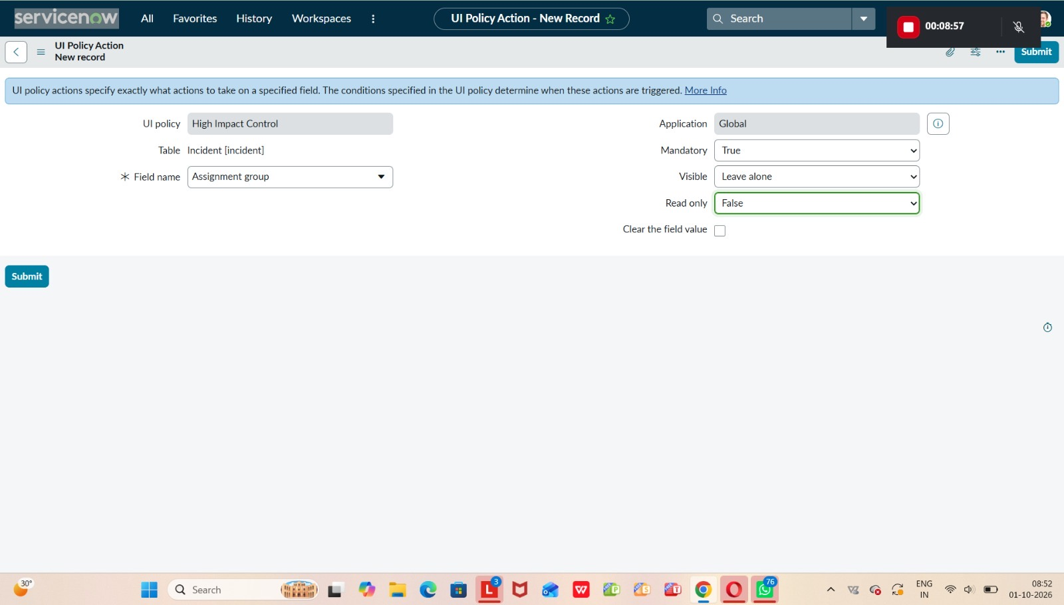

Task 3: Create onChange Client Script
- Navigate to System UI > Client Scripts and click New.
- Name: Auto set urgency for high impact; Table: Incident; Type: onChange; Field name: Impact; Active: true.
- Paste the script below and click Submit.
- Verify: change Impact to High on an Incident; Urgency updates automatically.
function onChange(control, oldValue, newValue, isLoading) {

if (isLoading || newValue == '') {
return;
}

if (newValue == '1') {
g_form.setValue('urgency', '1');
g_form.addInfoMessage('Urgency set to High for High impact incident.');
}
}

[ Insert screenshot: onChange Client Script record ]

Screenshot 4: Client Script – Auto set urgency for high impact
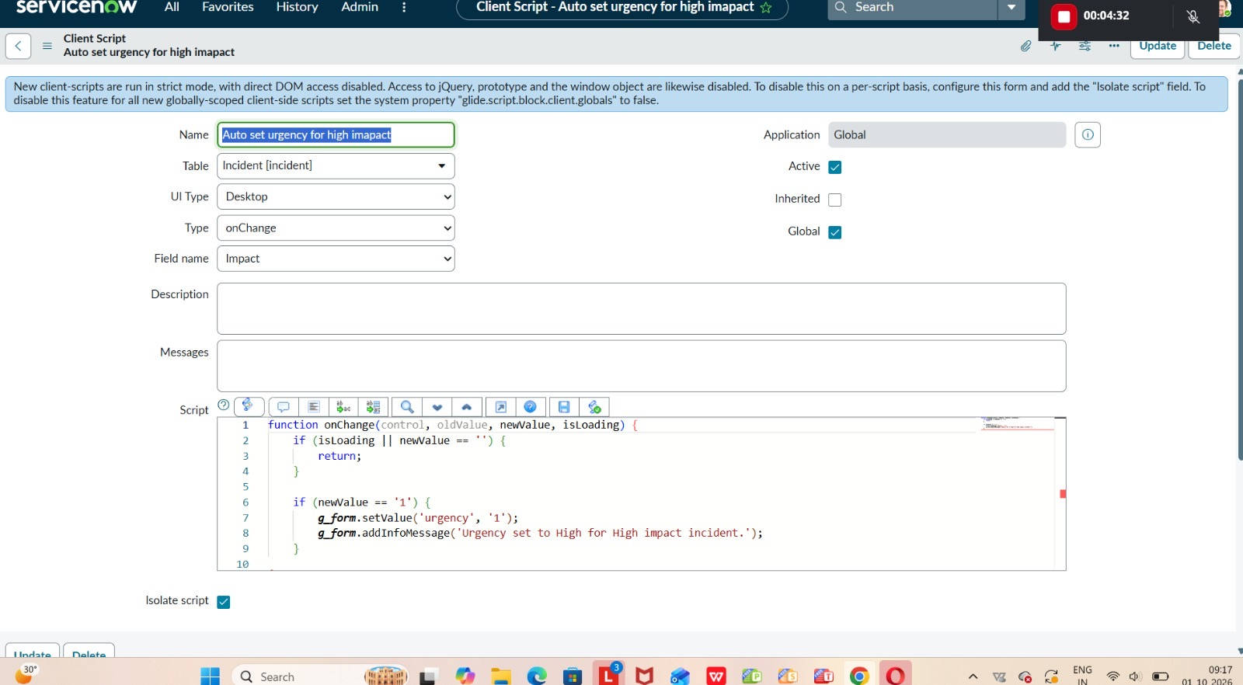

Task 4: Create onSubmit Client Script (Save Validation)
- Navigate to System UI > Client Scripts and click New.
- Name: Prevent save if Assigned To missing; Table: Incident; Type: onSubmit; Active: true.
- Paste the script below and click Submit.
- Verify: try to save a High-impact Incident without Assigned To; the save is prevented and an error is shown.
function onSubmit() {

if (g_form.getValue('impact') == '1' &&
g_form.getValue('assigned_to') == '') {
g_form.showErrorBox(
'assigned_to',
'Assigned To is mandatory for High impact incidents.'
);
return false;
}
return true;
}

[ Insert screenshot: onSubmit Client Script record and error message ]

Task 5: Create onCellEdit Client Script
- Navigate to System UI > Client Scripts and click New.
- Name: Prevent state change via list edit; Table: Incident; Type: onCellEdit; Field name: State; Active: true.
- Paste the script below and click Submit.
- Verify: in the Incident list, try to change State directly; the change is blocked.
function onCellEdit(sysIDs, table, oldValues, newValue, callback) {

alert('State cannot be updated using list editing. Please open the Incident.');
callback(false);
}

[ Insert screenshot: onCellEdit Client Script record and list-edit alert ]

Task 6: Testing the Configuration
Activity | Steps | Expected Outcome
1. Test mandatory enforcement | Incident > Create New; set Impact to High; leave Assigned To empty; Submit | Incident not saved; error shows Assigned To is required; UI Policy and Urgency behaviour work
2. Test successful save | Fill Assigned To; Submit | Incident saved; Urgency auto-set, read-only fields and State restrictions all function
3. Reverse condition test | Open a High-impact Incident; change Impact to Medium; Submit | Assigned To no longer mandatory; Urgency editable; record saves
4. Test list edit blocking | Incident > All; double-click State in a row | Alert shown; State unchanged
5. Test form-based update | Open the Incident; change State on the form; Update | State change saved; other fields still follow the rules

[ Insert screenshot: Test 1: error message when Assigned To is empty ]

[ Insert screenshot: Test 2: Incident saved successfully ]

[ Insert screenshot: Test 3: Impact changed to Medium (reverse condition) ]

[ Insert screenshot: Test 4: list edit blocked alert ]

[ Insert screenshot: Test 5: State updated on the form ]

Result: UI Policies and Client Scripts work together to enforce dynamic field behaviour, automate Urgency updates and prevent invalid Incident submissions.

8. Advantages and Disadvantages
Advantages | Disadvantages
Enforces mandatory fields and validation at the point of entry | Client-side controls can be bypassed by imports, integrations or APIs unless backed by server-side rules
Improves data quality, reporting accuracy and SLA compliance | onCellEdit script blocks every State edit in lists, without exceptions
Lightweight, fast and runs in the browser without server calls | Requires administrative access and script maintenance
Reverse if false restores normal behaviour automatically | Rules are tied to Impact = High; other conditions need additional configuration
Easy to implement and reuse on other tables | Users may find restrictions inconvenient if not communicated

9. Conclusion
The Implement Client Script & UI Policy (Incident) micro project demonstrates how UI Policies and Client Scripts work together to enforce dynamic field behaviour, automate updates and prevent incorrect data submission on Incident forms. By using onChange, onSubmit and onCellEdit scripts alongside UI Policy actions, fields such as Assigned To and Urgency respond appropriately to changes in Impact, maintaining clean and consistent data. The solution is lightweight, efficient and easy to implement, making it ideal for a short-duration micro project while showcasing practical best practices for form usability and data integrity in ServiceNow.

10. Future Scope
- Add server-side Business Rules or Data Policies as a backup so validation also applies to imports and integrations.
- Extend the rules to other fields and conditions, such as Priority or Category.
- Allow authorised roles to edit State in lists by adding a role check to the onCellEdit script.
- Apply the same pattern to Problem, Change and Request tables.
- Report on rejected saves to identify training needs.
Source Code (if any) | Client Scripts provided in Section 7.1, Tasks 3 to 5
Dataset Link | Not applicable
GitHub & Project Demo Link | [Enter link, if available]
UI Policy | High Impact Control (Incident)
Client Scripts | Auto set urgency for high impact; Prevent save if Assigned To missing; Prevent state change via list edit

