***Case Study Documentation on***

**Inventory Management System**

**Problem Statement**

A large-scale manufacturing company requires a Python-based automated inventory management system to streamline the tracking, procurement, and usage of raw materials and finished goods. The system must integrate with various production units, warehouse systems, and supplier networks to ensure optimal stock levels, minimize production delays, and avoid overstocking or stockouts.

The system should :

* Monitor the real-time availability of materials.
* Automate reordering when inventory falls below a predefined threshold.
* Manage the transfer of raw materials between warehouses.
* Generate reports on inventory turnover and forecast future demand based on historical data.
* Send alerts for discrepancies or delays in shipments.
* Support multiple concurrent processes to handle inventory updates from various production units simultaneously and ensure data security across all departments.

**Description**

This system is designed to provide seamless inventory management for a large manufacturing company. By utilizing object-oriented programming (OOP) principles in Python, the system manages the core operations of inventory tracking, reordering, material transfers, and forecasting. It ensures that the inventory system can be accessed and updated concurrently from various production units while safeguarding sensitive data via an authentication mechanism.

The system is divided into multiple modules:

* **Inventory Management**: Track the Material stock and Sales.
* **Reordering System**: Automatically triggers a reorder when stock levels fall below a predefined threshold and alert messages are sent to the user.
* **Transfer Database**: Store timely logs for all the material transactions in the database and can be viewed as a table for monitoring and evaluation.
* **Forecasting System**: Generates reports based on historical data to forecast future demand and calculate inventory turnover.
* **Alert System**: Automatically sends messages on shipments, reorders and alerts to the registered user for timely tracking.
* **Security**: Ensures authentication for secure access to inventory data and modifications.
* **Report Generation**: Generates reports on request by the user on the sales and turnover rate.

**Operations**

1. **Inventory Management**
   * **Add Material**: Allows the addition of new materials to the inventory.
   * **View Inventory**: Allows to view the inventory data in tabular format.
   * **Update Stock**: Updates the stock level of an existing material.
   * **Delete material:** Deletes the material on request by the user.
2. **Reorder System**
   * **Check for Reorder**: Checks stock levels and triggers an automatic reorder for materials with stock levels below a threshold.
   * **Reorder Alert**: If no materials need reordering, the system outputs a message indicating no reorder is required.
   * **Alert via email**: Email alerts are automatically triggered whenever reordering occurs.
   * **Reorder display**: Allows user to view the reorders in his main menu.
3. **Transfer System**
   * **Transfer Materials**: Manages the transfer of materials between warehouses, including time logs.
   * **Shipment Alert**: Sends email alerts when shipment is delivered .
   * **View shipments**: Allows user to view the shipments across the ware houses with their id , and their durations via transaction database .
4. **Forecasting**
   * **Inventory Turnover Report**: Calculates the inventory turnover rate for each item.
   * **Sales Forecast**: Generates a forecast based on historical sales data with an assumed growth rate.
5. **Security**
   * **Authentication**: Ensures that only authorized users can access the system by verifying their credentials.

**NOTE**: The credentials will be in authenticate file and can be edited as per user requirement. For the convenience of executing the program we have set both the username and password to **admin , admin143** respectively.

**Sample Input and Output**

**1.Authentication**

**Input:**

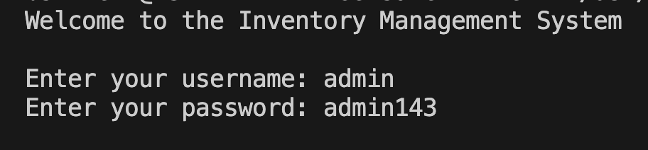

**Output:**

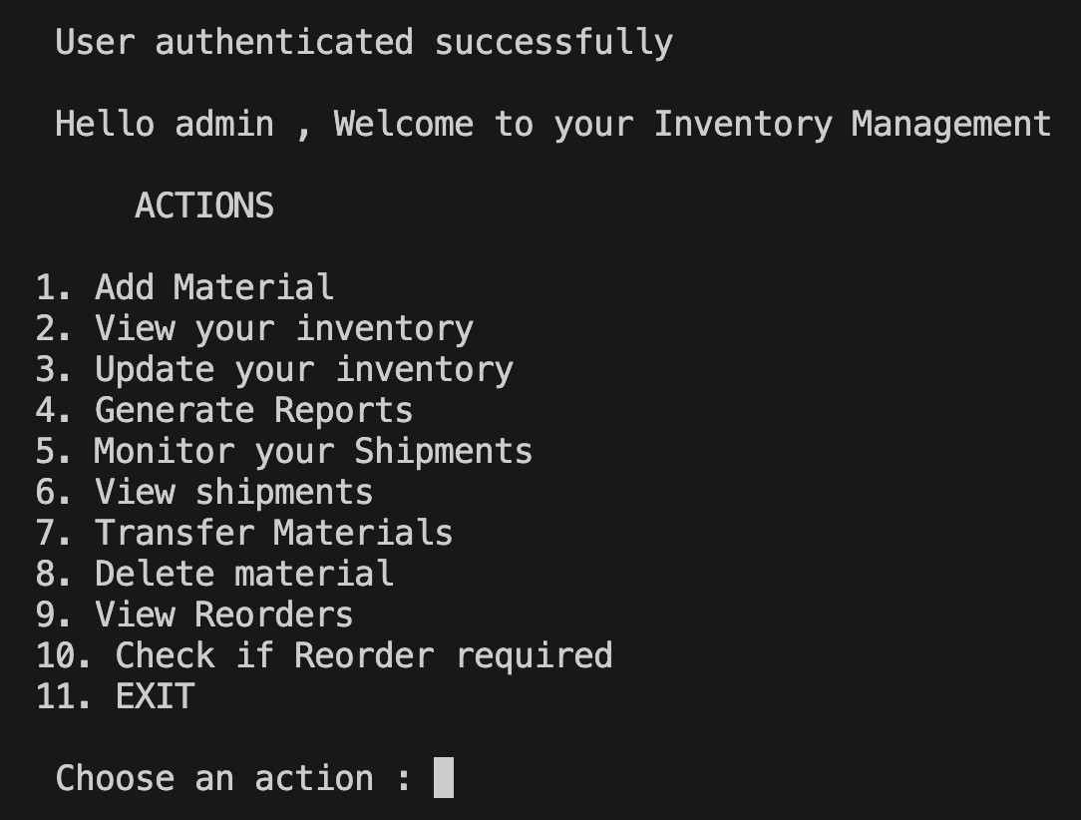

**2. Adding a Material**

**Input**:

**Output**:



**3. Displaying Stock Levels**

**Output**:

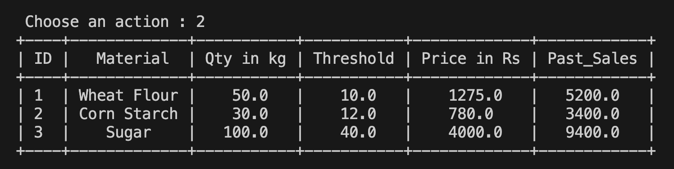

**3. Update Materials**

**Input and output:**

**4. Inventory Turnover and forecast Report**

**Output**:

**5. Transfer Materials**

**Output**:

1. **Monitor shipments**

1. **View Shipments**

1. **Delete material**

1. **Check if reorders required**

**Concepts learned and applied**

**1. SMTP (Simple Mail Transfer Protocol)**

SMTP is a protocol used to send emails from one server to another. In this project, I used SMTP for the **Alert System** to send automated email notifications for shipment delays. I learned how to configure an SMTP server, create an email message using MIME Text, and send it securely with TLS.

**2. OOP (Object-Oriented Programming) Concepts**

Throughout this project, I applied OOP principles such as:

* **Classes and Objects**: To model various system components (e.g., Inventory, Reorder, Transfer, Forecasting).
* **Encapsulation**: Each class encapsulates its functionality, making the code modular and maintainable.
* **Inheritance**: Although not used explicitly in this project, the concept of inheritance could be extended to enhance the code by creating a base class for shared functionality.

**3. Pandas**

I used the pandas library to manage and process the inventory data in a tabular format. Pandas is highly efficient in handling large datasets, and it allowed me to:

* **Generate Reports**: By transforming inventory data into DataFrame objects and calculating metrics like inventory turnover and sales forecasts.

**4. Authentication**

The **Security** class implemented a basic authentication system, where user credentials are stored in a dictionary and checked upon login. This ensures that only authorized personnel can perform sensitive operations like updating stock levels and managing materials.

**5. Threading**

Python’s threading module allows multiple threads to run concurrently, which is useful in scenarios where multiple users need to interact with the system at the same time. Locks allow you to force multiple threads to access a resource one at a time.

**6.Exception handling**

For catching input errors from users and preventing the crash of the program or exiting.

Also for displaying suitable formats and giving warnings.

**Required Modules**

To run the project, the following Python modules need to be installed:

1. pandas - For data manipulation and analysis.
2. smtplib - For sending email notifications.
3. email.mime - For constructing email messages.
4. Prettytable- For displaying data in tabular format
5. DateTime – For logging shipments information and tracking.
6. Sqlite3 – For databases and querying.

**Conclusion**

This inventory management system project has been a great learning of Python programming concepts and various other libraries in python. It helped me strengthen my understanding of OOP, SMTP for sending email alerts, working with the pandas library for data analysis, exception handling.

**Submitted by**

**Saketh Kukkadapu and Borusu Sri Venkata Maheswara Sai Krishna.**