Srividya Burra(002985163)

**Program Structures & Algorithms**

**Fall 2021**

**Assignment No. 1**

* **Task:**

Imagine a drunken man who, starting out leaning against a lamp post in the middle of an open space, takes a series of steps of the same length: 1 meter. The direction of these steps is randomly chosen from North, South, East or West. **After n steps, how far (d), generally speaking, is the man from the lamp post?** Note that d is the Euclidean distance of the man from the lamp-post.

Submission must include:

1. Your **conclusion** about the relationship between *d*and*n*;
2. Your **evidence** to support that relationship (screen shot and/or graph and/or spreadsheet);
3. Your **code** (*RandomWalk.java* plus anything else that you changed or created);
4. A **screen shot** of the unit tests all passing.

* **Tasks Performed:**

1. Written code for move(), randomWalk() and distance() functions in RandomWalk.java based on Euclidian and distance.
2. Verified if all the test cases passed.
3. Executed the program with different values for no. of steps
4. Tabulated the obtained values and plotted the graph.

* **Relationship Conclusion:**

**🡪** Observed that the mean distance obtained is approximately nearer to the input’s(no. of steps) square root.

**🡪** Hence we can deduce the relationship as **d=sqrt(n)**.

* **Evidence to support the conclusion:**

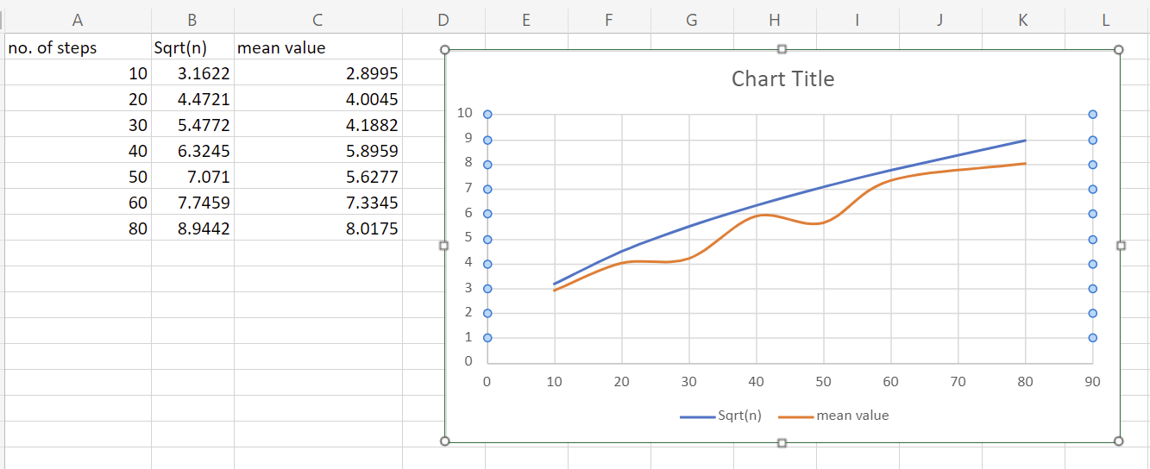

X-axis : Number of steps.

Y-axis : Mean distance calculated, sqrt(number of steps).

* **Test case execution result:**

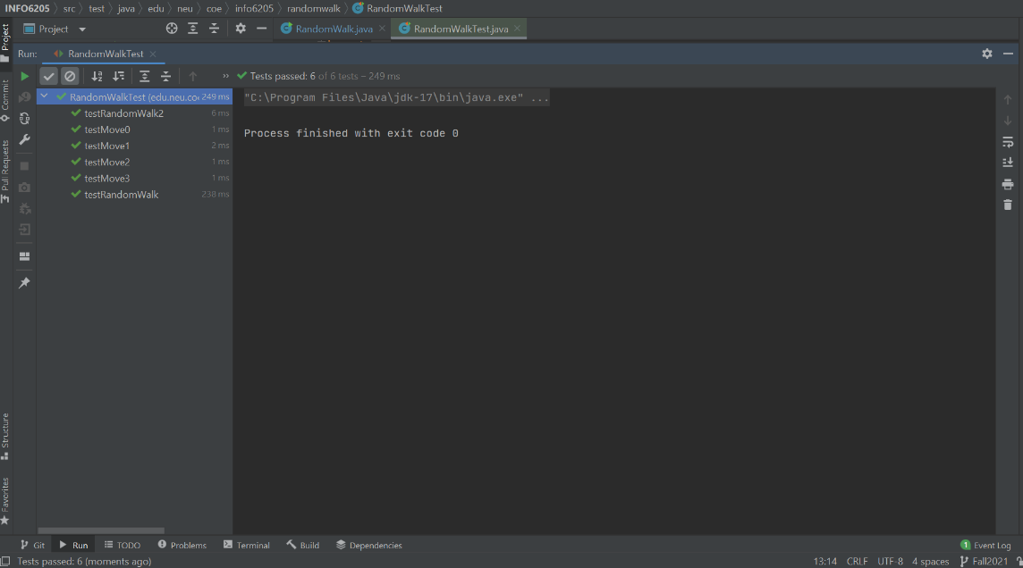

**Output (Snapshot of Code output in the terminal)**

