**Assignment 1**

**Title of the assignment:**

A book consists of chapters, chapters consist of sections and sections consist of subsections. Construct a tree and print the nodes.

**Relevant Theory:**

Tree represents the nodes connected by edges. We will discuss binary tree or binary search tree specifically.

Binary Tree is a special datastructure used for data storage purposes. A binary tree has a special condition that each node can have a maximum of two children. A binary tree has the benefits of both an ordered array and a linked list as search is as quick as in a sorted array and insertion or deletion operation are as fast as in linked list.

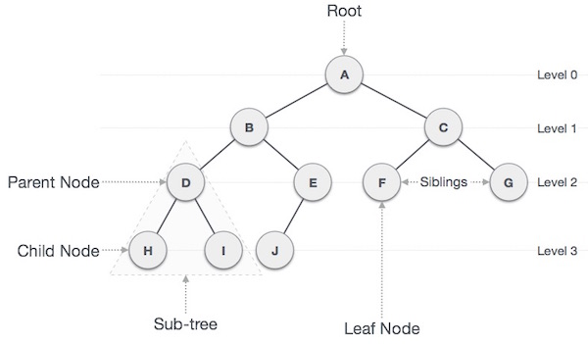

**Important Terms**

Following are the important terms with respect to tree.

* **Path** − Path refers to the sequence of nodes along the edges of a tree.
* **Root** − The node at the top of the tree is called root. There is only one root per tree and one path from the root node to any node.
* **Parent** − Any node except the root node has one edge upward to a node called parent.
* **Child** − The node below a given node connected by its edge downward is called its child node.
* **Leaf** − The node which does not have any child node is called the leaf node.
* **Subtree** − Subtree represents the descendants of a node.
* **Visiting** − Visiting refers to checking the value of a node when control is on the node.
* **Traversing** − Traversing means passing through nodes in a specific order.
* **Levels** − Level of a node represents the generation of a node. If the root node is at level 0, then its next child node is at level 1, its grandchild is at level 2, and so on.
* **keys** − Key represents a value of a node based on which a search operation is to be carried out for a node.

Traversal is a process to visit all the nodes of a tree and may print their values too. Because, all nodes are connected via edges (links) we always start from the root (head) node. That is, we cannot randomly access a node in a tree. There are three ways which we use to traverse a tree −

* In-order Traversal
* Pre-order Traversal
* Post-order Traversal

## In-order Traversal

In this traversal method, the left subtree is visited first, then the root and later the right sub-tree. We should always remember that every node may represent a subtree itself.

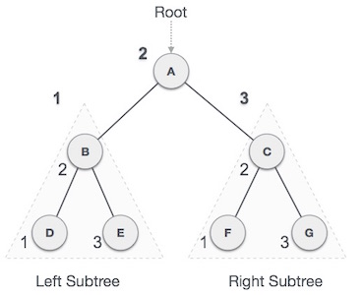

We start from **A**, and following in-order traversal, we move to its left subtree **B**. **B** is also traversed in-order. The process goes on until all the nodes are visited. The output of inorder traversal of this tree will be −

***D → B → E → A → F → C → G***

## Pre-order Traversal

In this traversal method, the root node is visited first, then the left subtree and finally the right subtree.

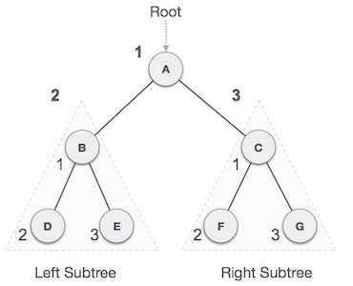

We start from **A**, and following pre-order traversal, we first visit **A** itself and then move to its left subtree **B**. **B** is also traversed pre-order. The process goes on until all the nodes are visited. The output of pre-order traversal of this tree will be −

***A → B → D → E → C → F → G***

## Post-order Traversal

In this traversal method, the root node is visited last, hence the name. First we traverse the left subtree, then the right subtree and finally the root node.

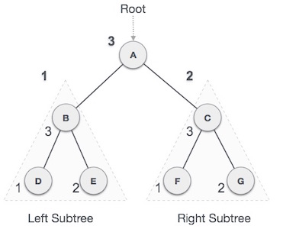

We start from **A**, and following pre-order traversal, we first visit the left subtree **B**. **B** is also traversed post-order. The process goes on until all the nodes are visited. The output of post-order traversal of this tree will be −

***D → E → B → F → G → C → A***

**Conclusion**: Construction of tree -BOOK is performed