**ASSIGNMENT-5**

**PL/SQL Block:**

declare

v_Rollno number(10);

v_Name varchar2(20);

v_days number(3,0);

v_amt number(6):=0;

cursor c1 is

select Roll_no,Name,(sysdate-Issue_date)

from borrower;

e1 exception;

begin

insert into fine(Roll_no)

select Roll_no from borrower b

where not exists(select Roll_no from fine where Roll_no=b.Roll_no) and (sysdate- Issue_date)>15;

open c1;

loop

fetch c1 into v_Rollno,v_Name,v_days;

if v_days>15 and v_days<=30

then v_amt:=(5*(v_days-15));

elsif v_days>30

then v_amt:=(75+50*(v_days-30));

elsif v_days<15

then v_amt:=0;

end if;

if v_days>15

then

update fine set return_date=sysdate,days=v_days,amount=v_amt

where Roll_no=v_Rollno;

update borrower

set status='R'

where Roll_no=v_Rollno;

end if;

if c1%notfound

then raise e1;

end if;

end loop;

close c1;

exception

when e1 then

dbms_output.put_line('No active Cursor');

end;

**Input: Borrower table**

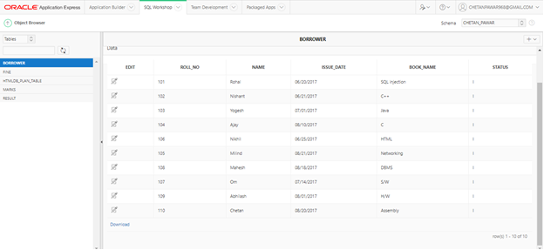

**Output:**

**Borrower table**

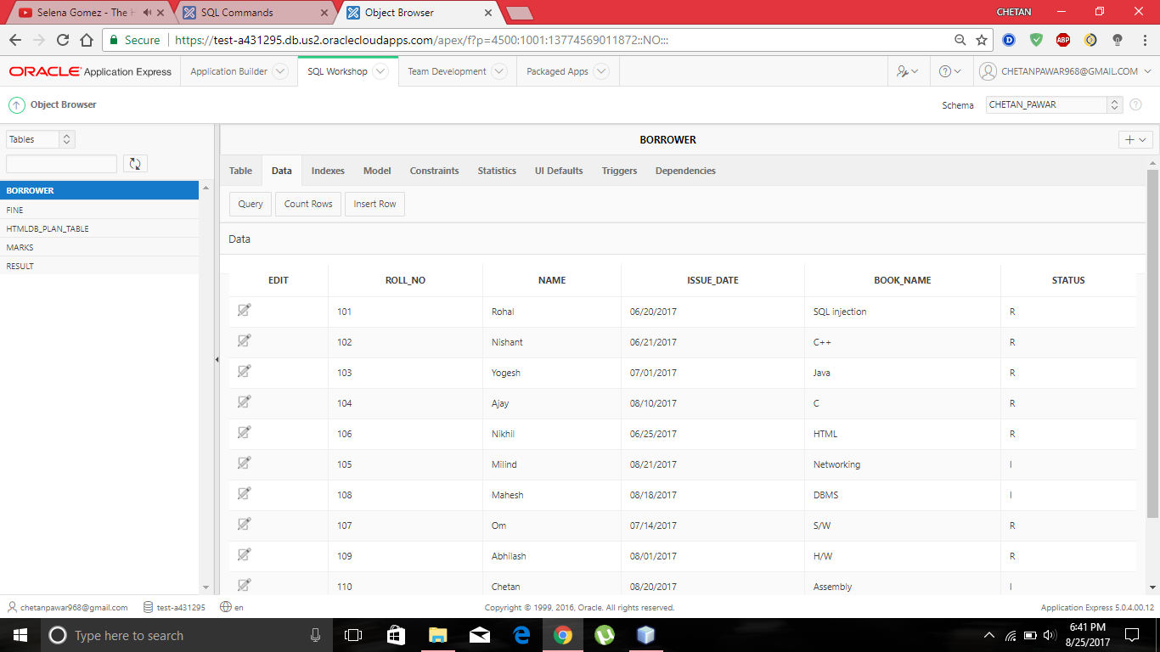

**Fine table**

