**ASSIGNMENT-7**

**Procedure: Grade_Proc**

create or replace procedure grade_proc(total in number,class out varchar2) is

begin

if total<=1500 and total>=990 then class:='Distinction';

elsif total<=989 and total>=900 then class:='First Class';

elsif total<=899 and total>=825 then class:='Second Class’;

else class:='Fail';

end if;

end grade_proc;

**PL/SQL block:**

declare

v_Rollno number(7);

v_Name varchar2(20);

v_total number(5,0);

v_class varchar2(20);

cursor c1 is

select Rollno,Name,Total

from Marks;

begin

open c1;

loop

fetch c1 into v_Rollno,v_Name,v_total;

exit when c1%notfound;

grade_proc(v_total,v_class);

insert into Result(Rollno,Name,Total)

select Rollno,Name,Total from Marks m

where not exists(select Rollno from Result where Rollno=m.Rollno);

update result

set class=v_class

where Rollno=v_Rollno;

end loop;

close c1;

end;

**Input: Marks table**

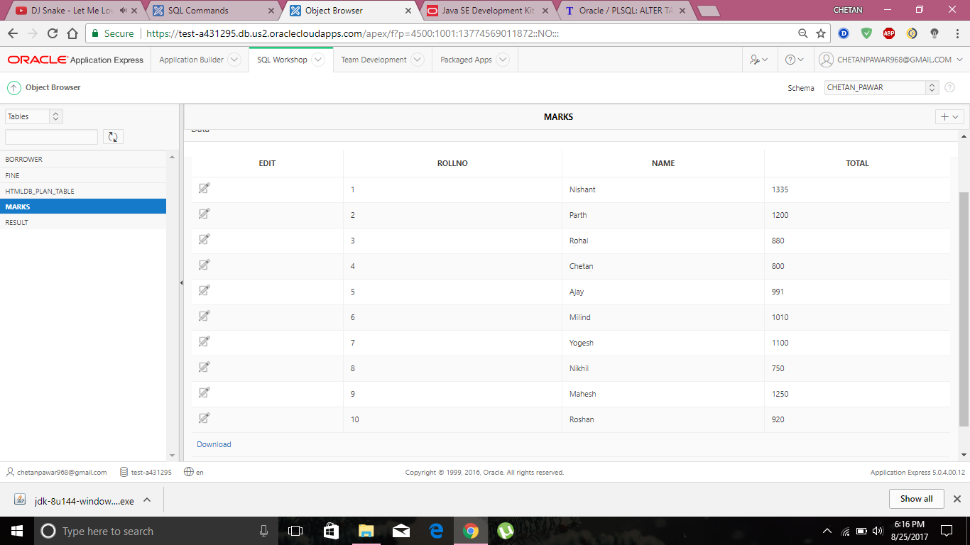

**Output: Result table**

