Hierarchical Structure of Jira Activities
1. Introduction
Jira is a project management tool used by teams to plan, organize, assign, and track their work. It helps team members understand what needs to be done, who is responsible for it, and the current progress of each activity.
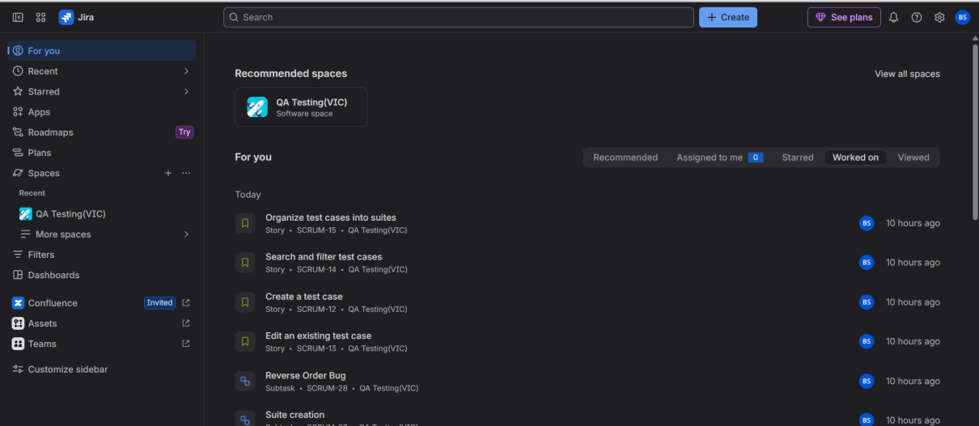

2.Usage of Jira
- Plan work: Break projects into tasks, set owners and due dates, and organize work into sprints or a backlog.
- Track progress: Follow work as it moves through your process, from to-do to done, on boards built for your team.
- Manage dependencies: See how work connects across teams and spot blockers before they slow you down.
- Report on results: Use built-in reports to answer how a project is tracking without building a spreadsheet.

3. Hierarchical Structure of Jira
Jira organizes work into different levels so that large activities can be divided into smaller and manageable tasks.
Basic hierarchy:
(The hierarchy structure follows the below order means in Space the epics are created and stories in epics and so on)
- Project/Space: The main place where related work items are organized.

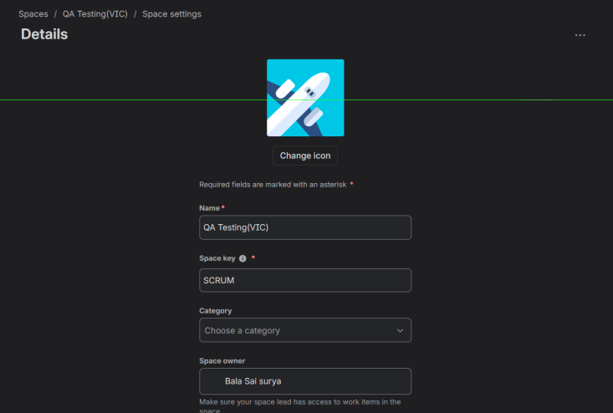

- Epic: A large activity or feature that can be divided into smaller work items.
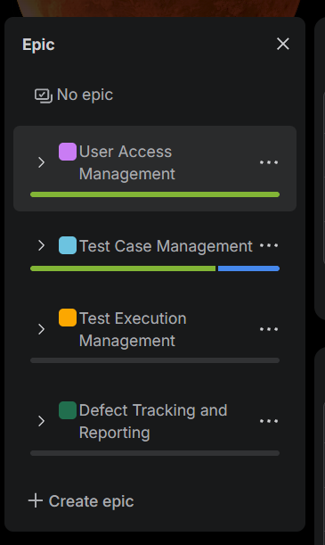

- Story: A requirement or feature that provides value to the user.

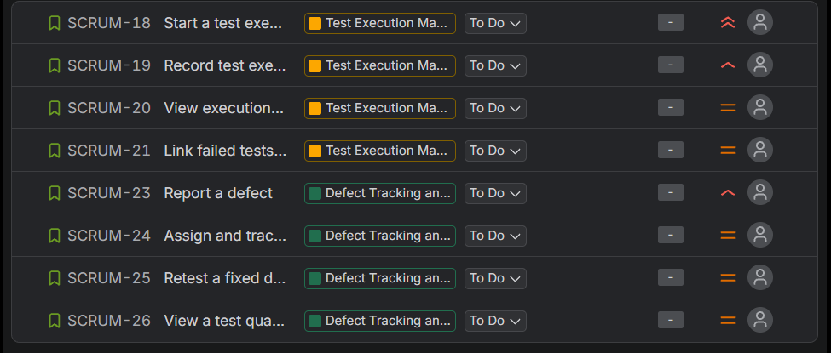

- Task: A specific activity that needs to be completed.

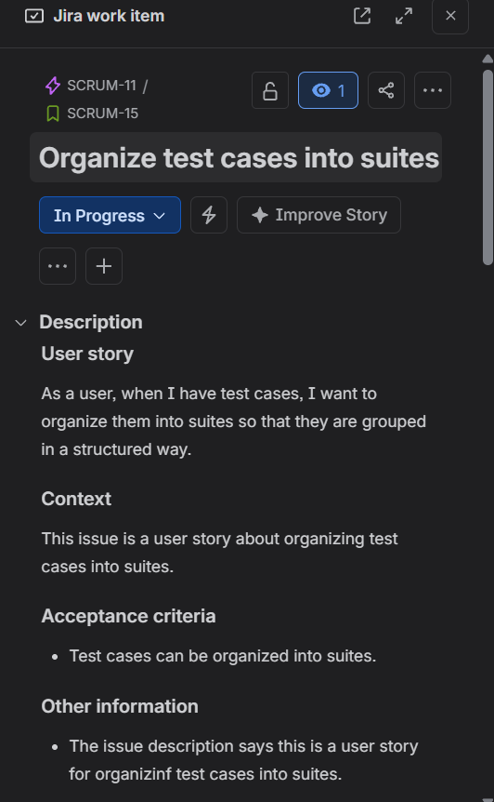
- Bug: An issue that identifies a defect or unexpected behaviour.

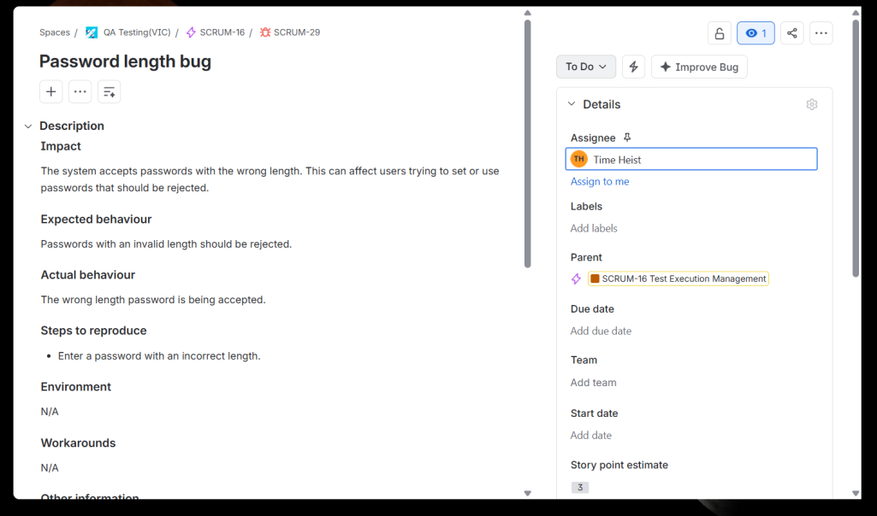
- Sub-task: A smaller part of a task or other supported work item.
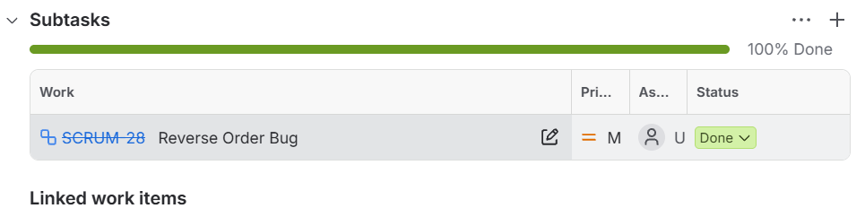

4. Workflow of Jira Activities
A workflow represents the stages through which a work item moves from the beginning to completion.
Example workflow:
To Do → In Progress → In Review → In Testing → Done
- To Do: Work has not started.
- In Progress: Work is being performed.
- In Review: The work is being reviewed.
- In Testing: The work is being tested.
- Done: The work has been completed.
The workflow can be customized according to the needs of the project.

5. Sprints and Releases
- Sprint: A sprint is a fixed period during which a team plans to complete selected work items. It is commonly used in Scrum projects.
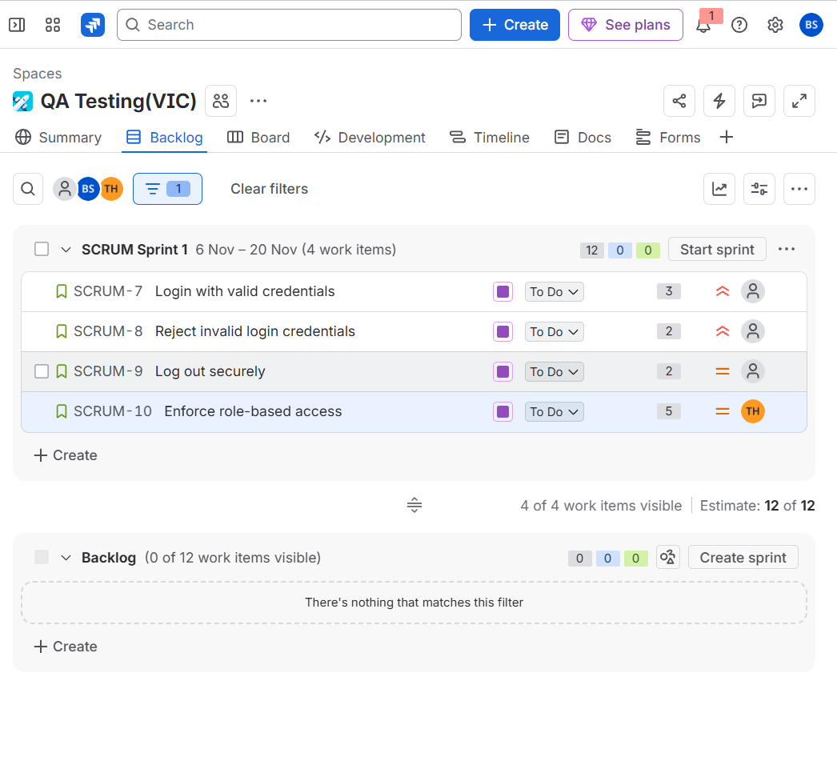
- Release: A release represents a version of the product planned for delivery. Related work items can be associated with a version using the Fix versions field.
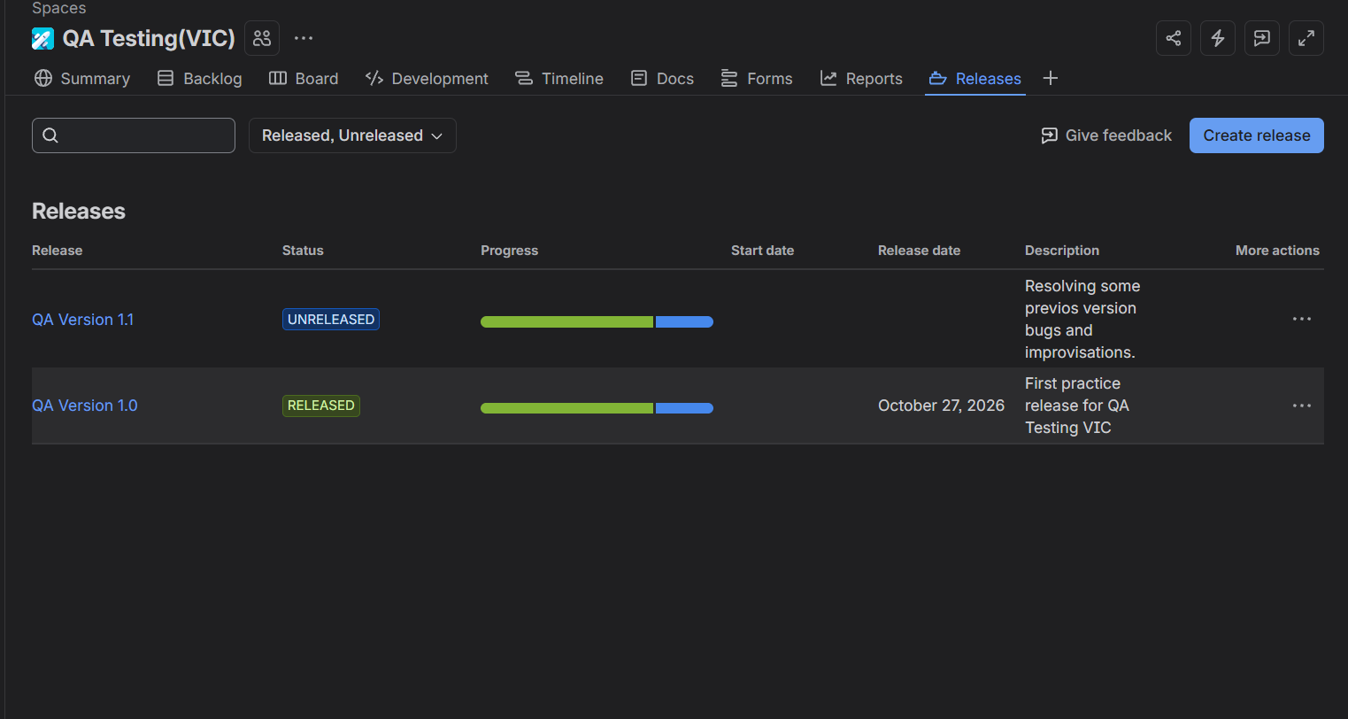
6. Conclusion
Jira provides a structured way to manage project activities. Epics help organize large features, stories and tasks represent individual pieces of work, and sub-tasks divide work into smaller activities. Workflows track progress, while sprints and releases support planning and delivery. This structure improves visibility, coordination, and tracking throughout the project.

