

Lab 03

Course | Game Dev
Instructor | M. Raza Butt

Roll Number | Name
BSSE23036 | Mustafa Fawwaz

Table of Contents
App & Process 3

Screenshots
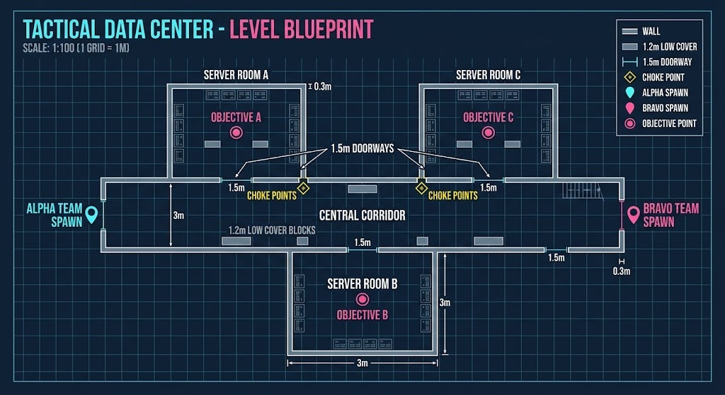
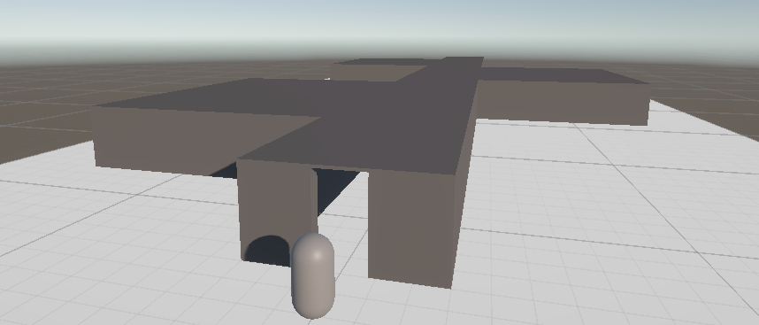
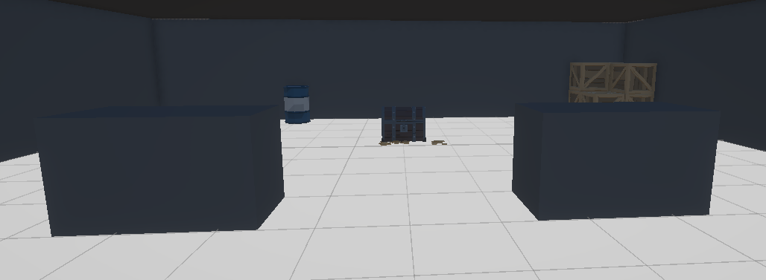
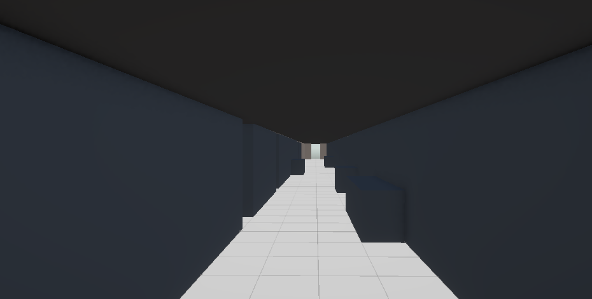

Level Overview & Gameplay Flow
This blockout adapts the tactical blueprint into a treasure-collection maze. The player starts at Alpha Spawn, navigates a 3-meter-wide central corridor, explores three side rooms to collect treasure chests, and exits at Bravo Spawn. Gameplay tension relies entirely on spatial layout and architectural bottlenecks rather than scripting.

Obstacles & Environmental Hazard
Built exclusively from primitive prefabs (cubes, planes, cylinders):
- Doorways: 1.5m widths create tight spatial bottlenecks that barely clear the 1m-wide player capsule.
- Low Cover: 1.2m-tall blocks successfully hide a crouching player but leave a standing player exposed.
- Blind Corners: 3m-tall walls obscure line-of-sight into the side rooms, forcing blind exploration.

Reasoning for Level Design Choice
- Validating Optional Space: Placing treasure at the back of the side rooms provides a clear spatial reward, justifying player exploration off the main path.
- Player-Centric Sizing: Dimensions strictly contrast comfortable movement (3m corridors) with restrictive caution (1.5m doors) based on the player capsule's limits.
- Flow vs. Risk: The linear Spawn-to-Exit route ensures new players will not get lost, while turning into the perpendicular treasure rooms introduces navigational risk.

Video
Walkthrough video is added in the Submission folder of the repository.

