CS464 Game Development · Lab 03
Level blockout: two Team Deathmatch arenas
Mohsin Raza Ojla · BSSE23040 · ITU
GitHub repository: github.com/bsse23040/ITU-CS-464-LAB-03-BSSE23040
Game I chose: PUBG Mobile, in its Team Deathmatch mode (the warehouse map).
For this lab I made two blockout levels in Unity using only primitive game objects (cubes), then flew a camera through them in the Scene view and recorded it. Both levels are built for fast four-versus-four fights, because that is what I actually play in PUBG Mobile. This document has my reference images, screenshots of both levels, an explanation of each level and its obstacles, and why I designed them this way. The screen recording is a separate file, LevelWalkthrough.mp4.

1. Reference material
These are screenshots I took in a Team Deathmatch match, and I also recorded a short gameplay video (PUBG_gameplay_video.mp4, in the References folder of the repository). They are what I looked at while I built the levels.
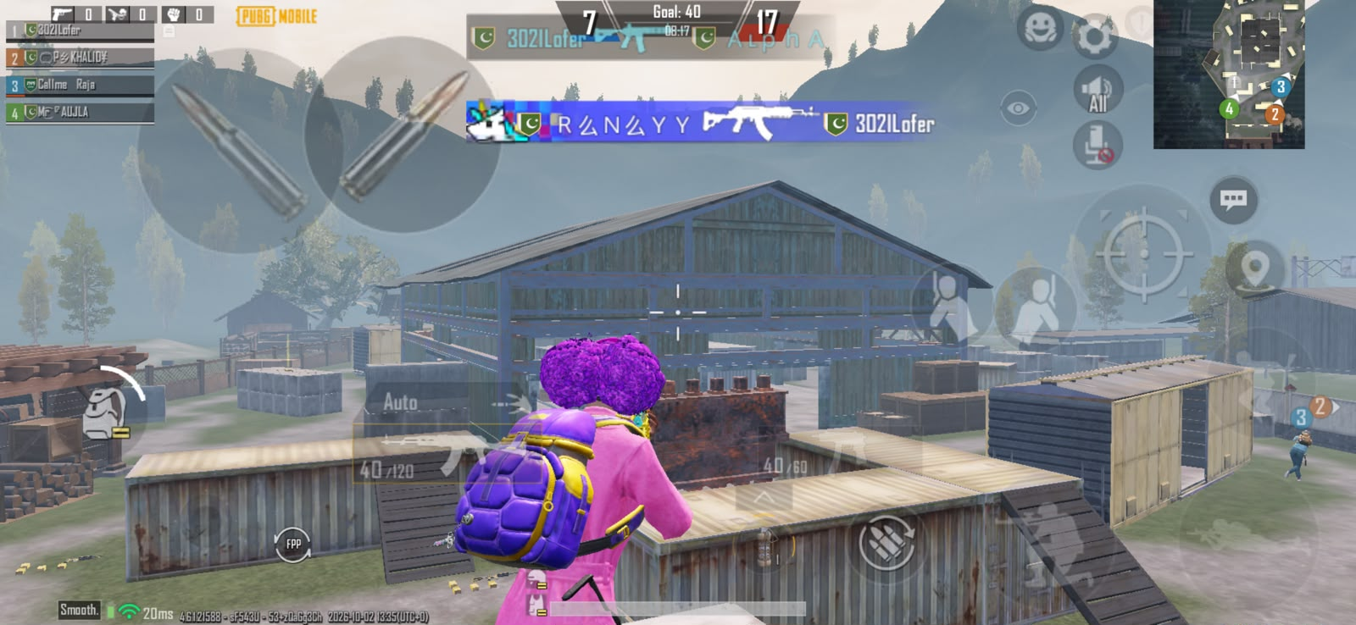
Reference 1: a big two-storey warehouse in the middle, with containers and crates around it.
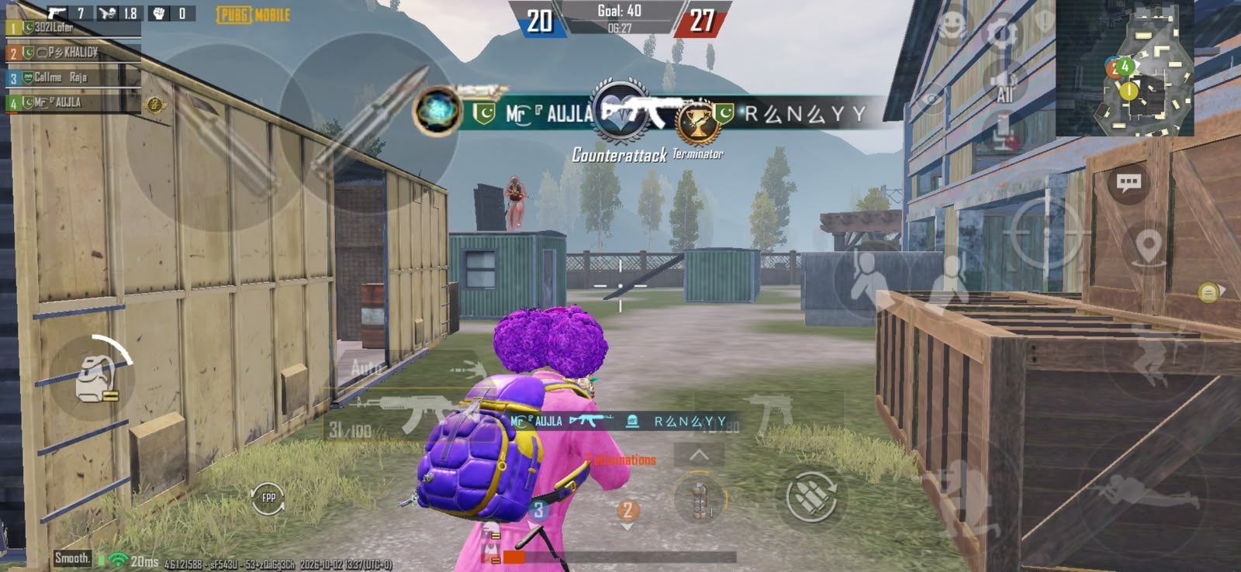
Reference 2: a lane between a wall of containers and wooden crates. An enemy is standing on a container roof.
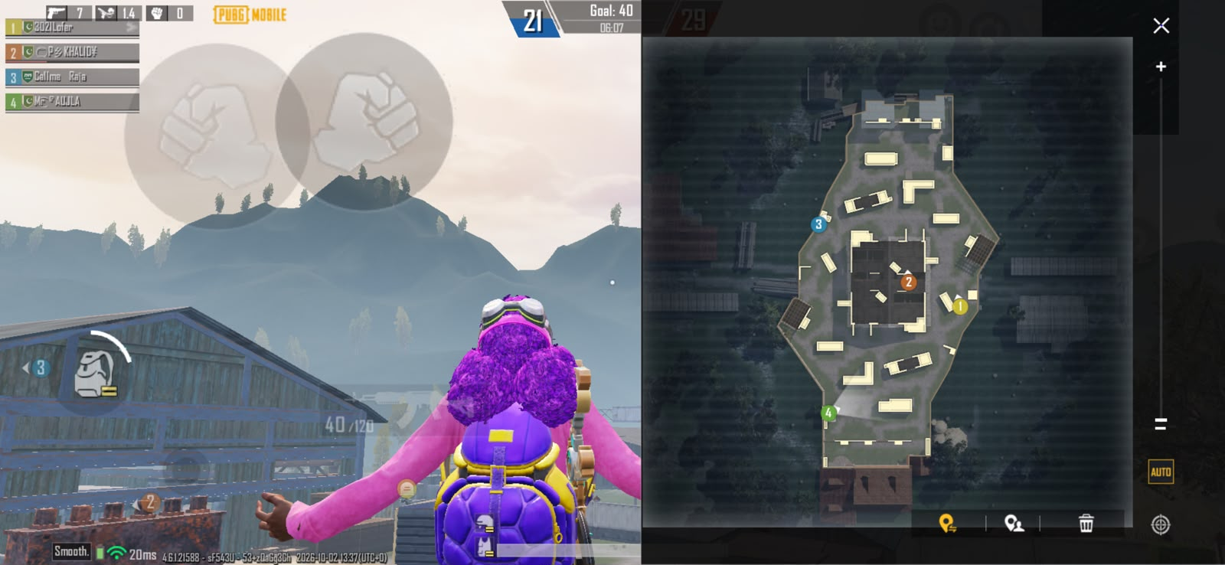
Reference 3: the full map. The arena is small, with a big central building, containers around it and spawns at both ends.
What I took from them: the arena is compact so teams meet within seconds. The middle is held by one large building. Shipping containers and crates are placed all over as cover, and some of them can be climbed, so height matters. Teams spawn at opposite ends, and every fight has to be won at a corner, a doorway or a roof edge.

2. Level 1: Warehouse (TDM_01_Warehouse)
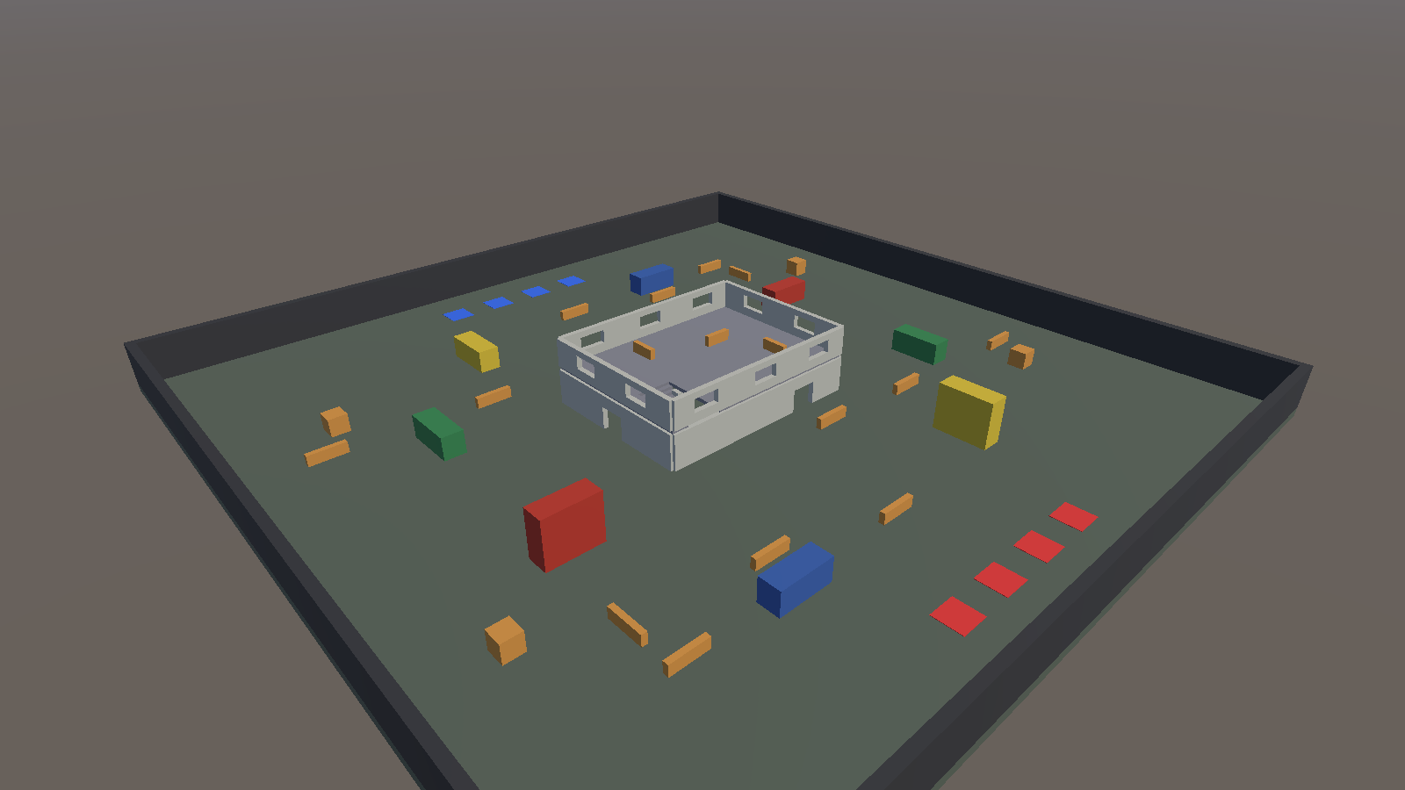  Overview: the whole arena from a corner. | 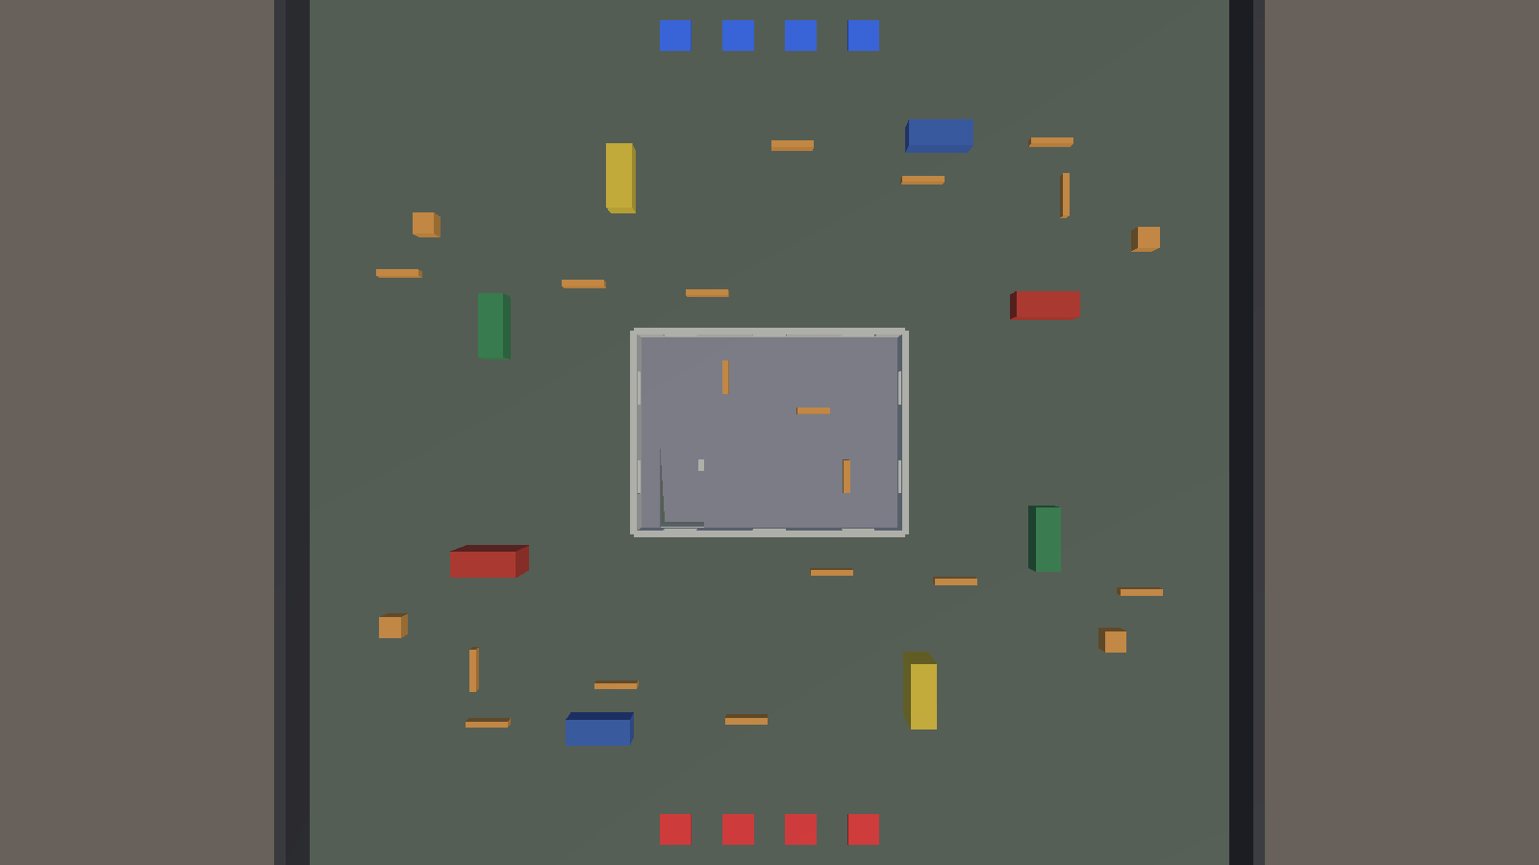  Top-down: red spawns at the bottom, blue at the top.
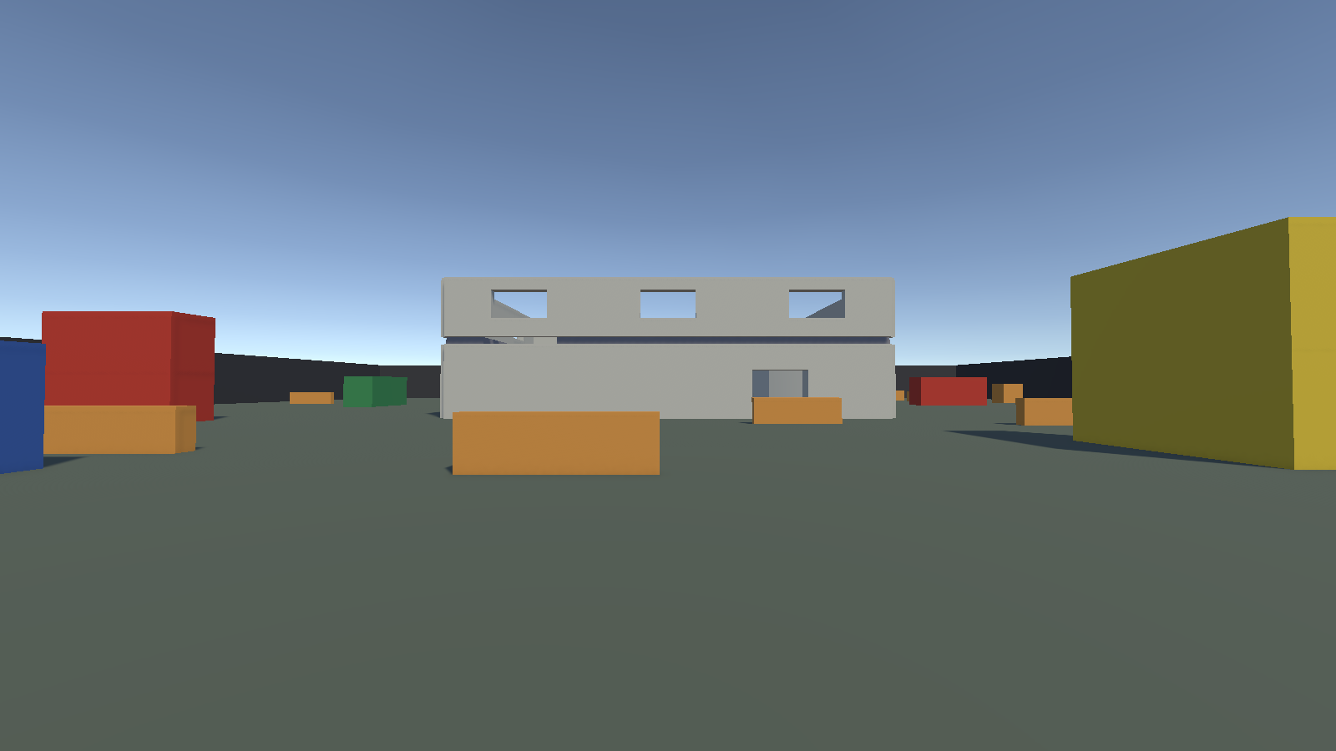  What a player sees from the red spawn. | 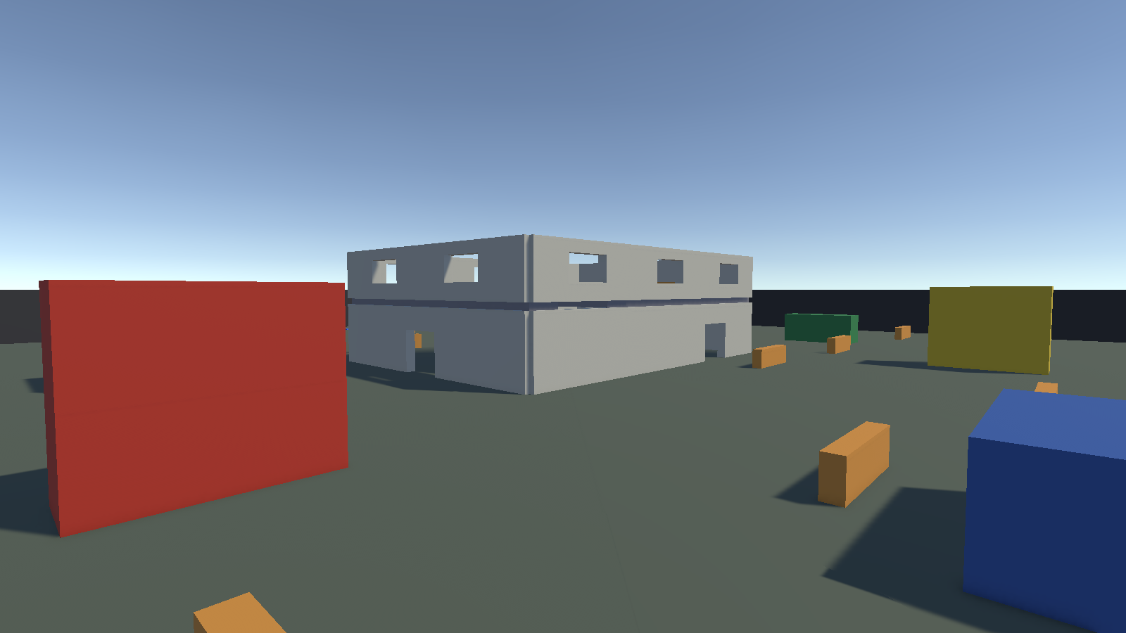  The warehouse from the outside.
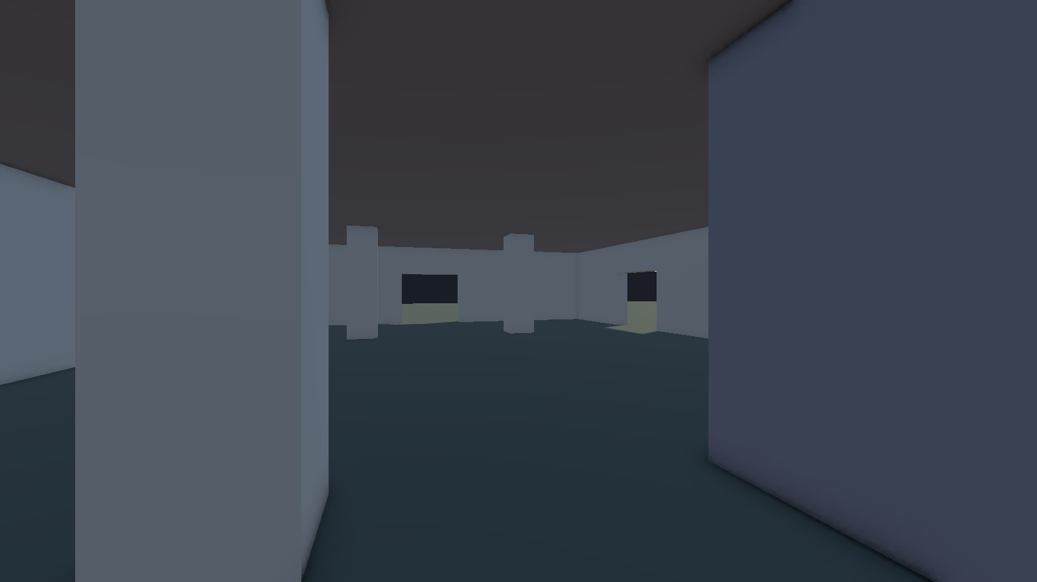  Ground floor, looking toward the pillars. | 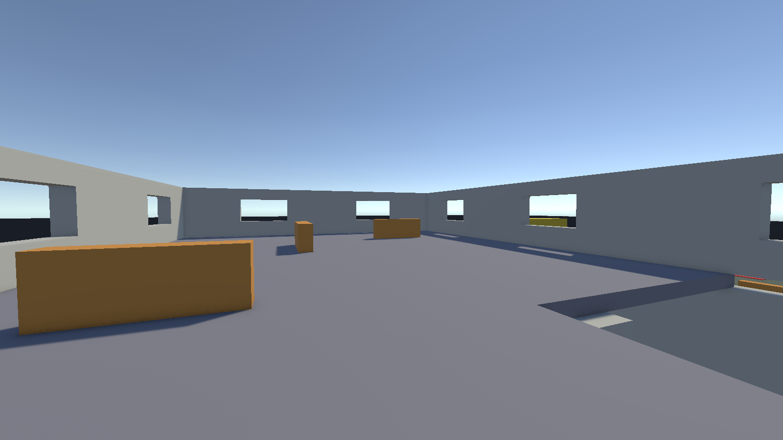  Upper floor, with window openings.

What the level is
A square arena of 90 m by 90 m inside a 5 m tall perimeter wall. The big landmark is a two-storey warehouse in the centre, 24 m by 18 m. Both teams spawn on pads at their own end: four red pads on one side and four blue pads on the other.

Obstacles and how they work
- Warehouse doorways and windows. The ground floor has a doorway on every side, so a fight can come from four directions. The upstairs has window openings for sniping.
- Interior stairs. A single 15-step stairway inside the warehouse is the only way up. Players on the stairs are exposed, and the opening in the upper floor lets people below shoot up at them.
- Pillars and low cover. Four pillars on the ground floor and low cover blocks on the upper floor break up the long sight lines inside.
- Containers. Ten shipping containers (6 m by 2.6 m by 2.4 m) are placed outside, two of them stacked. They block the long view across the arena and make lanes, like the container lane in my reference.
- Scattered crates and low walls. Crates and low walls (1.1 to 1.2 m high) are scattered in the open ground so a player crossing the yard always has something to duck behind.

Why I designed it this way
- It copies the reference: one dominant building in the middle with containers around it, so the first thing both teams want is the middle.
- Everything is mirrored through the centre. A spawn on one side has exactly the same cover and distances as the other, so the level is fair.
- It gives three kinds of fights: long range across the yard, medium range between containers, and close range inside the building.
- Low cover is 1.1 to 1.2 m, high enough to crouch behind and low enough to shoot over when standing.

3. Level 2: Docks (TDM_05_Docks)
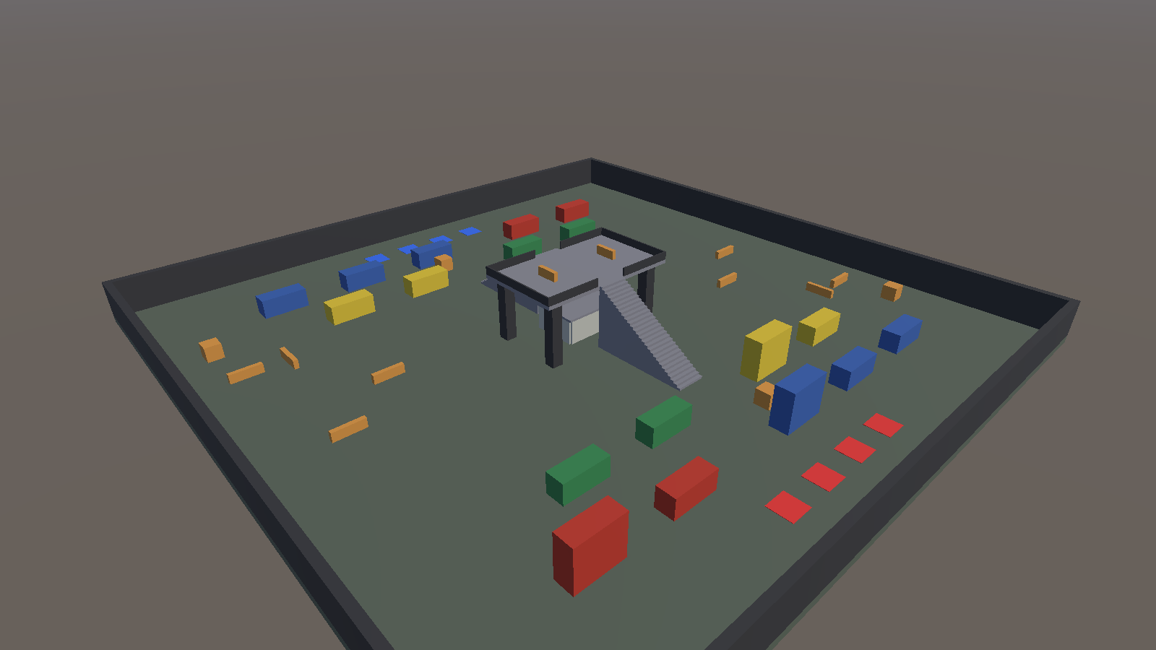  Overview: container lanes with the crane in the middle. | 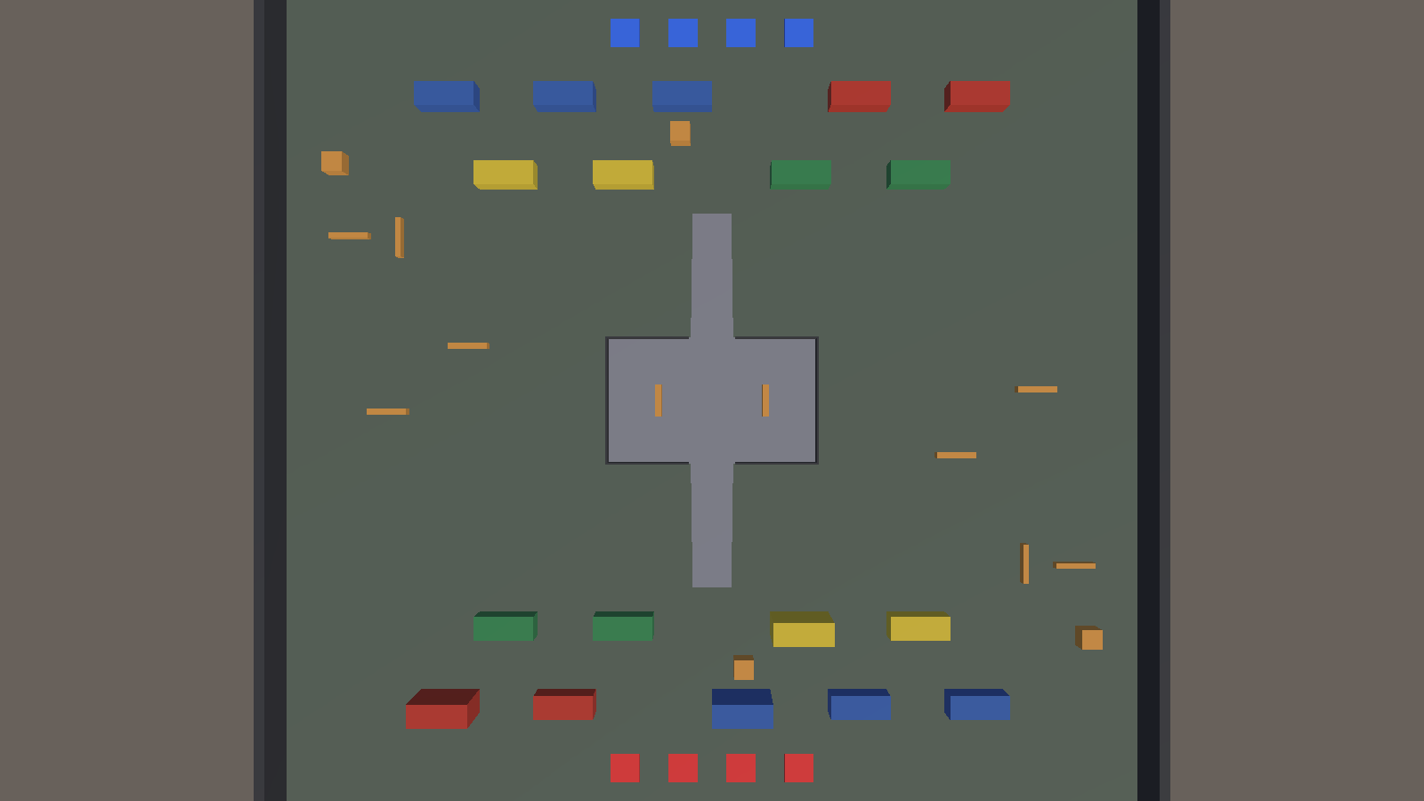  Top-down: two staggered rows of containers on each side.
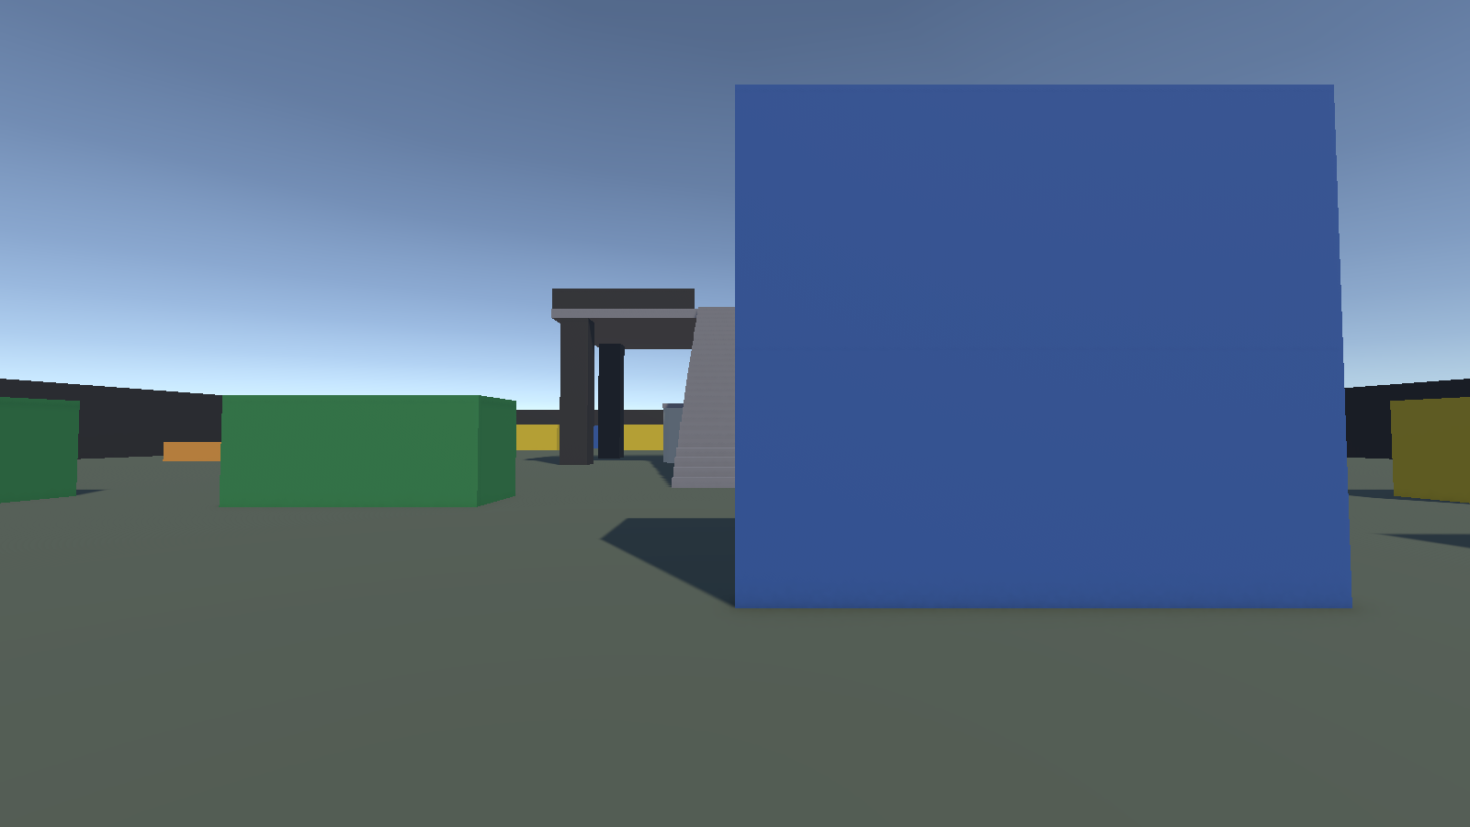  What a player sees from the red spawn. | 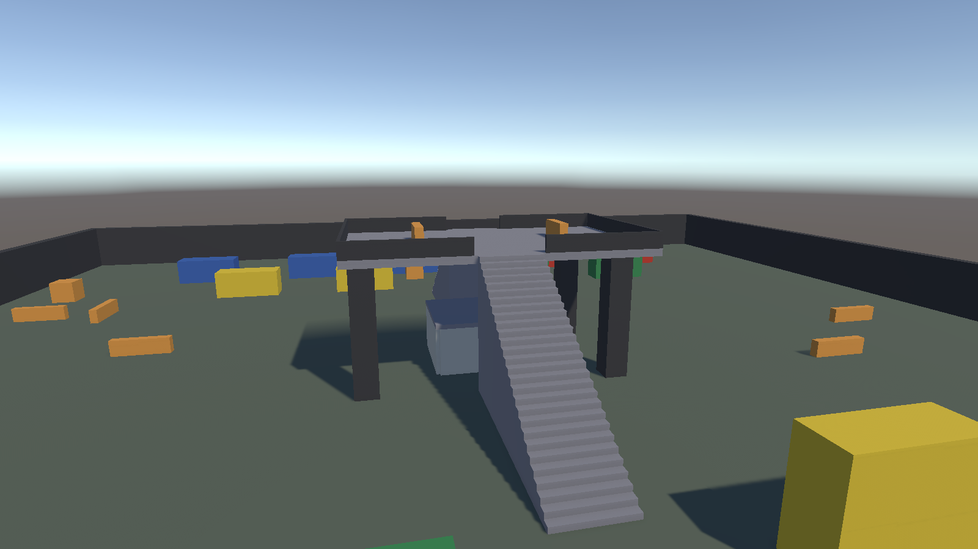  The crane gantry and its stairs.
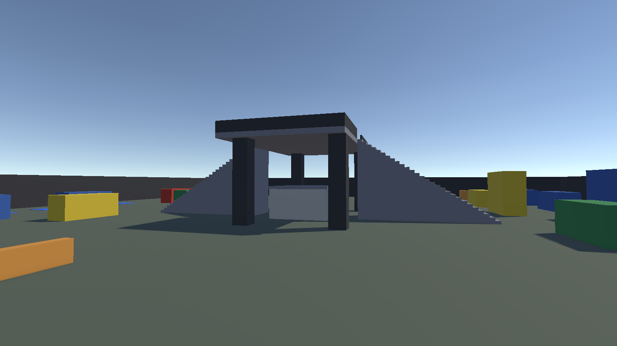  Side view: deck on four legs, stairs on both ends. | 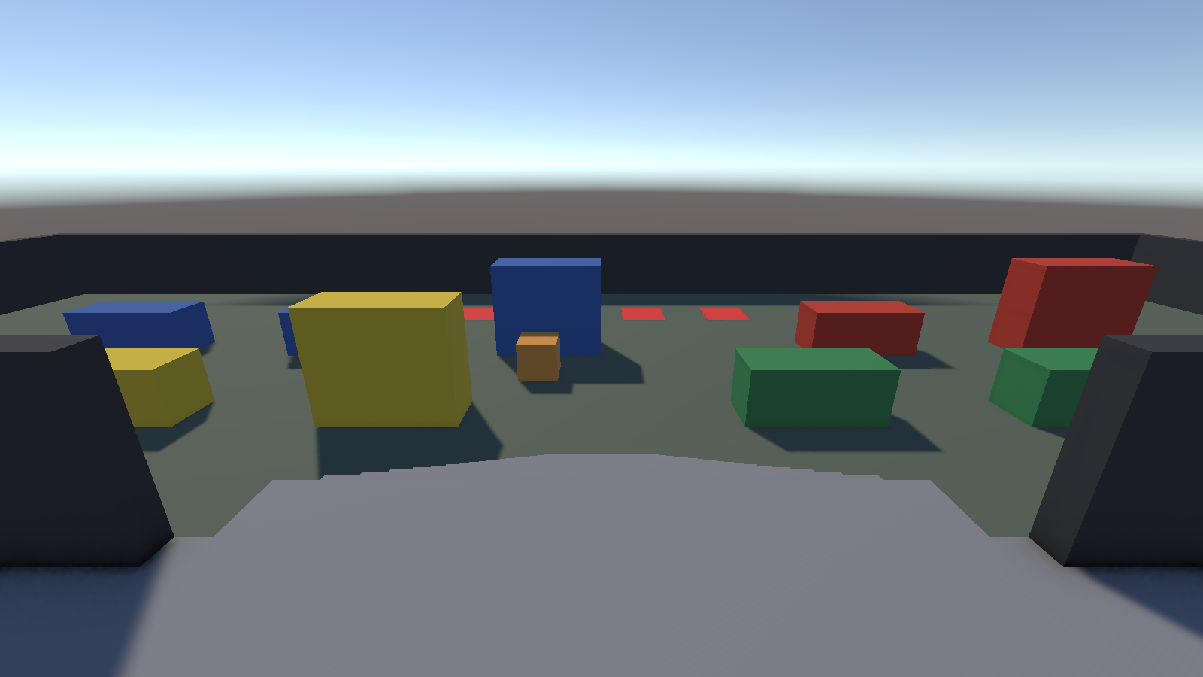  From the deck, looking over the containers.

What the level is
The same 90 m by 90 m arena and spawn layout, but a very different shape. Two staggered rows of containers fill each half, leaving lanes about 5.6 m wide. In the middle stands a crane gantry: a 20 m by 12 m deck on four legs, 8.5 m above the ground.

Obstacles and how they work
- Container rows. Nine containers per side, in two rows with gaps between them. The rows are staggered so no lane is straight for the whole length, which stops a single player from holding it.
- Long stairs. Two stairways of 28 steps lead up to the deck, one from each team's side. The climb is long and completely exposed, so going up is a real risk.
- Gantry deck. The deck is the strongest sniping spot on the map. It has railings and two cover blocks, and its stairs have openings in the rail.
- Control hut. A small hut under the deck (8 m by 6 m, one door) gives a close-range fight for players who stay on the ground.
- Cover in the gaps. Low walls and crates fill the gaps between the container rows.

Why I designed it this way
- The first level is about one building and fights at doors. I wanted the second one to play differently, so it is about height: whoever holds the deck sees the whole arena.
- The long stairs balance the deck. It is strong, but a team that wants it has to climb while the other team shoots at them, so it needs teamwork.
- The container rows copy the lane I saw in my second reference screenshot, and the staggered gaps stop any lane from becoming a shooting gallery.
- Same spawn pads and same mirrored layout as Level 1, so both levels stay fair to both teams.

4. How it was built
Everything is made from Unity primitive cubes with flat colours: grey ground and walls, orange cover, coloured containers, red and blue spawn pads. Nothing is downloaded. The levels are in Assets/Scenes/Blockout in the repository, and a small editor script (Assets/Editor/BlockoutBuilder.cs) builds them from the same set of helper functions for walls, doors, stairs and containers. I used Unity's Scene view to look around, and the walkthrough video is a camera path flown through the Scene view of both levels.
 | Level 1: Warehouse | Level 2: Docks
Main idea | One big building and doorway fights | Height, with a crane deck and container lanes
Strongest spot | The upper floor of the warehouse | The crane deck, 8.5 m up
Main cover | Containers, crates, pillars | Container rows, low walls
Way up | One 15-step stairway inside | Two 28-step stairways outside
Arena size | 90 m by 90 m | 90 m by 90 m
The Scene view walkthrough of both levels is in LevelWalkthrough.mp4, and everything (scenes, scripts, screenshots, references) is in the GitHub repository linked at the top.

