Game Development
Lab 3

Blockout Explanation:
The level is structured around a high-stakes "Point A to Point B" time-trial loop. The primary objective is to reach the extraction point (marked by the flag at the final platform) before the countdown expires while navigating enemy engagements. The destination point is marked by a flag, the path is mostly linear, with there being a two options to reach the flag at the final turn. There are cover assets in the path designed to provide protection against possible enemies.

Spawn Room:

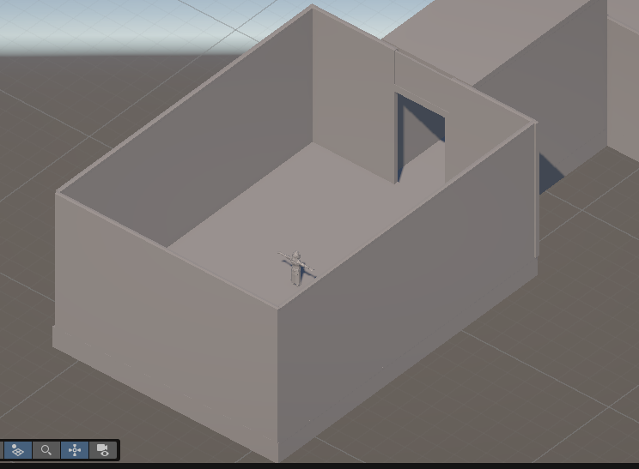
The spawn area acts as an enclosed preparation zone designed to orient the player before combat begins.
- Pacing & Framing: The narrow doorway creates a controlled threshold, signaling the start of the time-trial run.

Main Hallway:

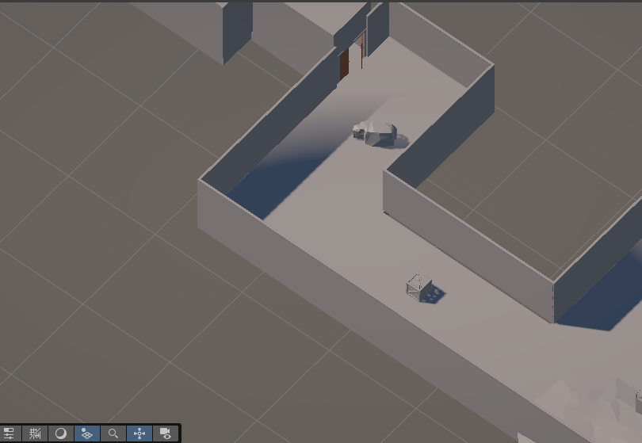

The corridor transitions the player into the primary combat encounter using a distinct pinch-and-release architectural flow.

The sharp turns provide a sense of where to go, and each turn has a cover asset meant to provide protection to the player

Final Turn:

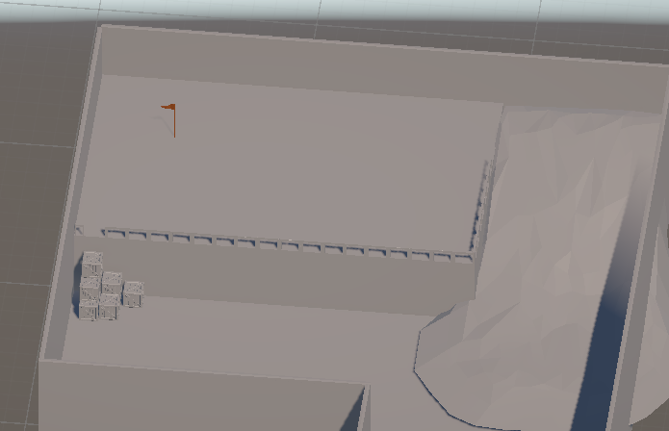

The destination is on a elevated platform, the user can reach it via walking up the slope (slow route) or user can jump up the crates in the corner (fast route). The user has to make a decision depending on their time and health which route they want to choose, climbing the crates requires precise platforming but it is faster and allows the player to ignore the enemy stationed there, while the slope is easier to walk on but the player must deal with the enemy stationed there because the enemy here would be constantly watching the slope entrance.

