

Software Development & Construction

Quiz 2

Docker & Kubernetes Challenge

Muhammad Hamza BSSE23001

Muhammad Sarmad BSSE23013

Hafiz Azfar Umar Sheikh BSSE23064

PHASE 1: Container Bootcamp

Nginx image container:
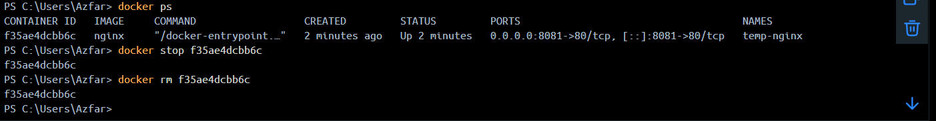

V1 of custom nginx:
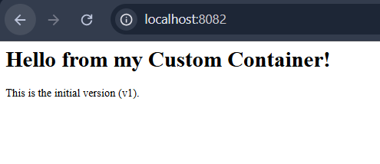

Changing content while container is running:
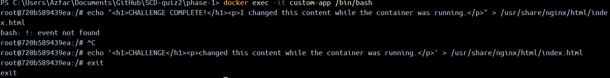
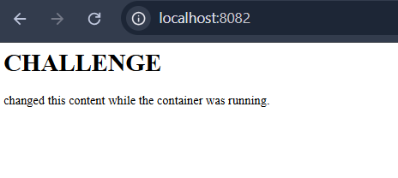

Rebuilt v2 image:
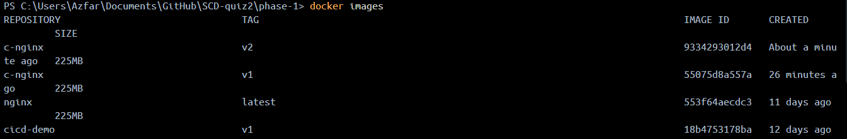
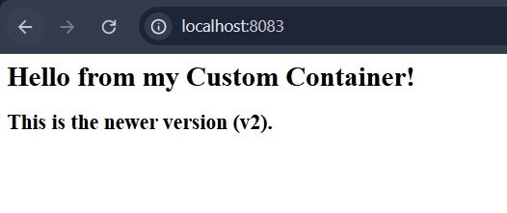

Phase 2: App to Containers

Pushing image:
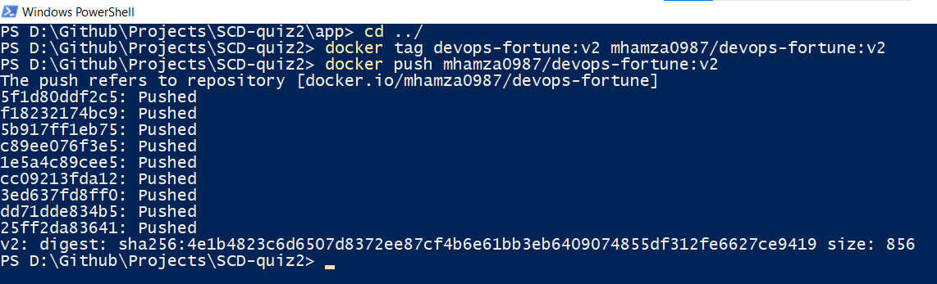

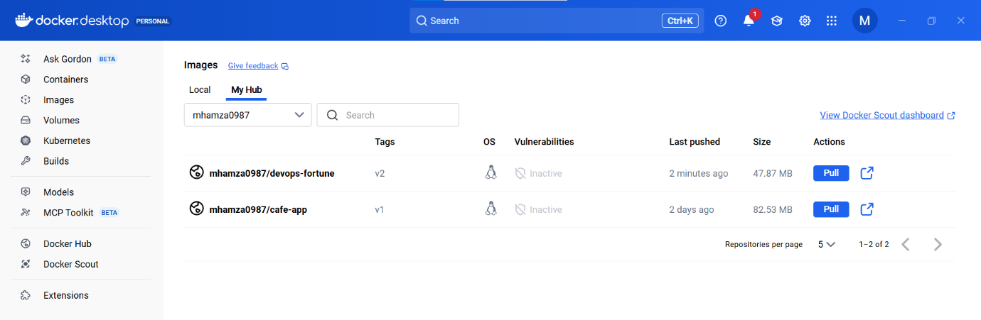

Yaml files:
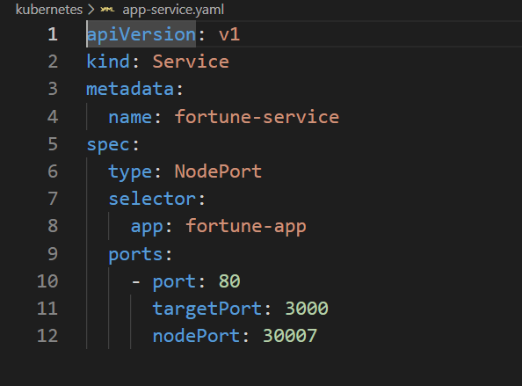
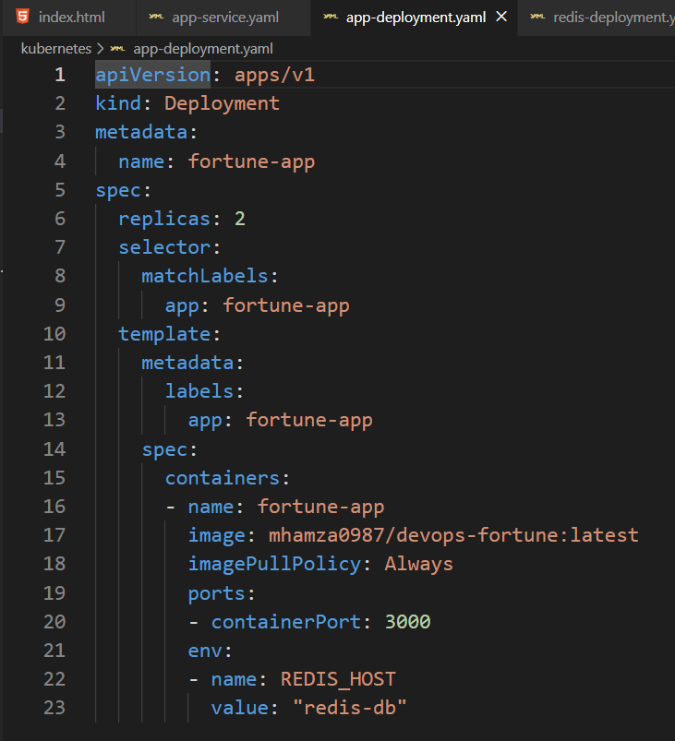
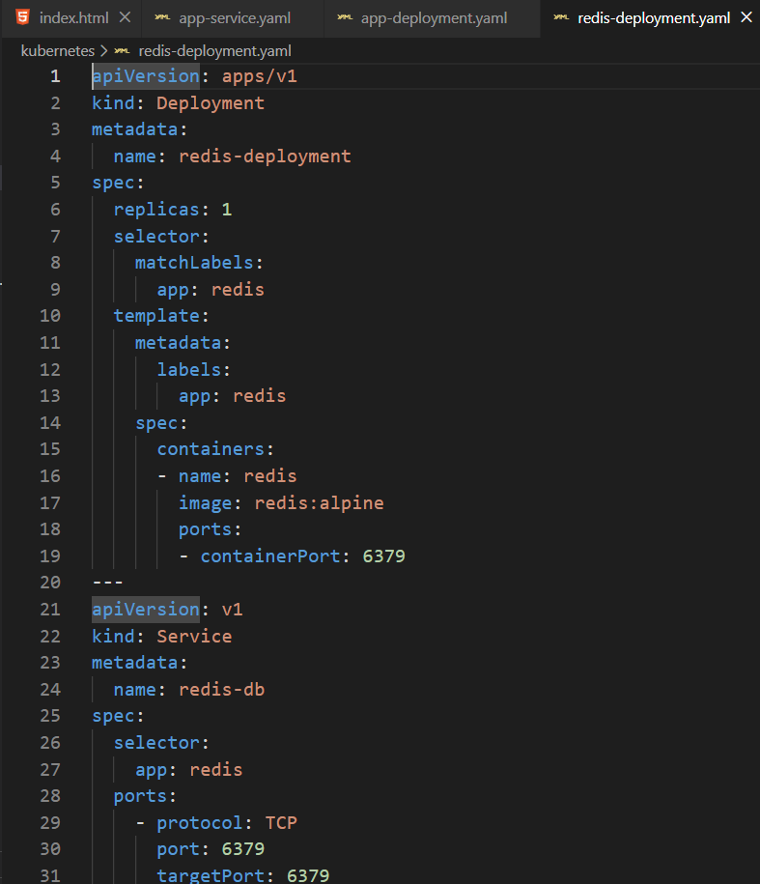

Pods:
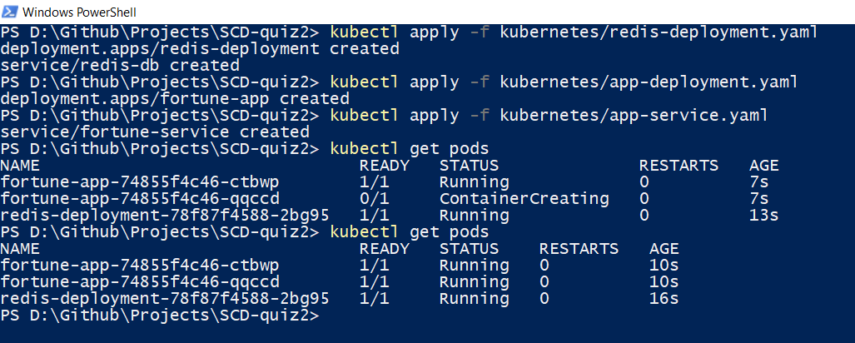
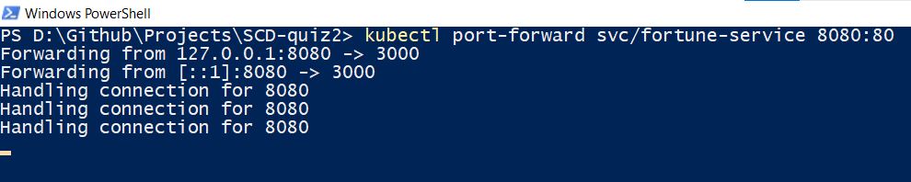
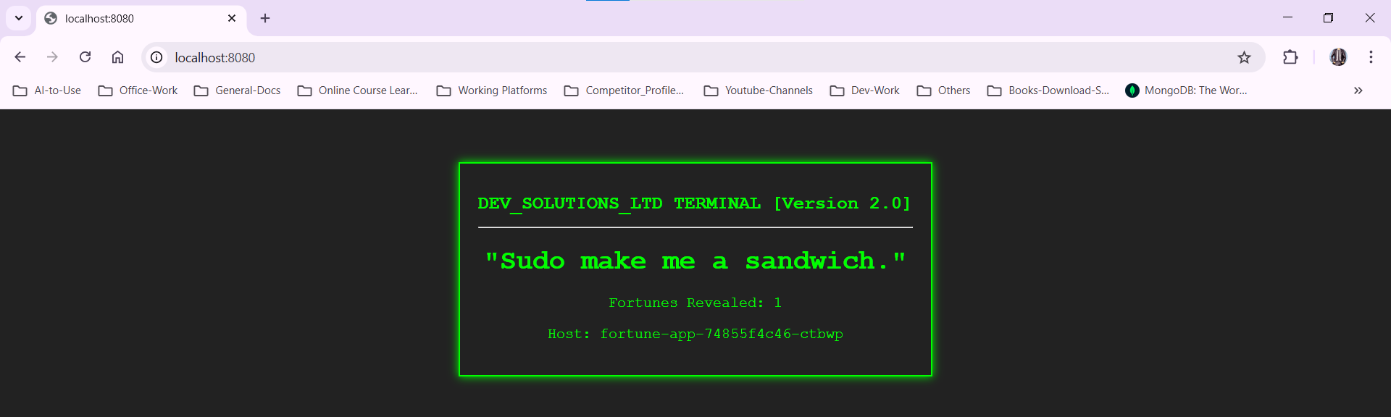

Phase 3 Multi-Service App

Docker-compose.yml:
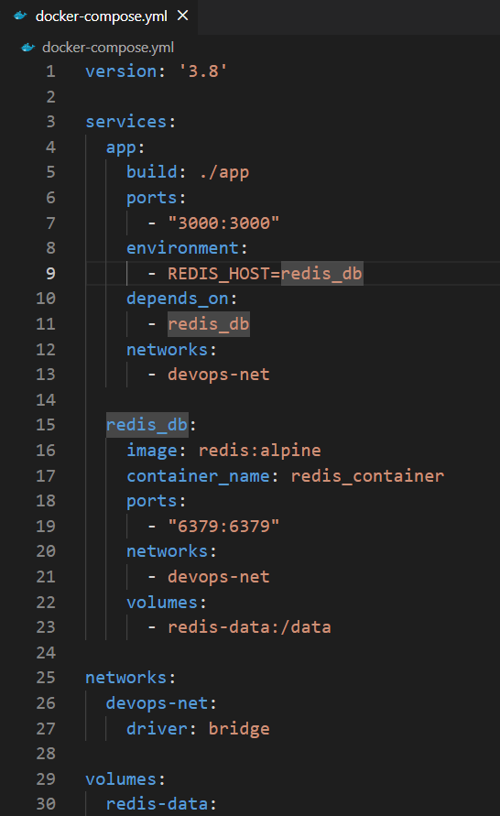

Building docker-compose up:
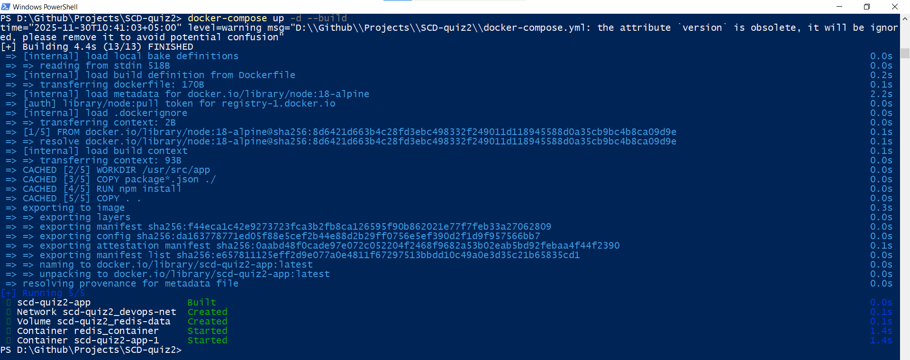

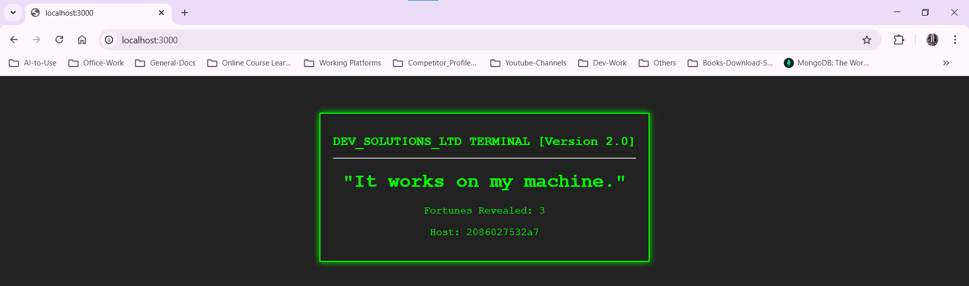

Removing and restarting service:
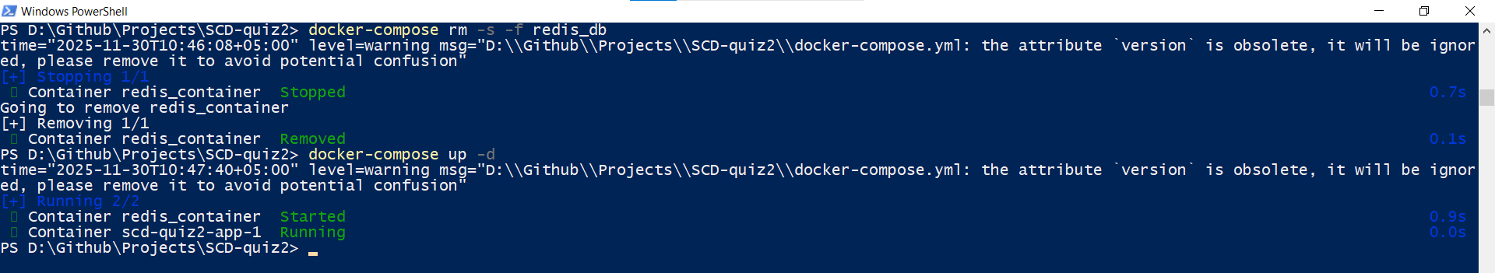
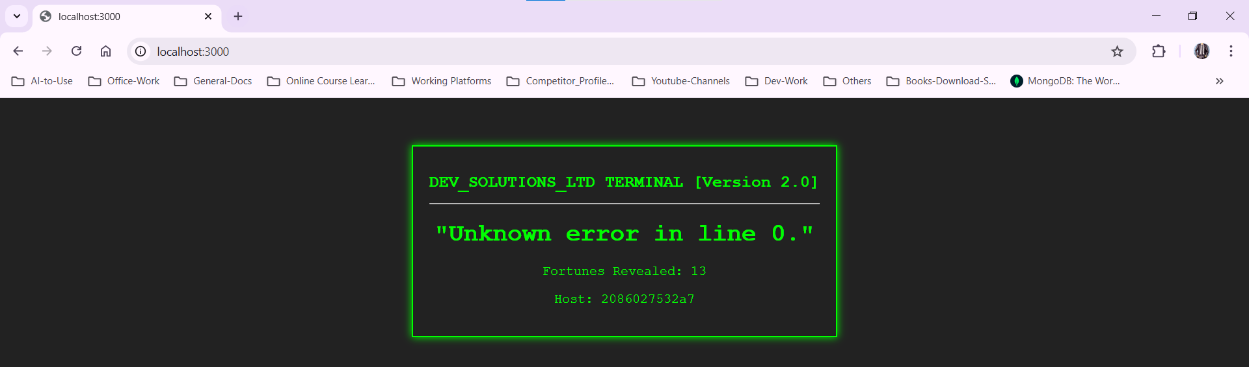

Killing backend and recovery:
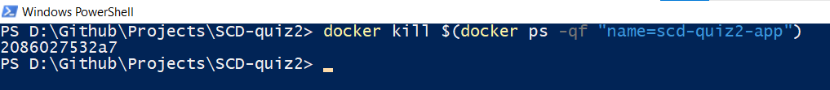
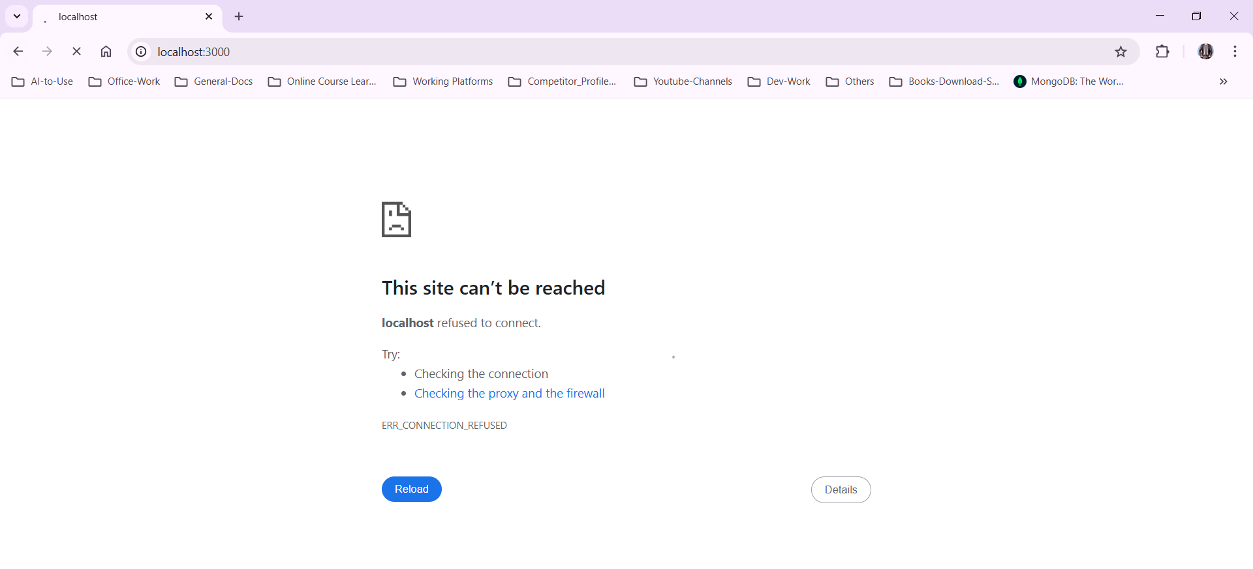
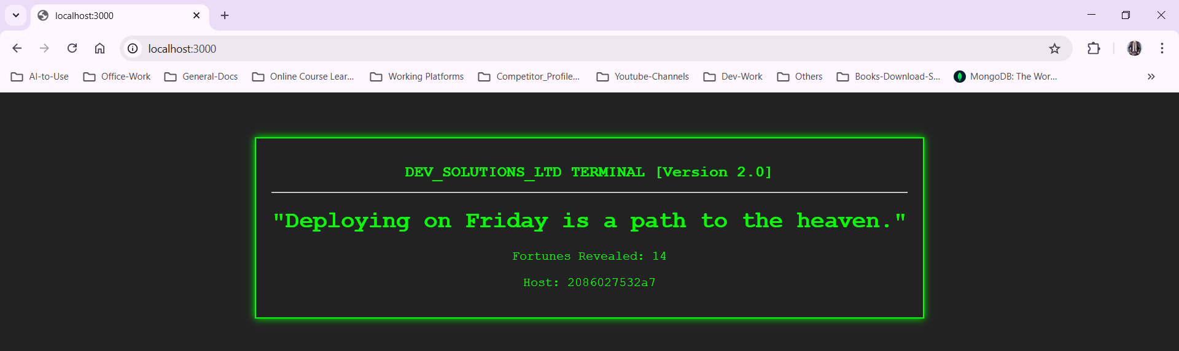

Phase 4: CI/CD War Zone

Initializing:
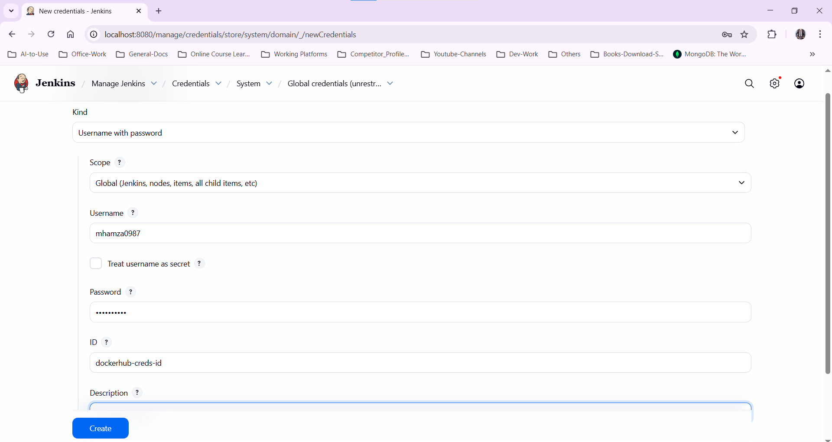
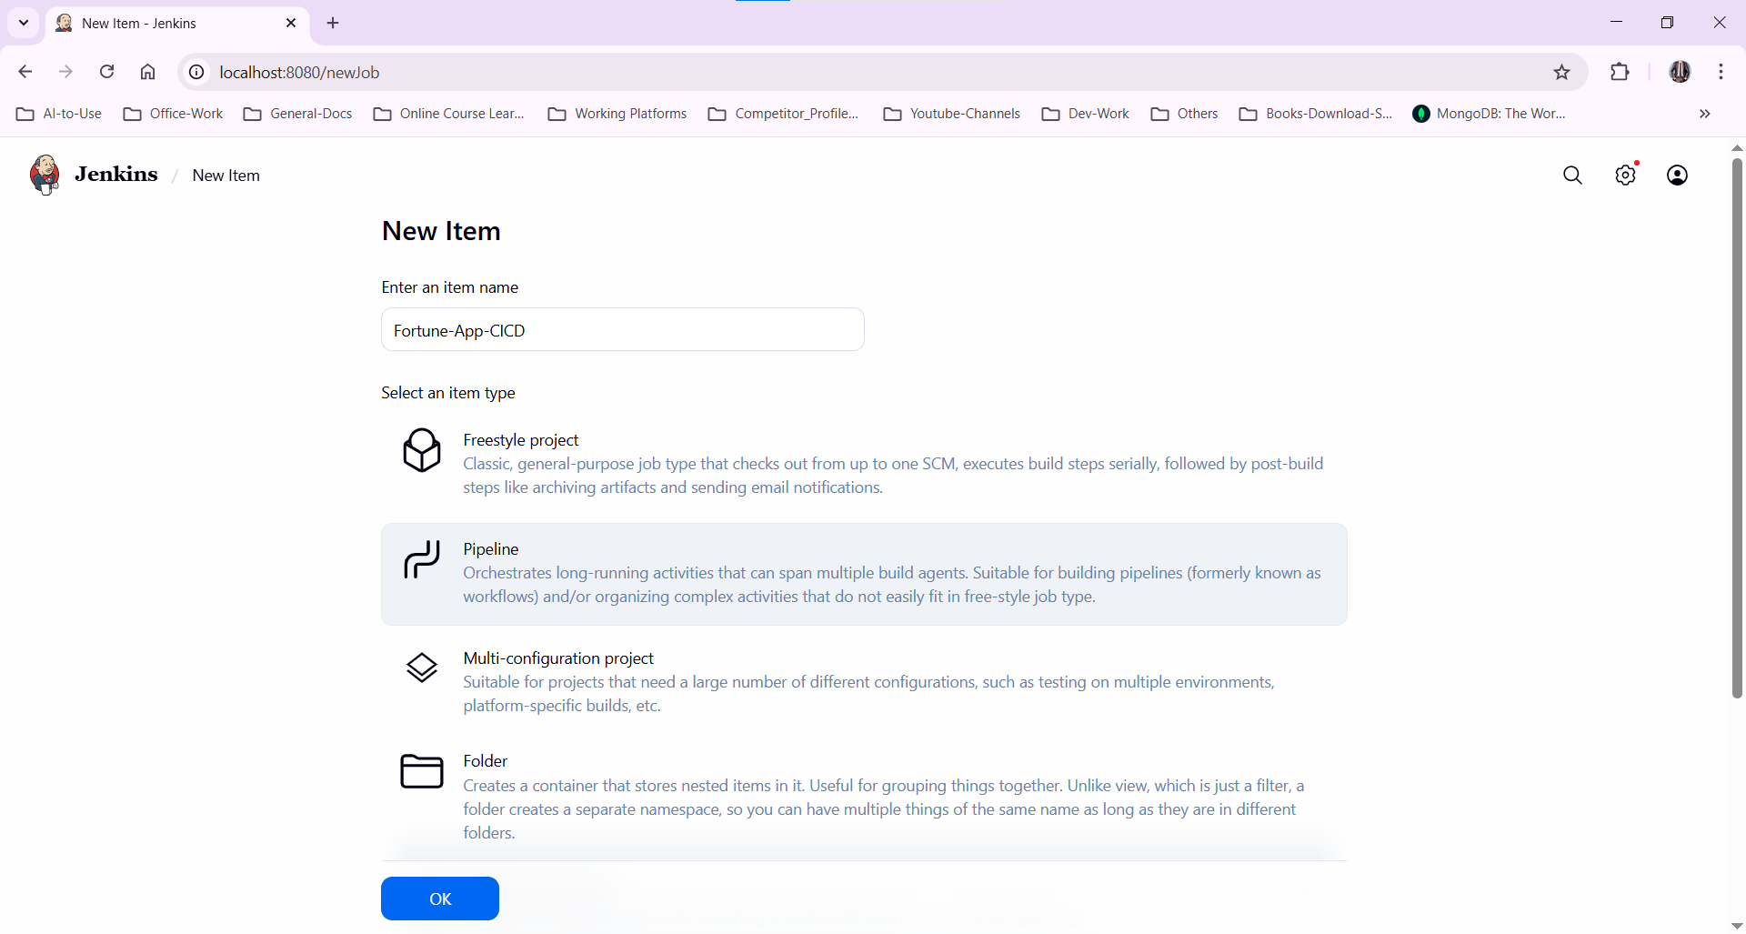
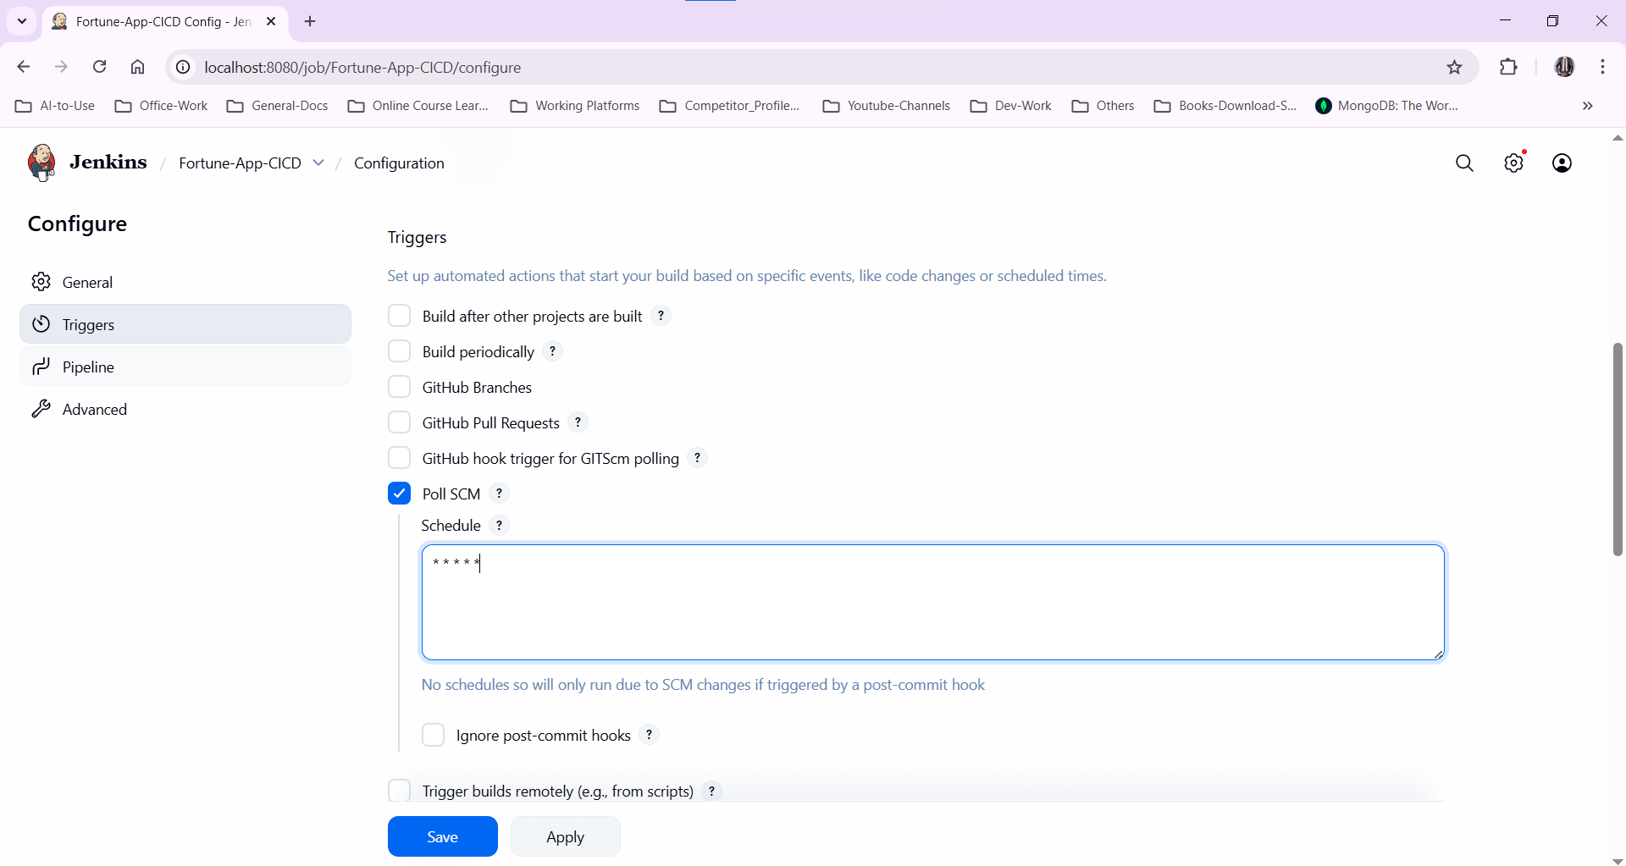
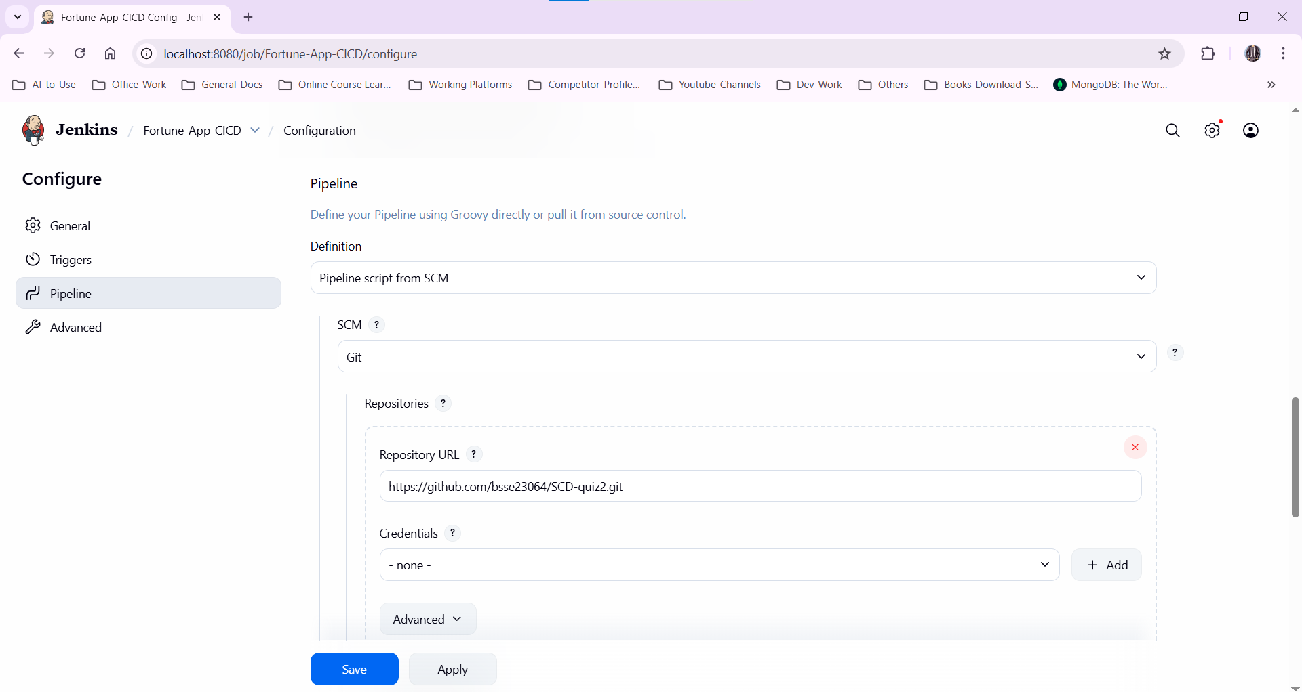
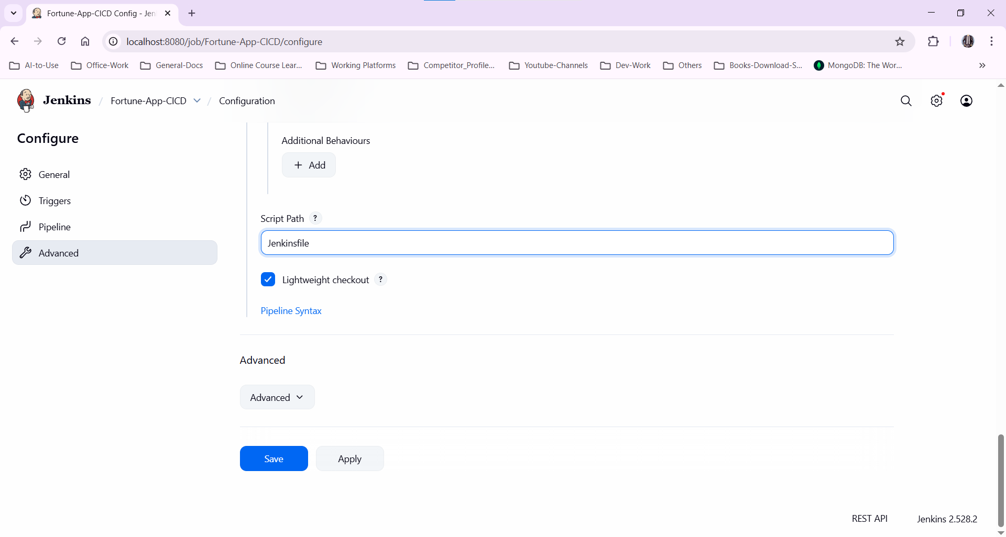
Note: The pipeline checks the repo after every min and if there is a commit then it triggers the ci/cd

Jenkinsfile:

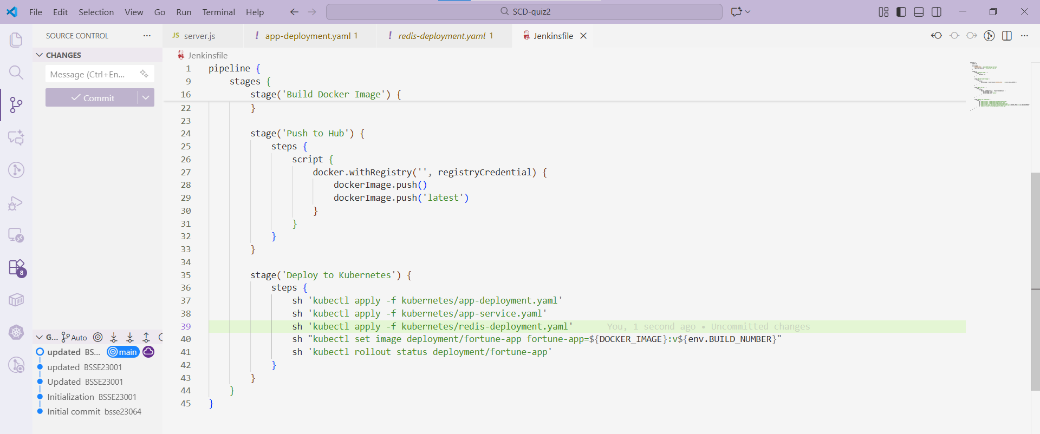
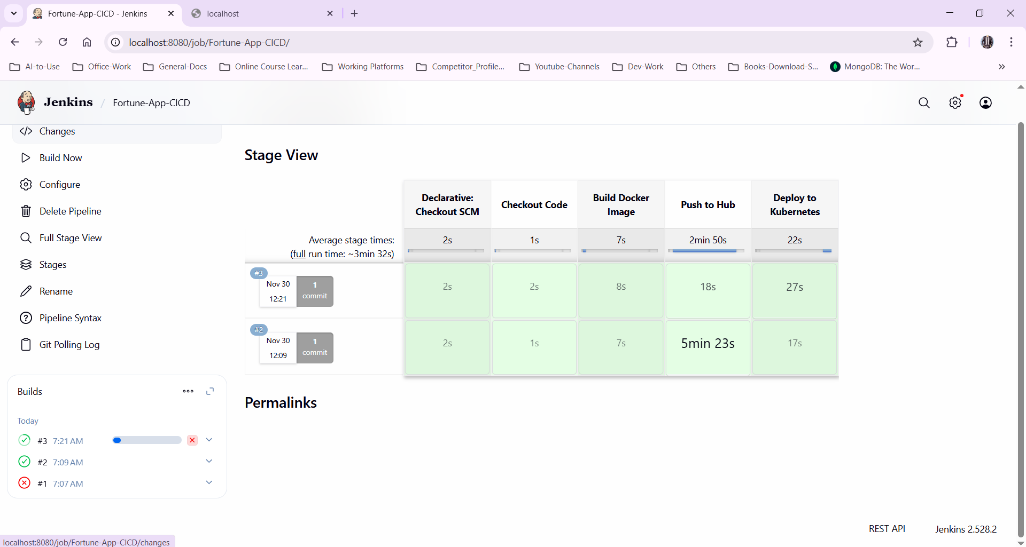

Making a commit:
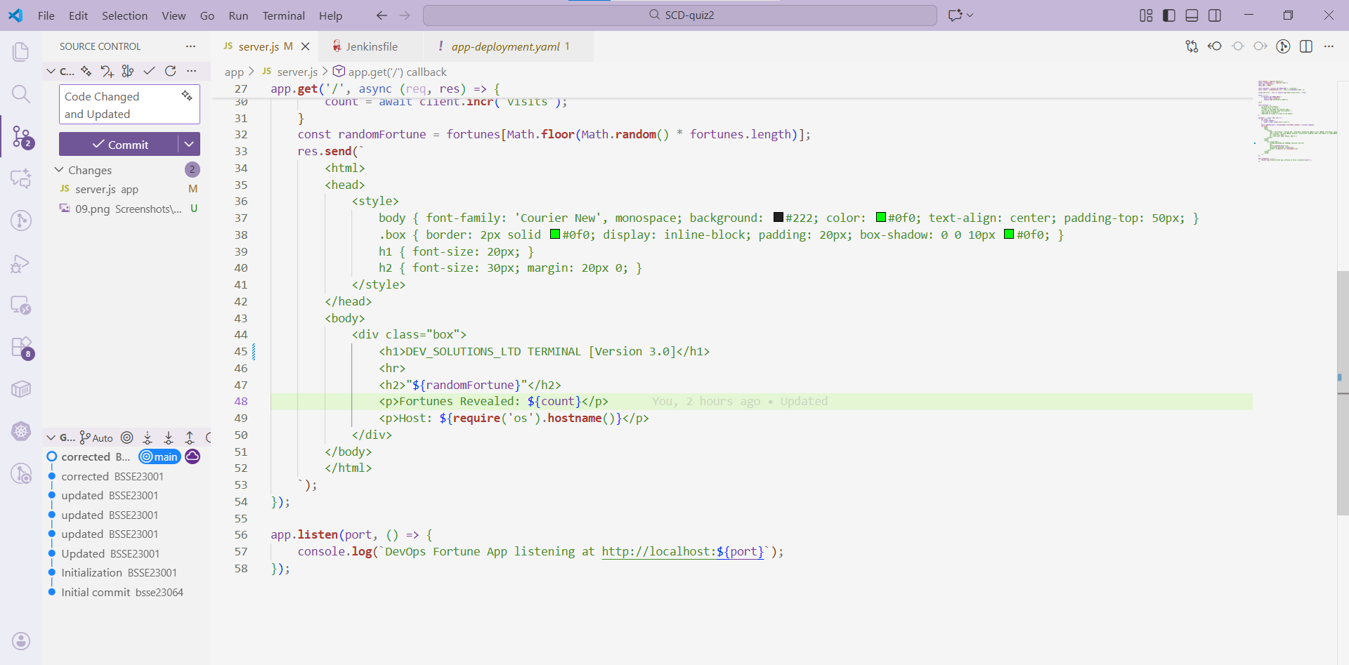
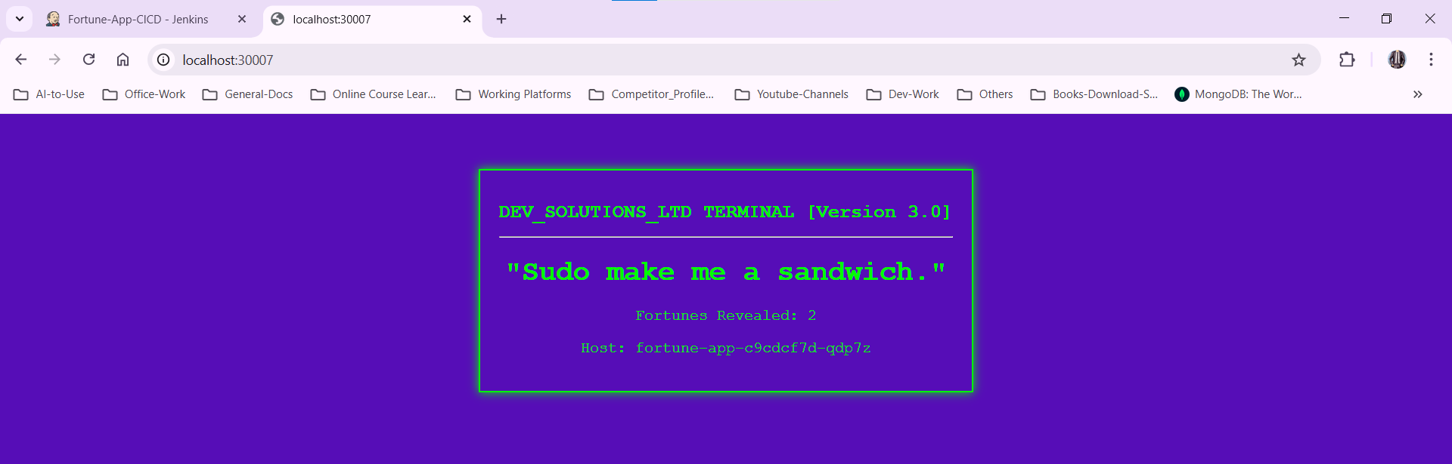

Pipeline trigger:
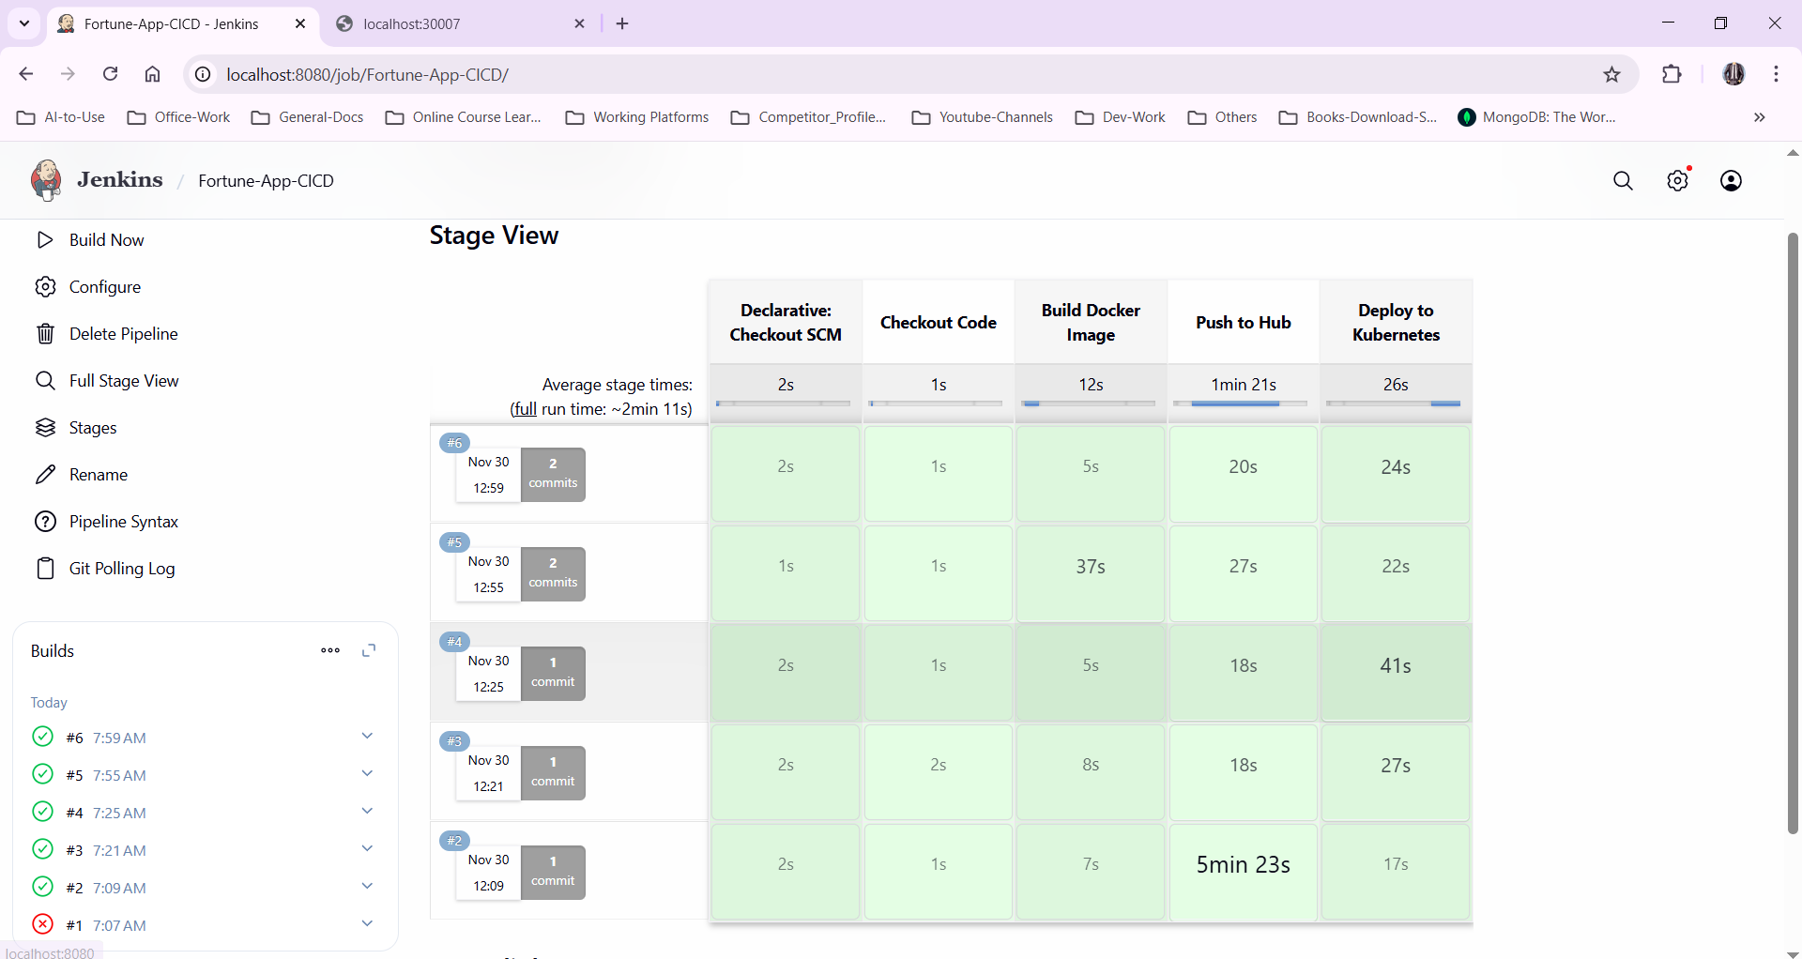
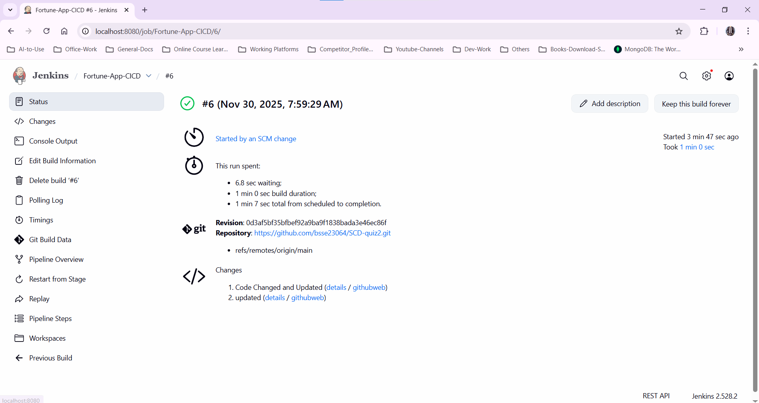

Pods and deployments:
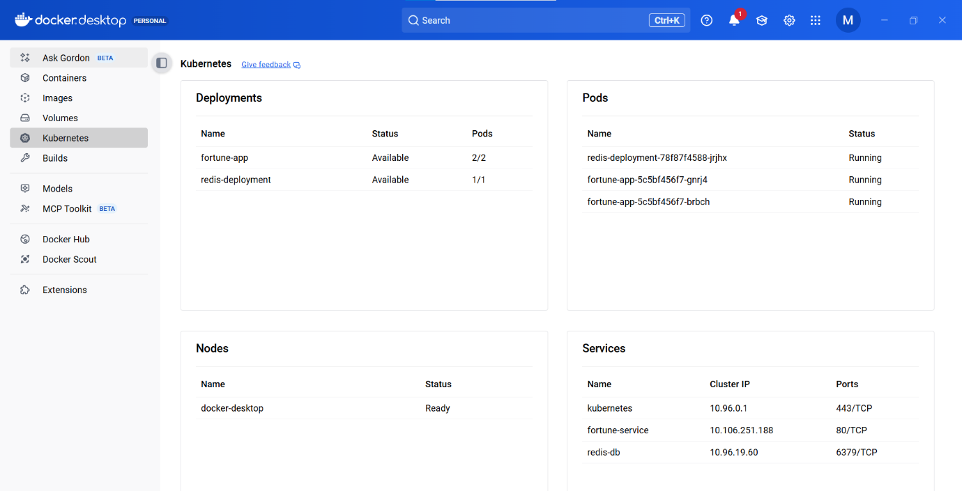

Cleanup:
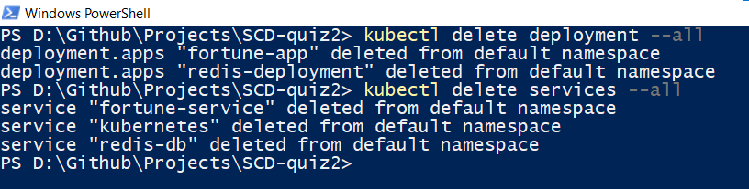
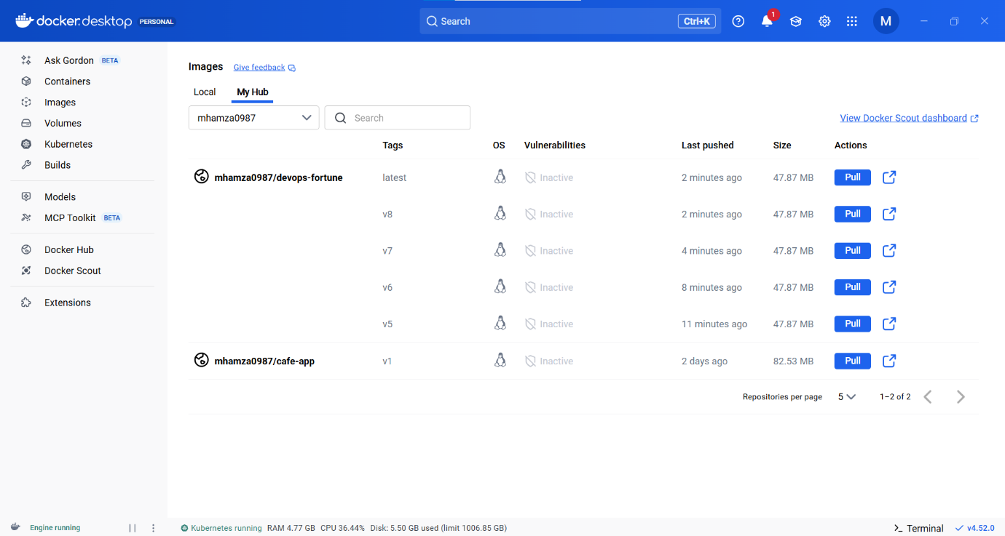

GITHUB LINK: https://github.com/bsse23064/SCD-quiz2

