ACCESS CONTROL ER DIAGRAM

this is the entity realtionship diagram for the access control system , this system comprises of a simple database that hold s the access control data and barcode information
the diagram comprises of
1) the Bracode Table : this table holds the basic information about the genearted barcodes
2)Image table is used to store thw barcode images and filelocation
3) BarcodeString : holds the actual barcode string

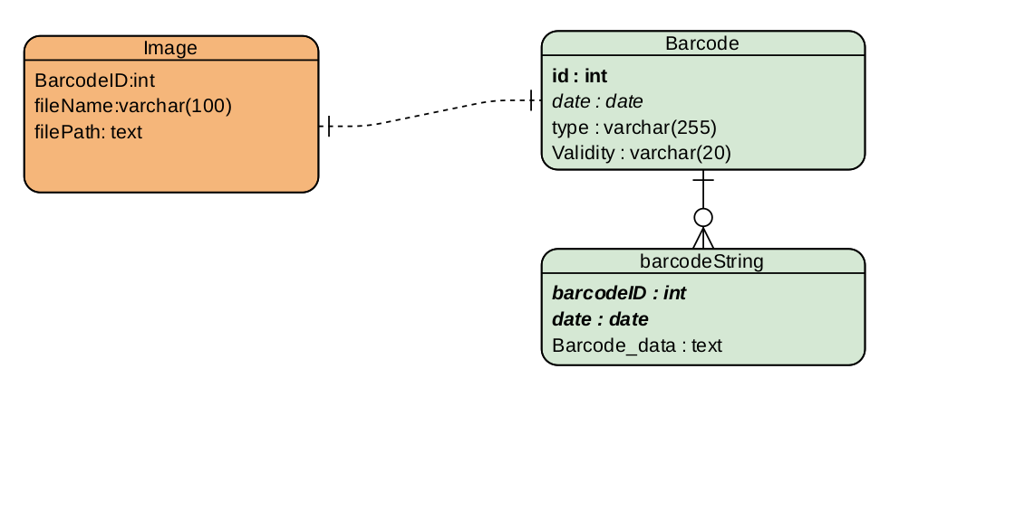

ACCESS CONTROL CLASS DIAGRAM

the class diagrams consist of four main classes for the access control module
1. Admin : this is the class used by the admin to collect user information and pass it off to the Acess contol Class
2. Acess Contol : this class is the class repsonsible for generating barcodes and barcode images.this class receives information from the admin class and uses it to generate the barcodes
3 .Barcode: classes that hold the logic for genersting barcodes and barcode images,it receives data from thr Acess control class and returns a barcode image or json object with abarcode image
4 Database : contains the database logid . This class is invoked by the Acess control class and is used to interact with the database

