The following steps outlines in a step by step manner, the customer jouney of different modules of the Android Application called NAPSA Market Sales.

Before the app can be used it need to be installed on smartphone running androind operating system.

If successfully installed, the app can invoked (started) by tapping on the icon showing NAPSA Market Sales. Figure 1 shows the start up screen for the mobile application.

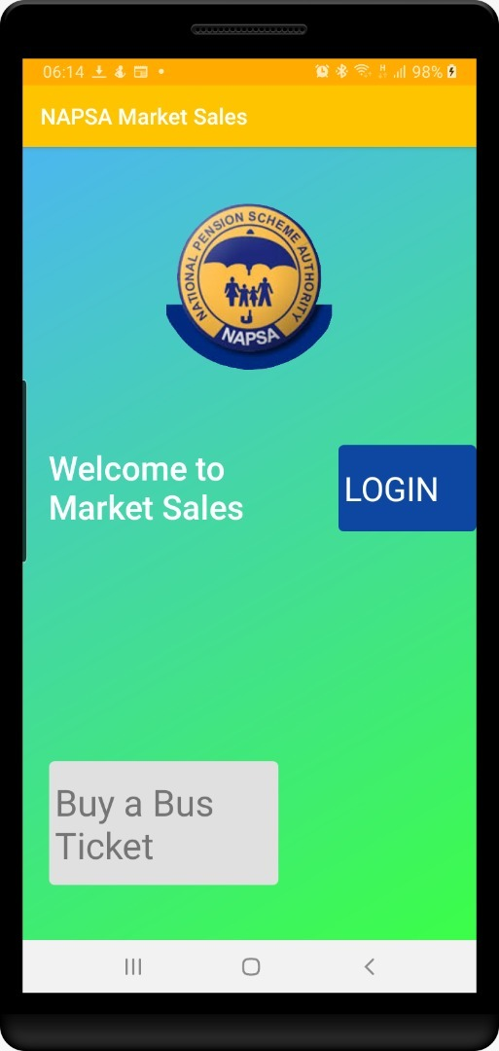

Figure : Start up screen

The start-up screen contains two clickable buttons; one called Login and the other buy a Bus Ticket. Login button leads to the main menu screen and buy a Bus Ticket is a self-service option for those who are not registered.

The following steps outlines the steps for buying a bus ticket without logging in (self service).

BUY BUS TICKET (SELF SERVICE)

To buy a bus ticket under self-service, tab on the button on the screen shown in figure 1. This will result in the displayed image in figure 2.

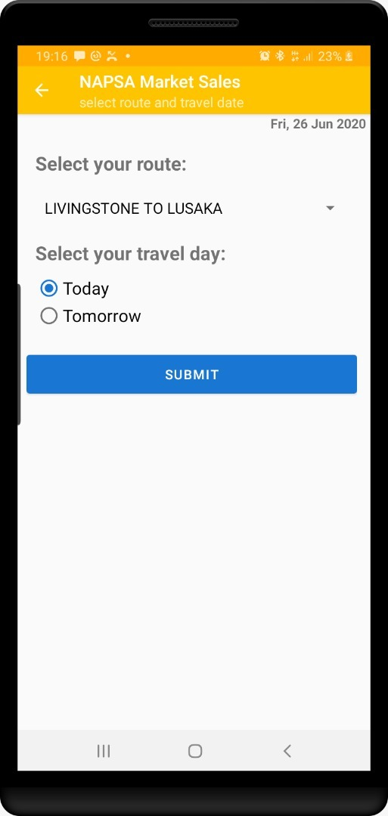

Select route from drop down combo

Choose day of travel: Today or Tomorrow

1

2

Tap submit

3

Figure : select route and day of travel

There are three steps required at this point:

1. Select the desire route as illustrated in figure 2 step one caption.
2. Choose the day of travel, this can be Today or Tomorrow.
3. Click or tap on the submit button.

When the submit button is pressed, it will results in the display of the image in figure 3 where you will be required to choose a bus.

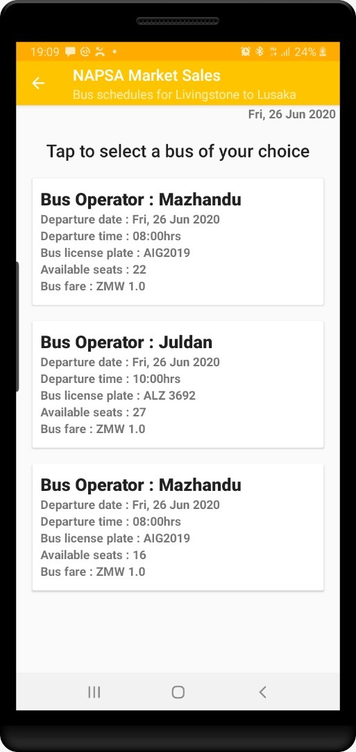

Tab on the bus information to choose a bus

Figure : Choose bus

Figure 3 is a display of all scheduled buses for the selected route. To proceed to buy a ticket, the user is expected to tap on the information describing the preferred bus. When this is done, the image in figure 4 is displayed.

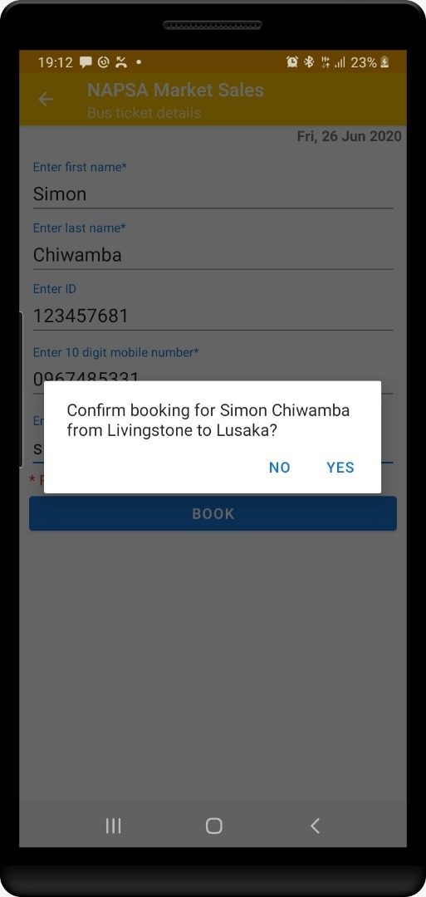

Figure : Traveller/Passenger KYC

Figure 4 is a screenshot for entering passenger details (KYC). The app provides for entering *first name*, *last name, Identification number* (ID), *Mobile number* for the person paying and *email address*. Once these are supplied, the user is expected to tab on the submit button. This will result in a pop up message as shown in figure 4. The message prompts the user to confirm the booking which results in the purchase of a bus ticket.

Confirm booking message will trigger a Mobile Money push menu to approve debit. Figure 5 is shows a notification message for approving transaction from the push menu coming from the mobile money provider.

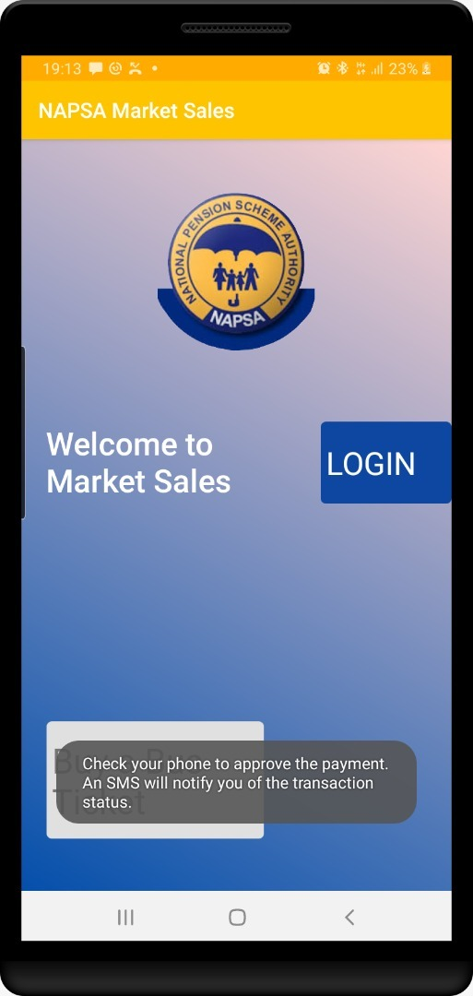

Figure : payment approval message

Figure 5, shows a message will appear on the screen remind the user to approve payment and check sms.

LOGIN

To login, one must be a registered user. From figure 1, tap on the login button. This will result in the display of the image shown in figure 6 where the user has to enter registered mobile number and pin.

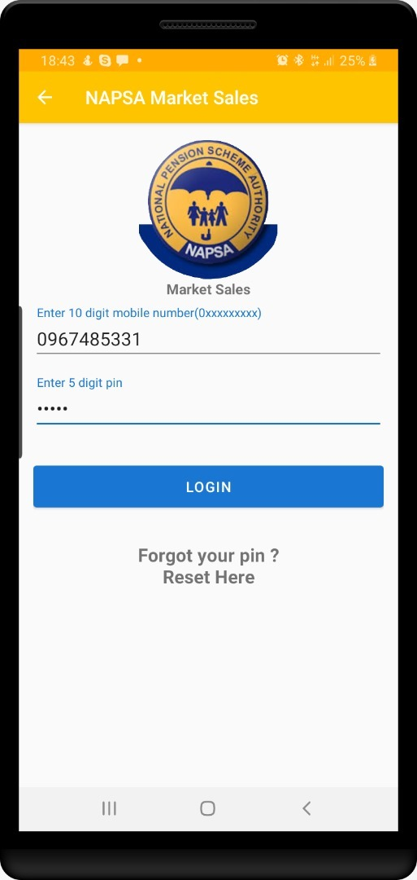

Figure : Login Screen

Figure 6 enables the user to enter registered mobile number and pin to proceed to the main menu shown in figure 7.

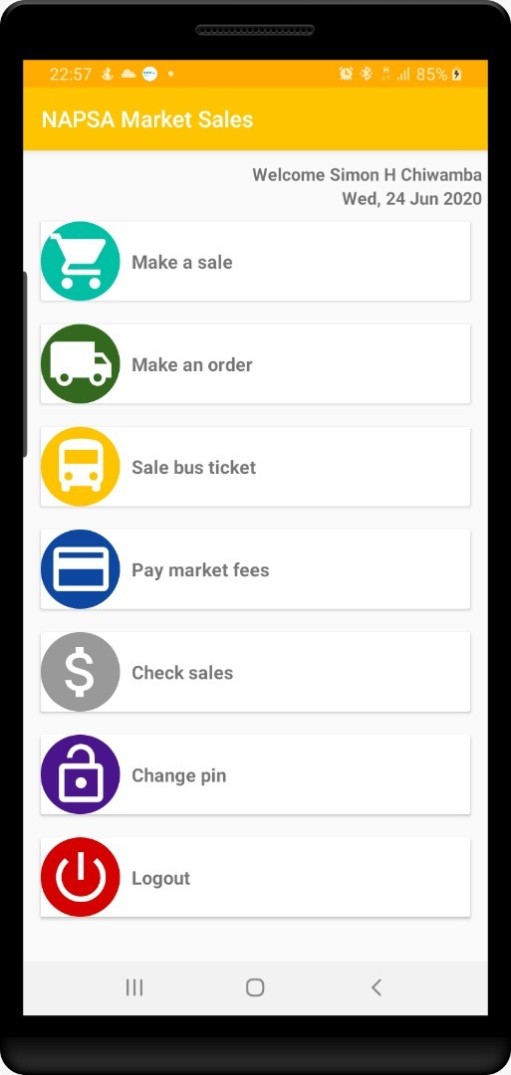

Figure : main menu screen

MAKE A SALE

Make sale is activity for a registered marketeers, hence the need to login to the Android Application. Figure 6 illustrate the login page and figure 8 is the main menu showing a logged in marketeer respectively. From the image in figure 8, tap or click on ***make a Sale*** menu item. This will display the image in figure 9.

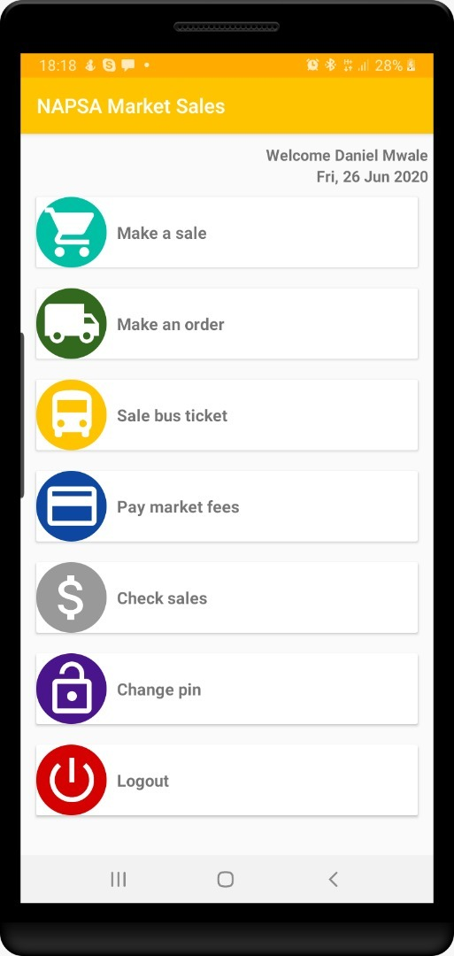

Figure : welcome screen

Figure 8 is welcome screen user named Daniel having logged in.

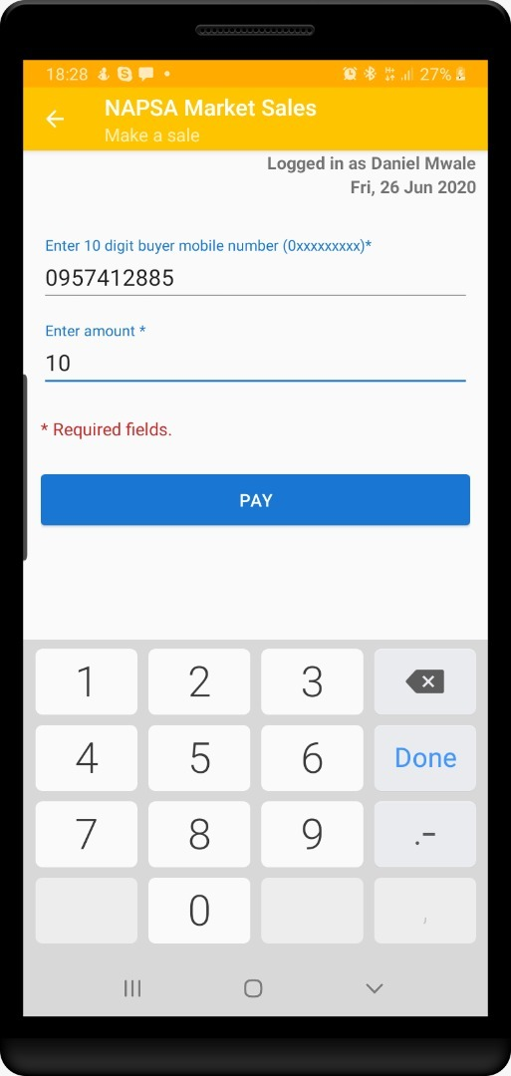

Figure : make a sale

Figure 9 is a screen showing the steps required for making a sale. Basically, the user is required to enter mobile number of the buyer and the total cost of the goods in the respective text areas.

User should then supposed to tab on pay to initiate mobile payment. This will result in the message displayed in figure 10.

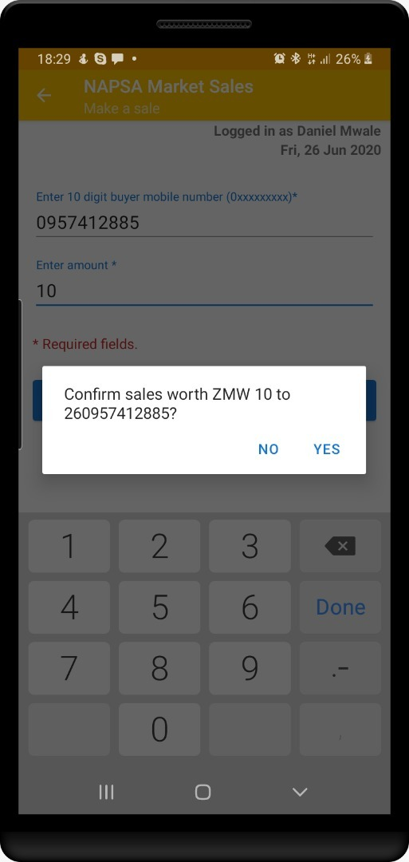

Figure : Sale confirmation

The message in figure 10 requires the user to confirm the purchase. This will results in the user being redirected to the main menu and the app will display the shown in figure 11.

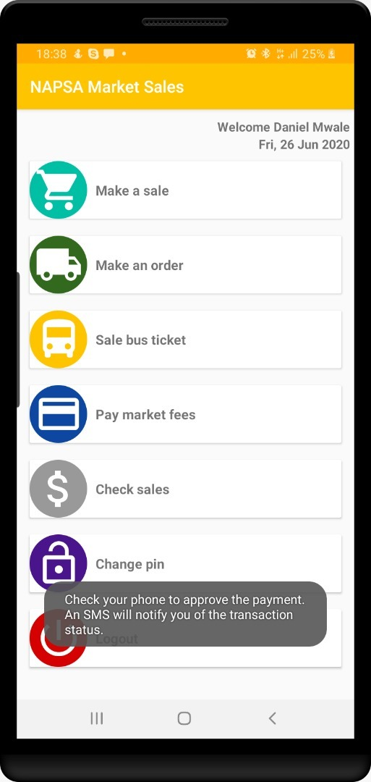

Figure : Reminder message

Figure 11 shows a reminder message for the user to tell the buyer to check their mobile phone for in order to approve payment from the mobile money part.

MAKE ORDER

Make order is the next menu item. From here, the user is buying goods in bulk from another registered user.

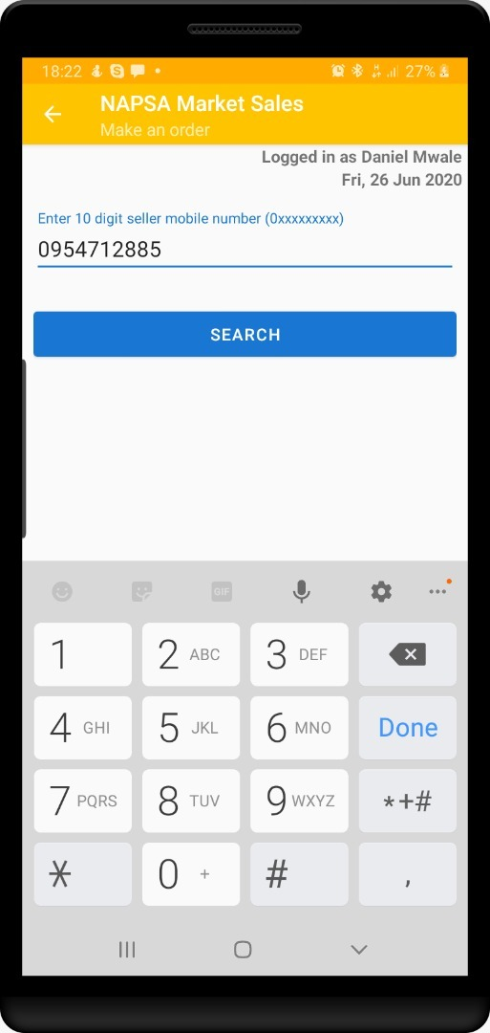

Figure : search bulk seller

Figure 12 is the image of the screen which is displayed when the user taps on Make Order Manu item. The user enters the mobile number of the person they are buying goods in bulk from and then tap search in order to retrieve the details of the seller. This will results in the display of the screen shown in figure 13.

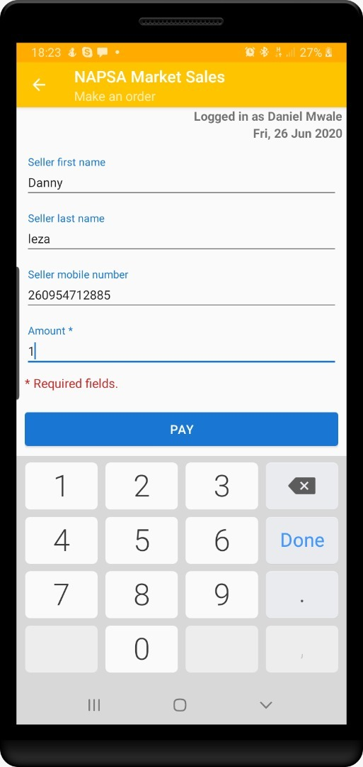

Figure : Seller Details

Figure 13 is the seller details screen showing the first name, last name and mobile number of the seller. From here the user enters the amount equivalent to the goods s/he wants to buy. The user is expected to tap on the pay button to proceed to the screen shown in figure 14.

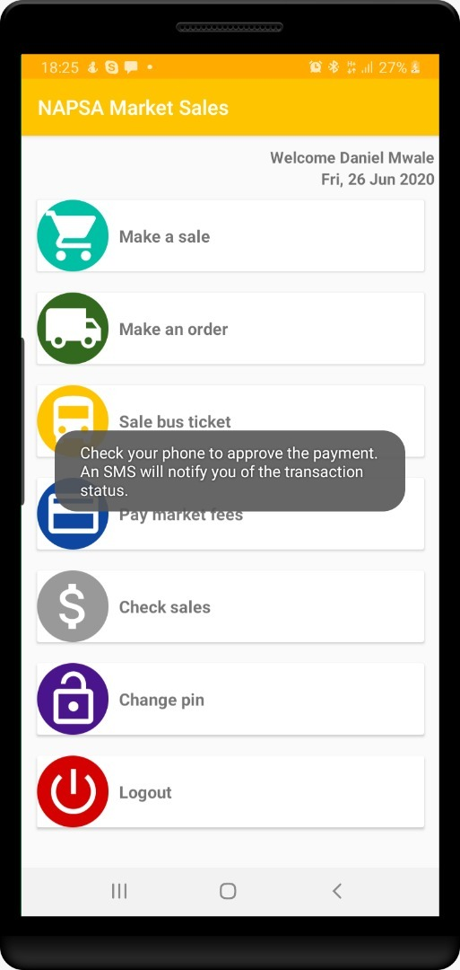

Figure : Notification message to approve payment

Figure 14 is a notification message to the logged in user advising him or her to approve the deduction from mobile money account.

SALE BUS TICKET

The next item is the sale bus ticket accessed only when a person has logged in. This feature is for users who will sell bus tickets on cash basis.

Once the user has tapped on Sale Bus Ticket menu item, the screen in figure 15 will be displayed.

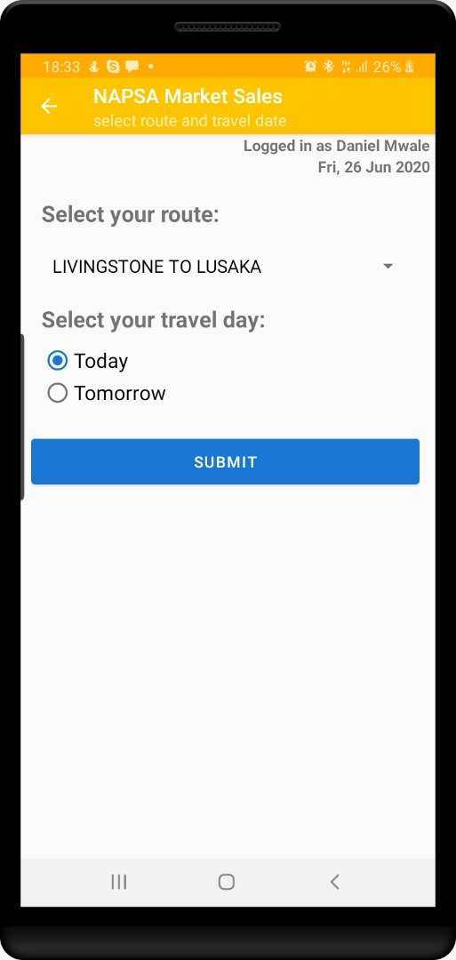

Figure : select route and travel date

From figure 15, the user follows the same steps illustrated in buy bus ticket. Here the user selects the route and then chooses the day of travel which can be Today or Tomorrow. After tapping submit the screen in figure 16 is displayed.

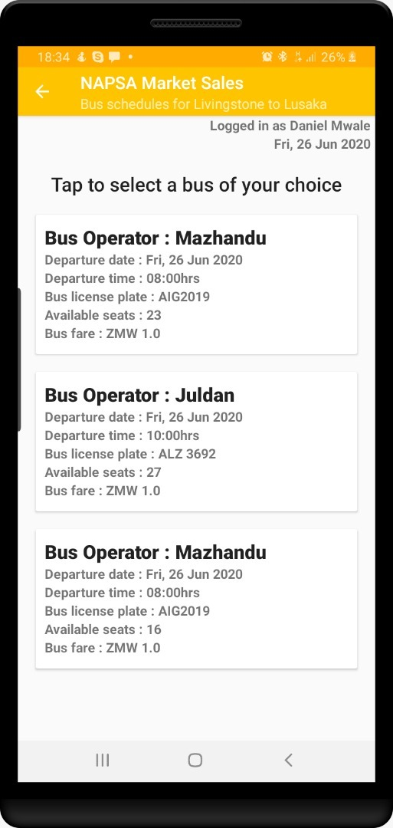

Figure : Choose bus

Figure 16 is the screen where the user taps on the information describing the bus of their choice. Once the user does this, the screen in figure 17 is displayed to enable the user enter passenger details as illustrated in figure 17.



Figure : Passenger details and confirm message

From figure 17, the user will enter the details of the person travelling and click on book. The dialogue message is then displayed as shown requiring the user to confirm by tapping yes.

Once the user has tapped on yes, the system will redirect to the landing page with a message as shown in figure 18.



Figure : information message

Figure 18 is an information message for the user to approve debit from mobile money. After approval, the buyer and user will receive sms with ticket number.

PAY MARKET FEES

When the marketeers wants to pay market fees, s/he must login to the app then tap on pay market fees. This will image in figure 19.

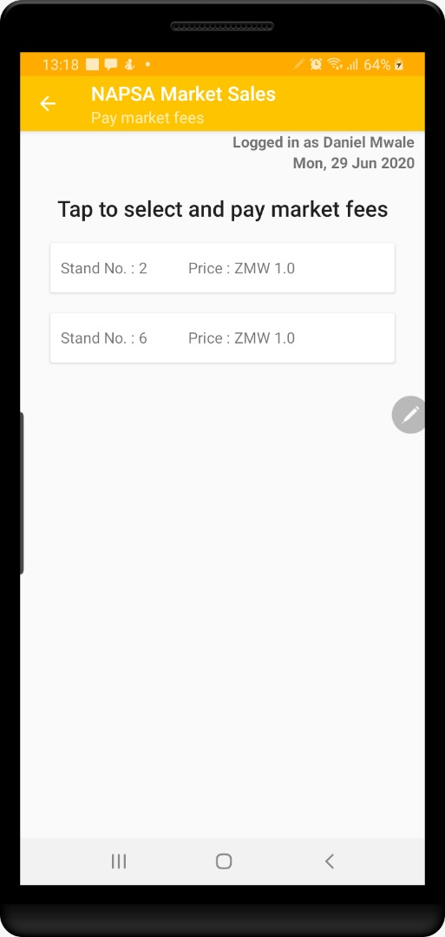

Figure : select stand to pay fees

From figure 19, the user is expected to select a stand for which they wish to pay market fees. Once they do this, the screenshot in figure 20 is displayed.

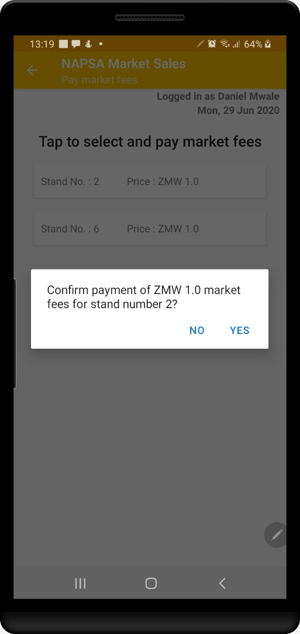

Figure : confirm payment dialogue message

Figure 20, shows the confirm pay dialogue message. From here the user is expected to tap on yes to proceed to the screenshot in figure 21.

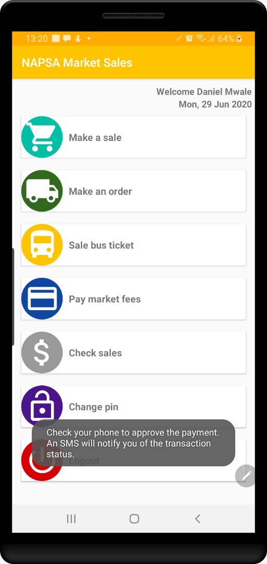

Figure : Approve payment information message

Figure 21 shows a message informing the user to approve payment.

CHECK SALES

From the main menu, the user is expected to tap on check sales in order for screen shown in figure 22 is displayed.

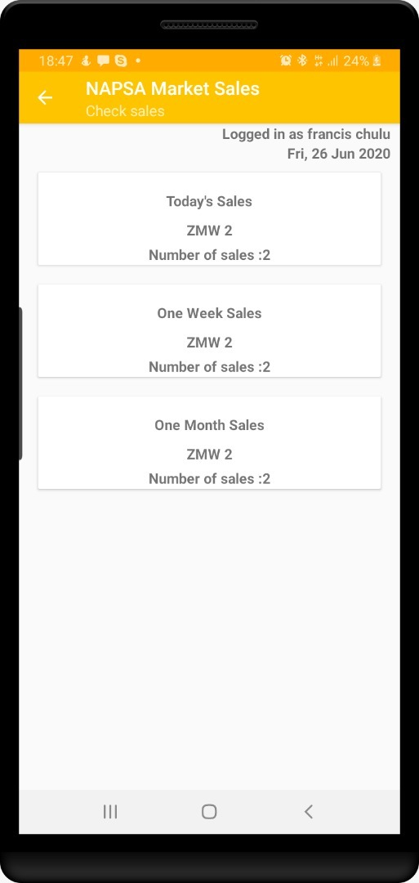

Figure : Check sales

Figure 19 shows the logged in user’s sales grouped as Daily, Weekly and Monthly.