officedown Example

David Gohel

2022-11-04

# Prerequisites

This is a *sample* book written with R package **bookdown** and R package **officedown**.

The **officedown** package can be installed from CRAN or Github:

install.packages("officedown")  
# remotes::install_github("davidgohel/officedown")

# Introduction

ft_link <- fp_text(font.size = 9, italic = TRUE, color = "#C32900", font.family = "Cambria")

The purpose of this bookdown is to test the functionality of the officedown package. It contains texts of no interest but illustrates most of the functions of the package.

## List demo

* This is a linked reference to Chapter .
* This is a linked reference to Chapter .
* This is a linked reference to Chapter .
* Figures and tables can have auto-numbered captions that can also be cross referenced:
  + This is a linked reference to a figure: , its number is computed by Word and it’s linked to the corresponding graphic when clicking on it.
  + This is a linked reference to a table: , its number is computed by Word and it’s linked to the corresponding table when clicking on it.

1. An item
2. An item
   1. An item
      1. An item
      2. An item
   2. An item
3. An item

# Tables of content

## Table of figures

## Table of tables

You can use officer code :

block_toc(style = "Table Caption")

## Table of content

# Tables

Placeholder

# Section

Placeholder

## A two columns section

## End of two columns section

## Landscape section

## Section margins

# Graphics

plot(sunspot.year)

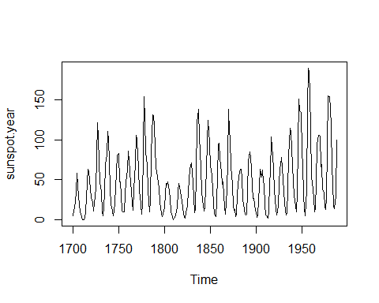

**Figure** **-:** Sunspot plot

Math latex in captions is supported:

plot(lynx)

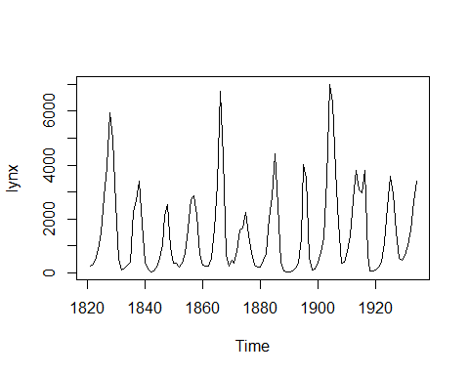

**Figure** **-: $\sum_{i=1}^{n}{X_{i}}$**