NAME : B S SUDHEENDRA
EMAIL ID : bssudheendra2006@gmail.com

TOPIC : Mention all windows tools for debugging with screenshots.
Introduction
In Windows environments, troubleshooting application issues, installations, and security
events often requires specialized utilities. The Sysinternals suite and other Windows tools
provide deep insights into processes, registry activity, network connections, and system
behavior.
This assignment explains key tools including
- LogonSessions,
- Autologon,
- ProcessExplorer,
- ProcessMonitoring,
- PsExec,
- PsTools,
- Whois,
- Sysmon.

LogonSessions
Purpose: Displays information about all active logon sessions on a computer.
Key Details:
- Shows logon session IDs, usernames, logon type (interactive, service, remote),and authentication method.
- Useful for auditing current and past user sessions.

Use in Debugging:
- Detects orphaned sessions that might lock resources.
- Helps trace suspicious logins during incident response.

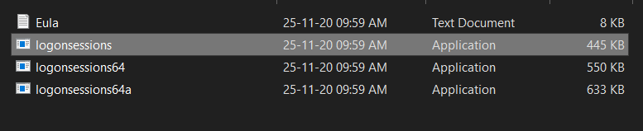

Autologon

Purpose: Configures Windows to automatically log in with specified credentials.

Key Details:
- Credentials are encrypted in the registry and used during system startup.
- Removes the need for manual user input at every reboot.

Use in Debugging:
- Automates repeated testing cycles after system reboots in packaging environments.
- Speeds up virtual machine testing scenarios where manual logon delays progress.

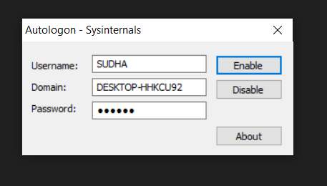

Process Explorer

Purpose: Advanced process management tool, often referred to as “Task Manager on steroids.”

Key Details:
- Displays process hierarchy, open handles, loaded DLLs, CPU/memory usage, and verified signatures.
- Highlights recently launched or suspicious processes in real time.

Use in Debugging:
- Identifies which process is locking a file or preventing an installer from running.
- Checks for unsigned binaries or malicious software

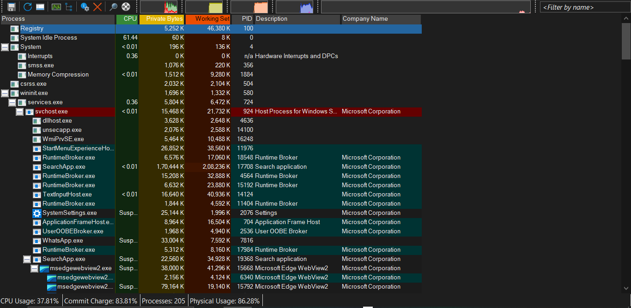

ProcessMonitoring

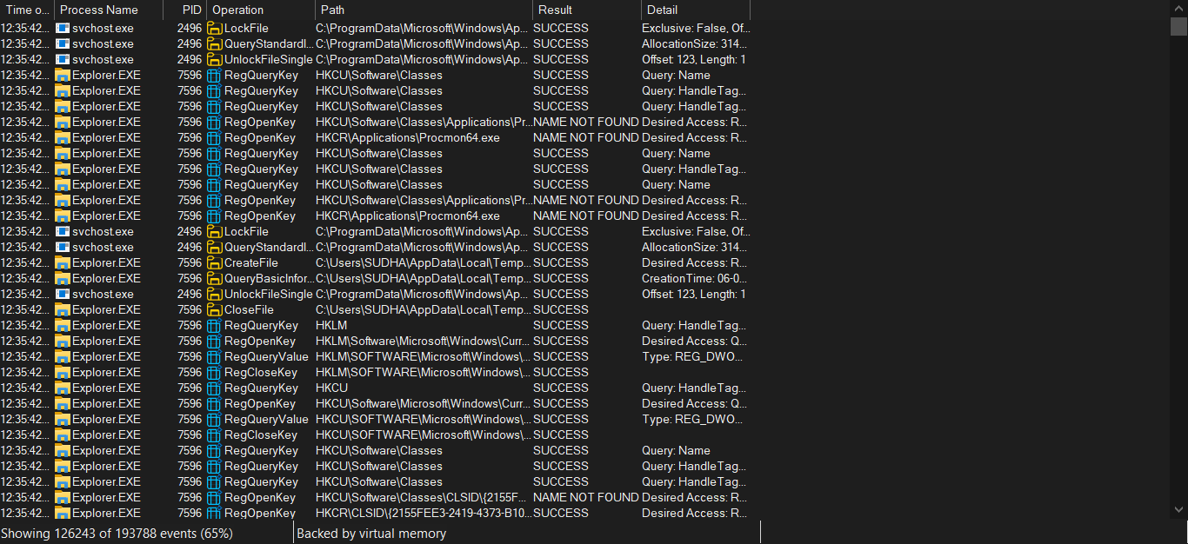

PsExec

Purpose: Executes processes on remote systems or under different user contexts.

Key Details:
- Allows launching commands as SYSTEM, administrator, or another user.
- Does not require manual login to the remote machine.

Use in Debugging:
- Testing MSI packages under SYSTEM context (similar to SCCM deployment).
- Troubleshooting permission-related installation failures.

PsTools

Purpose: A collection of command-line tools for remote administration.

Key Utilities in the Suite:
- PsList : View processes on remote systems.
- PsKill : Terminate processes remotely.
- PsLoggedOn : View logged-on users.
- PsShutdown : Reboot or shut down systems remotely.

Use in Debugging:
- Manage processes and sessions across multiple machines in a testing lab.
- Quickly restart services or kill problematic processes blocking an installation.

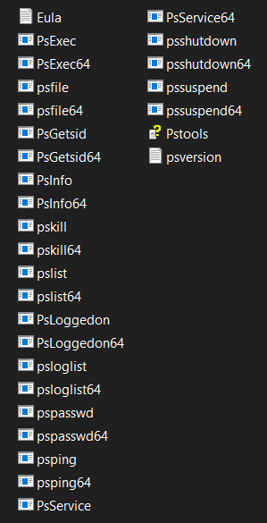
Whois

Purpose: Looks up registration details of a domain.

Key Details:
- Provides information on domain ownership, registrar, and contact details.
- Helps verify if a domain is legitimate.

Use in Debugging:
- Useful in security analysis when applications connect to suspicious external servers.
- Validates network endpoints used by software.

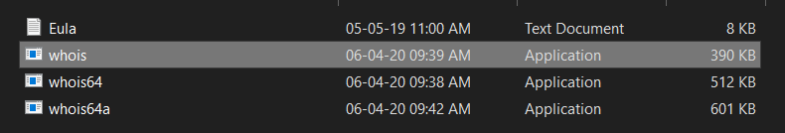

Sysmon

Purpose: A Windows service and driver for logging detailed system activity into Event Viewer.

Key Details:
- Records process creation (with hashes, command line), network connections, and file creation events.
- Supports custom configuration for filtering events of interest.

Use in Debugging:
- Tracks which processes and files are created by an installer or application.
- Detects unexpected or malicious activity that standard event logs miss.

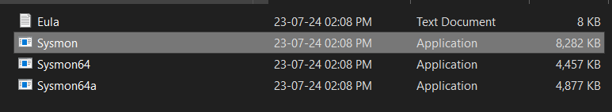

Conclusion

Each of these tools plays a vital role in application packaging, deployment, and security
analysis. From monitoring process and registry activity (Process Explorer, RegMon, Sysmon)
to managing remote executions (PsExec, PsTools) and session tracking (LogonSessions), they
provide comprehensive visibility into Windows systems. Mastering these utilities helps in
resolving installation issues, diagnosing application failures, and improving overall
troubleshooting efficiency.

TOPIC : Steps to create for Microsoft intune portal.

- Access the Intune Setup Account Page:
- Open a web browser and go to the Intune setup account page.

- Sign Up or Sign In:

- For new users: Enter your email address and click "Next." Follow the prompts to create a new account and provide the necessary information.
- For existing users: Sign in with your existing work or school account.

- Complete the Sign-Up Process:

- If creating a new account, you'll be asked to verify your email address and potentially provide additional information like your name, company details, and region.
- After signing up or signing in, you'll be directed to the Microsoft 365 Admin Center.

- Considerations for Existing Work or School Accounts:

- If you're using an existing work or school account, you might need to add Intune to your existing subscription.
- If you plan to use your organization's custom domain name or synchronize with on-premises Active Directory, you might need to close the browser window after the initial setup and configure these aspects separately.

- Accessing Intune After Enrollment:

- Once the free trial is set up, you can access the Microsoft Intune Admin Center to manage the service.
- You can use any device with a supported browser to sign in.

