Value Rate
User Manual Document

MODULE LIST:

Manage User Data
- Management Team
- Executive Summary
- Funding Materials

ADMIN PANEL CREDENTIALS:

URL: - http://betasoftdev.com/valuerate_dev/administrator

Admin Username: admin
Password : admin

SUMMARY : We have change the editing of the user into three tabs which are (Overview, Executive Summary, Funding Materials).

While editing the user we can edit the Team members of the user with their image , we can add and change the executive summary of that particular user , we can also add, edit, download and delete the funding materials documents .

MANAGEMENT TEAM :
Teams can be Added/Edited/Deleted for a particular user.

1.) Add Team member : Go to the manage users and then click on edit button for a user .
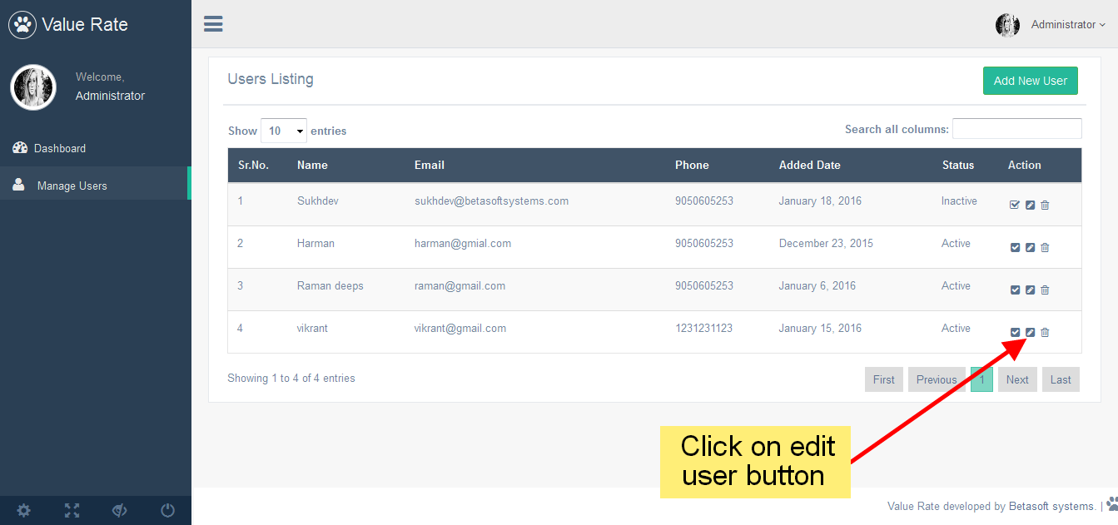
2.) Add Screen : You will be taken to a edit use section, when you scroll down there is a manage team section . There click on “Add“ button. Click on that add button

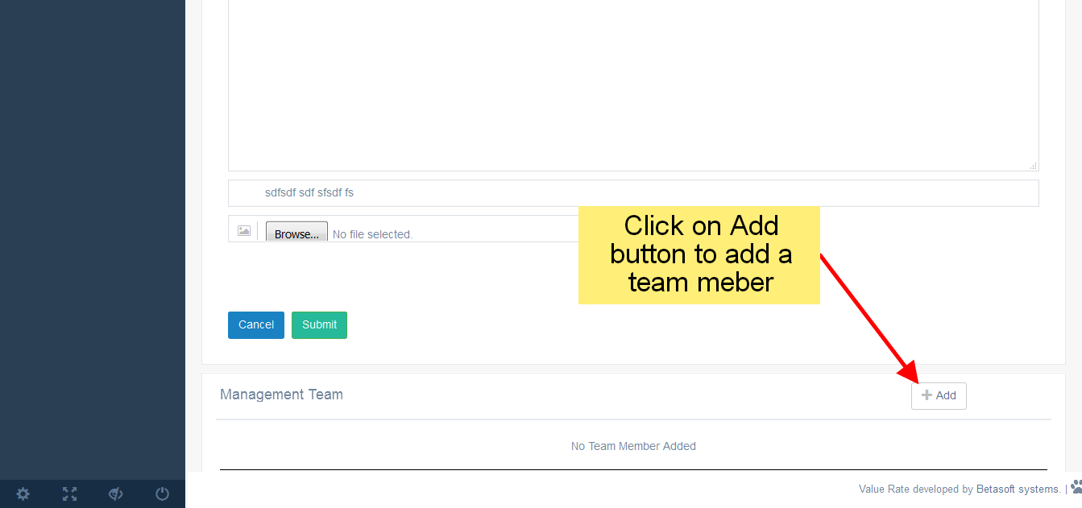

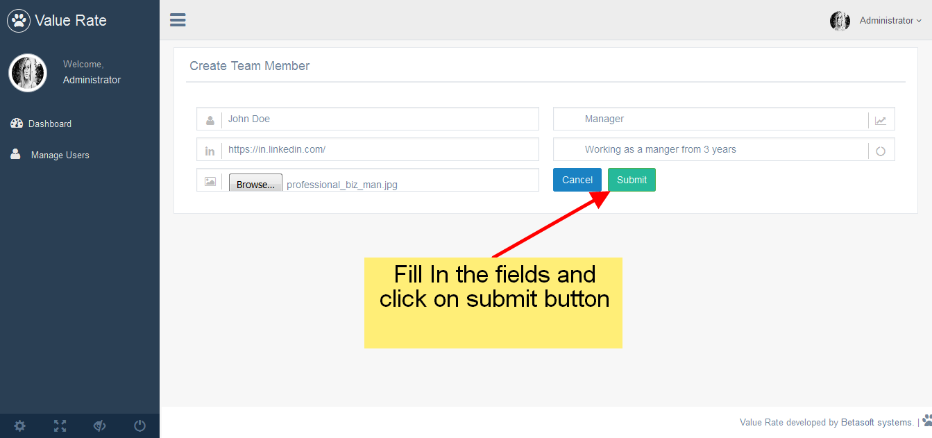

Now the new member will be saved for the current user .

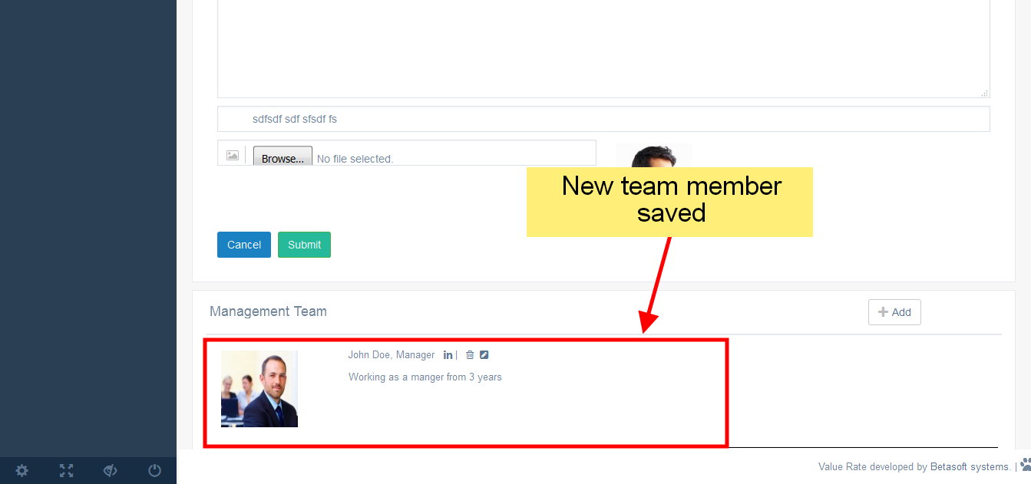

3.) Editing the member : Click on the Edit member button, you will be taken to a new view an make changes in the fields you want to and click on submit button to save that member.

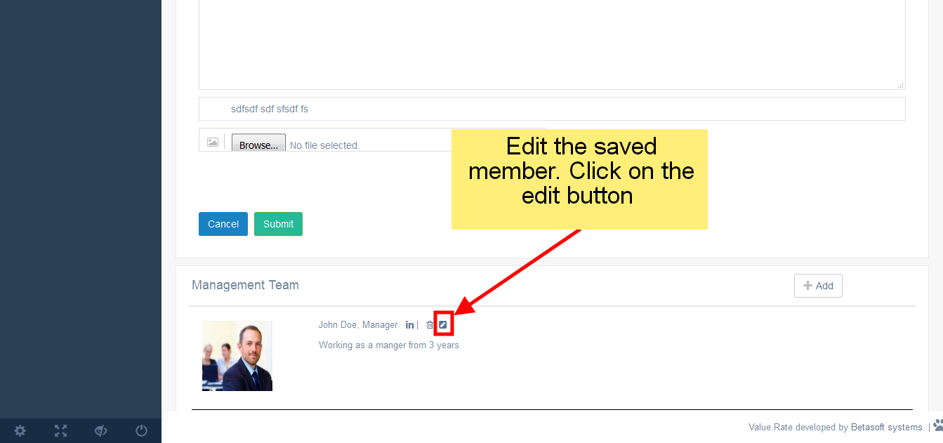
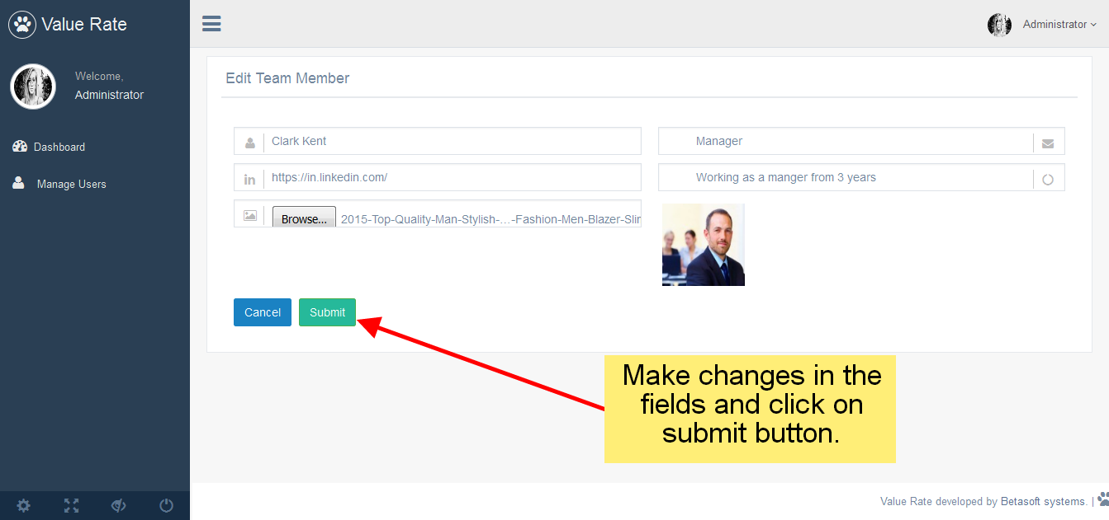

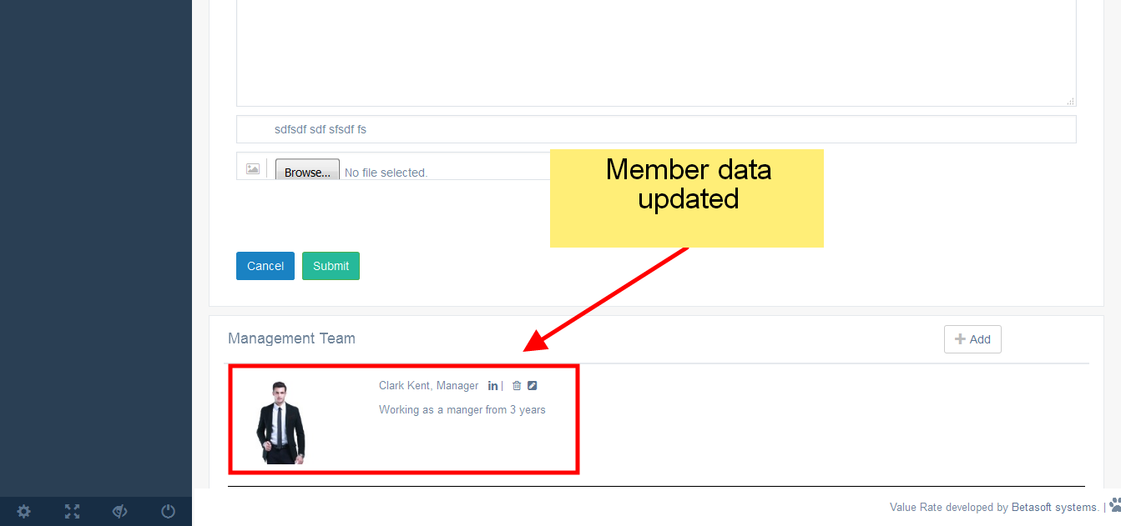

4.) Deleting a member : Click on Delete button and the member will be deleted .

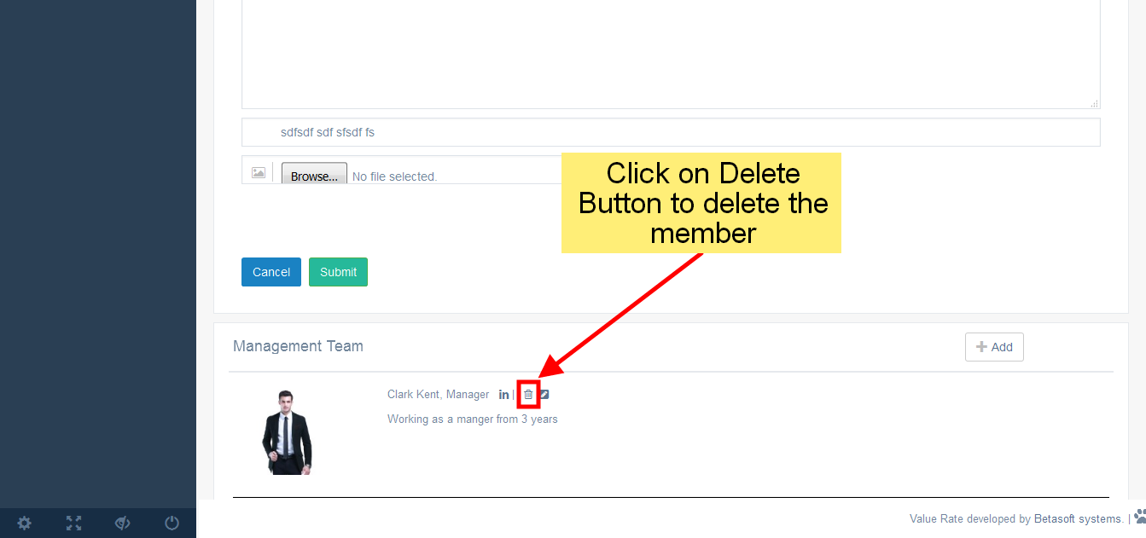

EXECUTIVE SUMMARY
1.) Executive Summary Tab : Click on “Executive Summary” Tab and you can update the contents which are (Business Model, Product Roadmap, Product Roadmap, Customers, Target Markit, Revenue Model, Buzz, Exit Plan, Financial, Valuation) and click on submit button.

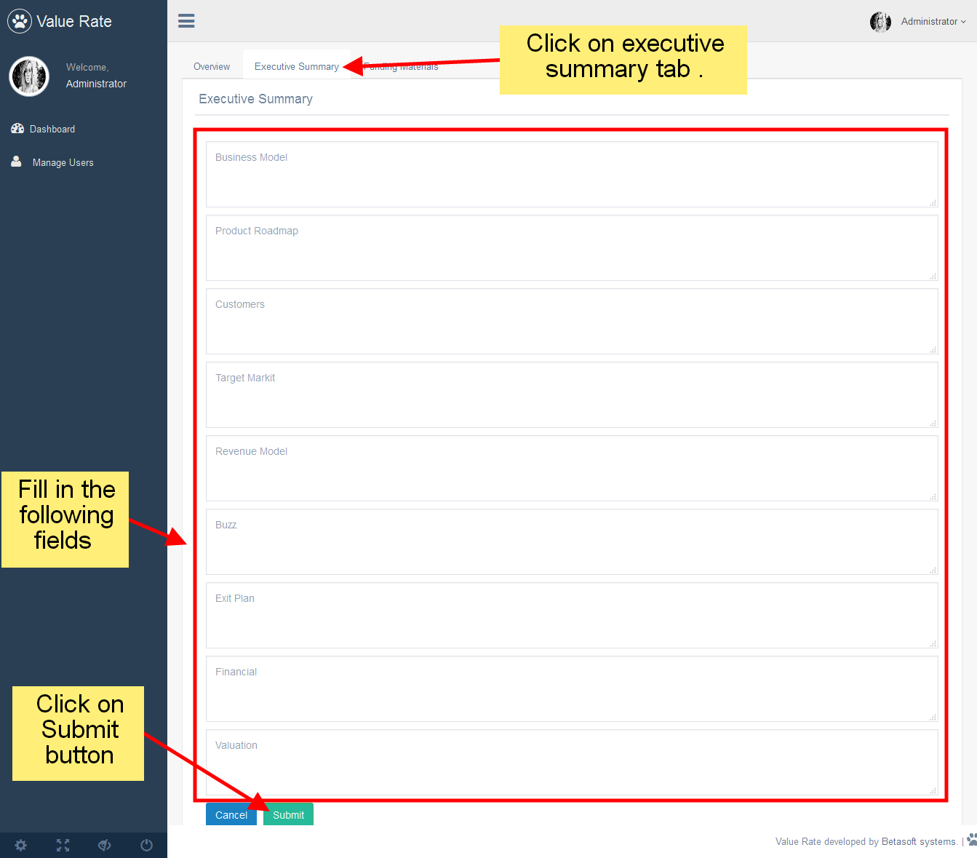

FUNDING MATERIALS

1.) Funding Materials Tab : Click on Funding Materials tab to Add/Edit/Delete/Download the documents.

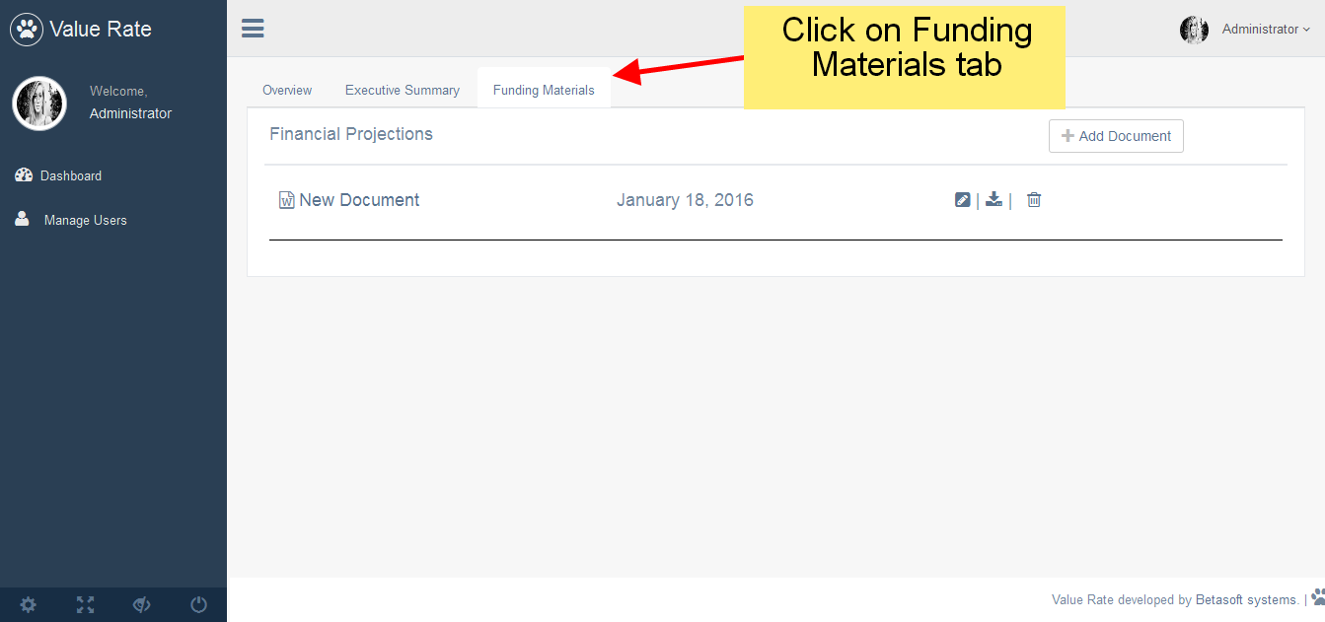
2.) Adding a new document : Click on add document field to add a new document. Add the fields (Document Name, Document File ) and then click on submit button.

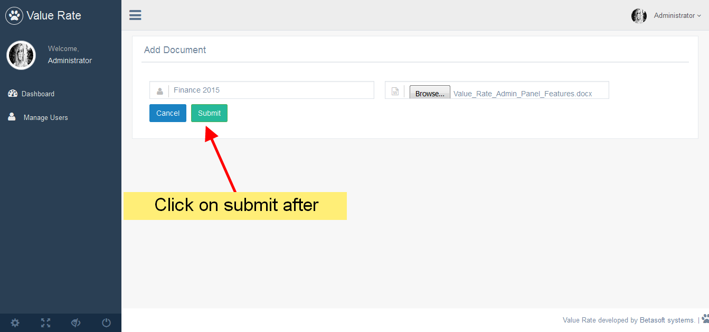

Document Saved :

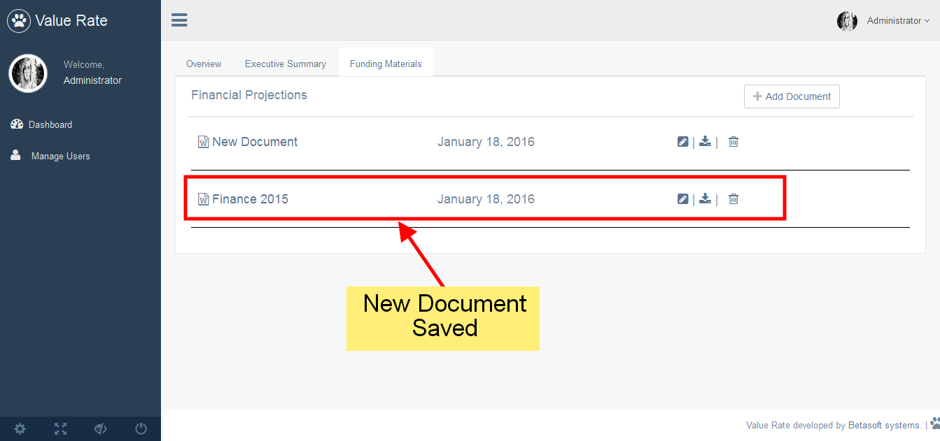
3.) Editing a document : Click on the edit document button and you will be taken to new view , there you can make changes to the document fields and then save the document by clicking on the submit button .

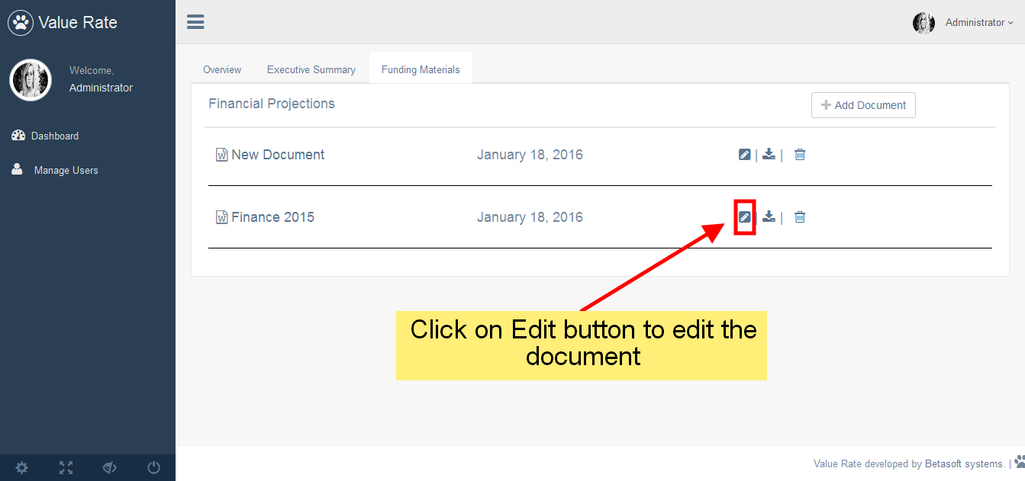
s

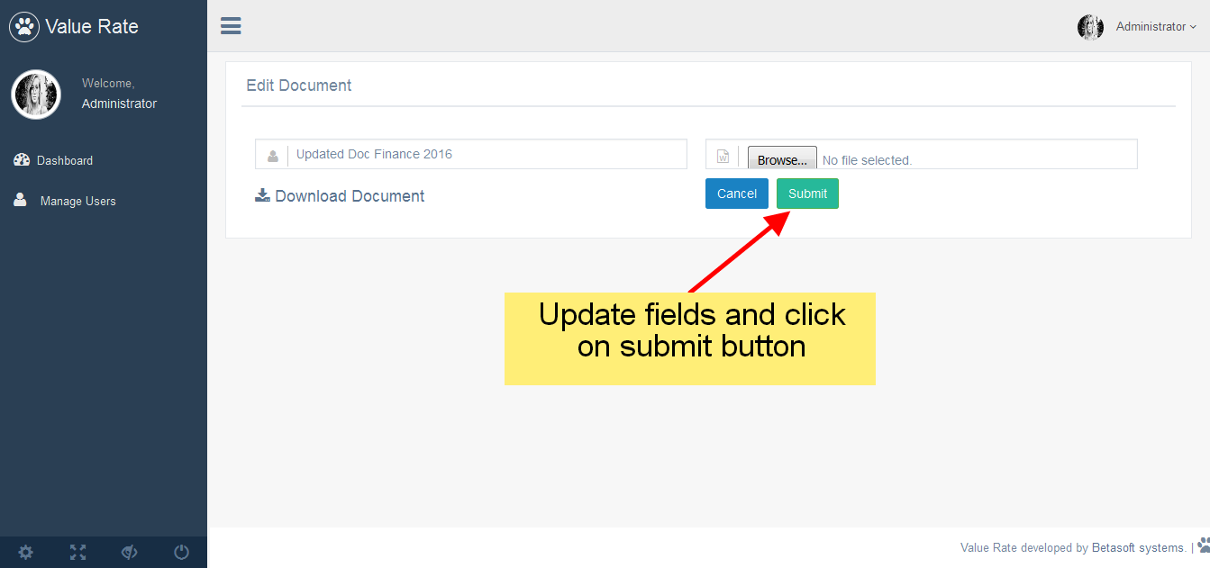
Updated Document :

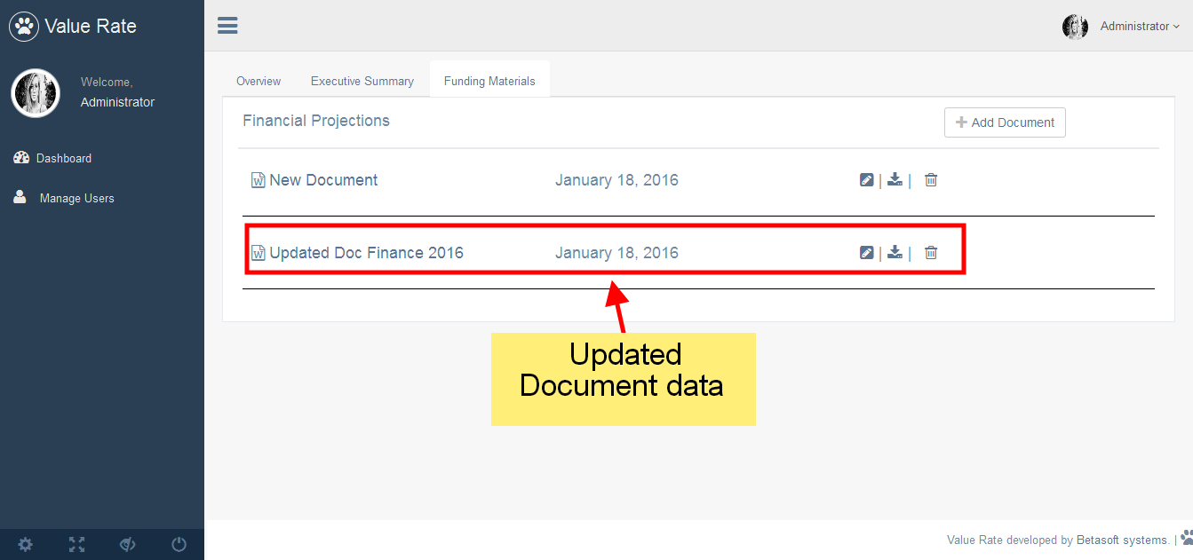

4.) Downloading the document : Click on the download Button to download the document file .

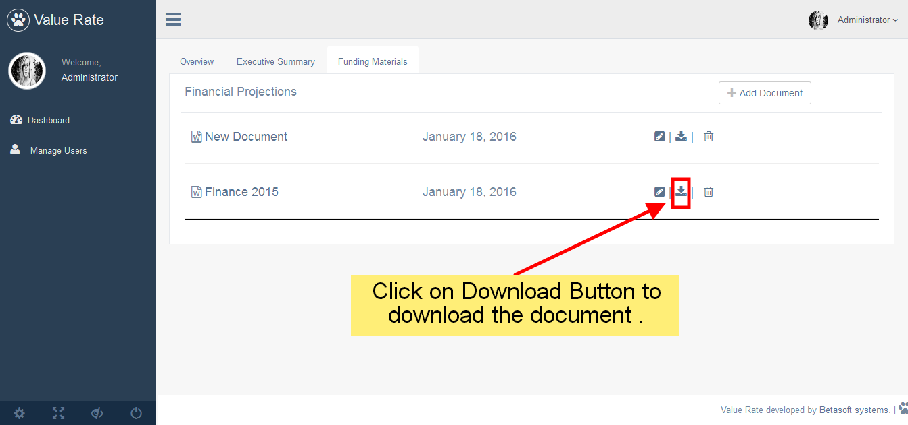
5.) Deleting a document: Click on the delete button to delete the document .

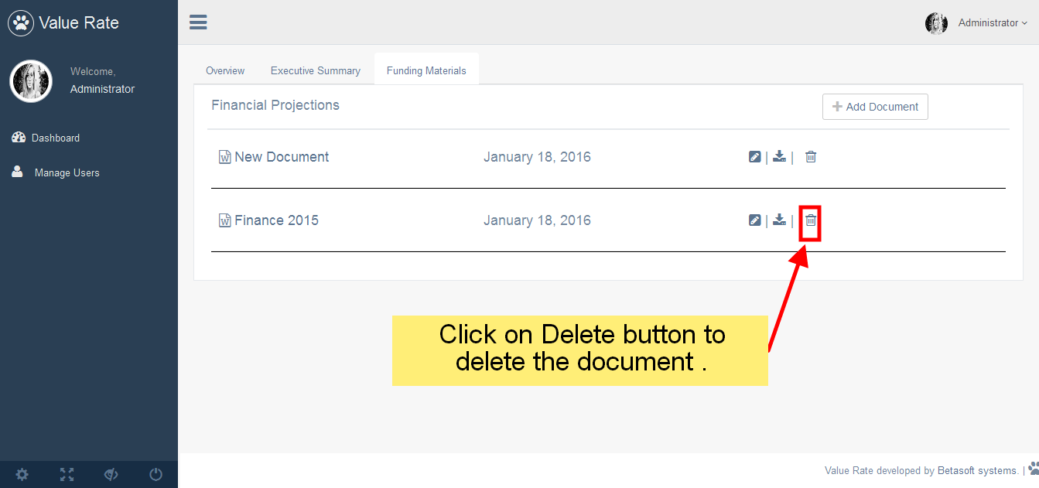
===================FINISH===================

