

Q1:

Software Requirements Specification

for

Koi Order System

Version 1.0 approved

Prepared by

Bui Sy Thai Hoang - HE186345

FPT University Ha Noi

24/07/2024

Q2:

<Student must replace this line, answer Q2 by drawing 1 context diagram that reflect this exam paper and copy and then paste the image of that context diagram here

Notes:

1. Draw the correct syntax to describe the context diagram (0.4 point)
2. Draw external entities (0.6 point)
3. Draw the data flows described in this exam paper (1.5 points)

>

Q3:

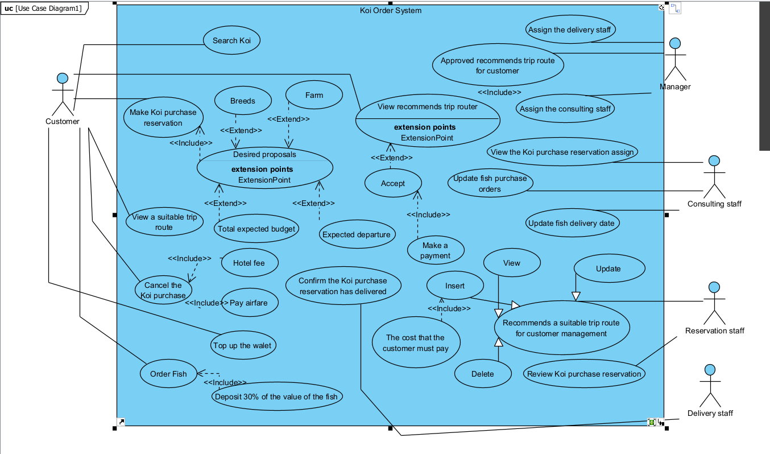

|  |  |  |
| --- | --- | --- |
| **#** | **Actor** | **Description** |
| 01 | Customer | Who purchases Koi |
| 02 | Manager | Who manage system and assign for staff |
| 03 | Delivery Staff | Who deliver Koi |
| 04 | Consulting staff | Who manage about Koi purchase |
| 05 | Reservation staff | Who manage trip router |

|  |  |  |  |
| --- | --- | --- | --- |
| **#** | **Use Case** | **Actors** | **Description** |
| UC-01 | Make Koi purchase reservation | Customer | Customer create Koi purchase reservation to buy fish at Japanese farms with desired proposals |
| UC-02 | View a suitable trip route | Customer | View a suitable trip route from reservation staff after manager accept |
| UC-03 | Order Fish | Customer | Order fish from system |
| UC-04 | Cancel the Koi purchase | Customer | Customers cant cancel the Koi purchase buy they will lost their deposit |
| UC-05 | Search Koi | Customer | Customer can search Koi in system |
|  |  |  |  |

Q4:

< Student must replace this line, answer of Q4 by fill the content to below table that reflect this exam paper

Notes:

1. Describe 4 business rules (1.0 point)
2. For each incorrect business rule, 0.25 points will be deducted

>

|  |  |  |
| --- | --- | --- |
| ID | Rule Definition | Use cases |
| BR-01 | Koi is valid in data base | UC-05 |
| BR-02 | Koi that user cancel is valid | UC-04 |
| BR-03 | Trip route is valid | UC-02 |
| BR-04 | Koi is valid in data base | UC-03 |

**Q5:**

< Student must replace this line

Notes:

1. Draw the correct syntax to describe the state transition diagram (0.3 point)
2. Draw states and brief descriptions (0.9 point)
3. Draw transitions (0.8 points)

>

<Student must replace this line, answer Q5 by drawing 1 state transition diagram that reflect this exam paper and copy and then paste the image of that state transition diagram here >

< Student must replace this line, **briefly describe** the states of the diagram by fill the content to below table>

|  |  |  |
| --- | --- | --- |
| **#** | **State** | **Description** |
| 01 | Accepted | The Requester submitted a completed chemical request and the system accepted it for processing. |
| 02 |  |  |
| 03 |  |  |