

Q1:

Software Requirements Specification

for

Koi pond construction ordering system

Version 1.0 approved

Prepared by

Bui Sy Thai Hoang – HE186345

FU – Hoa Lac

Wednesday, July 31

Q2:

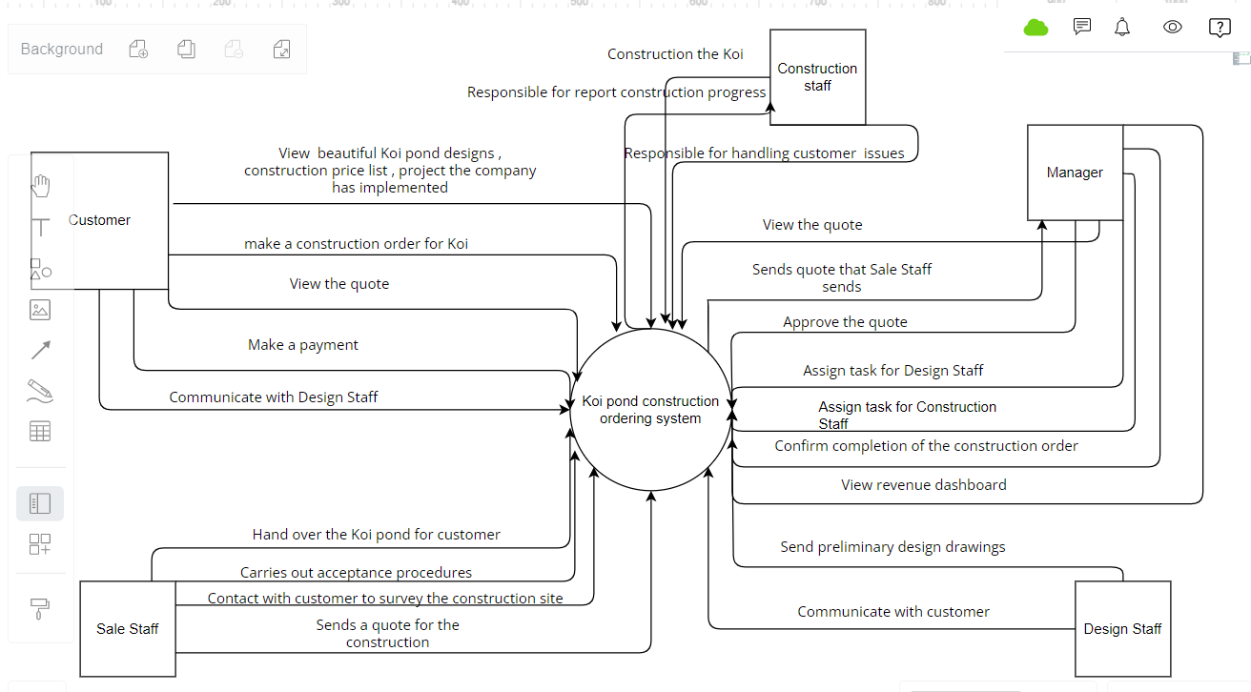

Q3:

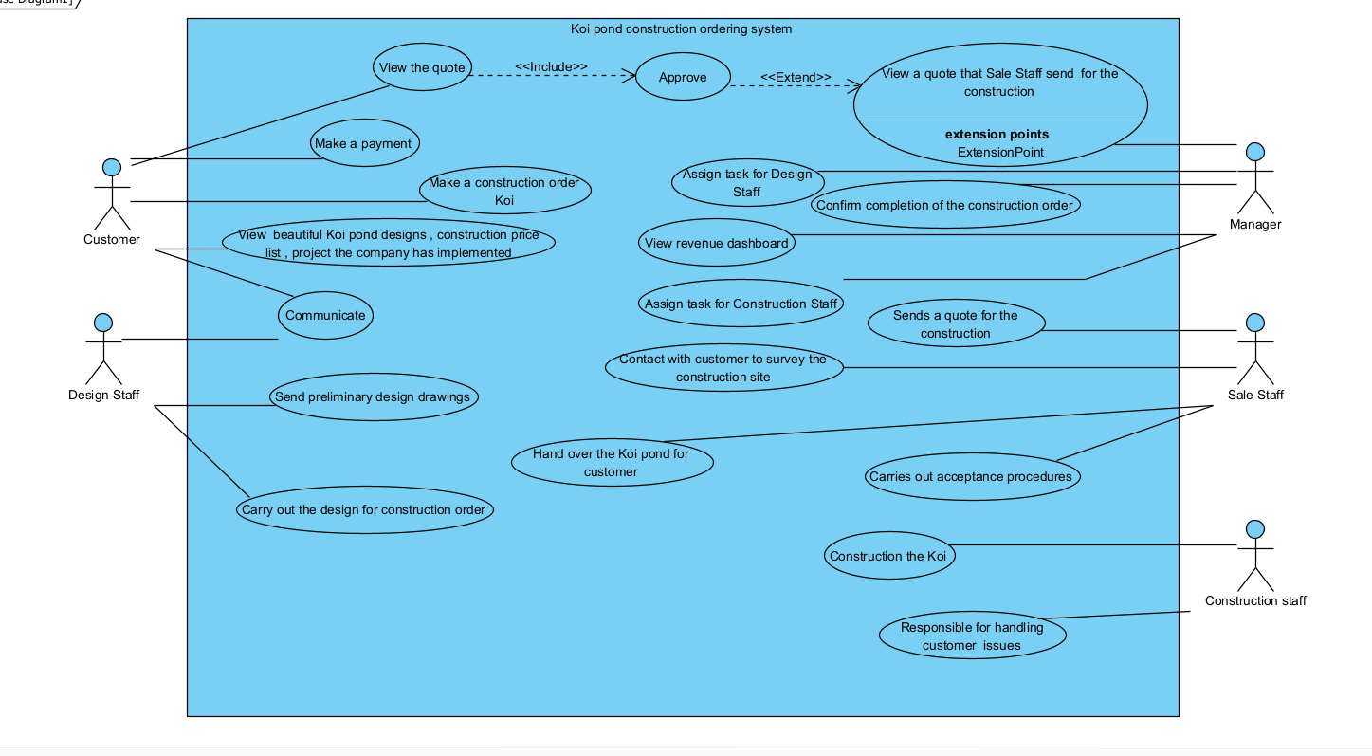

|  |  |  |
| --- | --- | --- |
| **#** | **Actor** | **Description** |
| 01 | Customer | People who view and make order about Koi fish by using system. |
| 02 | Manager | Manage quote of the customer |
| 03 | Design Staff | Responsible for carry out the design for the construction order |
| 04 | Construction staff | Responsible for carry out acceptance procedures |
| 05 | Sale Staff | Responsible for contact with customer |

|  |  |  |  |
| --- | --- | --- | --- |
| **#** | **Use Case** | **Actors** | **Description** |
| UC-01 | Carry out the design for the construction order | Design Staff | Design Staff carry out the design for the construction order after customer make a payment |
| UC-02 | Construction the Koi pond | Construction staff | Construction staff construction the Koi pond order after customer make the second payment |
| UC-03 | Confirm completion of the construction order | Manager | Manager confirm completion of the construction order after customer make the third payment |
| UC-04 | View the quote | Customer | Customer can view the quote after manager approve |

Q4:

|  |  |  |
| --- | --- | --- |
| ID | Rule Definition | Use cases |
| BR-01 | The customer needs to confirm and make first payment equivalent 20% of the total value of the construction order | UC-01 |
| BR-02 | The customer needs to confirm and make second payment equivalent 30% of the total value of the construction order | UC-02 |
| BR-03 | The customer needs to confirm and make third payment equivalent 50% of the total value of the construction order | UC-03 |
| BR-04 | Customer can view the quote when Manager approved | UC-04 |

**Q5:**

< Student must replace this line

Notes:

1. Draw the correct syntax to describe the state transition diagram (0.3 point)
2. Draw states and brief descriptions (0.9 point)
3. Draw transitions (0.8 points)

>

<Student must replace this line, answer Q5 by drawing 1 state transition diagram that reflect this exam paper and copy and then paste the image of that state transition diagram here >

< Student must replace this line, **briefly describe** the states of the diagram by fill the content to below table>

|  |  |  |
| --- | --- | --- |
| **#** | **State** | **Description** |
| 01 | Accepted | The Requester submitted a completed chemical request and the system accepted it for processing. |
| 02 |  |  |
| 03 |  |  |