Portal Chess Development Manual

Unspecified Behavior  
CS414-f20

Contents

Game 3

Eclipse 3

Source Files 3

IDE 3

Create project 3

Configure project 4

Create Package 5

Add files to project 5

Compile & run 6

Run JUnit tests 7

Deploy to Localhost 7

Tools 8

Important Notice 8

npm 8

Webpack 8

Material UI & Reactstrap 8

# Game

The game logic is implemented using Java

## Eclipse

### Source Files

Download source files from github

‘git clone https://github.com/bstaab/cs414-f20-UnspecifiedBehavior.git’

IDE

Download Eclipse IDE from the official download [link](https://www.eclipse.org/downloads/) and install

Version ‘2020‑09 R’ is used in this manual

### Create project

* File->New->Project  
  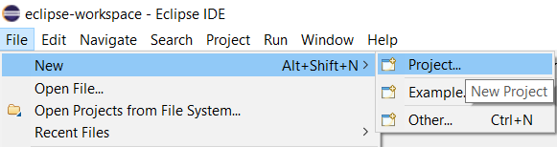
  + Select ‘Java Project’ then ‘Next >’  
    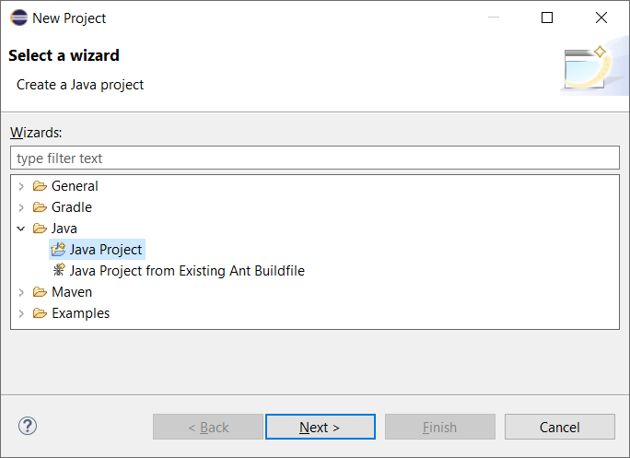
  + Set project properties
    - Project Name: portal_chess
    - JRE – ‘Use a projectct specific JRE:’ – jdk-15
    - Create separate folders for sources and class files
    - Click ‘Finish’  
      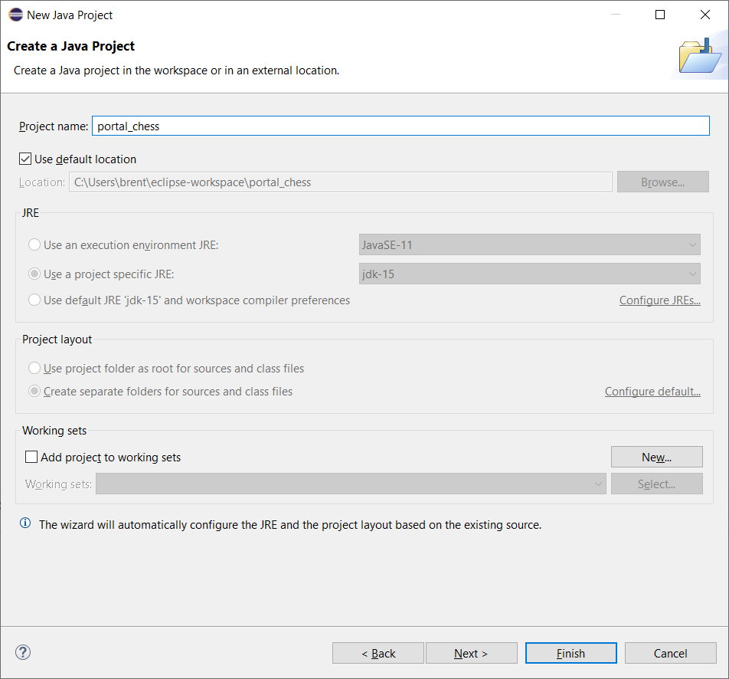
  + Module name: portal_chess  
    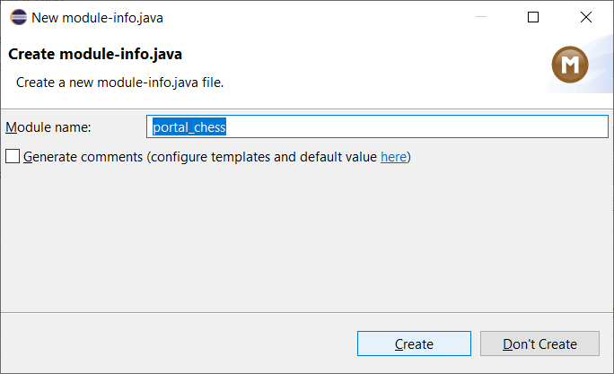

### Configure project

* Delete the module-info.java file
* Add JUnit to build path  
  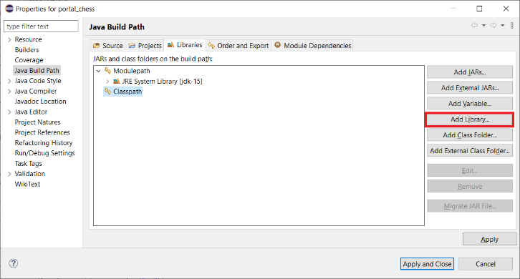  
  + Select JUnit   
    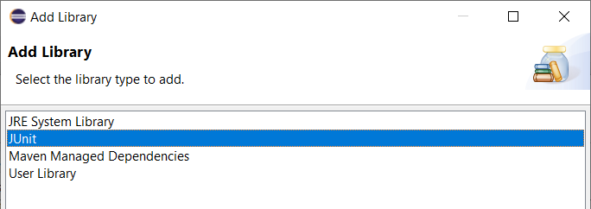  
    - Select JUnit 5  
      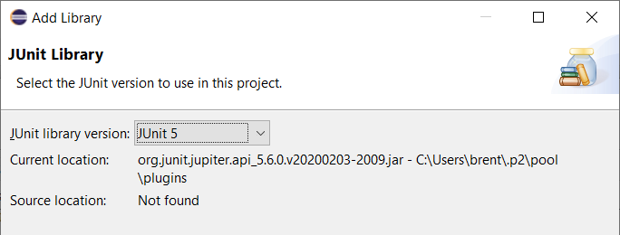

### Create Package

* Right click on the portal_chess project, select New then Package  
  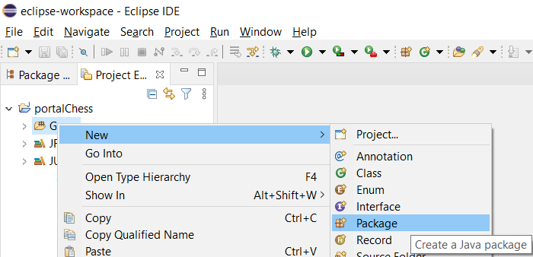
  + Source folder: portal_chess/src  
    Name: Game  
    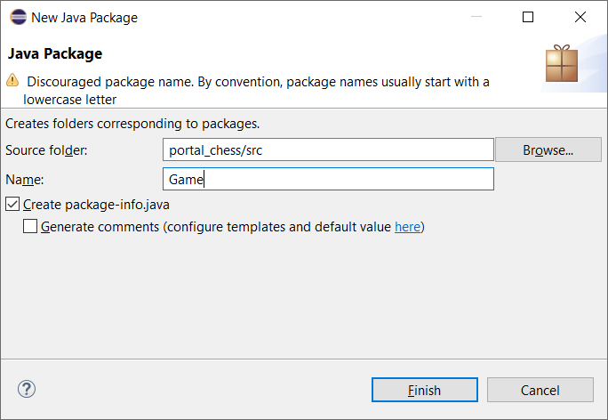

### Add files to project

* Using file explorer, browse to the files downloaded from git  
  Click and drag into the portal_chess/src/game/folder  
  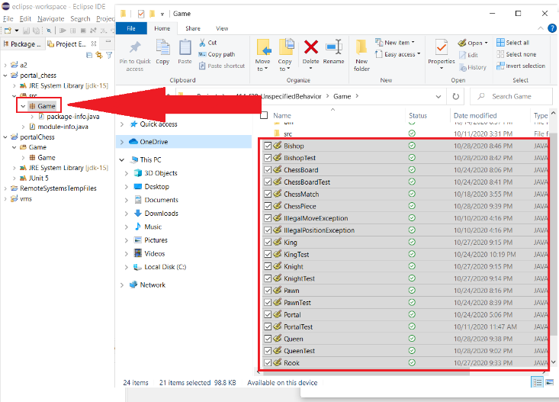  
    
    
  + Select “Link to files”  
    This will link to the original source files rather than making a new copy. Any changes you make will show up in git  
    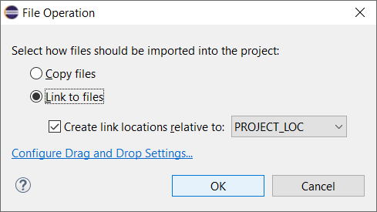

### Compile & run

* Select ChessBoard.java
* Select the down arrow highlighted at the top of the screen
* Select Run As -> Java Application
* In the ‘Console’ window at the bottom, you should see a chess board where the lines are displayed as ‘?’  
  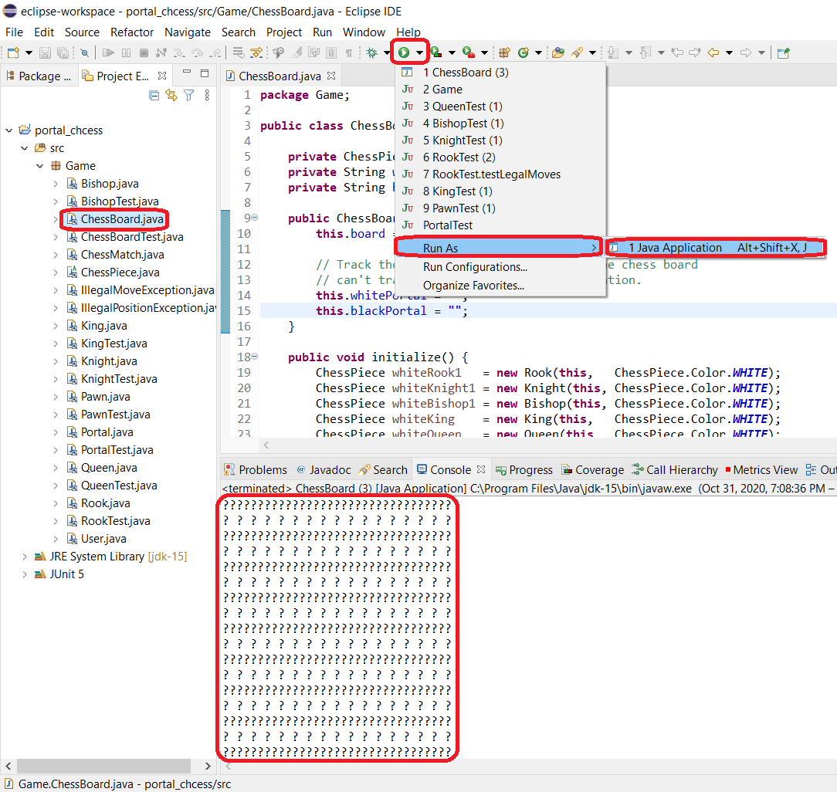

### Run JUnit tests

* Select the ‘Game’ package
* Select the down arrow highlighted at the top of the screen
* Select Run As -> JUnit Test  
  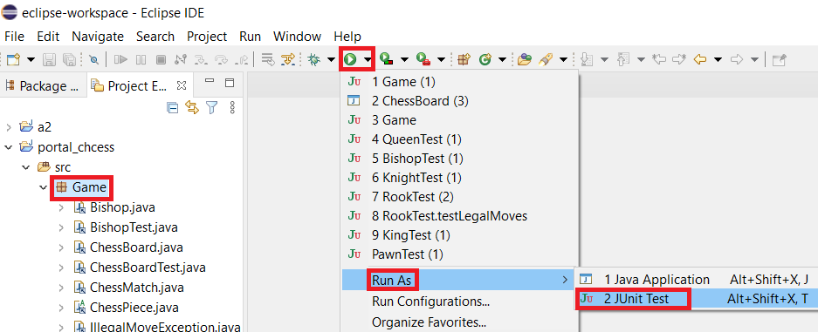
  + The results will be in the console window at the bottom  
    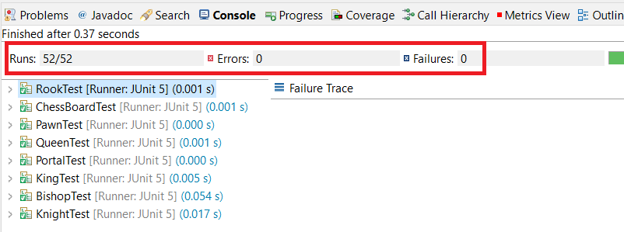

### Deploy to Localhost

* In the terminal run the command: **npm start**
  + This will the deploy the webpage
* If the website is not automatically deployed, you can click the link in the terminal

* Once the website is deployed you should see the login page

# Tools

### Important Notice

* Once you have the source code cloned from the GitHub repository make sure to run **npm install** to make sure all the correct dependencies are installed.

### npm

* We are using npm instead of yarn. Make sure that npm and Node.js are installed. In order to do so:

* If they are not installed you can go to this website: <https://www.npmjs.com/get-npm>
  + Once on the website you can download Node.js and npm

### Webpack

* We are using webpack as our module bundler in order to deploy the website
* In order to install webpack you must run:



### Material UI & Reactstrap

* For the front-end development and design, we are using a combination of Reactstrap and Material UI.
* To install Reactstrap:



* To install Material UI

