Practical 1: Computer Architecture

Drawing/Simulating logic circuits

**Introduction**

Logic circuits can be drawn by hand on paper and for your exam you may be asked to draw logic gates in a circuit. However this practical is going to concentrate on drawing circuits using a drawing application and demonstrate how one can enhance their knowledge and understanding with these drawing applications. There are many free drawing applications out there including ones you must pay for.

For today’s lab, we are going to use <http://logic.ly/demo/> which is actually an online free demo of logic.ly, a paid application that you can download and install on your machine that is used to teach students about logic gates via simulation.

1. **Draw an AND Gate with input switches and an output bulb:**

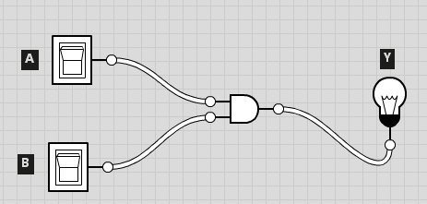

You can effectively go through all combinations of the AND gate truth table by switching the input switches on and off. The light bulb lights when the output is 1

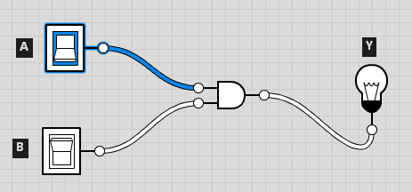

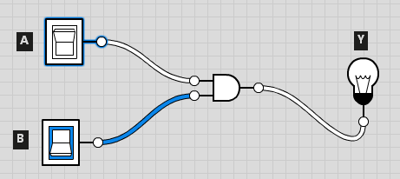

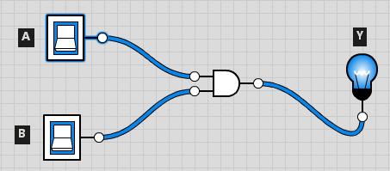

1. **Draw other gates with input switches and an output bulb**
   1. NOT
   2. NAND
   3. OR
   4. NOR
   5. XOR
   6. XNOR
2. **Demonstration of the output digit control:**

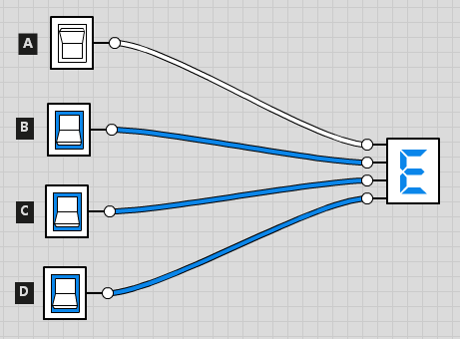

The digit is a readable output that represents the output of 4 binary input bits in hexadecimal

1. **Draw the following circuits:**

Z = A.C + B.C + A.B.D + A.D

Z = A.B + B.A (notice anything special about this ?)

1. **Look at other controls:**
   1. Constants
   2. Push button
   3. Clock
   4. Pausing/Playing simulation
2. **For submission**

Submit a written report on this lab to [billy.stack@staff.ittralee.ie](mailto:billy.stack@staff.ittralee.ie) highlighting how in your view logic circuit drawing applications and in particular logic circuit simulators can aid in understanding how logic works.

Illustrate your answer by creating your own circuit.