Practical 2: Computer Architecture

Number system relevance in programming

**Introduction**

This practical attempts to emphasize how binary is a huge building block in programming languages. In this practical we will be using the Java programming language to demonstrate.

**1. Data Types**

All data types are stored in bits/bytes i.e. the size of the data type is based on binary. Here is a list of some of the basic types in Java and their min, max and byte size:

|  |  |  |  |  |  |
| --- | --- | --- | --- | --- | --- |
| **Type** | **Class** | **Min** | **Max** | **Bits** | **2n** |
| boolean | Boolean | 0 | 1 | 1 | 0 |
| byte | Byte | -128 | 127 | 8 | 3 |
| short | Short | -32768 | 32767 | 16 | 4 |
| int | Integer | -2147483648 | 2147483647 | 32 | 5 |
| long | Long | -9223372036854775808 | 9223372036854775807 | 64 | 6 |

Look at Types.java to see how you can demonstrate each type listed above with data

**2. Boolean Expressions**

Boolean expressions are directly built into all programming languages. In Java, Boolean expressions use one of the following operations:

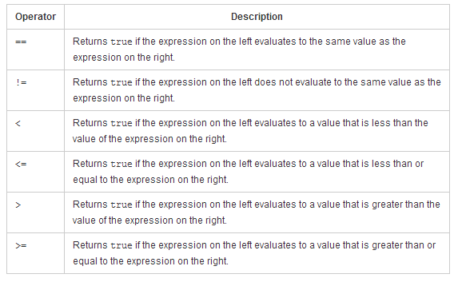

Look at Types.java to see how you can demonstrate each type listed above with data

**3. Logic gates are in the language**

The logic gate behaviour that we have learned over the last few weeks is directly ingrained into the Java language. The demonstration of this can be seen in Operations.java

Note the use of binary operators and the simulation of the different basic gates we have learned.

**4. Binary engrained in control statements**

Control statements are an integral part of programming languages and most have binary logic associated with them. The demonstration of this can be seen in ControlStatements.java

**5. For submission**

Submit a written report on this lab to [billy.stack@staff.ittralee.ie](mailto:billy.stack@staff.ittralee.ie)

Also, can you do the following:

1. Write another xor function, using simple logic gate behaviour instead of the ^ symbol.
2. Give another example not mentioned in the lab of the usage of two other number systems in Java.