Practical 3: Computer Architecture

Examining the PC both internally and externally

**Introduction**

This practical will help you become familiar with the basic peripheral components both internally and externally within a computer.

**1. Open up the computer**

Simply open up the computer by pressing a button on each side of the computer. Once opened up, identify the following components and explain physically from what you see how they are connected to the motherboard (if applicable):

* DVD\CD player
* Floppy drive
* Front panel
* Hard drive
* Power supply
* Memory
* CPU
* Heat Sinks

**2. Connectors at the back of the computer**

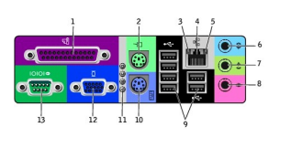

Identify each of the following connectors, what type of connection they are and what function

**3. Motherboard part identification**

Identify at least 15 of the following motherboard parts:

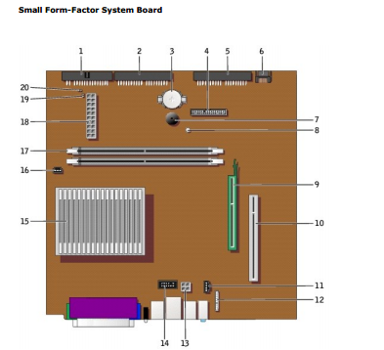

Also, can you also identify at least the following which is not in the above diagram and give a short note on appearance and where they are located:

* The BIOS chip
* The heat sink for the main chip set

**4. Removal/Re-installation of DELL CPU Fan and heat-sink**

Do the following:

1. Follow instructions in video here: <http://www.youtube.com/watch?v=wTLFKRAcOfo>
2. Also remove CPU – note socket connection
3. Revert all steps performed in Step 1

**5. Removal/Re-installation of Hard Drive**

Do the following:

1. Watch video here: <http://www.youtube.com/watch?v=vnEga6ga5hM>
2. Disconnect hard drive and view master slave configuration
3. Why does the configuration of jumpers with master/slave not apply in PC we are dissecting?
4. Do you notice anything bad about the current hard drive installation?
5. Revert all steps performed in Step 2 to re-install the hard-drive

**6. Removal/Re-installation of Memory**

Do the following:

1. Watch video here: <http://www.youtube.com/watch?v=J45xKRZULDM>
2. Uninstall memory form machine
3. How many memory modules are in the computer
4. How many memory slots are available in the computer
5. Why is it much easier to install\uninstall memory in the PC we are dissecting?
6. Revert all steps performed in Step 2 to re-install the memory

**7. For submission**

Submit a written report on this lab to [billy.stack@staff.ittralee.ie](mailto:billy.stack@staff.ittralee.ie)