Practical 4: HDD partitioning and defragmentation, BIOS

**Introduction**

In this lab we will learn how to partition and defragment a hard drive. We will also learn about DVD drives and how to configure various I/O devices (mouse, keyboard, monitor) and we will learn about sound cards specifications.

Also, we will go through an online tutorial on BIOS.

**1. Partitioning a HDD**

For a hard disk to be able to hold files and programs, it has to be partitioned and formatted. Partitioning is the process of creating logical divisions on a hard drive. A hard drive can have one or more partitions, represented by different drive letters. Formatting is the process of preparing a hard disk for use by an operating system. Formatting establishes a file system, creates and configures a file allocation table (FAT), and creates a root directory. Different operating systems support different types of file systems, such as FAT16, FAT32 and NTFS.

In this task we will learn how to partition unallocated space on a hard disk and format it.

Open Control Panel, Administrative Tools, Computer Management

Double click storage and click disk management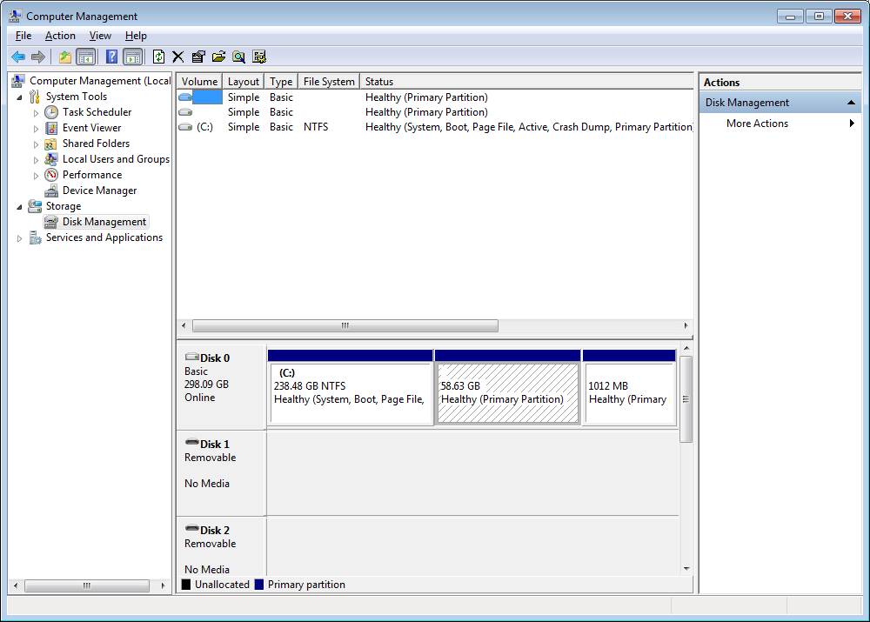

Right click an area of un-partitioned space and choose new partition

The Welcome screen of the New Partition Wizard appears. The Select Partition Type screen appears. You have the option of selecting either a primary or an extended partition. The Primary Partition option button should be selected.

Accept default selection by clicking next

The specify partition screen appears. Here you select the size of the partition – choose a partition size that is no greater than one-half of the size of the unallocated space. Enter a value for the size of the partition in the amount of disk space to be used.

Click next to open Assign Drive Letter (which you can change later) Typically the computer’s initial hard drive will be assigned the letter C with D assigned to the CD-ROM or DVD-ROM drive. Accept the default for now

Click Next to open Format Partition. Here a file system must be selected for the partition.

Choose NTFS and enter a label (name ) for the partition in the volume label.

Click Perform a Quick Format

After formatting return to the Computer Management window to see the newly created primary partition.

You should have something like the following:

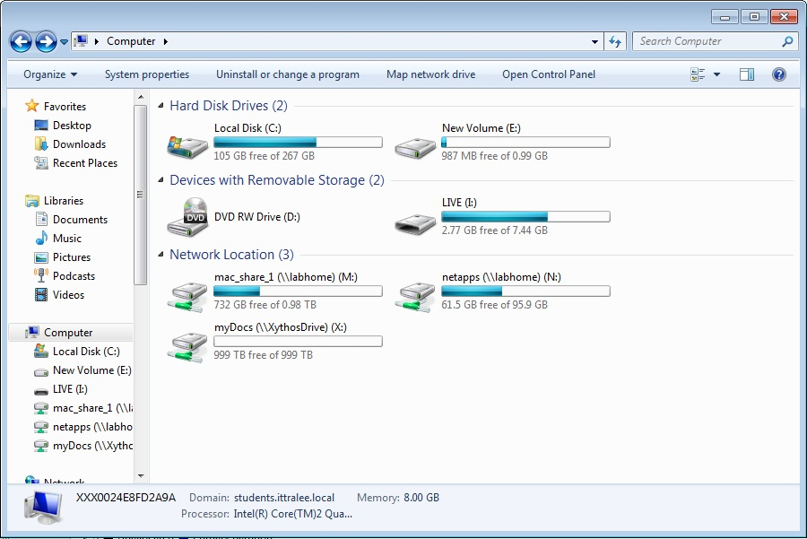

**2. Defragmenting a HDD**

When you create a file, it normally occupies contiguous hard-drive space (the clusters used to store the file are adjacent to each other). Over time, as the file size increases, there may not be enough contiguous space for the file. So the file gets broken up. This process is called fragmentation. When enough files become fragmented, the hard drive wastes time going to different clusters to retrieve them. If fragmentation becomes bad enough, a condition called disk thrashing occurs: Operations slow noticeably, and the hard-drive light flickers to indicate constant activity.

Microsoft provides a utility called Disk Defragmenter to help the hard drive reorganize itself. Defragmentation is the process of rewriting files and organizing them so that access to the files is improved. This process can take several hours if you do not have adequate free space for the system to rewrite files or if there is a lot of fragmentation on the hard drive.

Click Control Panel/System and Security/Administrative Tools/Defragment your hard disk

Analyze the C: disk

The computer will now analyse the fragmentation of the hard disk. A message box will appear when the analysis is complete with a recommendation as to whether the volume should be defragmented.

Click the View Report button.

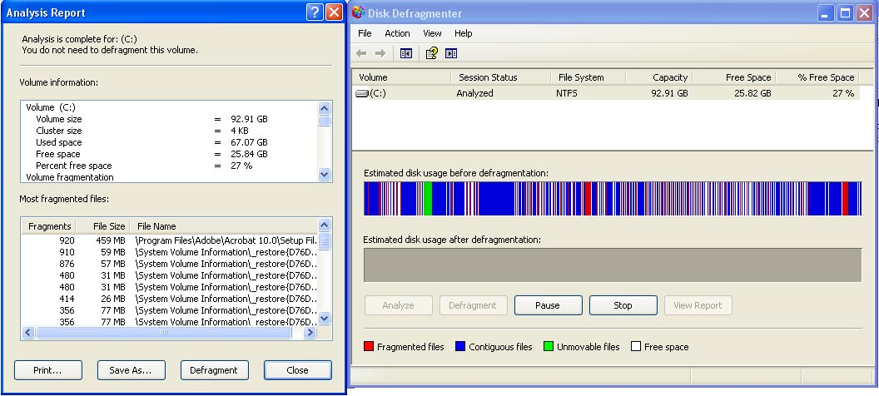

* Attempt to defragment the drive
* Look at the disk defragmenter information in detail
* Look at the analysis report in detail

**3. BIOS**

Have a look at the BIOS tutorial on <http://www.bcot1.com/bios1.html>

Note that some of the features we may not have covered fully but you should get a very good picture on what BIOS main functions are.

Go through the BIOS of your own computer at home illustrated by screenshots describing the different functions that the BIOS offers.

**4. For submission**

Submit a written report on this lab to [billy.stack@staff.ittralee.ie](mailto:billy.stack@staff.ittralee.ie) that has:

* A brief description of partitioning
* A brief description of defragmentation
* A description of the BIOS on your own machine (illustrated using screenshots)