**Institute of Technology Tralee**

**Computing Department**

**Object Oriented Programming 1**

**__________________________________________________**

**Tutorial 1 – Java Console, GUI Input/Output and**

**Calculations**

**(a)** Write a Java program that produces **exactly** the following output when it executes – try to **use just one statement** in your program and also use the **special characters** available in Java wherever possible. Also ensure that your program uses both types of **comment** at the top of the program. Note that the text “Press any key to continue…” appears automatically.

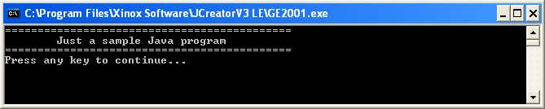

**(b)** Examine the following piece of Java code and identify the error it contains:

//TutorialQb.java

/*A very short Java program that just displays some text to the screen*/

public class TutorialQb {

public static void main(String args[])

{ System.out.println("=============================\n\tJust a sample " + "Java program\n============================";

}

}

**(c)** Examine the following piece of Java code and identify the error it contains:

//TutorialQb.java

/*A very short Java program that just displays some text to the screen*/

public class TutorialQb {

public static void main(string args[])

{ System.out.println("=============================\n\tJust a sample " + "Java program\n============================");

}

}

**(d)** Examine the following piece of Java code and identify the error it contains:

//TutorialQb.java

/*A very short Java program that just displays some text to the screen*/

public class TutorialQb

public static void main(String args[])

{ System.out.println("=============================\n\tJust a sample " + "Java program\n============================");

}

}

**(e)** What is the special character in Java for a backslash?

**(f)** Write Java initialisation statements which declare an integer variable called age whose initial value should be set to 10, a floating-point variable called height whose initial value should be set to 1.8m and a string variable called name whose initial value should be set to Joe Bloggs.

**(g)** Write a Java statement that will display the values of the variables referred to in the last question to the console window exactly as follows:

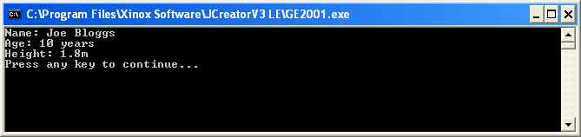

**(h)** List 3 kinds of identifier in Java

**(i)** List the rules that govern the naming of identifiers in Java.

**(j)** Write a Java program that will read in the age of a person and display it back on the console. In this case you should make use of the Scanner class. You can take it that the age of the person will be entered as a **whole number** in this case. Your program would run as indicated in the following screenshot:

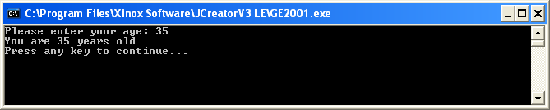

**(k)** Add to the program you have written in (j) so that after asking the user for their age, they are now also asked for their name, again using the Scanner class (be careful here!) This information should also end up getting displayed to the console. Your program would now run as indicated in the following screenshot:

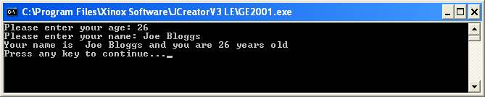

**(l)** Imagine that you have assigned variables called mathsMark, programmingMark, visualCommunicationsMark and webDesignMark the values 45, 64, 73 and 82 respectively. Write the line of Java code that could be used to display these variables neatly aligned, as indicated in the following screenshot:

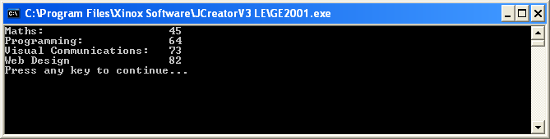

**(m)** Write a Java program that initialises a variable with your name and then displays the information in a message dialog as follows:

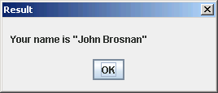

**(n)** Write a Java program that first of all reads in your t-number and then the number of modules you are taking in this semester, using input dialogs. You should use an integer variable to store the number of modules taken.

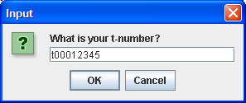 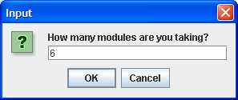

It should then display the information entered using a message dialog as follows:

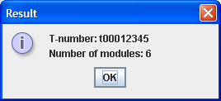

**(o)** In Java, what is the value of the expression 13/5 ?

**(p)** In Java, what is the value of the expression 17%3?

**(q)** In Java, what is the value of the expression 19 / 3 * 4 % 2

**(r)** Write the line of Java code that creates a single-precision floating-point constant called K and sets it to the value 22.56

**(s)** Write the line of Java code that creates an integer constant called MAX_LINES and sets it to the value 18

**(t)** Write a Java program that will read in values for the acceleration (a), time traveled (t) and initial speed (u) of a body and use these to determine the distance traveled (s) using the formula:

$$s=ut+\frac{1}{2}at^{2}$$

You can take it that u, a and t can all be fractional values. The distance traveled should then be displayed to **3 decimal places** and also to the **nearest whole number**. The program should run as indicated in the following sample screenshots:

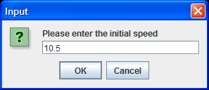 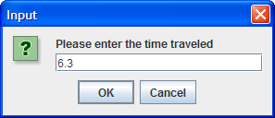

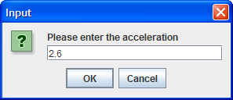

Once the 3 inputs are supplied the following message dialog appears:

