**1 Java naming conventions:**

Java naming conventions outlined here: <http://www.oracle.com/technetwork/java/javase/documentation/codeconventions-135099.html#15411>

1.1 Variable naming:

Using a Java program called DemoVariableNaming, demonstrate examples of valid and invalid variable names in Java.

What error is displayed if the name of a variable is invalid?

1.2 Class naming:

The following are valid Java class names True/False?

* Class1
* class1
* Converttodegrees
* Convert_to_degrees
* ConvertTodegrees
* ConvertToDegrees
* 2ComparerClasses
* CompareTwoclasses
* CompareTwoClasses
* Compare2Classes

**2. Primitive Data Types**

What are the eight primitive data types supported by the Java programming language? Using a Java program called DemoPrimitiveVariableTypes that declares a meaningful variable with assigned value for each primitive data type e.g. int age = 30; Then print out each variable value to the console.

**3. Primitive Data Type Default Values**

Using a Java program called DemoPrimitiveVariableTypeDefaultValues, copy all code you did in DemoPrimitiveVariableTypes but this time leave all fields uninitialized and then print out your values to the console

**Exercise 1**

Write a Java program that will print out exactly the following data:

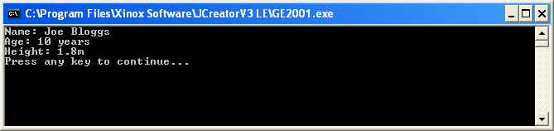

Note that all variables are declared with the appropriate type and value.

**Exercise 2**

Write a Java program called DivideNumbers that declares two variables called num1 and num2. The division result should be calculated and printed to the console

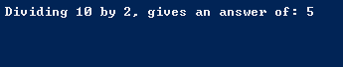

**Exercise 3**

Imagine that you have assigned variables called mathsMark, programmingMark, visualCommunicationsMark and webDesignMark the values 45, 64, 73 and 82 respectively. Write the line of Java code that could be used to display these variables neatly aligned, as indicated in the following screenshot:

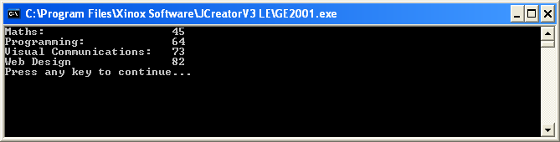

**Exercise 4:**

Explanation of bitwise or operators:

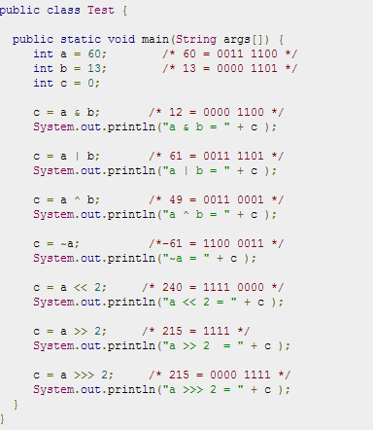

**Other stuff:**

Go over output formatting