**Institute of Technology Tralee**

**Computing Department**

**Object Oriented Programming 1**

**__________________________________________________**

**Continuous Assessment 1**

1. **(50 marks)**

You need to write an AverageGrade console program that asks the user for the following:

* Enter their math mark, read this in from the console and store it in a local variable
* Enter their science mark, read this in from the console and store it in a local variable
* Enter their geography mark, read this in from the console and store it in a local variable

You then need to output the following:

* Each subject mark entered
* The average grade, rounded to 3 decimal places
* Grade based on the table below

|  |  |
| --- | --- |
| **Average Mark** | **Grade** |
| 0 to 40 | Pass |
| 41 to 69 | Merit |
| 70 to 100 | Distinction |

For full marks your program should, along with a logically correct solution for the problem above, include comments, meaningful variable names and correct tabbing.

You must use an **if-else** statement to calculate the grade.

The output should be in the following form:

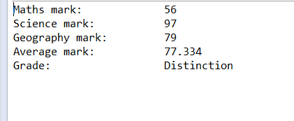

1. **(50 marks)**

In earthquake detection, the Richter scale works according to the following table:

|  |  |
| --- | --- |
| **Measurement** | **Probable Effects** |
| 1-3 | Detectable only by Instruments |
| 4 | Detectable within 32km of epicentre |
| 5 | May cause slight damage |
| 6 | Moderately destructive |
| 7 | A major earthquake |
| 8 | A very destructive earthquake |
| 9 | A catastrophe |

You must write a Java program that reads in an earthquake measurement value from the user (this should be a **whole number** value) using an **input dialog**. Then the probable effects of the earthquake should be displayed as a string to the console in accordance with the table above.

Note that if any number is entered that is not between 1 and 9, return the error “**Incorrect earthquake measurement value entered**”.

For full marks your program should, along with a logically correct solution for the problem above, include comments, meaningful variable names and correct tabbing.

A few sample runs of the program are as follows and your program should imitate these as closely as possible. Also, you should use the test values indicated when testing out your own program.

**Sample Screenshots**

**Run1 - Running the program with a valid earthquake measurement value:**

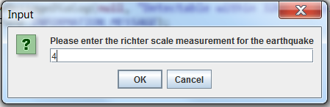

**Once the OK button is pressed (or the return key) the following window appears:**

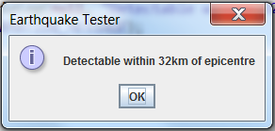

**Run 2 - Running the program with an invalid earthquake measurement value:**

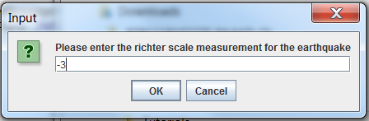

**Once the OK button is pressed (or the return key) the following window appears:**

