**Institute of Technology Tralee**

**Computing Department**

**Introduction to Programming**

**__________________________________________________**

**Continuous Assessment 2**

1. You need to write a WordParser console program that prints the words of a sentence that was entered by the user. You need to break the program into two parts:

* Reading in the sentence from the user.
* Print out each word in the sentence word for word

Part 1: Reading in the sentence from the user

Read in the sentence from the user, ensuring the sentence is greater than 15 characters. If not the user should be asked to re-enter the sentence. This should be implemented with a **do-while** loop

Part 2: Print out each word in the sentence word for word

Once a valid sentence has been entered, you now need to save each word in the sentence using a **String array**. You then need to print each word by iterating through the array using a **for-loop**.

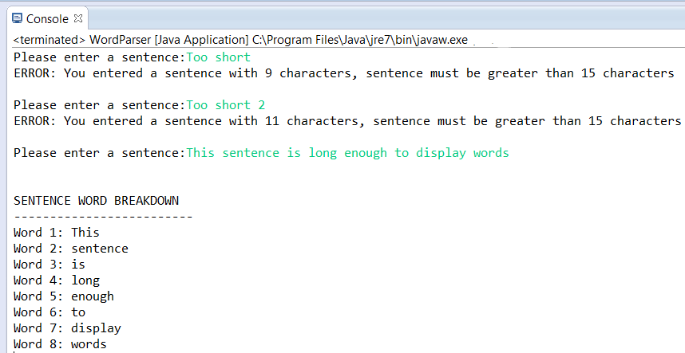

For full marks your program should, along with a logically correct solution for the problem above, include comments, meaningful variable names and correct tabbing.

**(60 marks)**

1. You need to write a FactorialCalculator console program that reads in a number from the user via an input box, calculates the factorial of that number and outputs the calculation with the result in a message box.

The factorial of a number n, denoted by n!, is a product of all the positive integers less than or equal to n. For example 5! = 5*4*3*2*1 = 120

You must use a **while loop** to calculate the factorial result in an iterative fashion.

This is best demonstrated by the following runs:

Factorial of 10:

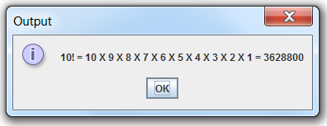

Factorial of 6:

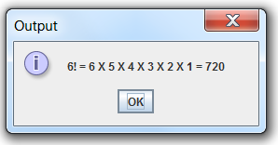

Factorial of 2:

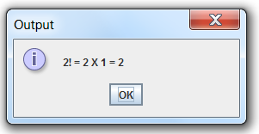

Factorial of 1:

