**Institute of Technology Tralee**

**Computing Department**

**Object Oriented Programming 1**

**__________________________________________________**

**Tutorial 3 – Java Loops and Input Validation**

**(a)** Write a Java program that reads in the titles of 5 books and then displays these titles in a message dialog as indicated below. Your program should use a **while loop** for reading in the book titles.

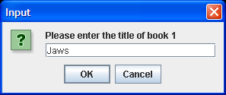 ………. 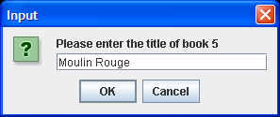

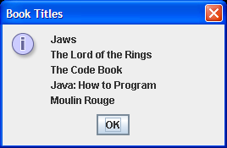

**(b)** Add code to your solution to part (a) so that the program will keep track of the book which has the longest and shortest title. The program should also display the lengths of these titles as indicated in the message dialog below:

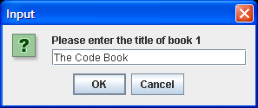 **…… followed by 4 more rounds of input**

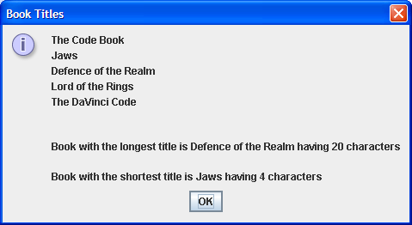

**(c)** Add code to your solution to part (b) so that the program is capable of rejecting any title that is the empty string i.e. where the user enters nothing for the title. The program should not accept this and continually issue an error message to the user to indicate the problem as shown in the screenshot below:

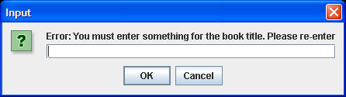

**(d)** Add code to your solution to part (c) so that the program is capable of keeping track of the percentage of the books whose title exceeds 10 characters. The message dialog will change as follows to reflect this percentage, correct to 2 decimal places, as follows:

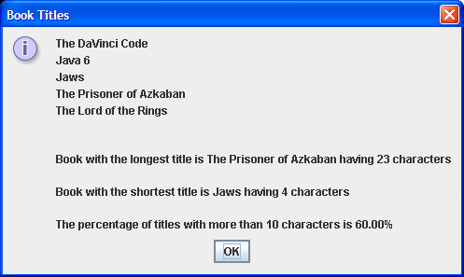

**(e)** Add code to your solution in part (d) so that the program is capable of keeping track of the title of the book that contains the most words and also displays the number of words it contains. You can assume here that every time a space character is encountered in the title, this signifies a new word. The message dialog now changes to become:

