Description of classes:

AvatarCalibrationController
Task:
It uses Methods from AvatarRigDefinition and AvatarRigFollower to set Avatars visible/invisible, set position and rotation of headTarget, leftHandTarget etc. Of RolesVisual to the position and rotation of headTarget, leftHandTarget etc. of Avatars.

Head, leftHand, rightHand etc. Of RolesVisual are following head, leftHand, rightHand of RolesTechnical. RolesVisual are adjusting for different role sizes via the RoleA_ScaleRoot, which scales the whole hierarchie in ConversationStage.ApplyRoleVisualScale. DriveActiveRoleFromInput and TakeRecorder are also adjusting for Rolesizes via EmbodimentCameraOffset. This is the y-position of the XR-Camera that sets it to the correct y-position.
AvatarCalibrationController is adjusting for the position and rotation offsets between the acual IKChainTargets of the avatar and the head, leftHand etc cubes of the RolesVisual.
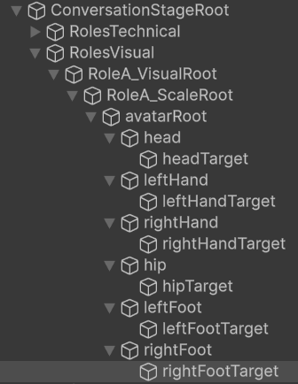
Where it is used:
AvatarCalibrationController is initialized in ConversationStage with the roles (List of RoleRig). The methods are called in CalibrationState.
It is attached to the empty GameObject „ConversationStageRoot“ where there is also the script „ConversationStage.cs“.

RoleRigUpdatePipeline
Task:
makes sure that update of the Avatar transforms is done after the update of the visualRig transforms. TechnicalRig -> VisualRig -> AvatarRig
Where it is used:
RoleRigUpdatePipeline is attached to ConversationStage/Roles/RoleA RoleB RoleC etc...

https://app.diagrams.net

