147-148 moving to SQL Database using Docker

download Docker desktop: https://www.docker.com/get-started/

Im Terminal eingeben:

docker run -p 3307:3306 --name studiostatedb -e MYSQL_ROOT_PASSWORD=root -e MYSQL_DATABASE=studiostate -v C:\Users\berto\Documents\Workspaces\react_tutorial\studiostate-data:/var/lib/mysql -d mysql

--name ..., MYSQL_DATABASE = ... und den Pfad C:\Users\berto\Documents\Workspaces\react_tutorial\studiostate-data: anpassen.

Sqlelectron braucht man, um die Datenbank zu befüllen.
Download sqlelectron.
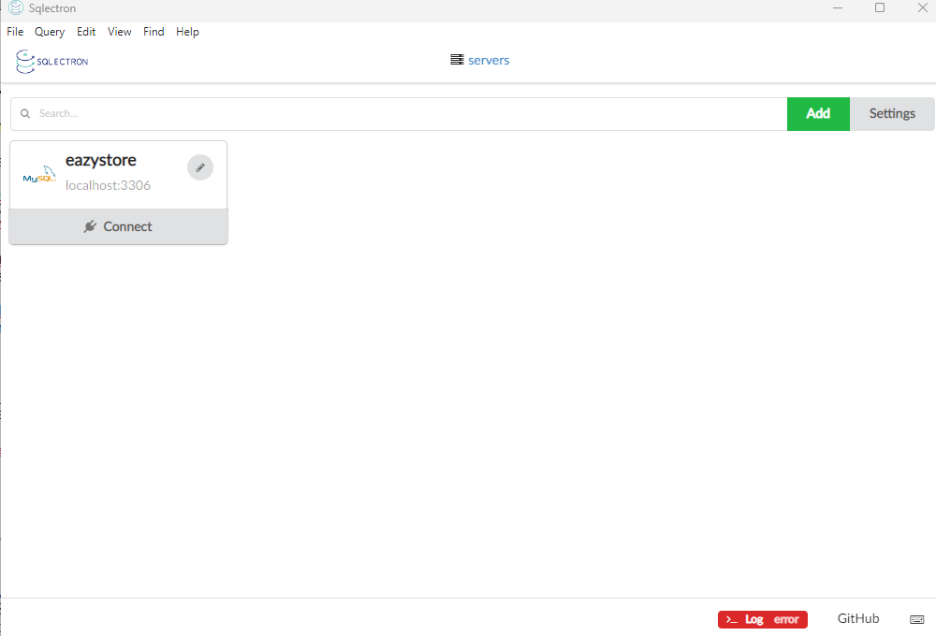
Click add:
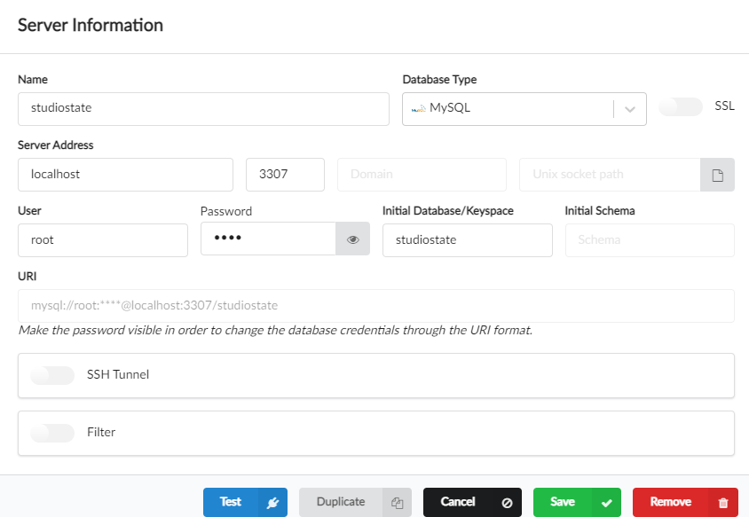
Dann save

Anschliessend kann man das Schema einfügen und die Daten in sqlelectron einfügen.

SQL Driver hinzufügen:
https://start.spring.io/, „ADD DEPENCENCIES“ -> my sql driver -> explore -> das folgende kopieren und in der pom.xml einfügen:

<dependency>
<groupId>com.mysql</groupId>
<artifactId>mysql-connector-j</artifactId>
<scope>runtime</scope>
</dependency>

maven aktualsieren. -> dependencies runterladen

die application.properties von h2 daten bank auf mysql umstellen:

spring.datasource.url=jdbc:mysql://${DATABASE_HOST:localhost}:${DATABASE_PORT:3307}/${DATABASE_NAME:studiostate}
spring.datasource.username=${DATABASE_USERNAME:root}
spring.datasource.password=${DATABASE_PASSWORD:root}
spring.jpa.show-sql=${JPA_SHOW_URL:true}
spring.jpa.properties.hibernate.format_sql=${HIBERNATE_FORMAT_SQL:true}

dann sollte alles von der mysql datenbank geladen werden.

149. Single page website
Die Seite lädt nur am Anfang (verbindet sich mit dem Server) nachher wird über routing -> react library jeweils die entsprechende Komponente gerendert. Das erfordert keine Verbindung zum Server mehr.

React router intstallieren
im terminal: npm install react-router-dom

Dann müssen die Mappings definiert werden. Man muss der App sagen, bei welcher Aktion des Users, welche Komponente gerendert werden soll. Das wird bei Vite-Projekten in der main.jsx Datei gemacht.

import { createBrowserRouter, RouterProvider } from "react-router-dom";

const appRouter = createBrowserRouter([
{
path: "/",
element: <App />,
},
{
path: "/about",
element: <About />,
}
]);

createRoot(document.getElementById("root")).render(
<StrictMode>
<RouterProvider router={appRouter}/>
</StrictMode>
);

bei path „/“ wird element „App“ geladen

163. Feedback über Erfolg bei Daten übermittlung
showing toast messages
npm i react-toastify

-> in main.jsx (damit es überall abrufbar ist)

import { ToastContainer, Bounce } from "react-toastify";
import "react-toastify/dist/ReactToastify.css";

->
createRoot(document.getElementById("root")).render(
<StrictMode>
<RouterProvider router={appRouter} />
<ToastContainer
position="top-center"
autoClose={3000}
hideProgressBar={false}
newestOnTop={false}
draggable
pauseOnHover
theme={localStorage.getItem("theme") === "dark" ? "dark" : "light"}
transition={Bounce}
/>
</StrictMode>,
);

in Contact.jsx

import { toast } from "react-toastify";

useEffect(() => {
if (actionData?.success) {
formRef.current?.reset();
toast.success("Your message has been submitted successfully");
}
}, [actionData]);

165. Dynamic Routes
in ProductCard.jsx

add:
import { Link } from "react-router-dom";

change:
export default function ProductCard({ product }) {
return (
<div className= ...
</div>

to:

<Link
to={`/products/${product.productId}`}
className=" ...> ...
</Link>

create: ProductDetail.jsx

in main.jsx: import ProductDetail from "./components/ProductDetail.jsx";

and add this line:
<Route path="/products/:productId" element={<ProductDetail />} />

166. enhancing the productDetail.jsx

in ProductCard.jsx

add:
return (
<Link
to={`/products/${product.productId}`}
state={{ product }} //hier geben wir die Daten weiter an ProductDetail
className=

in ProductDetail.jsx

add: import { useParams, useLocation } from "react-router-dom";

and:
const location = useLocation();
const product = location.state?.product;

169. avoiding manual restarts

start.spring.io -> add dependencies -> Spring Boot DevTools
add to pom.xml
then server starts much quicker as it only replaces bits, that were changed. In intellij got to settings -> type hot in search field --> click suggest HotSwaps in the editor when code is modified -> reload classes after compilation ->always

173-177. Mapping HTTP Requests

Check section 11 backend: controller/DummyController

@PostMapping("/create-user")
public String createUser(@RequestBody UserDto userDto){
System.out.println(userDto);
return "User created successfully";
}

in Postman: POST: http://localhost:8080/api/v1/dummy/create-user
and in raw json Body: {
"name": "Bertold"
}

leads to Print in Console:
UserDto(userId=null, name=Bertold, email=null, mobileNumber=null)
-------------------------------------------

@GetMapping("/search")
public String searchUser(@RequestParam(required = false, defaultValue = "Guest") String name){
return "Searching for user: " + name;
}
in Postman: GET: http://localhost:8080/api/v1/dummy/search?name=Madan

returns: 'Searching for user: Madan' in Postman.

178. Sending ResponseEntity:

see section11-> backend -> ContactController:

@PostMapping
public ResponseEntity<String> saveContacts(
@RequestBody ContactRequestDto contactRequestDto) {
boolean isSaved = iContactService.saveContact(contactRequestDto);
if(isSaved){
return ResponseEntity.status(HttpStatus.CREATED)
.body("Request processed successfully");
}else{
return ResponseEntity.status(HttpStatus.INTERNAL_SERVER_ERROR)
.body("An error occurred. Please try again or contact Dev team");
}
}
179. GlobalExceptionHandling

->new package -> „exception“ -> new Java Class -> „GlobalExceptionHandler.java“

@RestControllerAdvice
public class GlobalExceptionHandler {
@ExceptionHandler(Exception.class)
public ResponseEntity<ErrorResponseDto> handleGlobalException(Exception exception, WebRequest webRequest){
ErrorResponseDto errorResponseDto = new ErrorResponseDto(
webRequest.getDescription(false), HttpStatus.INTERNAL_SERVER_ERROR, exception.getMessage(),
LocalDateTime.now()
);
return ResponseEntity.status(HttpStatus.INTERNAL_SERVER_ERROR).body(errorResponseDto);
}
}
-> dann kann man die try and catch blocks au sen ServiceImplementations entfernen.
-> wenn man einen weiteren @ExceotionHandler(Exception.class) im Controller einfügen würde, dann würde der den global ExceptionHandler überschreiben.

