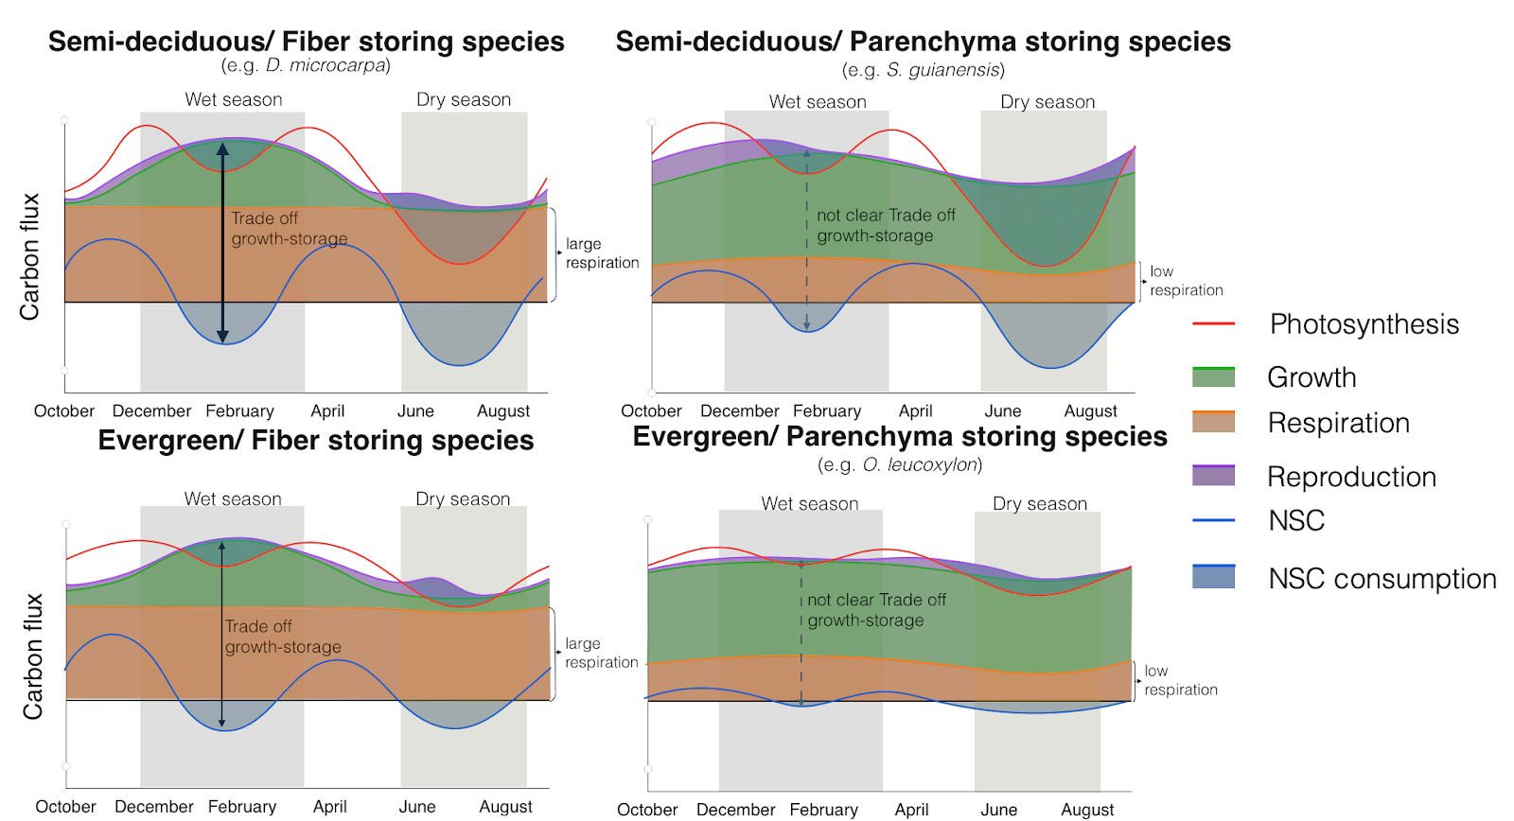

**Figure 1:** Conceptual framework that relates the differences in carbon dynamics for trees with different combinations of two functional traits: leaf habit and storage strategy of starch in the stem wood. Here we show the seasonal behavior of carbon sources - photosynthesis (red line)- and carbon sinks - growth (green), respiration (orange), and reproduction (purple) - and their interactions with NSC storage or consumption (blue line). Expected trade-offs between growth and storage are indicated by black arrows and the thickness of the line indicates the strength of the trade-off. Thus, thicker and darker lines indicate strong trade-offs, and dashed and lighter lines indicate weaker or less clear trade-offs. The seasonal patterns of photosynthesis are taken from the phenological observations of leaves reported in Fig. S2.

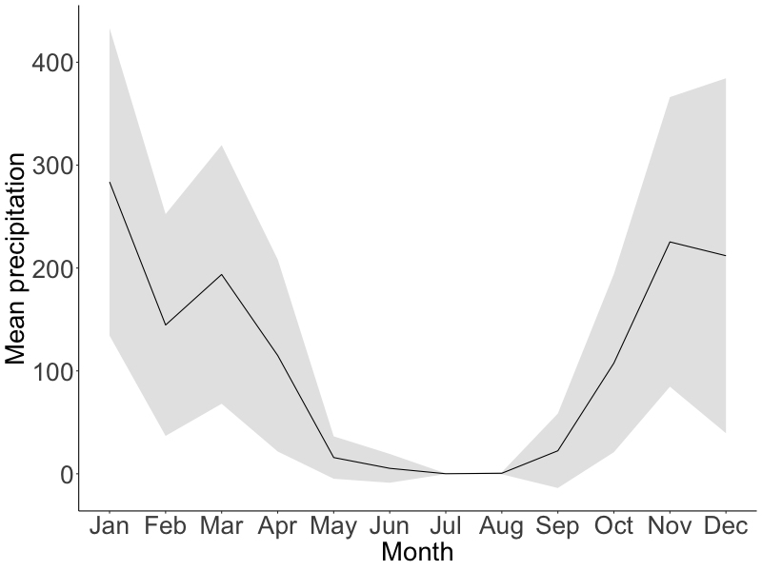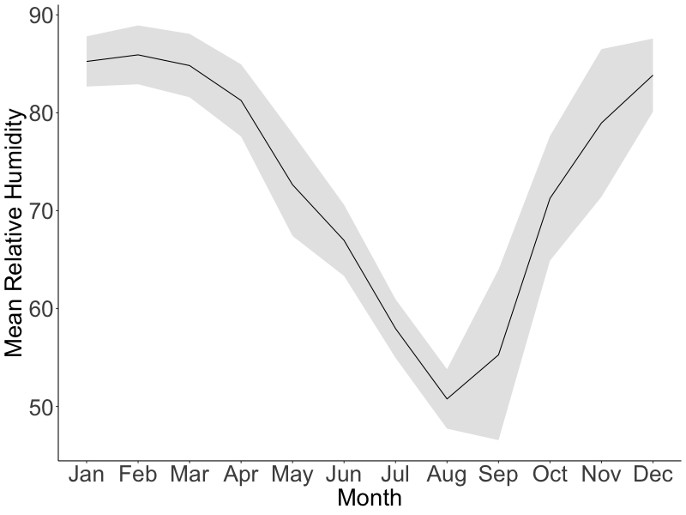

**Figure 2:** Mean seasonal course of monthly total precipitation (mm) and relative humidity (%) during 2016-2020 (black lines). Gray areas correspond to the standard deviation. Data provided by IPAM.

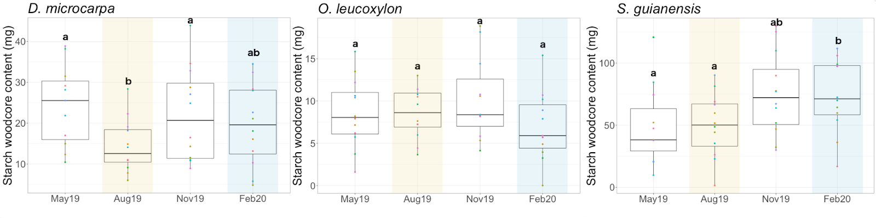

**Figure 3:** Box-plots that show the dispersion of the starch mass measured in the wood cores from trees of each evaluated species at different times/seasons during 2019. The yellow shaded area corresponds to the dry season, while the blue shaded areas correspond to the wet season. Differences between groups are indicated by different letters (with 95% confidence) above the box-plots and show the observed seasonality of starch mass in stem wood.

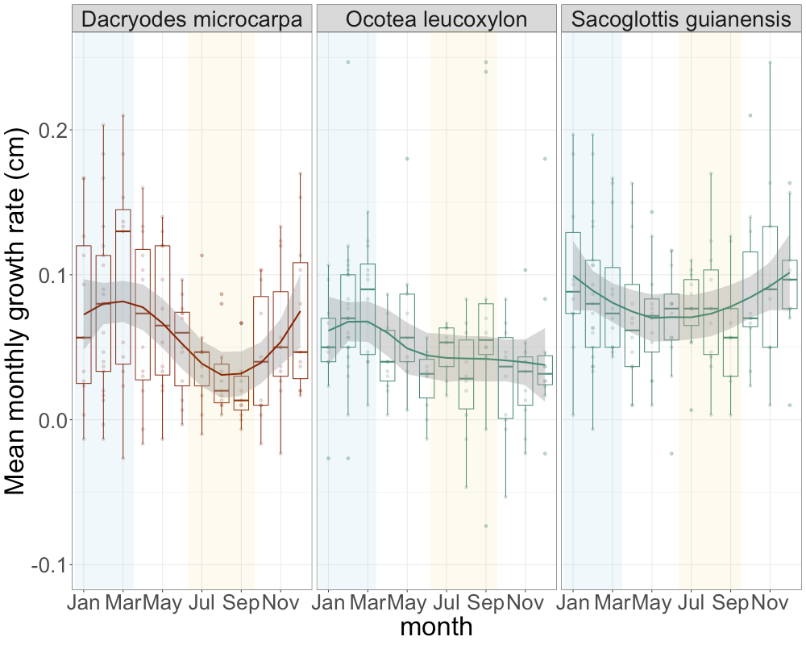

**Figure 4:** Seasonal trend of growth rates for the three species evaluated. Solid lines show the smoothing trends, while the dispersion of the measurements is shown by box-plots. The lines inside the box-plots show the median of the distribution of the measurements. Yellow shaded areas indicate the dry season and blue shaded areas indicate the wet season.

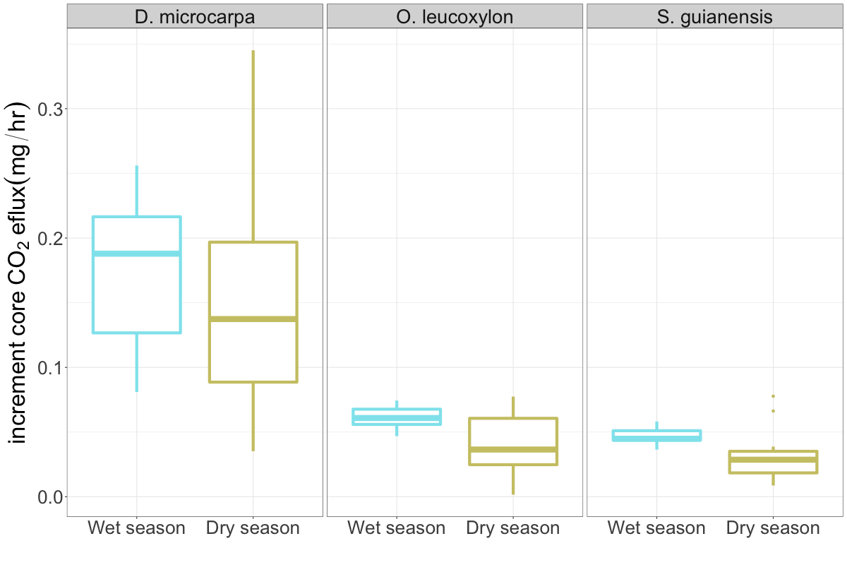

**Figure 5:** Box-plots showing the dispersion of the measured CO2 efflux from the stem core of the studied trees during the wet and the dry seasons of 2018, for each species. There were no significant differences between the wet and dry seasons for any species.

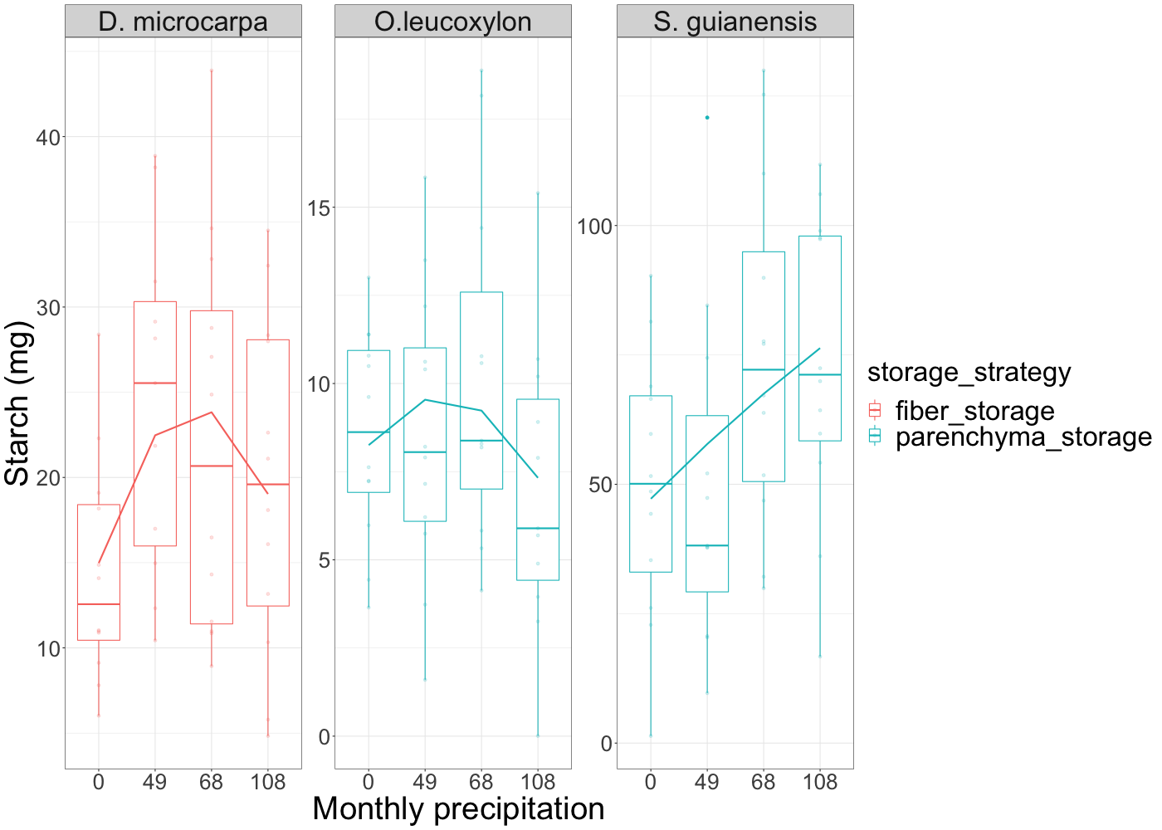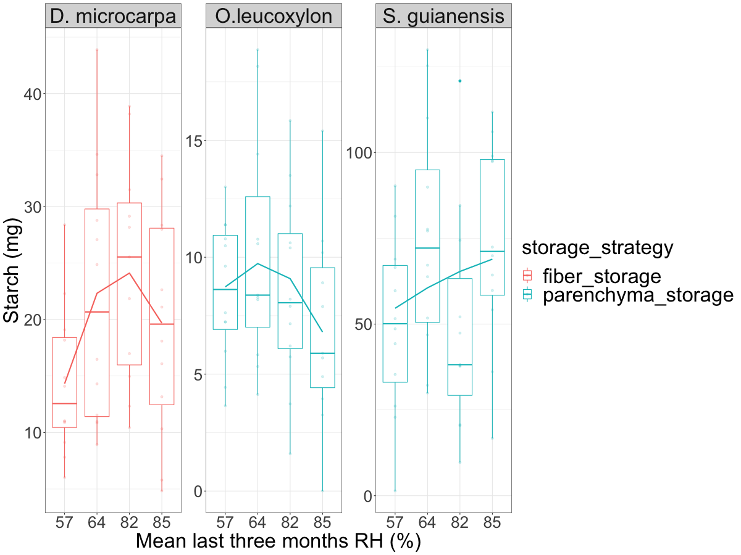

**Figure 6:** Box-plots showing the dispersion of the estimated starch mass in the wood of the selected trees and its changes with respect to 4 levels of monthly precipitation and the three months average relative humidity. The continuous lines in each plot show the general trend between the groups.

**Figure 7:** Relationship between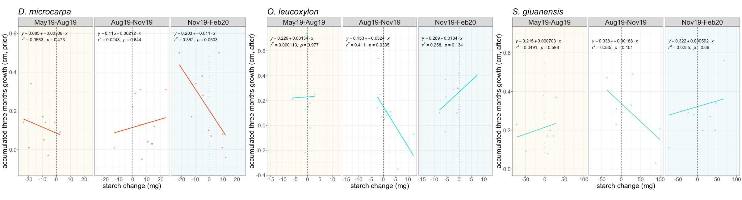 changes in starch mass (accumulation or consumption of starch) and three-month growth in 2019 for the three species studied. The dotted line marks the 0, points on the left indicate starch consumption and those on the right indicate scratch accumulation. The dry season is indicated by shaded yellow areas, while the wet season is indicated by shaded blue areas.

*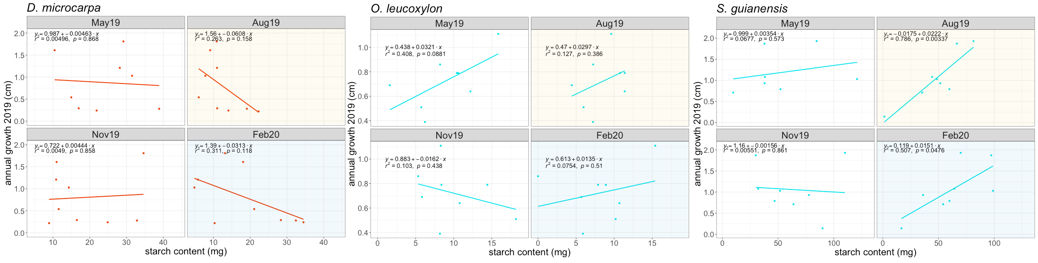****Figure 8:*** *Relationship between annual growth and the starch content at different times of the year for each of the species studied. The yellow shaded panels correspond to the dry season, while the blue shaded panels correspond to the wet season.*