Starch storage strategy in the stem wood influences carbon dynamics and storage-growth trade-offs in tropical trees

David Herrera-Ramírez1*, Henrik Hartmann1, Christine Römermann2,3, Susan Trumbore1, Jan Muhr1, 4, Leonardo Maracahipes-Santos7, Paulo Brando5, 6,7, Divino Silvério8, Huang Jianbei1, Iris Kuhlmann1 and Carlos A. Sierra1

1Max Planck Institute for Biogeochemistry, Hans-Knöll-Str 10, 07745 Jena

2Friedrich Schiller University Jena, Institute for Ecology and Evolution, Philosophenweg 16, 07743, Jena, Germany

3German Centre for Integrative Biodiversity Research (iDiv) Halle-Jena-Leipzig, D- 04103 Leipzig

4Georg August University Göttingen, Department of Bioclimatology, Büsgenweg 2, 37077 Göttingen, Germany

5Department of Earth System Science, University of California, Irvine, CA 92697, USA

6Yale School of the Environment, Yale University, New Haven, CT, United States.

7Instituto de Pesquisa Ambiental da Amazônia, Brasília, DF 70863-520, Brazil

8Department of Biology, Universidade Federal Rural da Amazônia-UFRA, Capitāo Poço 68650-000, Pará, Brazil

**Abstract**

1. Trees balance their carbon source and carbon sink activity over different time scales by accumulating and using non-structural carbon (NSC). The amount and distribution of NSC stored in stemwood influences trees’ ability to balance carbon sources and sinks, and impacts the tree survival and recovery from multiple disturbances. Thus, the strategy to store starch in the stemwood may influence the carbon dynamics of mature trees and may be reflected in the strength of storage-growth trade-offs.
2. In this work, we hypothesized that combining two life history traits, such as storage strategy of starch in the stem wood (parenchyma-storage and fiber-storage) and leaf habit (evergreen and semi-deciduous), would allow us to explain differences in the seasonal interplay between carbon sources and sinks and the use and accumulation of NSC. Thus, we expected semi-deciduous/fiber-storing species to have greater seasonality in NSC and carbon sink activity and stronger storage-growth trade-offs than parenchyma-storing species.
3. We measured monthly growth rates, soluble sugars and starch every three months during 2019 in *Dacryodes microcarpa* (semi-deciduous/fiber-storing-species), *Ocotea leucoxylon* (evergreen/parenchyma-storing-species), and *Sacoglottis guianensis* (semi-deciduous/parenchyma-storing-species).
4. We found seasonal changes in NSC content in the semi-deciduous species, but they were stronger in the fiber-storing species. This fiber-storing species had large storage capacity and stem respiration, and also showed a negative relationship between starch consumption/accumulation and growth during the rainy season, suggesting a clear trade-off between growth and storage, where starch is accumulated in some cases at the expense of growth.
5. **Synthesis:** Our results show the influence of starch storage strategy on carbon dynamics in tropical trees. They suggest that deciduous/fiber-storing species have larger plasticity of carbon sinks activity and larger prioritization of NSC storage, resulting in long-lived trees with lower mortality rates with respect to parenchyma-storing species. These results help us to better understand carbon dynamics in tropical trees and allow us to explain how storage strategies may influence survival and life span of tropical trees. Ultimately, our results provide insights into how vulnerable tropical trees may be to future compounding perturbations associated with climatic changes.
6. **Introduction**

Trees assimilate CO2 via photosynthesis to produce non-structural carbon (NSC), which consists mainly of soluble sugars, starch and lipids. Sugars are transported to all tree organs to fuel metabolism and growth, and locally accumulated as starch and lipids to provide energy reserves on different time scales, e.g., daily, seasonal or interannual (Chapin et al., 1990; Richardson et al., 2013). Seasonal changes in the NSC content in different tree organs reflect imbalances between carbon sources (e.g., photosynthesis) and sinks (e.g., growth and respiration) (Kozlowski, 1992; Körner, 2003), and can indicate the use of stored carbon to fuel different vital metabolic functions in order to survive multiple disturbances, such as dry and hot conditions, blowdowns, and droughts (Hartmann and Trumbore, 2016). Understanding how trees accumulate and use their NSC in key organs such as stem wood in order to balance carbon sources and sinks will improve our understanding about how trees maintain their metabolism under stress.

Stem wood plays a central role in NSC dynamics and long term storage in adult trees (Arx et al., 2017; Furze et al., 2018, 2020; Herrera-Ramírez et al., 2021). It is not only the largest reservoir of NSC in trees, but it is also the main transport route of NSC and water between tree organs (Plavcová et al., 2016; Furze et al., 2018). Wood anatomical traits can influence the way trees access or accumulate carbon reserves (Barbaroux and Bréda, 2002; Furze et al., 2020; Herrera-Ramírez et al., 2021). For instance, in temperate trees, wood anatomical traits such as vessel distribution constrain not only the NSC distribution in wood, but also its seasonal dynamics (Barbaroux and Bréda, 2002; Michelot et al., 2012; Furze et al., 2020). Other traits such as the formation of living fibers in the stem wood, the abundance and size of parenchyma cells, and their longevity may also influence the seasonal response of NSC and tree survival (Arx et al., 2017; Herrera-Ramírez et al., 2021). Understanding how wood traits are related to NSC dynamics will improve our mechanistic understanding about how trees regulate carbon storage to increase competitiveness and/or survival.

Non-structural carbon storage dynamics can be controlled by physiological processes related to carbon source or sink activity under the influence of environmental conditions (Würth et al., 2005; Palacio et al., 2014; O’Brien et al., 2015, 2020; Resco de Dios and Gessler, 2021). However, NSC storage processes can be up-regulated by increased gene expression, so that reserve formation competes with other carbon sinks (Wiley and Helliker, 2012; Martínez-Vilalta, 2014; Huang et al., 2021). This may allow trees to maintain carbon stores that enable them to face future compounding perturbations (Sala et al., 2012; Dietze et al., 2014; Resco de Dios and Gessler, 2021). Storage up-regulation may be species specific (Poorter and Kitajima, 2007) and likely greater in species that store NSC for long periods of time (Blumstein et al., 2022). A large amount of living cells used for NSC storage (e.g., species with living fibers and parenchyma) may indicate a high prioritization of storage formation, which may compete with other carbon sinks like growth and respiration (Plavcová et al., 2016; Herrera-Ramírez et al., 2021). We hypothesize that trees with larger plasticity in storage and sink activity may be better adapted to stressful conditions that severely reduce photosynthesis or increase carbon demand, because they may be more tolerant to a wider range of environmental conditions. Thus, we wanted to test whether life history traits such as the strategy to store starch in the stem wood are related to storage dynamics and plasticity of carbon sink activity in trees experiencing multiple disturbances in a tropical forest.

Regulation of storage and sink activity results in trade-offs between NSC storage and some important carbon sinks such as growth, respiration and defense compounds (Poorter and Kitajima, 2007). These trade-offs may indicate different plant survival strategies, ranging from long-lived species that may prioritize NSC storage at the expense of growth to ensure future survival, to short-lived species that invest into fast growth while storing less NSC (Wright et al., 2004; O’Brien et al., 2014; Blumstein et al., 2022). Trade-offs between NSC storage, growth and defense have been observed in some temperate species. For example, studies have shown that NSC may be prioritized over growth under various stressful conditions such as defoliation, drought and low atmospheric CO2 concentrations (Anderegg et al., 2012; Hartmann et al., 2015; Piper et al., 2015; Wiley et al., 2017; Huang et al., 2019; Piper and Paula, 2020). Allocation to defense compounds have been reduced to maintain the minimum operational NSC storage required for survival under shade and low CO2 (Huang et al., 2019; Huang et al., 2020). However, NSC can also be accumulated to build defenses in the future and therefore such trade-offs may not be immediate and may exhibit time lags. Thus, in many instances, trade-offs are not clear. In some cases, identifying growth-storage trade-offs can be difficult due to the variability in carbon assimilation or by other competing carbon sinks such as respiration and reproduction (Wiley and Helliker, 2012; Huang et al., 2019; Blumstein et al., 2022). For example, as carbon supply increases, both growth rate and NSC content may increase, masking the trade-offs between the two competing sinks (Huang et. al., 2019; Blumstein et al., 2022). Therefore, alternative ways to quantify these trade-offs are needed to better understand carbon dynamics in mature trees. Furthermore, investigating the relationship between these trade-offs and storage strategies will help us to identify the influence of storage strategies on carbon dynamics in mature trees and their relationship to tree survival and recovery from multiple disturbances in seasonally dry tropical forests.

In this context, here we aim to understand how life history traits such as storage strategy (fiber-storage and parenchyma-storage, Herrera-Ramirez et al., 2021) and leaf habit (evergreen and semi-deciduous) influence the seasonal carbon dynamics of trees in response to seasonal changes in precipitation and relative humidity, and the potential consequences for tree survival. We used leaf habit as a proxy for carbon source variation throughout the year. We chose three tree species and divided them into three functional groups (Fig. 1). Each of these groups is expected to have different seasonal dynamics in stem wood NSC, responding to different imbalances between carbon sources and sinks. These species were selected because they represent well the combinations between the considered life history traits (starch storage strategy in wood, leaf habit, mortality and growth), as estimated in Herrera-Ramírez et al., (2021). Based on this conceptual framework, we expect that: i) semi-deciduous/fiber-storing species would have larger seasonal changes in NSC due to a greater seasonal variation in photosynthesis, greater demand for carbon for respiration and a greater plasticity in growth rates than the other functional groups; ii) an increase in carbon sink activity during the wet season will lead to consumption of NSC reserves and therefore NSC storage-growth trade-offs would occur during this season; and iii) NSC storage-growth trade-offs would differ between functional groups. Thus, fiber-storing species would show a negative correlation between growth and storage during the wet season due to strong seasonality in growth rates, whereas parenchyma-storing species would not show a strong negative correlation between growth and storage.

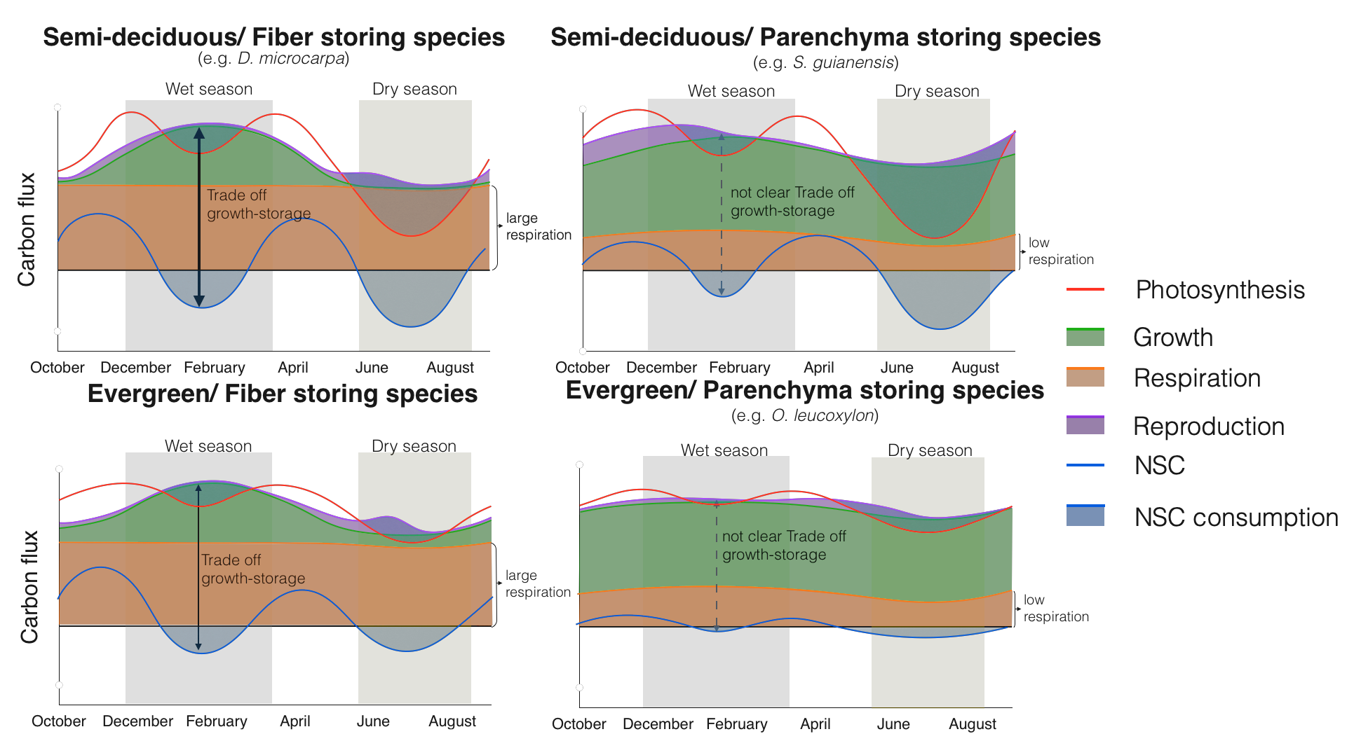

**Figure 1:** Conceptual framework that relates the differences in carbon dynamics for trees with different combinations of two functional traits: leaf habit and storage strategy of starch in the stem wood. Here we show the seasonal behavior of carbon sources - photosynthesis (red line)- and carbon sinks - growth (green), respiration (orange), and reproduction (purple) - and their interactions with NSC storage or consumption (blue line). Expected trade-offs between growth and storage are indicated by black arrows and the thickness of the line indicates the strength of the trade-off. Thus, thicker and darker lines indicate strong trade-offs, and dashed and lighter lines indicate weaker or less clear trade-offs. The seasonal patterns of photosynthesis are taken from the phenological observations of leaves reported in Fig. S2.

# Methods

# 2.1. Site description

This study was conducted in a transitional forest between the Amazon rainforest and the Cerrado, located at Tanguro Ranch, Mato Grosso, Brazil. It is a seasonally dry forest with mean annual precipitation of 1770 mm distributed between the dry season (May to September) with less than 10 mm of precipitation per month and a wet season (October to April) with a mean precipitation of 150 mm per month (Fig. 2). Relative humidity follows a similar seasonal pattern, falling below 60% from June to September and above 80% from December to February (Fig. 2). The mean temperature is 25˚C with almost no seasonal variation throughout the year (data obtained from the local station at Tanguro Ranch, operated by the Instituto de Pesquisa Ambiental da Amazônia, IPAM).

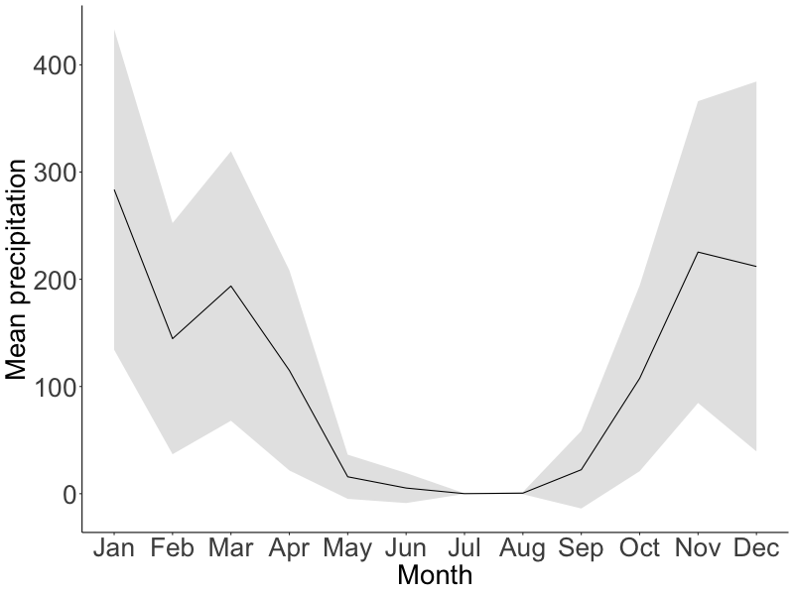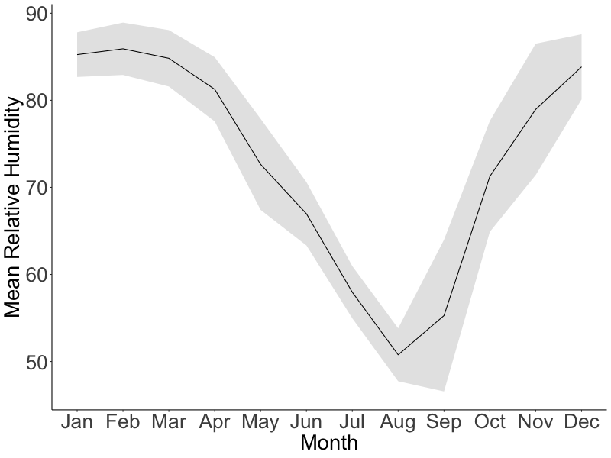

**Figure 2:** Mean seasonal course of monthly total precipitation (mm) and relative humidity (%) during 2016-2020 (black lines). Gray areas correspond to the standard deviation. Data provided by IPAM.

## 2.2. Species description

We selected three tree species previously shown to have contrasting starch storage strategies in wood, parenchyma-storing species and fiber-storing species (Herrera-Ramírez et al., 2021), different leaf habits (evergreen or semi-deciduous), and different growth and mortality rates (Table 1). From each tree species we chose 12 mature and healthy trees reaching the canopy with a diameter at breast height (at 1.3 m, dbh) bigger than 20 cm (Table 1).

**Table 1**: Species names and traits: wood storage strategy, growth rates, mortality rates, phenology, and the sampling dates.

|  |  |  |  |  |
| --- | --- | --- | --- | --- |
| Species name | Growth rate  (cm/year) | Mortality rate   (%/year) | Storage strategy | Leaf phenology  (~% of leaf loss) |
| *Ocotea leucoxylon* (Sw.) Laness | 0.295 | 5.7 | Parenchyma | Evergreen (~30) |
| *Sacoglottis guianensis* Benth. | 0.72 | 5.0 | Parenchyma | Semi-deciduous (~45) |
| *Dacryodes microcarpa* Cuart. | 0.078 | 1.6 | Fiber | Semi-deciduous (~60) |

## 2.3. Sampling strategy

We sampled the selected 36 trees every three months from May 2019 to February 2020, specifically in May 2019 (transition from wet to dry season), August 2019 (dry season), November 2019 (transition from dry to wet season), and February 2020 (wet season). During each field campaign we took two wood cores (~ 5mm diameter and 20 cm long) approximately 10 cm away from the last collection point. We used one wood core to quantify starch distribution along the radial axis from bark to pith using the histological quantification method described in Herrera-Ramírez et al. (2021). The second wood core was used to incubate CO2 and estimate wood respiration rates.

## 2.4. NSC seasonality

To quantify the starch concentration using the histological method we took 30 m thick slices and mounted them on a glass slide with glycerol. The wood surface was covered with Lugol’s iodine solution for 3 minutes to stain starch grains and then covered with a coverslip. The stained samples were photographed using an optical digital microscope with a large depth-of-field (Keyence, VHX-6000, USA) within 3 hours. Panoramic images of the sample were taken at 300x magnification.

We quantified the percentage of starch in the samples by repeatedly measuring the areal percentage of starch coverage for each 1 mm2 area over the wood surface using the Image J software (Schneider et al., 2012). We divided the images into radial increments of 5 mm from bark to pith to measure the radial distribution of starch in the wood core. We measured starch in all 5 mm-increment sections until no starch was found in the wood. While doing so, we also manually eliminated artifacts from the images that may have interfered with the quantification. After preparing the images, we ran an automatic script for identifying and quantifying starch grains in multiple 1 mm2 regions of interest (ROI), randomly selected along the images (see supplementary material Methods S2 in Herrera-Ramírez et al. (2021) for details). After identifying all starch grains in a ROI, the script calculates the percentage of the surface area covered by starch. We measured 50 ROIs in each image of 5 mm segments of the stem increment core. We took the average of these 50 ROI measurements as an estimate of the percentage of starch for each of the 5 mm sections of the increment core in each of the 12 trees per species. Measurements of the areal percentage covered by starch closely approximate the concentration of starch per gram of dry wood (Herrera-Ramírez et al., 2021). Finally, we estimated the mass of starch per wood core by integrating the starch mass per 5 mm segment based on wood density, segment volume, and the measured percentage of starch per unit of volume along the radial path of the wood core. We estimated the seasonal changes in the starch content by estimating the change in the starch mass between two consecutive sampling periods: thus the starch change for the dry season June-August 2019 (Aug19) was the change in estimated mass between May 2019 and August 2019; for the transition between dry and wet season September to November 2019 (Nov19) was the change between Augusts 2019 and November 2019; and the starch change in the wet season December 2019 to February 2020 was taken from the difference in mass between November 2019 and February 2020

To measure the concentration of soluble sugars, with a chemical method (Landhäusser et al., 2018), we segmented the wood core in two depth ranges: 0-2 cm and 2-4 cm. These measurements were made only for 5 individuals per species and for samples taken in January and July 2018. In order to quantify soluble sugars, we followed the protocol “*S1*" described in Landhäusser et al. (2018). Each wood core segment was ground to a fine powder using a ball mill (Retsch MM 400, Haan, Germany) at 25 Hz for 30 seconds and dried at 60 °C overnight. We weighed 50 mg of wood powder and mixed it with 1.5 ml of 80 % ethanol for 10 minutes at 90 ˚C in order to extract the soluble sugars. After cooling to room temperature, the samples were centrifuged at 13000 g for 2 minutes. The supernatant was recovered in a new vial, diluted, filtered, and then used for measuring three specific sugars (sucrose, fructose and glucose) by HPAE-PAD. For quality control we used blanks, standard solutions with known concentration of glucose, fructose and sucrose and internal standards made of a mix of tree leaf and branch samples as detailed in the protocol “*S3*" of Landhäusser et al. (2018). We estimated the average concentration of soluble sugars per wood core and compared between time points.

## 2.5. Sink activity measurements

We measured monthly stem growth with manual dendrometer bands (D1, Labcell Ltd, UK). These dendrometers were installed at breast height for each tree in July 2018, and measurements were collected monthly (by manually reading) until July 2020. We used three month moving averages of growth rates, which we calculated to reduce the effect of water dynamics in our growth data, capturing the average intra-annual radial growth variations (Zweifel et al., 2006, 2016). From these data we calculated annual growth for each tree during 2019 and compared it with the mean annual starch mass and the changes in the starch mass every three months. We also estimated seasonal growth, summing the monthly growth from the three months before each collection date and correlated this with the estimated starch mass and the starch change between seasons.

We measured wood respiration during the wet season (May) and the dry season (August) of 2019 by incubation of stem cores taken from each tree for a period of 36 hours following collection. The wood cores were cut at the depth in the stem we had previously identified where starch is depleted (6 cm for *O. leucoxylon*, 8 cm for *D. microcarpa* and 12 cm for *S. guianensis*). The cores were sealed in cylindrical chambers and incubated in parallel for 36 hours at ambient temperature (~25C˚). The produced CO2 was collected in custom made glass flasks. We purified the total amount of collected CO2 volumetrically after cryogenic separation on a vacuum line, and the total sample volume by measuring the pressure at room temperature. Flask volumes were calculated individually by filling with water and weighing. Then we calculated the respiration rate for each sample by dividing the total amount of collected CO2 (in mg C) by the incubation time and wood volume of the incubated core segment.

We monitored other seasonal carbon sink activities by observing leaf, flower and fruit phenology patterns, using observations made for each species at this location over the last 8 years. The percentage of crown coverage of young leaves, mature leaves, flowers and fruits have been recorded monthly from selected species. The patterns were classified in 5 categories (0, 25, 50, 75 and 100%). We used these data to estimate seasonal changes in the phenological data by fitting a smoothing spline model to the monthly data.

## 2.6. Data analysis

We used a Wilcoxon rank test with paired samples to compare starch content and growth between measurement dates. We used ANOVA and Wilcoxon tests to compare starch content between species, storage strategies and leaf habits. We estimated the effect of environmental variables such as precipitation and relative humidity on the starch mass variability by evaluating differences between the group of trees measured at different values of the climatic variables. We compared growth with the estimated starch mass and starch changes between seasons using linear regression models. We used R version 3.6.1 for all calculations.

# Results

## 3.1. Seasonality of NSC mass, growth and respiration

Starch and soluble sugar concentrations decreased radially across the sapwood from bark to pith for all species for all sampling dates. The soluble sugars concentration was always very low (up to 2 %) for all species and we did not find significant differences between the wet and dry season of 2018 (Fig. S1). Therefore, they were not measured for 2019.

We found significant differences in starch mass between sampling dates for semi-deciduous species *D. microcarpa* and *S. guianensis*, while the evergreen species *O. leucoxylon* did not show significant changes in starch mass in the stem wood during 2019. Furthermore, the effect of storage strategy on the starch dynamics was significant (*p = 0.055*). Seasonal changes in starch mass were stronger for the fiber-storing species *D. microcarpa* (*p*=0.009) than in the parenchyma-storing species *S. guianensis* (*p* = 0.059, Fig. 3). For both species the lowest starch mass was found during the dry season (August 2019) while the starch mass was higher in February 2020 for *S. guianensis* and in May 2019 for *D. microcarpa* (Fig. 3).

Seasonality in growth rates during 2019 were only significant for the fiber-storing species *D. microcarpa*. These trees grew slower during the dry season and faster during the wet season (Fig. 4). The two parenchyma-storing species did not show a clear seasonal pattern, although a slight decrease in growth rates during the dry season can be noticed (Fig. 4).

Wood respiration was higher in the fiber-storing species *D. microcarpa* (*p<0.01*) than in the parenchyma-storing species *S. guianensis* and *O. leucoxylon*. Nevertheless, the differences between wet and dry season in 2019 were not statistically significant for any of the species (Fig. 5).

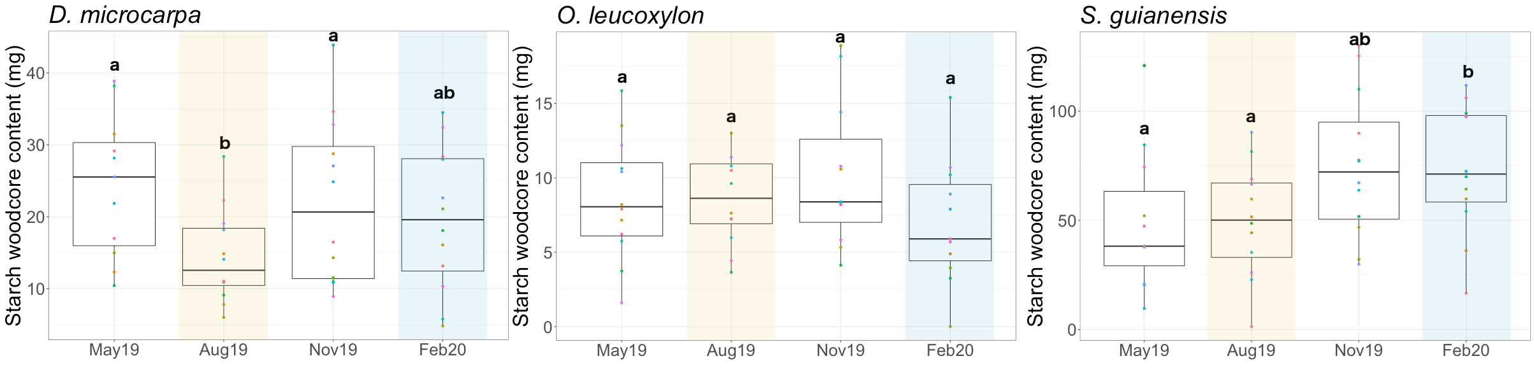

**Figure 3:** Box-plots that show the dispersion of the starch mass measured in the wood cores from trees of each evaluated species at different times/seasons during 2019. The yellow shaded area corresponds to the dry season, while the blue shaded areas correspond to the wet season. Differences between groups are indicated by different letters (with 95% confidence) above the box-plots and show the observed seasonality of starch mass in stem wood.

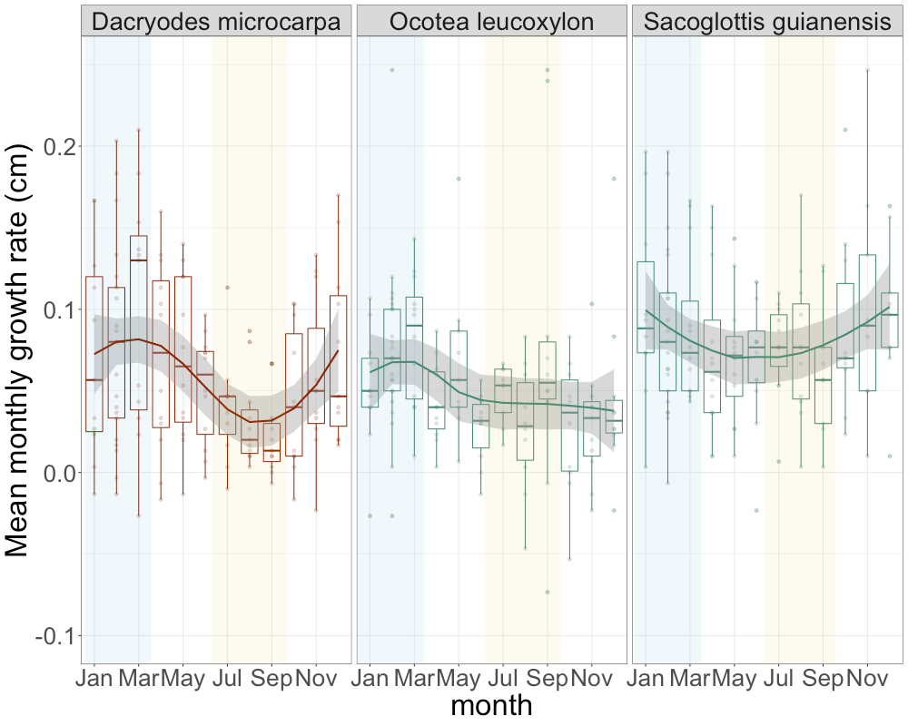

**Figure 4:** Seasonal trend of growth rates for the three species evaluated. Solid lines show the smoothing trends, while the dispersion of the measurements is shown by box-plots. The horizontal lines inside the box-plots show the median of the distribution of the measurements. Yellow shaded areas indicate the dry season and blue shaded areas indicate the wet season.

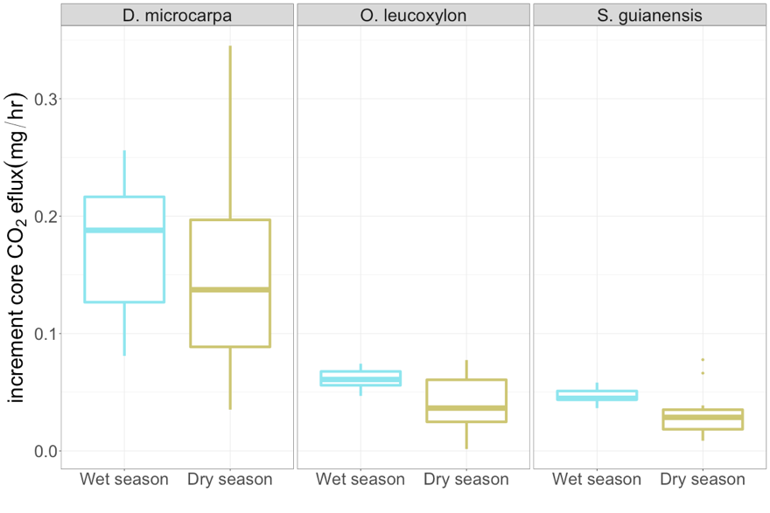

**Figure 5:** Box-plots showing the dispersion of the measured CO2 efflux from the stem core of the studied trees during the wet and the dry seasons of 2018, for each species. There were no significant differences between the wet and dry seasons for any species.

## 3.2. Relationship between NSC, precipitation and relative humidity

We observed a parabolic trend (inverted-U shape) between precipitation and relative humidity and starch mass in the fiber-storing species (*D. microcarpa*) where starch was greatest at moderate levels of both environmental variables (Fig. 6). In contrast, we observed a linear positive trend between starch mass and monthly precipitation for *S. guianensis* trees (Fig. 6a). Nevertheless, when considering three months of accumulated precipitation the trend between starch content and precipitation also becomes parabolic. For *O. leucoxylon*, there was also a slight parabolic trend in starch content with respect to precipitation and relative humidity (Fig. 6).

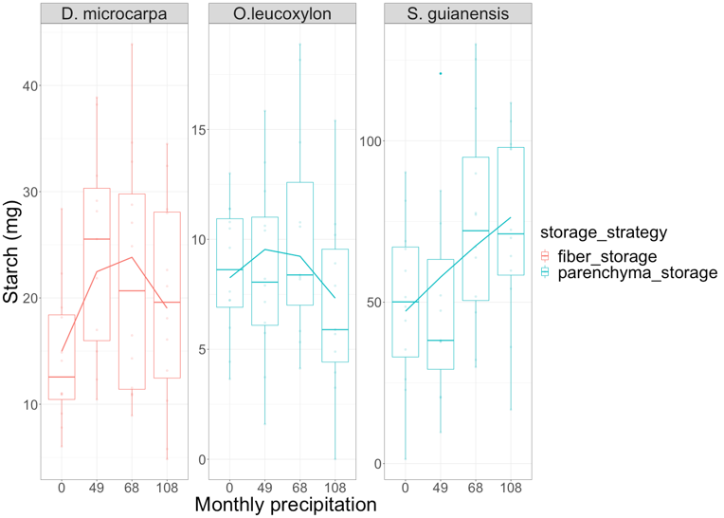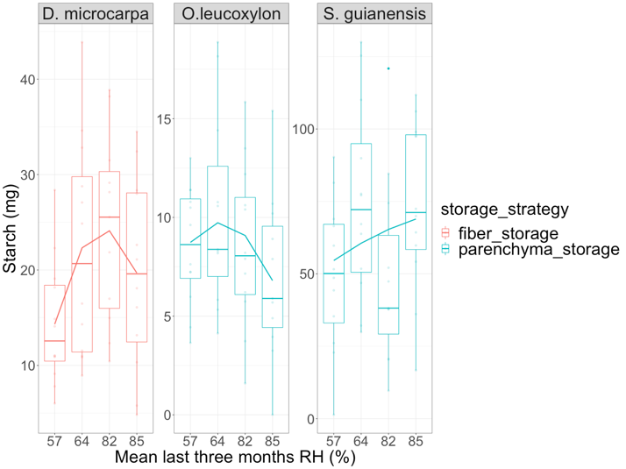

**Figure 6:** Box-plots showing the dispersion of the estimated starch mass in the wood of the selected trees and its changes with respect to 4 levels of monthly precipitation and the three months average relative humidity. The continuous lines in each plot show the general trend between the groups.

## 3.3. Storage-growth trade-offs

For the fiber-storing species *D. microcarpa* we observed a negative correlation between the last three months of growth and changes in starch content during the peak of the wet season between December 2019 and February 2020 (*p* = 0.05, r2 = 0.36). During this period some trees consumed starch to grow faster and some other individuals accumulated it at expense of growth (Fig. 7). For this species most of the individuals consumed large quantities of starch during the dry season (from June 2019 to August 2019), but this was not related with growth.

For the parenchyma-storing species *O. leucoxylon* and *S. guianensis*, the storage-growth trade-offs were less clear having a time lag in the relationship between the starch consumption/accumulation and growth. Starch accumulation during the transition months between the dry and wet seasons (from September 2019 to November 2019) resulted in a decrease in growth rates during the peak of the wet season (September 2019 to February 2020). For instance, most of *O. leucoxylon* accumulated starch during the period from September to November 2019 (transition from dry to wet season), which resulted in lower growth rates during the wet season (December 2019 to February 2020, *p*=0.033, r2=0.41, Fig. 7). A few individuals consumed a small proportion of NSC, which had a positive effect on growth during the upcoming wet season (Fig. 7). For this species, most of the trees consumed their reserves during the wet season, but it did not correlate with growth.

Most of the *S. guianensis* trees also accumulated starch during the transition months between dry and wet season, which also had a very marginal negative impact on the stem growth during the upcoming wet season (*p*=0.10, r2=0.38, Fig. 7). For this species, it was not clear when trees consumed more starch. During the peak of the wet season for instance, about half of sampled individuals consumed starch while half of them accumulated it, but it was also not related with stem growth.

We observed that starch mass was related to annual stem growth, but there were differences between storage strategies. The storage-growth trade-off was still distinguishable for the fiber-storing species *D. microcarpa*, which showed a marginal negative relationship between the starch mass in February 2020 and the annual growth calculated from February 2019 to February 2020 (*p*=0.11, r2=0.31, Fig. 8). This trade-off is stronger (*p*=0.08, r2=0.30) if we consider only the mean growth during the growing season and compare it with the starch content in February. This means that trees that grew slower during 2019 accumulated more starch, suggesting a higher priority for starch storage in this fiber-storing species. The parenchyma-storing species showed positive correlation between annual growth and starch content during the dry season. For instance, *O. leucoxylon* showed a positive relationship between starch content in May 2019 (transition time between the wet and the dry seasons) and the annual stem growth (*p*=0.088, r2=0.4), while *S. guianensis* showed it during August 2019 (*p*=0.003, r2=0.76, Fig. 8).

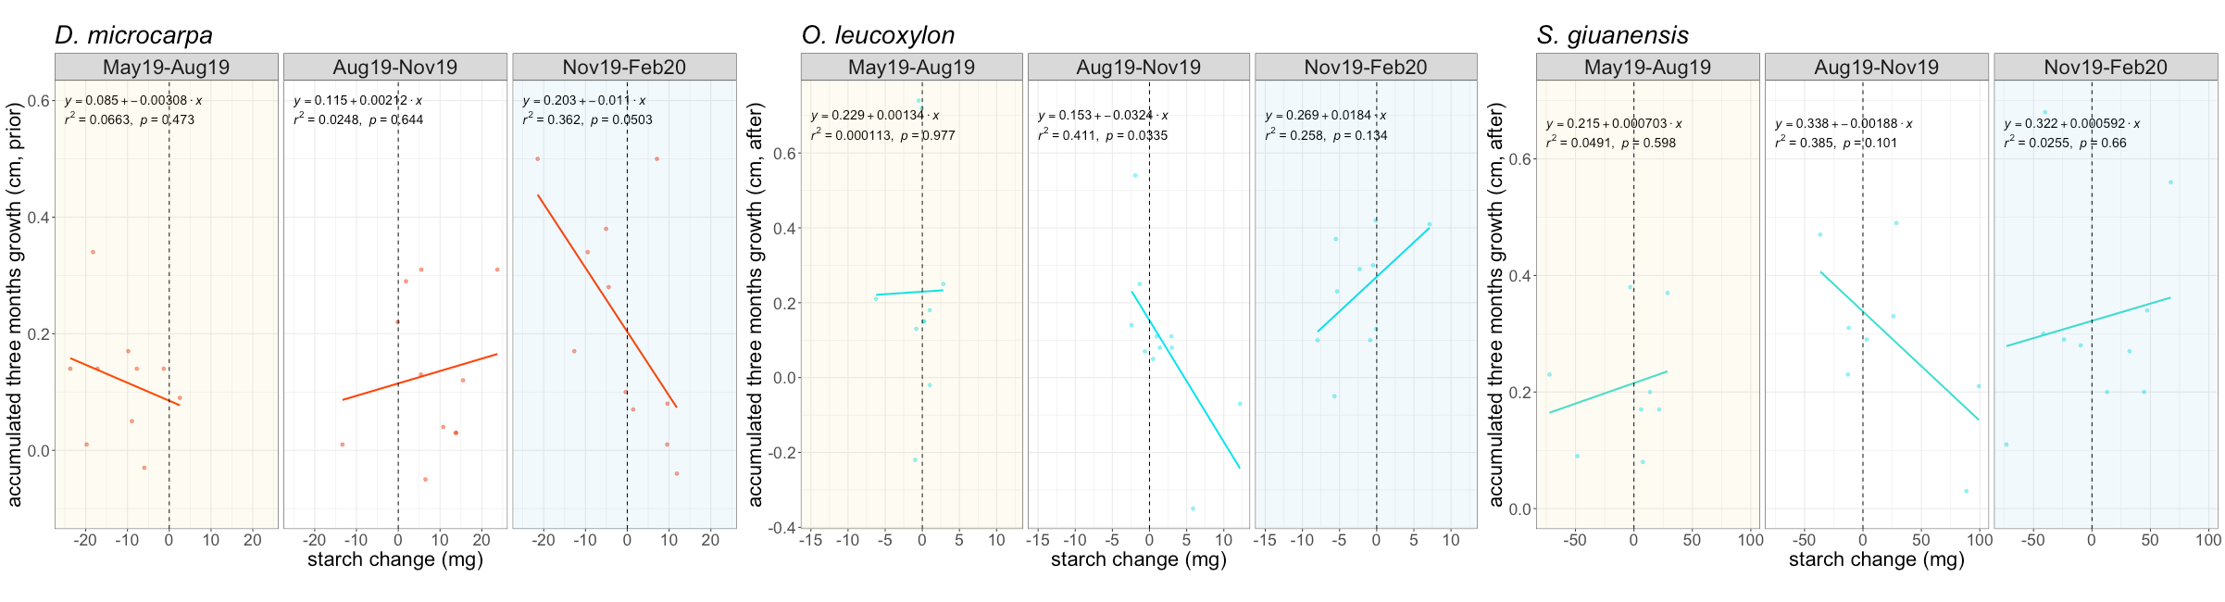**Figure 7:** Relationship between changes in starch mass (accumulation or consumption of starch) and three-month growth in 2019 for the three species studied. The dotted line marks the 0, points on the left indicate starch consumption and those on the right indicate scratch accumulation. The dry season is indicated by shaded yellow areas, while the wet season is indicated by shaded blue areas. 

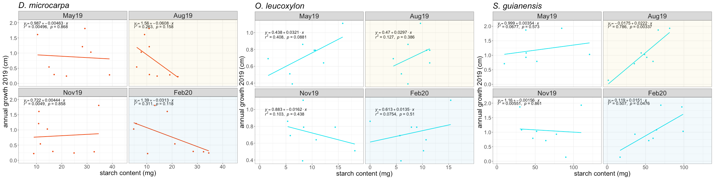**Figure 8:** Relationship between annual growth and the starch content at different times of the year for each of the species studied. The yellow shaded panels correspond to the dry season, while the blue shaded panels correspond to the wet season. 

1. **Discussion**

Our results support the hypotheses set up by our conceptual framework, which relates differences in carbon dynamics in mature trees to life history traits such as starch storage strategy and leaf habit (Fig. 1). The interaction between these traits in our conceptual framework illustrates the interplay between carbon sources (e.g., photosynthesis), the strength and seasonality of carbon sinks (e.g., respiration, growth and reproduction), and the NSC dynamics in stem wood, and together help to explain differences in growth and mortality response to stress among species. For instance, the slow growing semi-deciduous/fiber-storing species *Dacryodes microcarpa* showed stronger seasonality in NSC mass and growth rate than the other functional groups. For such species, storing large amounts of starch is fundamental to meet the future high carbon demand for respiration (due to the large volume of living stem tissue), resulting in a lower and more seasonal allocation of carbon to growth, which is likely to benefit plant competition/survival and result in low mortality rates and long lived trees (Table 1). The fast-growing semi-deciduous/parenchyma-storing species *Sacoglottis guianensis* showed seasonality in NSC but no plasticity in growth and respiration, and the evergreen/parenchyma-storing species *Ocotea leucoxylon* showed no seasonal variability in any of the carbon fluxes, suggesting a priority of growth over storage in the long run and a higher vulnerability to environmental changes, resulting in higher mortality rates for these species (Table 1).

Our conceptual framework and measurements also suggest the differential occurrence of trade-offs between growth and storage between different starch storage strategies (Fig. 1). Negative correlations between growth and storage occurred during the wet season for the slow-growing, fiber-storing species, mainly because of the strong seasonality in growth rates and NSC (Fig. 4, Fig. 7, Fig. 8). This indicates that these species may better regulate carbon sink activity to ensure long-term storage, which could result in lower growth and mortality rates than their counterparts the parenchyma-storing species (Table 1, Herrera-Ramírez et al., 2021). These trade-offs were less evident in parenchyma-storing species. They occurred during the transition months from the dry to the wet season, but with some months of delay, probably reflecting the use of reserves for other carbon sinks like reproduction. The conceptual framework supported by our results improves our understanding of the carbon dynamics in mature trees and provides insights into the mechanisms behind NSC accumulation and use that may lead to plant survival in tropical forests.

## 4.1. Semi-deciduous and fiber-storing species have seasonal changes of NSC

As we expected, leaf habit and storage strategy of starch in the wood influence the seasonal fluctuation of starch in the stem wood. Semi-deciduous species showed significant starch seasonality (*p*=0.001), while evergreen species did not. Semi-deciduous trees may experience large imbalances between carbon sources and sinks during the dry season due to the high demand for carbon to rebuild the canopy, therefore showing larger seasonal changes in starch mass than evergreen species (Kozlowski, 1992; Hoch et al., 2003; Würth et al., 2005; Richardson et al., 2013; Furze et al., 2018). This is consistent with studies showing strong seasonality in temperate deciduous species but not in evergreen species (Chapin et al., 1990; Piispanen and Saranpää, 2001; Trumbore et al., 2015; Martínez-Vilalta et al., 2016; Furze et al., 2018). Our results support the idea that semi-deciduous trees are more dependent on NSC storage than evergreen species in seasonally dry tropical forests. Nevertheless, a larger number of species and longer time series of NSC dynamics should be examined to confirm these patterns. Histological methods provide a rapid and convenient method for quantifying starch storage that can support observations in a high number of species over the longer term.

Here we show that starch storage strategy also influences the seasonal dynamics of NSC (*p*=0.055). So far, the fiber-storing species (*D. microcarpa*) had larger seasonal changes in starch mass than parenchyma-storing species. The starch storage strategies evaluated here allow us to gain some insight into the mechanisms behind carbon dynamics. In fiber-storing species, the high seasonal carbon consumption may be caused by the larger volume of living cells in the stem, which require more carbon for respiration than the smaller volume of living cells in parenchyma-storing species (Fig. 5). Despite the high carbon demand by the living fibers, the fiber-storing species also had a higher starch storage capacity than the parenchyma-storing species to buffer carbon deficits under stress. Such trees would be better prepared for the uncertainty under stressful conditions, which may be reflected in lower mortality rates (Table 1).

## 4.2. Fiber-storing species have larger plasticity in carbon sink activity, reflected in growth seasonality

Trees growing in a seasonally dry environment should balance their carbon sources and sinks in order to survive recurrent stressful conditions. The fast growing, parenchyma-storing species *S. guianensis* kept growth relatively constant throughout the year, whereas the slow-growing, fiber-storing species *D. microcarpa* significantly reduced growth during the dry season. Thus, these trees, with contrasting storage strategies, differentially adjust their balance between carbon sources and sinks to survive seasonally dry conditions (Fig. 1).

The fiber-storing species *D. microcarpa* reduced growth during the dry season from July to September and grew faster during the rainy season from October to May. This seasonal pattern is reflected in the anatomy of the tree rings, where the annual limit of the tree ring is defined by a reduction in the size of the fibers, indicating a reduction in growth.

By contrast, the parenchyma-storing species *S. guianensis* and *O. leucoxylon* may not be able to regulate their growth rates seasonally. For *S. guianensis* non-seasonal growth is also reflected in the absence of clear tree rings and wood anatomical changes. Nevertheless, *O. leucoxylon* has clear annual tree rings that are also defined by a reduction in fiber size, suggesting a seasonal reduction in wood growth. Then, it may be possible that growth rates in these trees did not have an accentuated seasonal change during the single year of observation (2019). Some tree rings of this species showed a diffuse limit, indicating that in other years trees did not strongly reduce growth during the dry season such as in 2019. These results suggest that *D. microcarpa* trees, which have significant NSC and growth seasonality, may have a larger plasticity in their carbon sink fluxes, which would make them more tolerant to a wider range of environmental conditions and would benefit when facing stronger changes in environmental conditions.

Contrary to the growth patterns described above, wood respiration showed no seasonal changes for any of the species evaluated. Although not significant, there was a small reduction in respiration during the dry season for all species (Fig. 5). Similarly, no changes in respiration between dry and wet seasons in tropical forest trees have been previously reported (Asao et al., 2015). Some other trees can regulate stem CO2 efflux to adapt to certain environmental conditions such as seasonal changes in precipitation and temperature, releasing resources for other metabolic activities (Teskey et al., 2008; Huang et al., 2019; Sierra et al., 2022). In addition, wood respiration was greater in *D. microcarpa* trees, probably because of the large amount of living tissue compared to *S. guianensis* and *O. leucoxylon* trees, where respiration was lower (Teskey et al., 2008; Meir et al., 2020). Therefore, fiber-storing species such as *D. microcarpa* trees may have greater carbon requirements to keep all living wood tissue alive, which may reduce their ability to regulate respiration seasonally. These results suggest that wood anatomical traits such as living fibers may indicate a large carbon demand for respiration that may heavily compete with other carbon sinks such as growth, leading these trees to have a stronger regulation of growth rates and have a high reliance on storage.

## 4.3. Starch mass is non-linearly related to precipitation and relative humidity in fiber-storing species

As discussed above, seasonal changes in starch content corresponded with imbalances between carbon sources and sinks. These imbalances might have been induced by seasonal changes in precipitation and relative humidity causing leaf abscission for the two semi-deciduous species. For *D. microcarpa*, the starch response to monthly precipitation and relative humidity appears to be non-linear following an inverted-U trend. For *S. guianensis* starch content and precipitation were positively correlated (Fig. 6), although the signal became non-linear when three months of accumulated precipitation were evaluated. Low starch mass during the dry and wet seasons could be associated with NSC investment in basic metabolism such as respiration, defense compounds, osmoregulation, reproduction and growth, which exceeded the fixation of new photoassimilates.

It is surprising that starch mass slightly decreased during the wet season under high precipitation and high relative humidity. There could be several reasons for this: For fiber-storing trees (*D. microcarpa*), it is possible that the carbon demand of wood growth (which is the highest during the wet season) and respiration exceeds the supply of new photoassimilates. In addition, some other sink activities such as reproduction may also contribute to a greater carbohydrate demand during the wet season (Hartmann and Trumbore, 2016). For instance, both *D. microcarpa and S. guianensis* produced fruit during the wet season (Fig. S2), which may constitute a large demand for carbon reserves. The use of NSC for reproduction and its impact in the NSC seasonality have been largely overlooked in the literature (Hartmann and Trumbore, 2016; Blumstein et al., 2022). These results suggest that for some tree species, flowering and fruiting may be a significant carbon sink that can influence the NSC seasonal dynamics, probably causing trees to deplete NSC during the wet season.

Alternatively, the rainy season comes with its own dangers that put pressure on available NSC. During the rainy season, blowdowns, storms and lightning can cause physical damage to trees, increasing the risk of individual mortality (Zuleta et al., 2022). Rebuilding the lost tissue could represent a large demand on NSC. There may also be an increase in herbivory or fungal infection, increasing the demand for NSC to rebuild lost foliage and roots and to ensure defenses (Zuleta et al., 2022). Because of these hazards, tree mortality is highest during the wet season in some tropical forests (Aleixo et al., 2019). Thus, trees that may not have fully replenished their NSC content and repaired their damage during the dry and wet seasons may be vulnerable to such stressors and more susceptible to die (Anderegg et al., 2013; Arellano et al., 2019; Aleixo et al., 2019). In a previous work, we found that fiber-storing species may have larger NSC pools, lower growth rates, and lower mortality than parenchyma-storing species (Herrera-Ramírez et al., 2021). Therefore, trees with larger and more seasonal NSC pools and larger plasticity of carbon sink activity (such as the fiber-storing species *D. microcarpa*) may be better prepared to face compounding perturbations coming during both the dry and the wet season, thereby increasing survival.

## 4.4. Storage-growth trade-offs occur in the fiber storing species during the wet season

Seasonal patterns in starch mass showed us when trees use and accumulate stem NSC. Our results indicate a trade-off between starch consumption/accumulation and growth only during the wet season for *D. microcarpa*, and less clearly during the transition from dry to wet season for the other two parenchyma-storing species (*O. leocoxylon* and *S. guianensis*), while consumption or accumulation of starch in the other seasons was not related to growth (Fig. 7).

For instance, *D. microcarpa* trees strongly reduced starch during the 2019 dry season, but this was not related to stem growth. This may indicate that all these resources could have been allocated to other functions such as respiration, which seems to be prioritized over growth (Fig. 5), flushing new leaves and flowers (Fig. S2), and maintaining osmotic potential (Salleo et al., 2004). The trade-offs between growth and starch consumption/accumulation were clear during the wet season (Fig. 7, Fig. 1). There, some trees consumed starch to grow faster, while others grew slower and accumulated starch.

For the parenchyma-storing species (*O. leocoxylon* and *S. guianensis*), trade-offs between growth and starch consumption/accumulation were less clear and had a time lag of three months. Trees that accumulated starch during the transition months from the dry to the wet season grew slower during the wet season. This accumulation of NSC during the transition months may reflect a preparation for growing fruits during the wet season (Fig. S2), while maintaining relatively high constant growth rates.

Identifying these trade-offs with field measurements is challenging (Blumstein et al., 2022). Here we show that annual estimates of starch content and growth may hide the seasonal trade-offs between these two variables (Fig. 8). Furthermore, we show that they may be restricted to certain periods of the year such as the wet season (Fig. 1, Fig. 7). Trade-offs may be affected by variations in carbon supply. Individuals with higher carbon supply may be more able to invest more in both growth and storage than individuals with lower carbon supply (Blumstein et al., 2022), as was the case for our parenchyma-storing species. These two parenchyma-storing species grew faster than the fiber-storing species and the correlation between annual growth and starch mass was positive for both species during the dry season. For more conservative species, such as the fiber-storing species, trade-offs between starch mass and growth were still observed. Our results suggest that these trade-offs may not be reflected in the annual carbon balance, but would only be evident on a seasonal basis. Therefore, evaluating seasonal changes in starch mass (rather than mean storage mass per year or max starch storage per year) in relation to seasonal growth can better inform us about when and under what conditions such trade-offs occur, avoiding the influence of some confounding factors when annual averages are used.

Evidence for growth-storage trade-offs is growing in the literature and has been linked to survival (Wright et al., 2004; Poorter and Kitajima, 2007; O’Brien et al., 2014, 2015; Klein and Hoch, 2015; D’Andrea et al., 2019, 2020). Studies comparing highly conservative species and highly competitive species in surviving stressful environmental conditions are needed to further understand how variation in storage-growth trade-offs are maintained across space and time. Our results are a good indication that highly conservative, slow-growing, and high-storing species, such as fiber-storing species (e.g., *D. microcarpa*), may have stronger trade-offs between starch storage and growth, indicating a greater plasticity in their sink activity, or a higher prioritization of storage, than parenchyma-storing species. Life history traits such as low growth and low mortality are associated with highly conservative species and are a good proxy for tree longevity (Wright et al., 2004; Herrera-Ramírez et al., 2021; Piovesan and Biondi, 2021). Therefore, we would expect that as stressors intensify, highly conservative trees, such as fiber-storing species, would have higher survival rates and would become more competitive in seasonally dry forests. Future work should focus on understanding how these storage strategies are distributed in forest communities and how their different storage-growth trade-offs affect productivity and species survival in tropical forests under climate change.

# 5. Acknowledgments

We want to thank the Max Planck Society, the Friedrich-Schiller University and the German Research Foundation (SI 1953/2-1) for the founding of this project. Also, we received funding from the EU, through the German Bundesanstalt für Landwirtschaft und Ernährung FKZ: 2816ERA03W (to S. T.); the Brazilian council for Scientific and Technological Development - CNPq (PELD/CNPq No. 441703/2016-0; No. 441940/2020-0; UNIVERSAL No. 430149/2018-2); and DH and ST acknowledge the support from the Balzan foundation.

**6. Author contributions**

DH-R, CAS, HH, CR, ST, and JM, conceived the idea, conceptualized the hypothesis, and planned the data collection and the experiments. DH, LM and DS collected and analyzed data. DH and IK performed sample analysis and quantification. DH-R wrote the manuscript. DH-R, HH, CR, ST, JM, LM, PB, DS, HJ, IK, and CAS contributed significantly to the writing of the manuscript and gave important and critical input. All authors revised the manuscript.

**7. Data accessibility statement**

The data here presented will be stored in an open git up repository once the manuscript is accepted.

# 8. References

Adams, H. D., Zeppel, M. J. B., Anderegg, W. R. L., Hartmann, H., Landhäusser, S. M., Tissue, D. T., et al. (2017). A multi-species synthesis of physiological mechanisms in drought-induced tree mortality. *Nature Ecology & Evolution* 1, 1285–1291. doi:[10.1038/s41559-017-0248-x](https://doi.org/10.1038/s41559-017-0248-x).

Aleixo, I., Norris, D., Hemerik, L., Barbosa, A., Prata, E., Costa, F., et al. (2019). Amazonian rainforest tree mortality driven by climate and functional traits. *Nature Climate Change* 9, 384–388. doi:[10.1038/s41558-019-0458-0](https://doi.org/10.1038/s41558-019-0458-0).

Anderegg, W. R. L., Berry, J. A., Smith, D. D., Sperry, J. S., Anderegg, L. D. L., and Field, C. B. (2012). The roles of hydraulic and carbon stress in a widespread climate-induced forest die-off. *Proceedings of the National Academy of Sciences* 109, 233–237. doi:[10.1073/pnas.1107891109](https://doi.org/10.1073/pnas.1107891109).

Anderegg, W. R. L., Kane, J. M., and Anderegg, L. D. L. (2013). Consequences of widespread tree mortality triggered by drought and temperature stress. *Nature Climate Change* 3, 30–36. doi:[10.1038/nclimate1635](https://doi.org/10.1038/nclimate1635).

Arellano, G., Medina, N. G., Tan, S., Mohamad, M., and Davies, S. J. (2019). Crown damage and the mortality of tropical trees. *New Phytologist* 221, 169–179. doi:[https://doi.org/10.1111/nph.15381](https://doi.org/https:/doi.org/10.1111/nph.15381).

Arx, G. von, Arzac, A., Fonti, P., Frank, D., Zweifel, R., Rigling, A., et al. (2017). Responses of sapwood ray parenchyma and non-structural carbohydrates of pinus sylvestris to drought and long-term irrigation. *Functional Ecology* 31, 1371–1382. doi:[10.1111/1365-2435.12860](https://doi.org/10.1111/1365-2435.12860).

Asao, S., Bedoya-Arrieta, R., and Ryan, M. G. (2015). Variation in foliar respiration and wood CO2 efflux rates among species and canopy layers in a wet tropical forest. *Tree Physiology* 35, 148–159. doi:[10.1093/treephys/tpu107](https://doi.org/10.1093/treephys/tpu107).

Barbaroux, C., and Bréda, N. (2002). Contrasting distribution and seasonal dynamics of carbohydrate reserves in stem wood of adult ring-porous sessile oak and diffuse-porous beech trees. *Tree Physiology* 22, 1201–1210. doi:[10.1093/treephys/22.17.1201](https://doi.org/10.1093/treephys/22.17.1201).

Blumstein, M., Sala, A., Weston, D. J., Holbrook, N. M., and Hopkins, R. (2022). Plant carbohydrate storage: Intra- and inter-specific trade-offs reveal a major life history trait. *New Phytologist* 235, 2211–2222. doi:[https://doi.org/10.1111/nph.18213](https://doi.org/https:/doi.org/10.1111/nph.18213).

Carlquist, S. (2013). Fibre dimorphism: Cell type diversification as an evolutionary strategy in angiosperm woods. *Botanical Journal of the Linnean Society* 174, 44–67. doi:[10.1111/boj.12107](https://doi.org/10.1111/boj.12107).

Chapin, F. S., Schulze, E., and Mooney, H. A. (1990). The ecology and economics of storage in plants. *Annual Review of Ecology and Systematics* 21, 423–447. doi:[10.1146/annurev.es.21.110190.002231](https://doi.org/10.1146/annurev.es.21.110190.002231).

Dietze, M. C., Sala, A., Carbone, M. S., Czimczik, C. I., Mantooth, J. A., Richardson, A. D., et al. (2014). Nonstructural carbon in woody plants. *Annual Review of Plant Biology* 65, 667–687. doi:[10.1146/annurev-arplant-050213-040054](https://doi.org/10.1146/annurev-arplant-050213-040054).

D’Andrea, E., Rezaie, N., Battistelli, A., Gavrichkova, O., Kuhlmann, I., Matteucci, G., et al. (2019). Winter’s bite: Beech trees survive complete defoliation due to spring late-frost damage by mobilizing old c reserves. *New Phytologist* 224, 625–631. doi:[https://doi.org/10.1111/nph.16047](https://doi.org/https:/doi.org/10.1111/nph.16047).

D’Andrea, E., Rezaie, N., Prislan, P., Gričar, J., Collalti, A., Muhr, J., et al. (2020). Frost and drought: Effects of extreme weather events on stem carbon dynamics in a mediterranean beech forest. *Plant, Cell & Environment* 43, 2365–2379. doi:[https://doi.org/10.1111/pce.13858](https://doi.org/https:/doi.org/10.1111/pce.13858).

Furze, M. E., Huggett, B. A., Chamberlain, C. J., Wieringa, M. M., Aubrecht, D. M., Carbone, M. S., et al. (2020). Seasonal fluctuation of nonstructural carbohydrates reveals the metabolic availability of stemwood reserves in temperate trees with contrasting wood anatomy. *Tree Physiology* 40, 1355–1365. doi:[10.1093/treephys/tpaa080](https://doi.org/10.1093/treephys/tpaa080).

Furze, M. E., Trumbore, S., and Hartmann, H. (2018). Detours on the phloem sugar highway: Stem carbon storage and remobilization. *Current Opinion in Plant Biology* 43, 89–95. doi:[https://doi.org/10.1016/j.pbi.2018.02.005](https://doi.org/https:/doi.org/10.1016/j.pbi.2018.02.005).

Galiano, L., Timofeeva, G., Saurer, M., Siegwolf, R., Martínez-Vilalta, J., Hommel, R., et al. (2017). The fate of recently fixed carbon after drought release: Towards unravelling c storage regulation in tilia platyphyllos and pinus sylvestris. *Plant, Cell & Environment* 40, 1711–1724. doi:[https://doi.org/10.1111/pce.12972](https://doi.org/https:/doi.org/10.1111/pce.12972).

Hartmann, H., and Trumbore, S. (2016). Understanding the roles of nonstructural carbohydrates in forest trees from what we can measure to what we want to know. *New Phytologist* 211, 386–403. doi:[10.1111/nph.13955](https://doi.org/10.1111/nph.13955).

Hartmann, H., McDowell, N. G., and Trumbore, S. (2015). Allocation to carbon storage pools in Norway spruce saplings under drought and low CO2. *Tree Physiology* 35, 243–252. doi:[10.1093/treephys/tpv019](https://doi.org/10.1093/treephys/tpv019).

Hartmann, H., Ziegler, W., and Trumbore, S. (2013). Lethal drought leads to reduction in nonstructural carbohydrates in norway spruce tree roots but not in the canopy. *Functional Ecology* 27, 413–427. doi:[https://doi.org/10.1111/1365-2435.12046](https://doi.org/https:/doi.org/10.1111/1365-2435.12046).

Herrera-Ramírez, D., Sierra, C. A., Römermann, C., Muhr, J., Trumbore, S., Silvério, D., et al. (2021). Starch and lipid storage strategies in tropical trees relate to growth and mortality. *New Phytologist* 230, 139–154. doi:[https://doi.org/10.1111/nph.17239](https://doi.org/https:/doi.org/10.1111/nph.17239).

Hoch, G., Richter, A., and Körner, C. (2003). Non-structural carbon compounds in temperate forest trees. *Plant, Cell & Environment* 26, 1067–1081. doi:[10.1046/j.0016-8025.2003.01032.x](https://doi.org/10.1046/j.0016-8025.2003.01032.x).

Huang, J., Hammerbacher, A., Gershenzon, J., Dam, N. M. van, Sala, A., McDowell, N. G., et al. (2021). Storage of carbon reserves in spruce trees is prioritized over growth in the face of carbon limitation. *Proceedings of the National Academy of Sciences* 118, e2023297118. doi:[10.1073/pnas.2023297118](https://doi.org/10.1073/pnas.2023297118).

Huang, J., Rücker, A., Schmidt, A., Gleixner, G., Gershenzon, J., Trumbore, S., et al. (2020). Production of constitutive and induced secondary metabolites is coordinated with growth and storage in Norway spruce saplings. *Tree Physiology* 40, 928-942. doi:<https://doi.org/10.1093/treephys/tpaa040.>

Huang, J., Hammerbacher, A., Weinhold, A., Reichelt, M., Gleixner, G., Behrendt, T., et al. (2019). Eyes on the future – evidence for trade-offs between growth, storage and defense in norway spruce. *New Phytologist* 222, 144–158. doi:[https://doi.org/10.1111/nph.15522](https://doi.org/https:/doi.org/10.1111/nph.15522).

Klein, T., and Hoch, G. (2015). Tree carbon allocation dynamics determined using a carbon mass balance approach. *New Phytologist* 205, 147–159. doi:[10.1111/nph.12993](https://doi.org/10.1111/nph.12993).

Kozlowski, T. T. (1992). Carbohydrate sources and sinks in woody plants. *The Botanical Review* 58, 107–222. doi:[10.1007/BF02858600](https://doi.org/10.1007/BF02858600).

Körner, C. (2003). Carbon limitation in trees. *Journal of Ecology* 91, 4–17. doi:[https://doi.org/10.1046/j.1365-2745.2003.00742.x](https://doi.org/https:/doi.org/10.1046/j.1365-2745.2003.00742.x).

Landhäusser, S. M., Chow, P. S., Dickman, L. T., Furze, M. E., Kuhlman, I., Schmid, S., et al. (2018). Standardized protocols and procedures can precisely and accurately quantify non-structural carbohydrates. *Tree Physiology* 38, 1764–1778. doi:[10.1093/treephys/tpy118](https://doi.org/10.1093/treephys/tpy118).

Martínez-Vilalta, J. (2014). Carbon storage in trees: pathogens have their say. *Tree Physiology* 34, 215–217. doi:[10.1093/treephys/tpu010](https://doi.org/10.1093/treephys/tpu010).

Martínez-Vilalta, J., Sala, A., Asensio, D., Galiano, L., Hoch, G., Palacio, S., et al. (2016). Dynamics of non-structural carbohydrates in terrestrial plants: A global synthesis. *Ecological Monographs* 86, 495–516. doi:[https://doi.org/10.1002/ecm.1231](https://doi.org/https:/doi.org/10.1002/ecm.1231).

Meir, P., Mencuccini, M., and Coughlin, S. I. (2020). Respiration in wood: Integrating across tissues, functions and scales. *New Phytologist* 225, 1824–1827. doi:[https://doi.org/10.1111/nph.16354](https://doi.org/https:/doi.org/10.1111/nph.16354).

Michelot, A., Simard, S., Rathgeber, C., Dufrêne, E., and Damesin, C. (2012). Comparing the intra-annual wood formation of three European species (Fagus sylvatica, Quercus petraea and Pinus sylvestris) as related to leaf phenology and non-structural carbohydrate dynamics. *Tree Physiology* 32, 1033–1045. doi:[10.1093/treephys/tps052](https://doi.org/10.1093/treephys/tps052).

Newell, E. A., Mulkey, S. S., and Wright, J. S. (2002). Seasonal patterns of carbohydrate storage in four tropical tree species. *Oecologia* 131, 333–342. doi:[10.1007/s00442-002-0888-6](https://doi.org/10.1007/s00442-002-0888-6).

O’Brien, M. J., Burslem, D. F. R. P., Caduff, A., Tay, J., and Hector, A. (2015). Contrasting nonstructural carbohydrate dynamics of tropical tree seedlings under water deficit and variability. *New Phytologist* 205, 1083–1094. doi:[https://doi.org/10.1111/nph.13134](https://doi.org/https:/doi.org/10.1111/nph.13134).

O’Brien, M. J., Leuzinger, S., Philipson, C. D., Tay, J., and Hector, A. (2014). Drought survival of tropical tree seedlings enhanced by non-structural carbohydrate levels. *Nature Climate Change* 4, 710 EP. Available at: <http://dx.doi.org/10.1038/nclimate2281>.

O’Brien, M. J., Valtat, A., Abiven, S., Studer, M. S., Ong, R., and Schmid, B. (2020). The role of soluble sugars during drought in tropical tree seedlings with contrasting tolerances. *Journal of Plant Ecology* 13, 389–397. doi:[10.1093/jpe/rtaa017](https://doi.org/10.1093/jpe/rtaa017).

Palacio, S., Hoch, G., Sala, A., Körner, C., and Millard, P. (2014). Does carbon storage limit tree growth? *New Phytologist* 201, 1096–1100. doi:[10.1111/nph.12602](https://doi.org/10.1111/nph.12602).

Piispanen, R., and Saranpää, P. (2001). Variation of non-structural carbohydrates in silver birch (betula pendula roth) wood. *Trees* 15, 444–451. doi:[10.1007/s004680100125](https://doi.org/10.1007/s004680100125).

Piovesan, G., and Biondi, F. (2021). On tree longevity. *New Phytologist* 231, 1318–1337. doi:[https://doi.org/10.1111/nph.17148](https://doi.org/https:/doi.org/10.1111/nph.17148).

Piper, F. I., and Paula, S. (2020). The role of nonstructural carbohydrates storage in forest resilience under climate change. *Current Forestry Reports* 6, 1–13. doi:[10.1007/s40725-019-00109-z](https://doi.org/10.1007/s40725-019-00109-z).

Piper, F. I., Gundale, M. J., and Fajardo, A. (2015). Extreme defoliation reduces tree growth but not C and N storage in a winter-deciduous species. *Annals of Botany* 115, 1093–1103. doi:[10.1093/aob/mcv038](https://doi.org/10.1093/aob/mcv038).

Plavcová, L., Hoch, G., Morris, H., Ghiasi, S., and Jansen, S. (2016). The amount of parenchyma and living fibers affects storage of nonstructural carbohydrates in young stems and roots of temperate trees. *American Journal of Botany* 103, 603–612. doi:[10.3732/ajb.1500489](https://doi.org/10.3732/ajb.1500489).

Poorter, L., and Kitajima, K. (2007). Carbohydrate storage and light requirements of tropical moist and dry forest tree species. *Ecology* 88, 1000–1011. doi:[https://doi.org/10.1890/06-0984](https://doi.org/https:/doi.org/10.1890/06-0984).

Resco de Dios, V., and Gessler, A. (2021). Sink and source co-limitation in the response of stored non-structural carbohydrates to an intense but short drought. *Trees* 35, 1751–1754. doi:[10.1007/s00468-021-02116-9](https://doi.org/10.1007/s00468-021-02116-9).

Richardson, A. D., Carbone, M. S., Keenan, T. F., Czimczik, C. I., Hollinger, D. Y., Murakami, P., et al. (2013). Seasonal dynamics and age of stemwood nonstructural carbohydrates in temperate forest trees. *New Phytologist* 197, 850–861. doi:[10.1111/nph.12042](https://doi.org/10.1111/nph.12042).

Sala, A., Woodruff, D. R., and Meinzer, F. C. (2012). Carbon dynamics in trees: Feast or famine? *Tree Physiology* 32, 764–775. doi:[10.1093/treephys/tpr143](https://doi.org/10.1093/treephys/tpr143).

Salleo, S., Lo Gullo, M. A., Trifilò, P., and Nardini, A. (2004). New evidence for a role of vessel-associated cells and phloem in the rapid xylem refilling of cavitated stems of laurus nobilis l. *Plant, Cell & Environment* 27, 1065–1076. doi:[10.1111/j.1365-3040.2004.01211.x](https://doi.org/10.1111/j.1365-3040.2004.01211.x).

Schneider, C. A., Rasband, W. S., and Eliceiri, K. W. (2012). NIH image to imagej: 25 years of image analysis. *Nature Methods* 9, 671–675. doi:[10.1038/nmeth.2089](https://doi.org/10.1038/nmeth.2089).

Sevanto, and M., Sanna, Dickman, L Turin, Pangle, Robert E., and Pockman, W. T. (2014). How do trees die? A test of the hydraulic failure and carbon starvation hypotheses. *Plant, Cell & Environment* 37, 153–161. doi:[10.1111/pce.12141](https://doi.org/10.1111/pce.12141).

Sierra, C. A., Ceballos-Núñez, V., Hartmann, H., Herrera-Ramírez, D., and Metzler, H. (2022). Ideas and perspectives: Allocation of carbon from net primary production in models is inconsistent with observations of the age of respired carbon. *Biogeosciences* 19, 3727–3738. doi:[10.5194/bg-19-3727-2022](https://doi.org/10.5194/bg-19-3727-2022).

Teskey, R. O., Saveyn, A., Steppe, K., and McGuire, M. A. (2008). Origin, fate and significance of CO2 in tree stems. *New Phytologist* 177, 17–32. doi:[https://doi.org/10.1111/j.1469-8137.2007.02286.x](https://doi.org/https:/doi.org/10.1111/j.1469-8137.2007.02286.x).

Trumbore, S., Czimczik, C. I., Sierra, C. A., Muhr, J., and Xu, X. (2015). Non-structural carbon dynamics and allocation relate to growth rate and leaf habit in California oaks. *Tree Physiology* 35, 1206–1222. doi:[10.1093/treephys/tpv097](https://doi.org/10.1093/treephys/tpv097).

Wiley, E., and Helliker, B. (2012). A re-evaluation of carbon storage in trees lends greater support for carbon limitation to growth. *New Phytologist* 195, 285–289. doi:[https://doi.org/10.1111/j.1469-8137.2012.04180.x](https://doi.org/https:/doi.org/10.1111/j.1469-8137.2012.04180.x).

Wiley, E., Casper, B. B., and Helliker, B. R. (2017). Recovery following defoliation involves shifts in allocation that favour storage and reproduction over radial growth in black oak. *Journal of Ecology* 105, 412–424. doi:[https://doi.org/10.1111/1365-2745.12672](https://doi.org/https:/doi.org/10.1111/1365-2745.12672).

Wright, I. J., Reich, P. B., Westoby, M., Ackerly, D. D., Baruch, Z., Bongers, F., et al. (2004). The worldwide leaf economics spectrum. *Nature* 428, 821–827. doi:[10.1038/nature02403](https://doi.org/10.1038/nature02403).

Würth, M. K. R., Peláez-Riedl, S., Wright, S. J., and Körner, C. (2005). Non-structural carbohydrate pools in a tropical forest. *Oecologia* 143, 11–24. doi:[10.1007/s00442-004-1773-2](https://doi.org/10.1007/s00442-004-1773-2).

Zuleta, D., Arellano, G., Muller-Landau, H. C., McMahon, S. M., Aguilar, S., Bunyavejchewin, S., et al. (2022). Individual tree damage dominates mortality risk factors across six tropical forests. *New Phytologist* 233, 705–721. doi:[https://doi.org/10.1111/nph.17832](https://doi.org/https:/doi.org/10.1111/nph.17832).

Zweifel, R., Haeni, M., Buchmann, N., and Eugster, W. (2016). Are trees able to grow in periods of stem shrinkage? *New Phytologist* 211, 839–849. doi:[https://doi.org/10.1111/nph.13995](https://doi.org/https:/doi.org/10.1111/nph.13995).

Zweifel, R., Zimmermann, L., Zeugin, F., and Newbery, D. M. (2006). Intra-annual radial growth and water relations of trees: implications towards a growth mechanism. *Journal of Experimental Botany* 57, 1445–1459. doi:[10.1093/jxb/erj125](https://doi.org/10.1093/jxb/erj125).

**9. Tables**

Table 1: Species names and traits: wood storage strategy, growth rates, mortality rates, phenology, and the sampling dates.

|  |  |  |  |  |
| --- | --- | --- | --- | --- |
| Species name | Growth rate (cm/year) | Mortality rate  (%/year) | Storage strategy | Leaf phenology  (~% of leaf loss) |
| *Ocotea leucoxylon* (Sw.) Laness | 0.295 | 5.7 | Parenchyma | Evergreen (~30) |
| *Sacoglottis guianensis* Benth. | 0.72 | 5.0 | Parenchyma | Semi-deciduous (~45) |
| *Dacryodes microcarpa* Cuart. | 0.078 | 1.6 | Fiber | Semi-deciduous (~60) |

**10. Figure Legends**

**Figure 1:** Conceptual framework that relates the differences in carbon dynamics for trees with different combinations of two functional traits: leaf habit and storage strategy of starch in the stem wood. Here we show the seasonal behavior of carbon sources - photosynthesis (red line)- and carbon sinks - growth (green), respiration (orange), and reproduction (purple) - and their interactions with NSC storage or consumption (blue line). Expected trade-offs between growth and storage are indicated by black arrows and the thickness of the line indicates the strength of the trade-off. Thus, thicker and darker lines indicate strong trade-offs, and dashed and lighter lines indicate weaker or less clear trade-offs. The seasonal patterns of photosynthesis are taken from the phenological observations of leaves reported in Fig. S2.

**Figure 2:** Mean seasonal course of monthly total precipitation (mm) and relative humidity (%) during 2016-2020 (black lines). Gray areas correspond to the standard deviation. Data provided by IPAM.

**Figure 3:** Box-plots that show the dispersion of the starch mass measured in the wood cores from trees of each evaluated species at different times/seasons during 2019. The yellow shaded area corresponds to the dry season, while the blue shaded areas correspond to the wet season. Differences between groups are indicated by different letters (with 95% confidence) above the box-plots and show the observed seasonality of starch mass in stem wood.

**Figure 4:** Seasonal trend of growth rates for the three species evaluated. Solid lines show the smoothing trends, while the dispersion of the measurements is shown by box-plots. The lines inside the box-plots show the median of the distribution of the measurements. Yellow shaded areas indicate the dry season and blue shaded areas indicate the wet season.

**Figure 5:** Box-plots showing the dispersion of the measured CO2 efflux from the stem core of the studied trees during the wet and the dry seasons of 2018, for each species. There were no significant differences between the wet and dry seasons for any species.

**Figure 6:** Box-plots showing the dispersion of the estimated starch mass in the wood of the selected trees and its changes with respect to 4 levels of monthly precipitation and the three months average relative humidity. The continuous lines in each plot show the general trend between the groups.

**Figure 7:** Relationship between changes in starch mass (accumulation or consumption of starch) and three-month growth in 2019 for the three species studied. The dotted line marks the 0, points on the left indicate starch consumption and those on the right indicate scratch accumulation. The dry season is indicated by shaded yellow areas, while the wet season is indicated by shaded blue areas.

**Figure 8:** Relationship between annual growth and the starch content at different times of the year for each of the species studied. The yellow shaded panels correspond to the dry season, while the blue shaded panels correspond to the wet season.