Starch storage strategy in the stem wood influences carbon dynamics and storage-growth trade-offs in tropical trees

David Herrera-Ramírez1*, Henrik Hartmann1, Christine Römermann2,3, Susan Trumbore1, Jan Muhr1, 4, Leonardo Maracahipes-Santos7, Paulo Brando5, 6,7, Divino Silvério8, Huang Jianbei1, Iris Kuhlmann1 and Carlos A. Sierra1

1Max Planck Institute for Biogeochemistry, Hans-Knöll-Str 10, 07745 Jena

2Friedrich Schiller University Jena, Institute for Ecology and Evolution, Philosophenweg 16, 07743, Jena, Germany

3German Centre for Integrative Biodiversity Research (iDiv) Halle-Jena-Leipzig, D- 04103 Leipzig

4Georg August University Göttingen, Department of Bioclimatology, Büsgenweg 2, 37077 Göttingen, Germany

5Department of Earth System Science, University of California, Irvine, CA 92697, USA

6Yale School of the Environment, Yale University, New Haven, CT, United States.

7Instituto de Pesquisa Ambiental da Amazônia, Brasília, DF 70863-520, Brazil

8Department of Biology, Universidade Federal Rural da Amazônia-UFRA, Capitāo Poço 68650-000, Pará, Brazil

**Abstract**

1. Trees balance their carbon source and carbon sink activity over different time scales by accumulating and using non-structural carbon (NSC). The amount and distribution of NSC stored in stemwood influences trees’ ability to balance carbon sources and sinks, and impacts the tree survival and recovery from multiple disturbances. Thus, the strategy to store starch in the stemwood may influence the carbon dynamics of mature trees and may be reflected in the strength of storage-growth trade-offs.
2. In this work, we hypothesized that combining two life history traits, such as storage strategy of starch in the stem wood (parenchyma-storage and fiber-storage) and leaf habit (evergreen and semi-deciduous), would allow us to explain differences in the seasonal interplay between carbon sources and sinks and the use and accumulation of NSC. Thus, we expected semi-deciduous/fiber-storing species to have greater seasonality in NSC and carbon sink activity and stronger storage-growth trade-offs than parenchyma-storing species.
3. We measured monthly growth rates, soluble sugars and starch every three months during 2019 in *Dacryodes microcarpa* (semi-deciduous/fiber-storing-species), *Ocotea leucoxylon* (evergreen/parenchyma-storing-species), and *Sacoglottis guianensis* (semi-deciduous/parenchyma-storing-species).
4. We found seasonal changes in NSC content in the semi-deciduous species, but they were stronger in the fiber-storing species. This fiber-storing species had large storage capacity and stem respiration, and also showed a negative relationship between starch consumption/accumulation and growth during the rainy season, suggesting a clear trade-off between growth and storage, where starch is accumulated in some cases at the expense of growth.
5. **Synthesis:** Our results show the influence of starch storage strategy on carbon dynamics in tropical trees. They suggest that deciduous/fiber-storing species have larger plasticity of carbon sinks activity and larger prioritization of NSC storage, resulting in long-lived trees with lower mortality rates with respect to parenchyma-storing species. These results help us to better understand carbon dynamics in tropical trees and allow us to explain how storage strategies may influence survival and life span of tropical trees .
6. **Introduction**

Trees assimilate CO2 via photosynthesis to produce non-structural carbon (NSC), which consists mainly of soluble sugars, starch and lipids. Sugars are transported to all tree organs to fuel metabolism and growth, and locally accumulated as starch and lipids to provide energy reserves on different time scales, e.g., daily, seasonal or interannual (Chapin et al., 1990; Richardson et al., 2013). Seasonal changes in the NSC content in different tree organs reflect imbalances between carbon sources (e.g., photosynthesis) and sinks (e.g., growth and respiration) (Kozlowski, 1992; Körner, 2003), and can indicate the use of stored carbon to fuel different vital metabolic functions in order to survive multiple disturbances, such as dry and hot conditions, blowdowns, and droughts (Hartmann and Trumbore, 2016). Understanding how trees accumulate and use their NSC in key organs such as stem wood in order to balance carbon sources and sinks will improve our understanding about how trees maintain their metabolism under stress.

Stem wood plays a central role in NSC dynamics and long term storage in adult trees (Arx et al., 2017; Furze et al., 2018, 2020; Herrera-Ramírez et al., 2021). It may be the largest reservoir of NSC in trees in terms of mass due to its large volume. But, it is also an important pathway in the transport route of NSC and water between tree organs (Plavcová et al., 2016; Furze et al., 2018). Wood is always in contact with phloem, which is the main transport route of NSC along the tree and an important NSC storage tissue (Rosell et al., 2021), interchanging constantly NSC with it and allowing some trees to store NSC for long periods of time (Furze et al., 2018). Wood anatomical traits can influence the way trees access or accumulate carbon reserves (Barbaroux and Bréda, 2002; Furze et al., 2020; Herrera-Ramírez et al., 2021). For instance, in temperate trees, wood anatomical traits such as vessel distribution constrain not only the NSC distribution in wood, but also its seasonal dynamics (Barbaroux and Bréda, 2002; Michelot et al., 2012; Furze et al., 2020). Other traits such as the formation of living fibers in the stem wood, the abundance and size of parenchyma cells, and their longevity may also influence the seasonal response of NSC and tree survival (Arx et al., 2017; Herrera-Ramírez et al., 2021). Understanding how wood traits are related to NSC dynamics will improve our mechanistic understanding about how trees regulate carbon storage to increase competitiveness and/or survival.

Non-structural carbon storage dynamics can be controlled by physiological processes related to carbon source or sink activity under the influence of environmental conditions (Würth et al., 2005; Palacio et al., 2014; O’Brien et al., 2015, 2020; Resco de Dios and Gessler, 2021). However, NSC storage processes can be up-regulated by increased gene expression, so that reserve formation competes with other carbon sinks (Wiley and Helliker, 2012; Martínez-Vilalta, 2014; Huang et al., 2021). This may allow trees to maintain carbon stores that enable them to face future compounding perturbations (Sala et al., 2012; Dietze et al., 2014; Resco de Dios and Gessler, 2021). Storage up-regulation may be species specific (Poorter and Kitajima, 2007) and likely greater in species that store NSC for long periods of time (Blumstein et al., 2022). Living fibers are septate fibers that remain alive several years after maturation and serve for storing starch in their lumens (Carlquist 2013). A large amount of living cells used for NSC storage (e.g., species with living fibers and parenchyma) may indicate a high prioritization of storage formation, which may compete with other carbon sinks like growth and respiration (Plavcová et al., 2016; Herrera-Ramírez et al., 2021). Thus, it is possible that trees with larger plasticity in carbon storage and sink fluxes may be better adapted to stressful conditions that severely reduce photosynthesis or increase carbon demand, because they may be more tolerant to a wider range of environmental conditions. We wanted to test whether life history traits such as the strategy to store starch in the parenchyma or living fibers of the stem wood are related to the accumulation and consumption of stored NSC and to the plasticity of carbon sink fluxes in trees that experience multiple and seasonal environmental disturbances in a tropical forest.

Regulation of storage and sink activity results in trade-offs between NSC storage and some important carbon sinks such as growth, respiration and defense compounds (Poorter and Kitajima, 2007). These trade-offs may indicate different plant survival strategies, ranging from long-lived species that may prioritize NSC storage at the expense of growth to ensure future survival, to short-lived species that invest into fast growth while storing less NSC (Wright et al., 2004; O’Brien et al., 2014; Blumstein et al., 2022). Trade-offs between NSC storage, growth and defense have been observed in some temperate species. For example, studies have shown that the storage of NSC may be prioritized over growth under various stressful conditions such as defoliation, drought and low atmospheric CO2 concentrations (Anderegg et al., 2012; Hartmann et al., 2015; Piper et al., 2015; Wiley et al., 2017; Huang et al., 2019; Piper and Paula, 2020). Allocation to defense compounds has been reduced to maintain the minimum operational NSC storage required for survival under shade and low CO2 (Huang et al., 2019; Huang et al., 2020). However, NSC can also be accumulated to build defenses in the future and therefore such trade-offs may not be immediate and may exhibit time lags. Thus, in many instances, trade-offs are not clear. In some cases, identifying growth-storage trade-offs can be difficult due to the variability in carbon assimilation or by other competing carbon sinks such as respiration and reproduction (Wiley and Helliker, 2012; Huang et al., 2019; Blumstein et al., 2022). For example, as carbon supply increases, both growth rate and NSC content may increase, masking the trade-offs between the two competing sinks (Huang et. al., 2019; Blumstein et al., 2022). Therefore, alternative ways to quantify these trade-offs are needed to better understand carbon dynamics in mature trees. Furthermore, investigating the relationship between these trade-offs and storage strategies will help us to identify the influence of storage strategies on carbon dynamics in mature trees and their relationship to tree survival and recovery from multiple disturbances in seasonally dry tropical forests.

In this context, here we aim to understand how life history traits such as starch storage strategy (fiber-storage and parenchyma-storage, Herrera-Ramirez et al., 2021) and leaf habit (evergreen and semi-deciduous) influence the seasonal carbon dynamics of trees in response to seasonal changes in precipitation and relative humidity. For this, we propose a conceptual framework to explain the seasonal behaviour of the main carbon fluxes in four groups of trees based on the possible combinations of the considered life history traits (Fig. 1). The carbon fluxes in the framework were estimated based on our observations of growth, respiration, and leaf an fruit phenology collected during the last 2 years. Unfortunately, we did not consider one combination of traits (evergreen/fiber-storing-species) in our analysis because a previous multidimensional analysis suggested that the three selected combinations of traits represented well the variability in growth, mortality and NSC (see Herrera-Ramirez et al., 2021). Therefore, we would expect that evergreen/fiber-storing-species behaves similarly in terms of carbon dynamics to the semi-deciduous/fiber-storing-species. Nevertheless, all four groups should be included in future research.

Based on this conceptual framework, we expected that: i) semi-deciduous/fiber-storing species would have larger seasonal changes in wood starch mass due to a greater seasonal variation in photosynthesis, greater demand for carbon for respiration (due to a larger amount of living cells in the stem wood) and a greater plasticity in growth rates than the Parenchyma storing species; ii) a negative carbon balance during the wet season will lead to some consumption of starch reserves, principally because there may be a slight decrease in photosynthetic capacity, probably due to a reduction in mature leaves, and a large demand of carbon from growth and respiration; then iii) we would expect to observe seasonal storage-growth trade-offs during the wet season where growth would be negative correlated with starch consumption/accumulation.

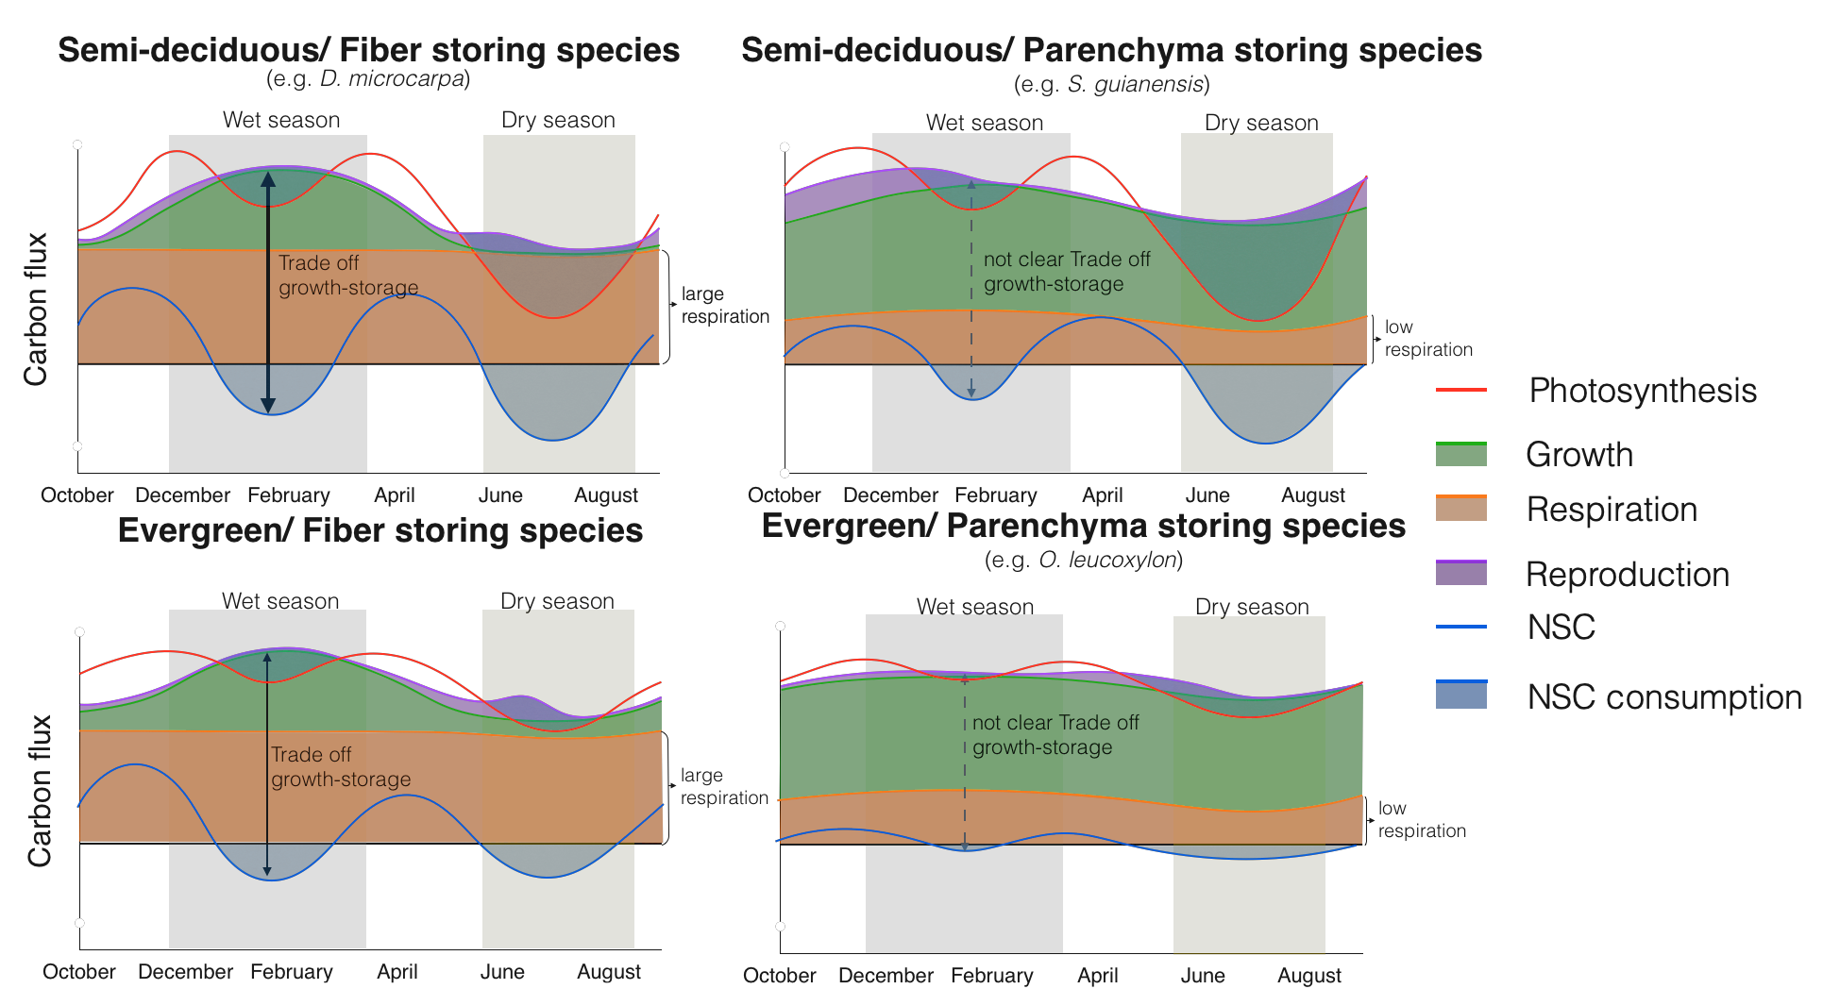

**Figure 1:** Conceptual framework that relates the differences in carbon dynamics for trees with different combinations of two functional traits: leaf habit and storage strategy of starch in the stem wood. Here we show the seasonal behavior of carbon sources - photosynthesis (red line)- and carbon sinks - growth (green), respiration (orange), and reproduction (purple) - and their interactions with NSC storage or consumption (blue line). Expected trade-offs between growth and storage are indicated by black arrows and the thickness of the line indicates the strength of the trade-off. Thus, thicker and darker lines indicate strong trade-offs, and dashed and lighter lines indicate weaker or less clear trade-offs. The seasonal patterns of photosynthesis are taken from the phenological observations of leaves reported in Fig. S2.

# Methods

# 2.1. Site description

This study was conducted in a transitional forest between the Amazon rainforest and the Cerrado, located at Tanguro Ranch, Mato Grosso, Brazil. It is a seasonally dry forest with mean annual precipitation of 1770 mm distributed between the dry season (May to September) with less than 10 mm of precipitation per month and a wet season (October to April) with a mean precipitation of 150 mm per month (Fig. 2). Relative humidity follows a similar seasonal pattern, falling below 60% from June to September and above 80% from December to February (Fig. 2). The mean temperature is 25˚C with almost no seasonal variation throughout the year (data obtained from the local station at Tanguro Ranch, operated by the Instituto de Pesquisa Ambiental da Amazônia, IPAM).

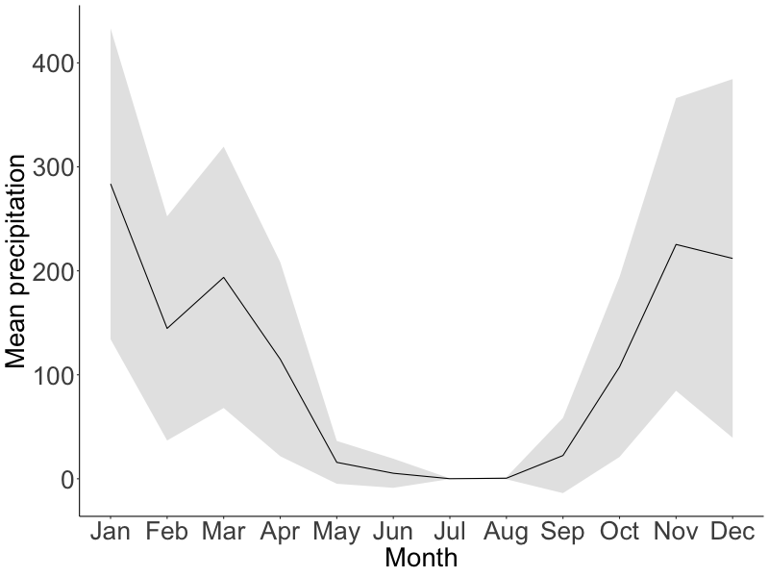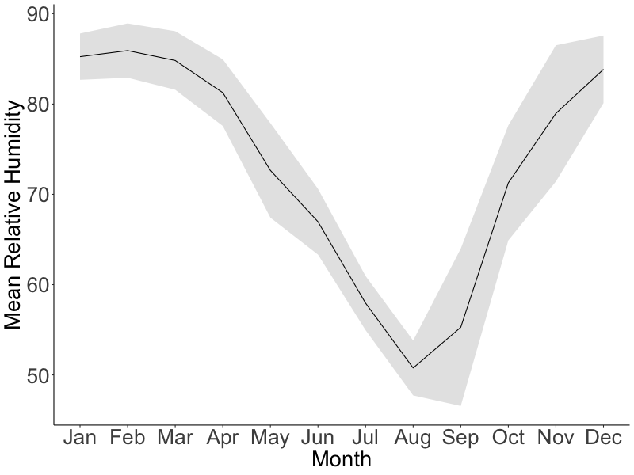

**Figure 2:** Mean seasonal course of monthly total precipitation (mm) and relative humidity (%) during 2016-2020 (black lines). Gray areas correspond to the standard deviation. Data provided by IPAM.

## 2.2. Species description

We selected three tree species previously shown to have contrasting starch storage strategies in wood, parenchyma-storing species and fiber-storing species (Herrera-Ramírez et al., 2021), different leaf habits (evergreen or semi-deciduous), and different growth and mortality rates (Table 1). These species are in the top 10 % of the most dominant species in the forest, together they represent the XX % of the species composition (Cite?). From each tree species we chose 12 mature and healthy trees reaching the canopy with a diameter at breast height (at 1.3 m, dbh) bigger than 20 cm (Table 1).

**Table 1**: Species names and traits: wood storage strategy, growth rates, mortality rates, phenology, and the sampling dates.

|  |  |  |  |  |
| --- | --- | --- | --- | --- |
| Species name | Growth rate  (cm/year) | Mortality rate   (%/year) | Storage strategy | Leaf phenology  (~% of annual leaf loss) |
| *Ocotea leucoxylon* (Sw.) Laness | 0.295 | 5.7 | Parenchyma | Evergreen (~30) |
| *Sacoglottis guianensis* Benth. | 0.72 | 5.0 | Parenchyma | Semi-deciduous (~45) |
| *Dacryodes microcarpa* Cuart. | 0.078 | 1.6 | Fiber | Semi-deciduous (~60) |

## 2.3. Sampling strategy

We sampled the selected 36 trees every three months from May 2019 to February 2020, specifically in May 2019 (transition from wet to dry season), August 2019 (dry season), November 2019 (transition from dry to wet season), and February 2020 (wet season). During each field campaign we took two wood cores (~ 5mm diameter and 20 cm long) approximately 10 cm away from the last collection point. We used one wood core to quantify starch distribution along the radial axis from bark to pith using the histological quantification method described in Herrera-Ramírez et al. (2021). The second wood core was used to incubate CO2 and estimate wood respiration rates. Wood cores were placed in ice immediately after collection and frozen at -18 ˚C within two hours in order to stop respiration. After freezing, they were dried at 60 ˚C for two days.

## 2.4. NSC seasonality

We quantified soluble sugars with a High-Performance Anion Exchange Chromatography with Pulsed Amperometric Detection (HPAE-PAD) following the protocols from Landhäusser et al. (2018). We quantified starch based on the histological method proposed by Herrera-Ramirez et al. (2021).

To quantify the starch concentration using the histological method we took 30 m thick slices and mounted them on a glass slide. The wood surface was covered with Lugol’s iodine solution for 3 minutes to stain starch grains and then covered with a coverslip. The stained samples were photographed using an optical digital microscope with a large depth-of-field (Keyence, VHX-6000, USA) within 3 hours. Panoramic images of the sample were taken at 300x magnification.

We quantified the percentage of starch in the samples by repeatedly measuring the areal percentage of starch coverage for each 1 mm2 area over the wood surface using the Image J software (Schneider et al., 2012). We divided the images into radial increments of 5 mm from bark to pith to measure the radial distribution of starch in the wood core. We measured starch in all 5 mm-increment sections until no starch was found in the wood. While doing so, we also manually eliminated artifacts from the images that may have interfered with the quantification. After preparing the images, we ran an automatic script for identifying and quantifying starch grains in multiple 1 mm2 regions of interest (ROI), randomly selected along the images (see supplementary material Methods S2 in Herrera-Ramírez et al. (2021) for details). After identifying all starch grains in a ROI, the script calculates the percentage of the surface area covered by starch. We measured 50 ROIs in each image of 5 mm segments of the stem increment core from bark to pith. We took the average of these 50 ROI measurements as an estimate of the percentage of starch for each of the 5 mm sections of the wood increment core. Measurements of the areal percentage covered by starch closely approximate the concentration of starch per gram of dry wood explaining 80% of the variability of starch concentrations measured by the HPAE-PAD (Herrera-Ramírez et al., 2021). Finally, we estimated the mass of starch per wood core by integrating the starch mass per 5 mm segment based on wood density, segment volume, and the measured percentage of starch per unit of volume along the radial path of the wood core from bark to pith.

To measure the concentration of sucrose, fructose and glucose (soluble sugars), with the HPAE-PAD (Landhäusser et al., 2018), we segmented the wood core in two depth ranges: 0-2 cm and 2-4 cm. These measurements were made only for 5 individuals per species and for samples taken in January (wet season) and July 2018 (dry season). Each wood core segment was ground to a fine powder using a ball mill (Retsch MM 400, Haan, Germany) at 25 Hz for 30 seconds and dried at 60 °C overnight. We weighed 50 mg of wood powder and mixed it with 1.5 ml of 80 % ethanol for 10 minutes at 90 ˚C in order to extract the soluble sugars. After cooling to room temperature, the samples were centrifuged at 13000 g for 2 minutes. The supernatant was recovered in a new vial, diluted, filtered, and then used for measuring three specific sugars (sucrose, fructose and glucose) by HPAE-PAD. For quality control we used blanks, standard solutions with known concentration of glucose, fructose and sucrose and internal standards made of a mix of tree leaf and branch samples as detailed in the protocol “*S3*" of Landhäusser et al. (2018). We estimated the average concentration of soluble sugars per wood core and compared between time points. Due to the low concentration of soluble sugars and their lack of seasonality, these measurements were not made in 2019, and we assumed that NSC storage dynamics are well represented by starch dynamics in these three tropical species, then we focused only on quantifying starch seasonal dynamics.

We used Wilcoxon signed-rank test to compare starch and soluble sugar mass and concentration between different sampling dates and different wood depths, in order to evaluate seasonality and differences between wood depths from bark to pith.

We estimated the seasonal changes in the starch mass (mg) between two consecutive sampling periods. Thus: the starch change observed in the dry season was the difference in the starch mass between May 2019 and August 2019 and we denominated it May19-Aug19; The starch change observed in the transition months from the dry to the wet season was the difference in starch mass between August 2019 and November 2019 (Aug19-Nov19); and the starch change observed during the wet season constituted the difference in starch mass between November 2019 and February 2020 (Nov19-Feb20). Unfortunately, due to the Covid 19 pandemic, we could not measure May 2020 to observe the change in starch mass during the transition months from the wet to the dry season (February 2020 to May 2020) and close the year of observations.

We also estimated the relative change of starch mass between the seasons previously described, for that we divided the starch change by the starch mass in the final month (equation 1).

(eq 1)

Where t2 is chronologically the second time point between seasons and t1 is the first time point.

We evaluated the significance of the relative starch change between seasons and we compared these relative changes between seasons and species by building 95% non-parametric confidence intervals for the mean using bootstrapping.

## 2.5. Sink activity measurements

We measured monthly stem growth with manual dendrometer bands (D1, Labcell Ltd, UK). These dendrometers were installed at breast height for each tree in July 2018, and measurements were collected monthly (by manually reading) until July 2020. We used three month moving averages of growth rates, which we calculated to reduce the effect of water dynamics in our growth data, capturing the average intra-annual radial growth variations (Zweifel et al., 2006, 2016). From these data we calculated annual growth for each tree during 2019 and compared it with the mean annual starch mass and the changes in the starch mass every three months. We used Wilcoxon signed-rank tests with 95% significance confidence to compare growth between months in each species and test for significant seasonal changes in growth for each species. We also estimated seasonal accumulated growth of the three months considering the seasons already described. We estimated Pearson’s correlations and linear regressions between the accumulated growth and starch changes in mass for each season in order to estimate seasonal trade-offs between storage and growth. Before doing so, we tested the data for normality and heteroscedasticity.

We measured wood respiration during the wet season (May) and the dry season (August) of 2019 by incubation of stem cores taken from each tree for a period of 36 hours following collection. The wood cores were cut at the depth in the stem we had previously identified where starch is depleted (6 cm for *O. leucoxylon*, 8 cm for *D. microcarpa* and 12 cm for *S. guianensis*). The cores were sealed in cylindrical chambers and incubated in parallel for 36 hours at ambient temperature (~25 ˚C). The produced CO2 was collected in custom made glass flasks. We purified the total amount of collected CO2 after cryogenic separation on a vacuum line, and the total sample volume by measuring the pressure at room temperature. Flask volumes were calculated individually by filling with water and weighing. Then we calculated the respiration rate for each sample by dividing the total amount of collected CO2 (in mg C) by the incubation time and wood volume of the incubated core segment. We used Wilcoxon rank test to compare respiration between seasons and between species.

We used previous observations of leaf, flower and fruit phenology patterns to estimate other carbon source and sink fluxes such as photosynthesis and reproduction. These observations were made for each species at this location over the last 8 years. The percentage of crown coverage of young leaves, mature leaves, flowers and fruits have been recorded monthly from selected species. The patterns were classified in 5 categories (0, 25, 50, 75 and 100%). We used these data to estimate seasonal changes in the phenological data by fitting a smoothing spline model to the monthly data (Fig. S2). We used this phenological data to give an idea of the contribution of flowering and fruiting to the seasonal sink carbon fluxes but we did not measure the amount of carbon allocated to these fluxes. Then in relative terms we expect a higher flux of carbon to reproduction whenever there is more presences of the fruiting and flowering throughout the year. We report this data in the Fig. S2.

# Results

## 3.1. Seasonality of starch mass, growth and respiration

Starch and soluble sugar concentrations decreased radially across the sapwood from bark to pith for all species for all sampling dates (Fig. 3). The soluble sugars concentration was always very low (up to 2 %) for all species and we did not find significant differences between the wet and dry season of 2018 (Fig. S1). Therefore, they were not measured for 2019. For these species starch represented the 70, 85 and 90 % of the stored NSC for *D. microcarpa, S. guianensis* and *O. leucoxylon*, respectively. Therefore, we assumed that NSC dynamics are mainly represented by starch changes over time.

We found significant differences in the starch mass of the entire wood core between sampling dates for the semi-deciduous species *D. microcarpa* (*p*=0.01) and marginally significant for the semi-deciduous species *S. guianensis* (*p* = 0.059, Fig. 4), while the evergreen species *O. leucoxylon* did not show significant changes in starch mass in the stem wood during 2019 (p>0.1). Seasonality of starch mass changed at each wood depth (Fig. 3). For instance, *D. microcarpa* and *O. leucoxylon* showed the largest change in starch mass in the first radial 20mm of wood from bark to pith, while *S. guianensis* showed the largest changes in starch mass at around 80mm deep in the wood (Fig. 3). Interestingly, despite the small changes in mass, starch was totally remobilized from the deepest layers of wood during the dry season in all the species, showing high metabolic activity of deep sap wood and the capacity of these species to totally remobilized the stored starch from the deepest living layers of wood when it is needed.

We found a marginal significant effect of the storage strategy on the starch seasonality (*p*=0.055, Fig. S3). Seasonal changes in starch mass were stronger for the fiber-storing species *D. microcarpa* (*Fig. S3*) than in the parenchyma-storing species *S. guianensis* and *O. leucoxylon* (*Fig. S3*). *D. microcarpa* trees reduced significantly their starch content during the period May19-Aug19 by around -0.75% (*ci*: -1.15, -0.37, Fig. S3), while *S. guianensis* had significant gains in starch content from May 2019 to February 2020 by around 0.25% (*ci*: 0.06, 0.53, Fig. S3).

Seasonality in growth rates during 2019 were only significant for the fiber-storing species *D. microcarpa (p<0.05, Fig. 5)*. These trees grew slower during the dry season and faster during the wet season (Fig. 5). The two parenchyma-storing species did not show a clear seasonal pattern (*p*>0.1, for all comparison between all months), although a slight decrease in growth rates during the dry season can be noticed for both species in Fig. 5.

Wood respiration was higher in the fiber-storing species *D. microcarpa* than in the parenchyma-storing species *S. guianensis* and *O. leucoxylon* (*p<0.01, Fig. 6*). Nevertheless, the differences between wet and dry season in 2019 were not statistically significant for any of the species (Fig. 6).

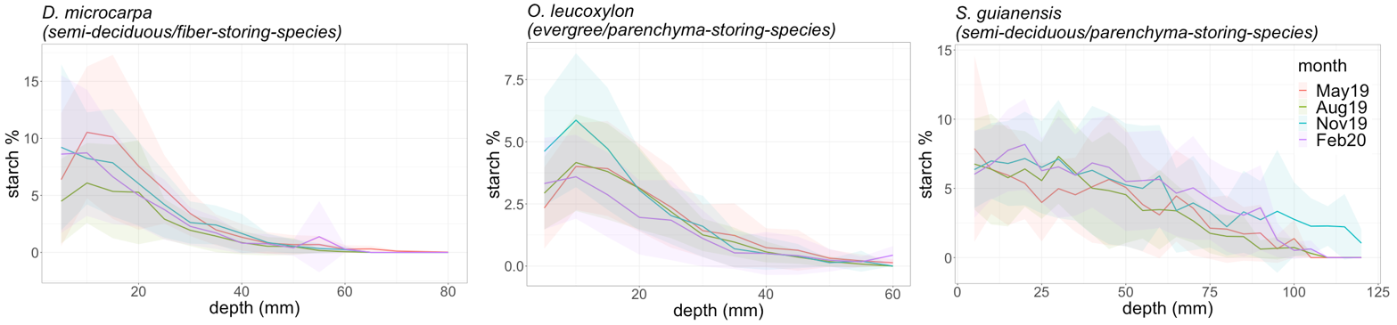

*Figure 3: Radial distribution of starch concentrations measured in 4 months during 2019. The concentrations were measured in the wood core every 5 mm from bark to pith until starch disappeared completely from the wood sample. The shadowed areas correspond to the standard variation of the measurements at each depth point.*

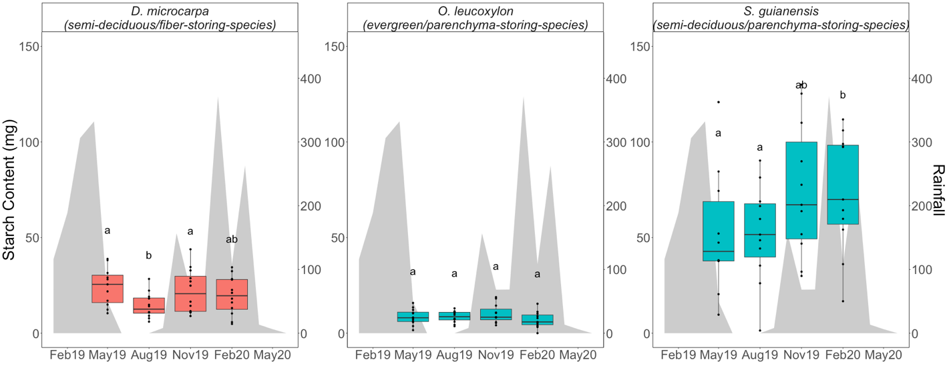

**Figure 4:** Box-plots that show the dispersion of the starch mass measured in the wood cores from trees of each evaluated species at different times/seasons during 2019. The yellow shaded area corresponds to the dry season, while the blue shaded areas correspond to the wet season. Differences between groups are indicated by different letters (with 90% confidence) above the box-plots and were tested with Wilcoxon signed-rank tests. Blue boxplots represent the parenchyma storing species while red boxplots represent fiber storing species. Shaded areas correspond to the precipitation in the corresponding months and its values are shown in the right axis.

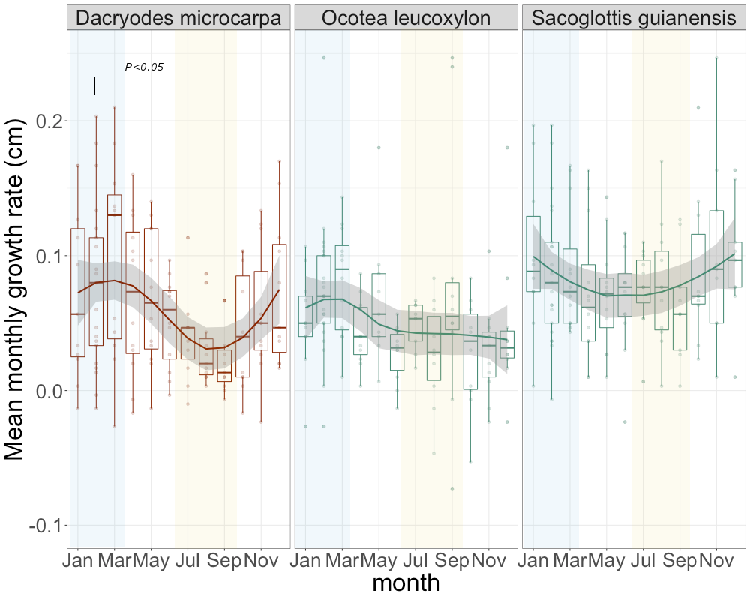

**Figure 5:** Seasonal trend of growth rates for the three species evaluated. Solid lines show the smoothing trends, while the dispersion of the measurements is shown by box-plots. The horizontal lines inside the box-plots show the median of the distribution of the measurements. Yellow shaded areas indicate the dry season and blue shaded areas indicate the wet season.

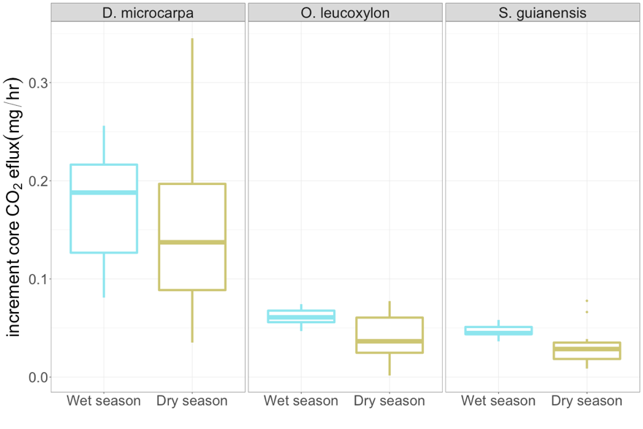

**Figure 6:** Box-plots showing the dispersion of the measured CO2 efflux from the stem core of the studied trees during the wet and the dry seasons of 2018, for each species. There were no significant differences between the wet and dry seasons for any species.

## 3.3. Accumulation and consumption of starch and the Storage-growth trade-offs

We only observed a strong significant consumption of starch during the dry season for the fiber storing species *D. macrocarpa* (Fig. 4 and Fig. S3)*.*  The parenchyma-storing species (*S. guianensis* and *O. leucoxylon*) did not show a significant accumulation or consumption of starch during the dry season (Fig. S3). Nevertheless, our data suggest that *S. guianensis* may have a strong consumption of starch during the transition months between the wet and the dry season from February to May (Fig. 4).

We observed a marginally significant consumption of starch during the wet season for the fiber-storing species *D. microcarpa* (Fig. S3) and a significant consumption for the evergreen/parenchyma-storing species *O. leucoxylon* (Fig. S3). Accumulation of starch happened clearly during the transition from the dry to the wet season August 2019 to November 2020 in the fiber-storing species trees (*D. macrocarpa*); for the parenchyma-storing species (*S. guianensis*) it took longer to detect a significant accumulation of starch, from May 2019 to February 2020 (Fig. S3).

We observed a negative correlation between the accumulated three months of growth (December, January and February) and changes in starch mass during the wet season between November 2019 and February 2020 (*p* = 0.05, r2 = 0.36), f. During this period some trees consumed starch while they grew fast and some other individuals accumulated it instead and had lower growth rates (Fig. 7). For this species most of the individuals consumed large quantities of starch during the dry season (from May 2019 to August 2019), but this was not related with growth (Fig. 7).

For the parenchyma-storing species *O. leucoxylon* and *S. guianensis* the storage-growth trade-offs were less clear or inexistent. We did not observe any significant correlation when we compared simultaneous growth and starch change in each season. Nevertheless, we found significant correlations when a three-month time lag was considered between growth and starch change for these species. For instance, we observed a negative correlation between the change in starch mass during the transition months from the dry to the wet season (from August 2019 to November 2019) and the three months of accumulated growth of the wet season (from November 2019 to February 2020), for *O. leucoxylon* (*p*=0.03). For *S. guianensis* this trend is also noticed but it is not significant (*p*=0.1, r2=0.38).

We observed that starch mass from the whole tree core was related to annual stem growth, but there were differences between storage strategies. The storage-growth trade-off trend was still distinguishable for the fiber-storing species *D. microcarpa*, which showed a not significant negative relationship between the starch mass in February 2020 and the annual growth calculated from February 2019 to February 2020 (*p*=0.11, r2=0.31, Fig. S4). There is more statistical support for a significant relationship, but it is still very marginal (*p*=0.08, r2=0.30), if we consider only the mean growth during the growing season and compare it with the starch mass measured in February. The semi-deciduous/parenchyma-storing species (*S. guianensis*) showed positive correlation between annual growth and starch mass during the dry season (August 2019, *p=0.003,*  r2= 0.79, Fig. S4), and it also showed a positive correlation between annual growth and starch mass in the wet season, although it was weaker (February 2020, p=0.05, r2=0.51, Fig. S4). Evergreen/parenchyma-storing species (*O. leucoxylon*) showed a marginal positive relationship between starch mass in May 2019 (transition month 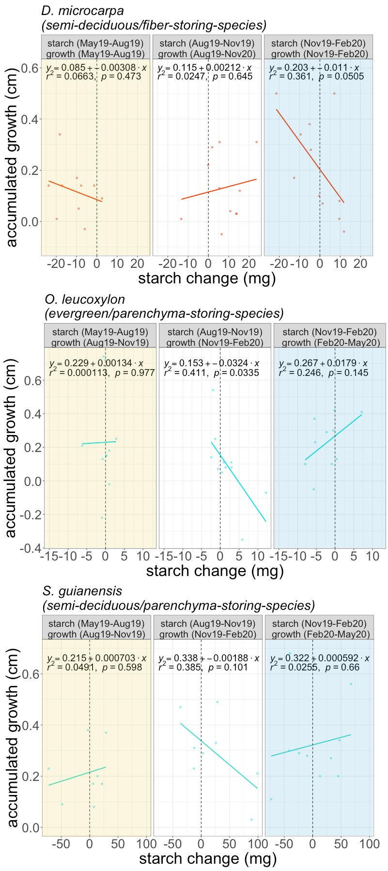between the wet and the dry seasons) and the annual stem growth (*p*=0.088, r2=0.4, Fig. S4).

**Figure 7:** Relationship between changes in starch mass (accumulation or consumption of starch) and three-month growth in 2019 for the three species studied. The dotted line marks the 0, points on the left indicate starch consumption and those on the right indicate scratch accumulation. The dry season is indicated by shaded yellow areas, while the wet season is indicated by shaded blue areas. 

1. **Discussion**

Our results relate differences in carbon dynamics in mature trees to life history traits such as starch storage strategy and leaf habit and allowed us summarized them in a conceptual framework (Fig. 1). Unfortunately, we only evaluated three of the four conceptualized groups in our framework, but we expect that differences in terms of carbon fluxes between fiber-storing species are not significant. We found that the slow growing semi-deciduous/fiber-storing species *Dacryodes microcarpa* showed stronger seasonality in starch mass and growth rates than the other functional groups. For such species, storing large amounts of starch is fundamental to meet the future high carbon demand for respiration, due to the large volume of living stem tissue (parenchyma and living fibers), resulting in a lower and more seasonal allocation of carbon to growth. This would likely benefit plant competition/survival and result in low mortality rates (e.g. Table 1). Reducing wood growth during stressful periods would help trees to reduce pressure on energy resources and release them to keep cells alive (Huang et al., 2019; Huang et al., 2021). The slow-growing evergreen/parenchyma-storing species (*Ocotea leucoxylon*) showed no seasonal variability in growth, respiration and starch mass. Nevertheless, it showed a significant consumption of starch during the wet season. For The fast-growing semi-deciduous/parenchyma-storing species *Sacoglottis guianensis* we found marginal seasonality in starch mass, where starch was accumulated towards the wet season from November to February. We did not detect significant consumption of starch during the wet or the dry season. Nevertheless, our data suggest a strong starch consumption in the transition between the wet and the dry season from February 2020 and May 2019, unfortunately we have no data from this period. For this species we observed no seasonal variability in growth and respiration, therefore strong consumption and accumulation of starch may respond mainly to changes in photosynthesis. This suggests that these parenchyma-storing species probably prioritize growth over storage in the long run, probably resulting in a higher vulnerability to stressful environmental changes resulting in higher mortality rates than fiber-storing species (Table 1).

Our conceptual framework and measurements also suggest the differential occurrence of seasonal growth-storage trade-offs between different starch storage strategies (Fig. 1). Negative correlations between growth and storage occurred during the wet season for the slow-growing fiber-storing species, mainly because of the strong seasonality in growth rates and starch (Fig. 7). This suggests that these species may better regulate carbon sink activity to ensure long-term storage. These trade-offs were less evident or not significant in parenchyma-storing species (Fig 7), probably reflecting the use of reserves for another metabolic needs such as reproduction (Fig. S2, Blumstein et al., 2022, Hartmann and Trumbore 2016). Our conceptual framework in conjunction with our results help us to improve our understanding of the carbon dynamics in mature trees and provides insights into the mechanisms behind starch accumulation and use and its interplay with carbon sources and sinks that may lead to plant survival in tropical forests.

## 4.1. Semi-deciduous and fiber-storing species have seasonal changes of starch

As we expected, leaf habit and storage strategy of starch in the wood influence the seasonal fluctuation of starch in the stem wood. Semi-deciduous species showed significant starch seasonality (*p*=0.001), while evergreen species did not. Semi-deciduous trees may experience large imbalances between carbon sources and sinks during the dry season due to the high demand for carbon to rebuild the canopy, therefore showing larger seasonal changes in starch mass than evergreen species (Kozlowski, 1992; Hoch et al., 2003; Würth et al., 2005; Richardson et al., 2013; Furze et al., 2018). This is consistent with studies showing strong seasonality in temperate deciduous species but not in evergreen species (Chapin et al., 1990; Piispanen and Saranpää, 2001; Trumbore et al., 2015; Martínez-Vilalta et al., 2016; Furze et al., 2018). Our results support the idea that semi-deciduous trees are more dependent on NSC storage than evergreen species in seasonally dry tropical forests. Nevertheless, a larger number of species and longer time series of NSC dynamics should be examined to confirm these patterns. Histological methods provide a rapid and convenient method for quantifying starch storage that can support observations in a high number of species over the longer term.

Our results also suggest that starch storage strategy also influences the seasonal dynamics of NSC (Fig. S3). In terms of soluble sugars, all species showed very low concentrations with no apparent seasonality. In addition, only one species (*D. macrocarpa*) showed accumulation of lipids, also in lower concentrations than starch (Herrera-Ramirez et al., 2021). Therefore, for these species, starch seasonal changes seem to be a good proxy for NSC seasonality. So far, the fiber-storing species (*D. microcarpa*) had larger seasonal changes in starch mass than parenchyma-storing species (Fig. S3). This provides us some insights into the mechanisms behind carbon dynamics. In fiber-storing species, the high seasonal carbon consumption may be caused by the larger proportion of living cells in the stem, which require more carbon for respiration than the smaller proportion of living cells in parenchyma-storing species (Fig. 5). This high metabolic cost may compete for carbon resources with other carbon sinks such as growth during the dry season, probably leading to a seasonal growth and a high reliance on storage to keep cells alive during low photosynthetic periods. Nevertheless, having living fibers allow trees to use a larger wood volume to store starch to cover all metabolic demands, which probably would reduce their vulnerability to starve.

## 4.2. Fiber-storing species have larger plasticity in wood growth rates but not in respiration rates

Trees growing in a seasonally dry environment should balance their carbon sources and sinks in order to survive recurrent stressful conditions. The fast growing, parenchyma-storing species *S. guianensis* kept radial growth relatively constant throughout the year, whereas the slow-growing, fiber-storing species *D. microcarpa* significantly reduced growth during the dry season. Thus, these trees, with contrasting storage strategies and respiratory demands, differentially adjust their balance between carbon sources and sinks during seasonally dry conditions (Fig. 1). It is important to note that radial growth is not the only form of growth in trees and other type of growth can be differentially adjusted or prioritized. Nevertheless, reducing wood growth rates during low productivity periods may make trees more tolerant to a wider range of environmental conditions.

Contrary to the growth patterns described above, wood respiration showed no seasonal changes for any of the species evaluated during the year of measurements (Fig. 5). No changes in respiration between dry and wet seasons in tropical forest trees have been previously reported (Asao et al., 2015). Nevertheless, it has been shown that some trees can regulate stem CO2 efflux to adapt to certain environmental conditions such as seasonal changes in precipitation and temperature, releasing resources for other metabolic activities (Teskey et al., 2008; Huang et al., 2019; Sierra et al., 2022). Then, it may also be possible that the dry period of 2019 was not strong enough to induce changes in CO2 efflux, and longer time series of wood respiration are needed to confirm this pattern.

Wood respiration was greater in fiber-storing species (*D. microcarpa)*, probably because the proportion of living cells in the wood in these species, which is all parenchyma plus living fibers, is larger than in parenchyma-storing species (*S. guianensis* and *O. leucoxylon*), where respiration was lower. Therefore, fiber-storing species may have greater carbon requirements to keep all living wood tissue alive, which may potentially reduce their ability to regulate respiration seasonally. These results suggest that wood anatomical traits such as living fibers may indicate a large carbon demand for respiration that may heavily compete with other carbon sinks such as growth, leading these trees to have a stronger regulation of growth rates and have a high reliance on storage. Then, this suggests that the proportion of living wood biomass may have a larger control over wood respiration than environmental conditions.

## 4.3. Starch is consumed during the peak of the dry and the wet season

Our results show that, for most trees, starch seems to be consumed not only during the peak of the dry season but also during the peak of the wet season (Fig 7, Fig S3). This is clear for *D. microcarpa* and *O. leucoxylon* trees but we did not observe a starch consumption during the wet season for *S. guianensis* (Fig S3). We would assume that trees may recharge the carbon storage pools during the wet season because of favorable conditions for growth and less photosynthesis limitations (Dietze et al., 2014). Nevertheless, the consumption of starch during the wet season suggests a negative carbon balance in these trees. There could be several reasons for this: For fiber-storing trees (*D. microcarpa*), it is possible that the carbon demand of wood growth (which is the highest during the wet season) and respiration exceeds the supply of new photoassimilates. In addition, some other sink activities such as reproduction may also contribute to a greater carbohydrate demand during the wet season (Hartmann and Trumbore, 2016, Fig. S2). For instance, both *D. microcarpa* and *S. guianensis* produced flowers and fruit during the wet season (Fig. 1, Fig. S2), which may constitute a large demand for carbon reserves (Hartmann and Trumbore, 2016; Blumstein et al., 2022). This suggest that for some tree species, flowering and fruiting may be a significant carbon sink that can influence the NSC seasonal dynamics, probably contributing to deplete NSC during the wet season. Alternatively, the rainy season comes with its own dangers that put pressure on available NSC. During the rainy season, blowdowns, storms and lightning can cause physical damage to trees, as well as an increase on herbivory or fungal infections increasing the risk of individual mortality (Zuleta et al., 2022, Aleixo et al., 2019). Rebuilding the lost tissue during the wet season, or building up defense compounds could represent a large demand on NSC (Huang et al., 2021). Thus, trees that, in the transition months between the wet and the dry seasons, may have not replenished their NSC reserves and repaired damage may be vulnerable and susceptible to die when facing stress (Anderegg et al., 2013; Arellano et al., 2019; Aleixo et al., 2019).

## 4.4. Storage-growth trade-offs occur in the fiber storing species during the wet season

Seasonal patterns in starch mass showed us when trees consumed and accumulate stem NSC. Our results indicate a trade-off between starch consumption/accumulation and growth only during the wet season for the fiber-storing species *D. microcarpa*. For the parenchyma-storing species (*O. leocoxylon* and *S. guianensis*) storage-growth trade-offs were not clear. Nevertheless, it is important to clarify that these storage-growth trade-offs may change when other forms of growth are considered. Potentially, other starch storage tissues such as phloem (Rosell et al., 2021) or roots (Hillman et all., 2021) may offer different insights into these trade-offs.

Identifying these trade-offs with field measurements is challenging (Blumstein et al., 2022). Here we show that annual estimates of starch mass and growth may hide the seasonal trade-offs between these two variables (Fig. S4). This may be influenced by the fact that one time point measurement of starch mass is the result of the past fluctuations of the carbon balance in the plant and therefore may not reflect the actual growing conditions of trees. Also, trade-offs may be affected by variations in carbon supply. Individuals with higher photosynthetic capacity, may be more able to invest more in both growth and storage than individuals with lower photosynthetic capacity (Blumstein et al., 2022), as might have been the case for our parenchyma-storing species. These two parenchyma-storing species grew faster than the fiber-storing species and the correlation between annual growth and starch mass was positive for both species during the dry season (Aug19) for *S. guianenesis* and during the transition months from wet to dry season (May 19) for *O. leucoxylon*. For more conservative species, such as the fiber-storing species, trade-offs between starch mass and growth were still observed during the wet season (Fig. S4). Our results suggest that these trade-offs may not be reflected in the annual carbon balance, but would only be evident on a seasonal basis. Therefore, evaluating seasonal changes in starch mass (rather than mean storage mass per year or max starch storage per year) in relation to seasonal growth can better inform us about when and under what conditions such trade-offs occur, avoiding the influence of some confounding factors when annual averages are used.

Evidence for growth-storage trade-offs is growing in the literature and has been linked to survival (Wright et al., 2004; Poorter and Kitajima, 2007; O’Brien et al., 2014, 2015; Klein and Hoch, 2015; D’Andrea et al., 2019, 2020). Studies comparing highly conservative species and highly competitive species in surviving stressful environmental conditions are needed to further understand how variation in storage-growth trade-offs are maintained across space and time. Our results are a good indication that highly conservative, slow-growing, and high-storing species, such as fiber-storing species (e.g., *D. microcarpa*), may have stronger trade-offs between starch storage and growth, indicating a greater plasticity in their sink activity, or/and a higher prioritization of storage, than parenchyma-storing species. Life history traits such as low growth and low mortality are associated with highly conservative species and are a good proxy for tree longevity (Wright et al., 2004; Herrera-Ramírez et al., 2021; Piovesan and Biondi, 2021). Therefore, we would expect that as stressors intensify, highly conservative trees, such as fiber-storing species, would have higher survival rates and would become more competitive in seasonally dry forests. Future work should focus on understanding how these storage strategies are distributed in forest communities and how their different storage-growth trade-offs affect productivity and species survival in tropical forests under climate change.

# 5. Acknowledgments

We want to thank the Max Planck Society, the Friedrich-Schiller University and the German Research Foundation (SI 1953/2-1) for the founding of this project. Also, we received funding from the EU, through the German Bundesanstalt für Landwirtschaft und Ernährung FKZ: 2816ERA03W (to S. T.); the Brazilian council for Scientific and Technological Development - CNPq (PELD/CNPq No. 441703/2016-0; No. 441940/2020-0; UNIVERSAL No. 430149/2018-2); and DH and ST acknowledge the support from the Balzan foundation.

**6. Author contributions**

DH-R, CAS, HH, CR, ST, and JM, conceived the idea, conceptualized the hypothesis, and planned the data collection and the experiments. DH, LM and DS collected and analyzed data. DH and IK performed sample analysis and quantification. DH-R wrote the manuscript. DH-R, HH, CR, ST, JM, LM, PB, DS, HJ, IK, and CAS contributed significantly to the writing of the manuscript and gave important and critical input. All authors revised the manuscript.

**7. Data accessibility statement**

The data here presented will be stored in an open GitHub repository once the manuscript is accepted.

# 8. References

Adams, H. D., Zeppel, M. J. B., Anderegg, W. R. L., Hartmann, H., Landhäusser, S. M., Tissue, D. T., et al. (2017). A multi-species synthesis of physiological mechanisms in drought-induced tree mortality. *Nature Ecology & Evolution* 1, 1285–1291. doi:[10.1038/s41559-017-0248-x](https://doi.org/10.1038/s41559-017-0248-x).

Aleixo, I., Norris, D., Hemerik, L., Barbosa, A., Prata, E., Costa, F., et al. (2019). Amazonian rainforest tree mortality driven by climate and functional traits. *Nature Climate Change* 9, 384–388. doi:[10.1038/s41558-019-0458-0](https://doi.org/10.1038/s41558-019-0458-0).

Anderegg, W. R. L., Berry, J. A., Smith, D. D., Sperry, J. S., Anderegg, L. D. L., and Field, C. B. (2012). The roles of hydraulic and carbon stress in a widespread climate-induced forest die-off. *Proceedings of the National Academy of Sciences* 109, 233–237. doi:[10.1073/pnas.1107891109](https://doi.org/10.1073/pnas.1107891109).

Anderegg, W. R. L., Kane, J. M., and Anderegg, L. D. L. (2013). Consequences of widespread tree mortality triggered by drought and temperature stress. *Nature Climate Change* 3, 30–36. doi:[10.1038/nclimate1635](https://doi.org/10.1038/nclimate1635).

Arellano, G., Medina, N. G., Tan, S., Mohamad, M., and Davies, S. J. (2019). Crown damage and the mortality of tropical trees. *New Phytologist* 221, 169–179. doi:[https://doi.org/10.1111/nph.15381](https://doi.org/https:/doi.org/10.1111/nph.15381).

Arx, G. von, Arzac, A., Fonti, P., Frank, D., Zweifel, R., Rigling, A., et al. (2017). Responses of sapwood ray parenchyma and non-structural carbohydrates of pinus sylvestris to drought and long-term irrigation. *Functional Ecology* 31, 1371–1382. doi:[10.1111/1365-2435.12860](https://doi.org/10.1111/1365-2435.12860).

Asao, S., Bedoya-Arrieta, R., and Ryan, M. G. (2015). Variation in foliar respiration and wood CO2 efflux rates among species and canopy layers in a wet tropical forest. *Tree Physiology* 35, 148–159. doi:[10.1093/treephys/tpu107](https://doi.org/10.1093/treephys/tpu107).

Barbaroux, C., and Bréda, N. (2002). Contrasting distribution and seasonal dynamics of carbohydrate reserves in stem wood of adult ring-porous sessile oak and diffuse-porous beech trees. *Tree Physiology* 22, 1201–1210. doi:[10.1093/treephys/22.17.1201](https://doi.org/10.1093/treephys/22.17.1201).

Blumstein, M., Sala, A., Weston, D. J., Holbrook, N. M., and Hopkins, R. (2022). Plant carbohydrate storage: Intra- and inter-specific trade-offs reveal a major life history trait. *New Phytologist* 235, 2211–2222. doi:[https://doi.org/10.1111/nph.18213](https://doi.org/https:/doi.org/10.1111/nph.18213).

Carlquist, S. (2013). Fibre dimorphism: Cell type diversification as an evolutionary strategy in angiosperm woods. *Botanical Journal of the Linnean Society* 174, 44–67. doi:[10.1111/boj.12107](https://doi.org/10.1111/boj.12107).

Chapin, F. S., Schulze, E., and Mooney, H. A. (1990). The ecology and economics of storage in plants. *Annual Review of Ecology and Systematics* 21, 423–447. doi:[10.1146/annurev.es.21.110190.002231](https://doi.org/10.1146/annurev.es.21.110190.002231).

Dietze, M. C., Sala, A., Carbone, M. S., Czimczik, C. I., Mantooth, J. A., Richardson, A. D., et al. (2014). Nonstructural carbon in woody plants. *Annual Review of Plant Biology* 65, 667–687. doi:[10.1146/annurev-arplant-050213-040054](https://doi.org/10.1146/annurev-arplant-050213-040054).

D’Andrea, E., Rezaie, N., Battistelli, A., Gavrichkova, O., Kuhlmann, I., Matteucci, G., et al. (2019). Winter’s bite: Beech trees survive complete defoliation due to spring late-frost damage by mobilizing old c reserves. *New Phytologist* 224, 625–631. doi:[https://doi.org/10.1111/nph.16047](https://doi.org/https:/doi.org/10.1111/nph.16047).

D’Andrea, E., Rezaie, N., Prislan, P., Gričar, J., Collalti, A., Muhr, J., et al. (2020). Frost and drought: Effects of extreme weather events on stem carbon dynamics in a mediterranean beech forest. *Plant, Cell & Environment* 43, 2365–2379. doi:[https://doi.org/10.1111/pce.13858](https://doi.org/https:/doi.org/10.1111/pce.13858).

Furze, M. E., Huggett, B. A., Chamberlain, C. J., Wieringa, M. M., Aubrecht, D. M., Carbone, M. S., et al. (2020). Seasonal fluctuation of nonstructural carbohydrates reveals the metabolic availability of stemwood reserves in temperate trees with contrasting wood anatomy. *Tree Physiology* 40, 1355–1365. doi:[10.1093/treephys/tpaa080](https://doi.org/10.1093/treephys/tpaa080).

Furze, M. E., Trumbore, S., and Hartmann, H. (2018). Detours on the phloem sugar highway: Stem carbon storage and remobilization. *Current Opinion in Plant Biology* 43, 89–95. doi:[https://doi.org/10.1016/j.pbi.2018.02.005](https://doi.org/https:/doi.org/10.1016/j.pbi.2018.02.005).

Galiano, L., Timofeeva, G., Saurer, M., Siegwolf, R., Martínez-Vilalta, J., Hommel, R., et al. (2017). The fate of recently fixed carbon after drought release: Towards unravelling c storage regulation in tilia platyphyllos and pinus sylvestris. *Plant, Cell & Environment* 40, 1711–1724. doi:[https://doi.org/10.1111/pce.12972](https://doi.org/https:/doi.org/10.1111/pce.12972).

Hartmann, H., and Trumbore, S. (2016). Understanding the roles of nonstructural carbohydrates in forest trees from what we can measure to what we want to know. *New Phytologist* 211, 386–403. doi:[10.1111/nph.13955](https://doi.org/10.1111/nph.13955).

Hartmann, H., McDowell, N. G., and Trumbore, S. (2015). Allocation to carbon storage pools in Norway spruce saplings under drought and low CO2. *Tree Physiology* 35, 243–252. doi:[10.1093/treephys/tpv019](https://doi.org/10.1093/treephys/tpv019).

Hartmann, H., Ziegler, W., and Trumbore, S. (2013). Lethal drought leads to reduction in nonstructural carbohydrates in norway spruce tree roots but not in the canopy. *Functional Ecology* 27, 413–427. doi:[https://doi.org/10.1111/1365-2435.12046](https://doi.org/https:/doi.org/10.1111/1365-2435.12046).

Herrera-Ramírez, D., Sierra, C. A., Römermann, C., Muhr, J., Trumbore, S., Silvério, D., et al. (2021). Starch and lipid storage strategies in tropical trees relate to growth and mortality. *New Phytologist* 230, 139–154. doi:[https://doi.org/10.1111/nph.17239](https://doi.org/https:/doi.org/10.1111/nph.17239).

Hoch, G., Richter, A., and Körner, C. (2003). Non-structural carbon compounds in temperate forest trees. *Plant, Cell & Environment* 26, 1067–1081. doi:[10.1046/j.0016-8025.2003.01032.x](https://doi.org/10.1046/j.0016-8025.2003.01032.x).

Huang, J., Hammerbacher, A., Gershenzon, J., Dam, N. M. van, Sala, A., McDowell, N. G., et al. (2021). Storage of carbon reserves in spruce trees is prioritized over growth in the face of carbon limitation. *Proceedings of the National Academy of Sciences* 118, e2023297118. doi:[10.1073/pnas.2023297118](https://doi.org/10.1073/pnas.2023297118).

Huang, J., Rücker, A., Schmidt, A., Gleixner, G., Gershenzon, J., Trumbore, S., et al. (2020). Production of constitutive and induced secondary metabolites is coordinated with growth and storage in Norway spruce saplings. *Tree Physiology* 40, 928-942. doi:<https://doi.org/10.1093/treephys/tpaa040.>

Huang, J., Hammerbacher, A., Weinhold, A., Reichelt, M., Gleixner, G., Behrendt, T., et al. (2019). Eyes on the future – evidence for trade-offs between growth, storage and defense in norway spruce. *New Phytologist* 222, 144–158. doi:[https://doi.org/10.1111/nph.15522](https://doi.org/https:/doi.org/10.1111/nph.15522).

Klein, T., and Hoch, G. (2015). Tree carbon allocation dynamics determined using a carbon mass balance approach. *New Phytologist* 205, 147–159. doi:[10.1111/nph.12993](https://doi.org/10.1111/nph.12993).

Kozlowski, T. T. (1992). Carbohydrate sources and sinks in woody plants. *The Botanical Review* 58, 107–222. doi:[10.1007/BF02858600](https://doi.org/10.1007/BF02858600).

Körner, C. (2003). Carbon limitation in trees. *Journal of Ecology* 91, 4–17. doi:[https://doi.org/10.1046/j.1365-2745.2003.00742.x](https://doi.org/https:/doi.org/10.1046/j.1365-2745.2003.00742.x).

Landhäusser, S. M., Chow, P. S., Dickman, L. T., Furze, M. E., Kuhlman, I., Schmid, S., et al. (2018). Standardized protocols and procedures can precisely and accurately quantify non-structural carbohydrates. *Tree Physiology* 38, 1764–1778. doi:[10.1093/treephys/tpy118](https://doi.org/10.1093/treephys/tpy118).

Martínez-Vilalta, J. (2014). Carbon storage in trees: pathogens have their say. *Tree Physiology* 34, 215–217. doi:[10.1093/treephys/tpu010](https://doi.org/10.1093/treephys/tpu010).

Martínez-Vilalta, J., Sala, A., Asensio, D., Galiano, L., Hoch, G., Palacio, S., et al. (2016). Dynamics of non-structural carbohydrates in terrestrial plants: A global synthesis. *Ecological Monographs* 86, 495–516. doi:[https://doi.org/10.1002/ecm.1231](https://doi.org/https:/doi.org/10.1002/ecm.1231).

Meir, P., Mencuccini, M., and Coughlin, S. I. (2020). Respiration in wood: Integrating across tissues, functions and scales. *New Phytologist* 225, 1824–1827. doi:[https://doi.org/10.1111/nph.16354](https://doi.org/https:/doi.org/10.1111/nph.16354).

Michelot, A., Simard, S., Rathgeber, C., Dufrêne, E., and Damesin, C. (2012). Comparing the intra-annual wood formation of three European species (Fagus sylvatica, Quercus petraea and Pinus sylvestris) as related to leaf phenology and non-structural carbohydrate dynamics. *Tree Physiology* 32, 1033–1045. doi:[10.1093/treephys/tps052](https://doi.org/10.1093/treephys/tps052).

Newell, E. A., Mulkey, S. S., and Wright, J. S. (2002). Seasonal patterns of carbohydrate storage in four tropical tree species. *Oecologia* 131, 333–342. doi:[10.1007/s00442-002-0888-6](https://doi.org/10.1007/s00442-002-0888-6).

O’Brien, M. J., Burslem, D. F. R. P., Caduff, A., Tay, J., and Hector, A. (2015). Contrasting nonstructural carbohydrate dynamics of tropical tree seedlings under water deficit and variability. *New Phytologist* 205, 1083–1094. doi:[https://doi.org/10.1111/nph.13134](https://doi.org/https:/doi.org/10.1111/nph.13134).

O’Brien, M. J., Leuzinger, S., Philipson, C. D., Tay, J., and Hector, A. (2014). Drought survival of tropical tree seedlings enhanced by non-structural carbohydrate levels. *Nature Climate Change* 4, 710 EP. Available at: <http://dx.doi.org/10.1038/nclimate2281>.

O’Brien, M. J., Valtat, A., Abiven, S., Studer, M. S., Ong, R., and Schmid, B. (2020). The role of soluble sugars during drought in tropical tree seedlings with contrasting tolerances. *Journal of Plant Ecology* 13, 389–397. doi:[10.1093/jpe/rtaa017](https://doi.org/10.1093/jpe/rtaa017).

Palacio, S., Hoch, G., Sala, A., Körner, C., and Millard, P. (2014). Does carbon storage limit tree growth? *New Phytologist* 201, 1096–1100. doi:[10.1111/nph.12602](https://doi.org/10.1111/nph.12602).

Piispanen, R., and Saranpää, P. (2001). Variation of non-structural carbohydrates in silver birch (betula pendula roth) wood. *Trees* 15, 444–451. doi:[10.1007/s004680100125](https://doi.org/10.1007/s004680100125).

Piovesan, G., and Biondi, F. (2021). On tree longevity. *New Phytologist* 231, 1318–1337. doi:[https://doi.org/10.1111/nph.17148](https://doi.org/https:/doi.org/10.1111/nph.17148).

Piper, F. I., and Paula, S. (2020). The role of nonstructural carbohydrates storage in forest resilience under climate change. *Current Forestry Reports* 6, 1–13. doi:[10.1007/s40725-019-00109-z](https://doi.org/10.1007/s40725-019-00109-z).

Piper, F. I., Gundale, M. J., and Fajardo, A. (2015). Extreme defoliation reduces tree growth but not C and N storage in a winter-deciduous species. *Annals of Botany* 115, 1093–1103. doi:[10.1093/aob/mcv038](https://doi.org/10.1093/aob/mcv038).

Plavcová, L., Hoch, G., Morris, H., Ghiasi, S., and Jansen, S. (2016). The amount of parenchyma and living fibers affects storage of nonstructural carbohydrates in young stems and roots of temperate trees. *American Journal of Botany* 103, 603–612. doi:[10.3732/ajb.1500489](https://doi.org/10.3732/ajb.1500489).

Poorter, L., and Kitajima, K. (2007). Carbohydrate storage and light requirements of tropical moist and dry forest tree species. *Ecology* 88, 1000–1011. doi:[https://doi.org/10.1890/06-0984](https://doi.org/https:/doi.org/10.1890/06-0984).

Resco de Dios, V., and Gessler, A. (2021). Sink and source co-limitation in the response of stored non-structural carbohydrates to an intense but short drought. *Trees* 35, 1751–1754. doi:[10.1007/s00468-021-02116-9](https://doi.org/10.1007/s00468-021-02116-9).

Richardson, A. D., Carbone, M. S., Keenan, T. F., Czimczik, C. I., Hollinger, D. Y., Murakami, P., et al. (2013). Seasonal dynamics and age of stemwood nonstructural carbohydrates in temperate forest trees. *New Phytologist* 197, 850–861. doi:[10.1111/nph.12042](https://doi.org/10.1111/nph.12042).

Rosell, J. A., Piper, F. I., Jiménez-Vera, C., Vergílio, P. C.,  Marcati, C. R., et al. (2021). Inner bark as a crucial tissue for non-structural carbohydrate storage across three tropical woody plant communities. *Plant, Cell & Environment*  44, 156– 170. [doi:10.1111/pce.13903](https://doi.org/10.1111/pce.13903)

Sala, A., Woodruff, D. R., and Meinzer, F. C. (2012). Carbon dynamics in trees: Feast or famine? *Tree Physiology* 32, 764–775. doi:[10.1093/treephys/tpr143](https://doi.org/10.1093/treephys/tpr143).

Salleo, S., Lo Gullo, M. A., Trifilò, P., and Nardini, A. (2004). New evidence for a role of vessel-associated cells and phloem in the rapid xylem refilling of cavitated stems of laurus nobilis l. *Plant, Cell & Environment* 27, 1065–1076. doi:[10.1111/j.1365-3040.2004.01211.x](https://doi.org/10.1111/j.1365-3040.2004.01211.x).

Schneider, C. A., Rasband, W. S., and Eliceiri, K. W. (2012). NIH image to imagej: 25 years of image analysis. *Nature Methods* 9, 671–675. doi:[10.1038/nmeth.2089](https://doi.org/10.1038/nmeth.2089).

Sevanto, and M., Sanna, Dickman, L Turin, Pangle, Robert E., and Pockman, W. T. (2014). How do trees die? A test of the hydraulic failure and carbon starvation hypotheses. *Plant, Cell & Environment* 37, 153–161. doi:[10.1111/pce.12141](https://doi.org/10.1111/pce.12141).

Sierra, C. A., Ceballos-Núñez, V., Hartmann, H., Herrera-Ramírez, D., and Metzler, H. (2022). Ideas and perspectives: Allocation of carbon from net primary production in models is inconsistent with observations of the age of respired carbon. *Biogeosciences* 19, 3727–3738. doi:[10.5194/bg-19-3727-2022](https://doi.org/10.5194/bg-19-3727-2022).

Teskey, R. O., Saveyn, A., Steppe, K., and McGuire, M. A. (2008). Origin, fate and significance of CO2 in tree stems. *New Phytologist* 177, 17–32. doi:[https://doi.org/10.1111/j.1469-8137.2007.02286.x](https://doi.org/https:/doi.org/10.1111/j.1469-8137.2007.02286.x).

Trumbore, S., Czimczik, C. I., Sierra, C. A., Muhr, J., and Xu, X. (2015). Non-structural carbon dynamics and allocation relate to growth rate and leaf habit in California oaks. *Tree Physiology* 35, 1206–1222. doi:[10.1093/treephys/tpv097](https://doi.org/10.1093/treephys/tpv097).

Wiley, E., and Helliker, B. (2012). A re-evaluation of carbon storage in trees lends greater support for carbon limitation to growth. *New Phytologist* 195, 285–289. doi:[https://doi.org/10.1111/j.1469-8137.2012.04180.x](https://doi.org/https:/doi.org/10.1111/j.1469-8137.2012.04180.x).

Wiley, E., Casper, B. B., and Helliker, B. R. (2017). Recovery following defoliation involves shifts in allocation that favour storage and reproduction over radial growth in black oak. *Journal of Ecology* 105, 412–424. doi:[https://doi.org/10.1111/1365-2745.12672](https://doi.org/https:/doi.org/10.1111/1365-2745.12672).

Wright, I. J., Reich, P. B., Westoby, M., Ackerly, D. D., Baruch, Z., Bongers, F., et al. (2004). The worldwide leaf economics spectrum. *Nature* 428, 821–827. doi:[10.1038/nature02403](https://doi.org/10.1038/nature02403).

Würth, M. K. R., Peláez-Riedl, S., Wright, S. J., and Körner, C. (2005). Non-structural carbohydrate pools in a tropical forest. *Oecologia* 143, 11–24. doi:[10.1007/s00442-004-1773-2](https://doi.org/10.1007/s00442-004-1773-2).

Zuleta, D., Arellano, G., Muller-Landau, H. C., McMahon, S. M., Aguilar, S., Bunyavejchewin, S., et al. (2022). Individual tree damage dominates mortality risk factors across six tropical forests. *New Phytologist* 233, 705–721. doi:[https://doi.org/10.1111/nph.17832](https://doi.org/https:/doi.org/10.1111/nph.17832).

Zweifel, R., Haeni, M., Buchmann, N., and Eugster, W. (2016). Are trees able to grow in periods of stem shrinkage? *New Phytologist* 211, 839–849. doi:[https://doi.org/10.1111/nph.13995](https://doi.org/https:/doi.org/10.1111/nph.13995).

Zweifel, R., Zimmermann, L., Zeugin, F., and Newbery, D. M. (2006). Intra-annual radial growth and water relations of trees: implications towards a growth mechanism. *Journal of Experimental Botany* 57, 1445–1459. doi:[10.1093/jxb/erj125](https://doi.org/10.1093/jxb/erj125).

**9. Tables**

Table 1: Species names and traits: wood storage strategy, growth rates, mortality rates, phenology, and the sampling dates.

|  |  |  |  |  |
| --- | --- | --- | --- | --- |
| Species name | Growth rate (cm/year) | Mortality rate  (%/year) | Storage strategy | Leaf phenology  (~% of leaf loss) |
| *Ocotea leucoxylon* (Sw.) Laness | 0.295 | 5.7 | Parenchyma | Evergreen (~30) |
| *Sacoglottis guianensis* Benth. | 0.72 | 5.0 | Parenchyma | Semi-deciduous (~45) |
| *Dacryodes microcarpa* Cuart. | 0.078 | 1.6 | Fiber | Semi-deciduous (~60) |

**10. Figure Legends**

**Figure 1:** Conceptual framework that relates the differences in carbon dynamics for trees with different combinations of two functional traits: leaf habit and storage strategy of starch in the stem wood. Here we show the seasonal behavior of carbon sources - photosynthesis (red line)- and carbon sinks - growth (green), respiration (orange), and reproduction (purple) - and their interactions with NSC storage or consumption (blue line). Expected trade-offs between growth and storage are indicated by black arrows and the thickness of the line indicates the strength of the trade-off. Thus, thicker and darker lines indicate strong trade-offs, and dashed and lighter lines indicate weaker or less clear trade-offs. The seasonal patterns of photosynthesis are taken from the phenological observations of leaves reported in Fig. S2.

**Figure 2:** Mean seasonal course of monthly total precipitation (mm) and relative humidity (%) during 2016-2020 (black lines). Gray areas correspond to the standard deviation. Data provided by IPAM.

**Figure 3:** Box-plots that show the dispersion of the starch mass measured in the wood cores from trees of each evaluated species at different times/seasons during 2019. The yellow shaded area corresponds to the dry season, while the blue shaded areas correspond to the wet season. Differences between groups are indicated by different letters (with 95% confidence) above the box-plots and show the observed seasonality of starch mass in stem wood.

**Figure 4:** Seasonal trend of growth rates for the three species evaluated. Solid lines show the smoothing trends, while the dispersion of the measurements is shown by box-plots. The lines inside the box-plots show the median of the distribution of the measurements. Yellow shaded areas indicate the dry season and blue shaded areas indicate the wet season.

**Figure 5:** Box-plots showing the dispersion of the measured CO2 efflux from the stem core of the studied trees during the wet and the dry seasons of 2018, for each species. There were no significant differences between the wet and dry seasons for any species.

**Figure 6:** Box-plots showing the dispersion of the estimated starch mass in the wood of the selected trees and its changes with respect to 4 levels of monthly precipitation and the three months average relative humidity. The continuous lines in each plot show the general trend between the groups.

**Figure 7:** Relationship between changes in starch mass (accumulation or consumption of starch) and three-month growth in 2019 for the three species studied. The dotted line marks the 0, points on the left indicate starch consumption and those on the right indicate scratch accumulation. The dry season is indicated by shaded yellow areas, while the wet season is indicated by shaded blue areas.

**Figure 8:** Relationship between annual growth and the starch content at different times of the year for each of the species studied. The yellow shaded panels correspond to the dry season, while the blue shaded panels correspond to the wet season.