Starch storage strategy in the stem wood influences carbon dynamics and storage-growth trade-offs in tropical trees

David Herrera-Ramírez1*, Henrik Hartmann1, Christine Römermann2,3, Susan Trumbore1, Jan Muhr1, 4, Leonardo Maracahipes-Santos7, Paulo Brando5, 6,7, Divino Silvério8, Huang Jianbei1, Iris Kuhlmann1 and Carlos A. Sierra1

1Max Planck Institute for Biogeochemistry, Hans-Knöll-Str 10, 07745 Jena

2Friedrich Schiller University Jena, Institute for Ecology and Evolution, Philosophenweg 16, 07743, Jena, Germany

3German Centre for Integrative Biodiversity Research (iDiv) Halle-Jena-Leipzig, D- 04103 Leipzig

4Georg August University Göttingen, Department of Bioclimatology, Büsgenweg 2, 37077 Göttingen, Germany

5Department of Earth System Science, University of California, Irvine, CA 92697, USA

6Yale School of the Environment, Yale University, New Haven, CT, United States.

7Instituto de Pesquisa Ambiental da Amazônia, Brasília, DF 70863-520, Brazil

8Department of Biology, Universidade Federal Rural da Amazônia-UFRA, Capitāo Poço 68650-000, Pará, Brazil

**Abstract**

1. Trees balance their carbon source and sink activity over different time scales by accumulating and using non-structural carbon (NSC). The amount and distribution of NSC stored in stemwood influences trees’ ability to balance carbon sources and sinks, and impacts tree survival and recovery from multiple disturbances. Thus, the strategy to store starch - a major component of NSC - in the stemwood may influence carbon dynamics of mature trees and may be reflected in the strength of storage-growth trade-offs.
2. In this work, we hypothesized that combining two life history traits, such as storage strategy of starch in the stem wood (parenchyma-storage and fiber-storage) and leaf habit (evergreen and semi-deciduous), would allow us to explain differences in the seasonal interplay between carbon sources and sinks and the use and accumulation of starch. Thus, we expected semi-deciduous/fiber-storing species to have greater seasonal amplitude of starch mass and carbon sink activity, and stronger storage-growth trade-offs than parenchyma-storing species.
3. We measured monthly growth rates, soluble sugars and starch every three months during 2019 in *Dacryodes microcarpa* (semi-deciduous/fiber-storing-species), *Ocotea leucoxylon* (evergreen/parenchyma-storing-species), and *Sacoglottis guianensis* (semi-deciduous/parenchyma-storing-species).
4. We found seasonal changes in starch in the semi-deciduous species, but they had greater amplitude in the fiber-storing species with larger storage capacity and stem respiration rates. Fiber-storing species further showed a negative relationship between starch consumption/accumulation and growth during the rainy season, suggesting a trade-off between growth and storage, where starch accumulates in some cases at the expense of growth.
5. **Synthesis:** Our results show the influence of starch storage strategy on carbon dynamics in a set of tropical trees. They suggest that deciduous/fiber-storing species have larger plasticity of carbon sink activities and more seasonally dynamic starch mass, resulting in long-lived trees with lower mortality rates with respect to parenchyma-storing species. These results help us better understand carbon dynamics in tropical trees and how storage strategies may influence their survival and life span.
6. **Introduction**

Trees assimilate CO2 via photosynthesis to produce non-structural carbon (NSC), which consists mainly of soluble sugars, starch and lipids. Sugars are transported to all tree organs to fuel metabolism and growth, and locally accumulated as starch and lipids to provide energy reserves on different time scales, e.g., daily, seasonal or interannual (Chapin et al., 1990; Richardson et al., 2013). Seasonal changes in the NSC content in different tree organs reflect imbalances between carbon sources (e.g., photosynthesis) and sinks (e.g., growth and respiration) (Kozlowski, 1992; Körner, 2003), and can indicate the use of stored carbon to fuel different vital metabolic functions in order to survive multiple disturbances, such as dry and hot conditions, blowdowns, and droughts (Hartmann and Trumbore, 2016). Information about how trees accumulate and use their NSC in key organs such as stem wood in order to balance carbon sources and sinks would improve our understanding about how trees maintain their metabolism under stress.

Stem wood plays a central role in NSC dynamics and long term storage in adult trees (Arx et al., 2017; Furze et al., 2018, 2020; Herrera-Ramírez et al., 2021). It may be the largest reservoir of NSC in trees in terms of mass due to its large volume. But, it is also an important pathway in the transport route of NSC and water between tree organs (Plavcová et al., 2016; Furze et al., 2018). Wood is always in contact with secondary phloem, the main transport route of NSC along the tree and an important NSC storage tissue (Rosell et al., 2021). There is constant mixing of NSC between secondary phloem and adjacent wood tissue, which allows some trees to store NSC for long periods of time (Furze et al., 2018). Wood anatomical traits can influence the way trees access or accumulate carbon reserves (Barbaroux and Bréda, 2002; Furze et al., 2020; Herrera-Ramírez et al., 2021). For instance, in temperate trees, wood anatomical traits such as vessel distribution constrain not only the NSC distribution in wood, but also its seasonal dynamics (Barbaroux and Bréda, 2002; Michelot et al., 2012; Furze et al., 2020). Other traits such as the formation of living fibers in the stem wood (septate fibers that remain alive after maturation), the abundance and size of parenchyma cells, and their longevity, may also influence the seasonal response of NSC and tree survival (Arx et al., 2017; Herrera-Ramírez et al., 2021). Understanding how wood traits are related to NSC dynamics would improve our mechanistic understanding about how trees regulate carbon storage to increase competitiveness and/or survival.

Non-structural carbon storage dynamics can be controlled by physiological processes related to carbon source or sink activity under the influence of environmental conditions (Würth et al., 2005; Palacio et al., 2014; O’Brien et al., 2015, 2020; Resco de Dios and Gessler, 2021). However, NSC storage processes can be up-regulated by increased gene expression, so that reserve formation competes with other carbon sinks (Wiley and Helliker, 2012; Martínez-Vilalta, 2014; Huang et al., 2021). This may allow trees to maintain carbon stores that enable them to face future compounding perturbations (Sala et al., 2012; Dietze et al., 2014; Resco de Dios and Gessler, 2021). Storage up-regulation may be species specific (Poorter and Kitajima, 2007) and likely greater in species that store NSC for long periods of time (Blumstein et al., 2022). A large amount of living cells used for NSC storage (e.g., species with living fibers and parenchyma) may indicate a high prioritization of storage formation, which may compete with other carbon sinks like growth and respiration (Plavcová et al., 2016; Herrera-Ramírez et al., 2021). Thus, it is possible that trees with larger plasticity in carbon storage and sink fluxes may be better adapted to stressful conditions that severely reduce photosynthesis or increase carbon demand, because they may be more tolerant to a wider range of environmental conditions. Here, our aim was to evaluate whether life history traits such as the strategy to store starch in the parenchyma or living fibers of the stem wood are related to the seasonal balance of accumulation and consumption of stored NSC and to the plasticity of carbon sink fluxes in trees that experience multiple and seasonal environmental disturbances in a seasonally dry tropical forest.

Regulation of storage and sink activity results in trade-offs between NSC storage and some important carbon sinks such as growth, respiration, reproduction and production of defense compounds (Poorter and Kitajima, 2007). These trade-offs may indicate different plant survival strategies, ranging from long-lived species that may prioritize NSC storage at the expense of growth to ensure future survival, to short-lived species that invest into fast growth while storing less NSC (Wright et al., 2004; O’Brien et al., 2014; Blumstein et al., 2022). Trade-offs between NSC storage, growth and defense have been observed in some temperate species. For example, studies have shown that the storage of NSC may be prioritized over growth under various stressful conditions such as defoliation, drought and low atmospheric CO2 concentrations (Anderegg et al., 2012; Hartmann et al., 2015; Piper et al., 2015; Wiley et al., 2017; Huang et al., 2019; Piper and Paula, 2020). Allocation to defense compounds can be reduced to maintain the minimum operational NSC storage required for survival under shade and low CO2 (Huang et al., 2019; Huang et al., 2020). However, NSC can also be accumulated to build defenses in the future and therefore such trade-offs may not be immediate and may exhibit time lags. Thus, in many instances, trade-offs may not be clear, especially if they are measured on an annual basis. In some cases, identifying growth-storage trade-offs can be difficult due to variability in carbon assimilation or in other competing carbon sinks such as respiration and reproduction (Wiley and Helliker, 2012; Huang et al., 2019; Blumstein et al., 2022). For example, as carbon supply increases, both growth rate and NSC content may increase, masking trade-offs between the two competing sinks (Huang et. al., 2019; Blumstein et al., 2022). Therefore, alternative ways to quantify these trade-offs, such as evaluating growth and storage fluxes on a seasonal basis, are needed to better understand carbon dynamics in mature trees. Furthermore, investigating the relationship between these trade-offs and trees’ storage strategies may help us to identify the influence of storage strategies on carbon dynamics in mature trees and their relationship to tree survival and recovery.

In this context, here we aim to understand how life history traits such as starch storage strategy (fiber-storage and parenchyma-storage, Herrera-Ramirez et al., 2021, Fig. S1) and leaf habit (evergreen and semi-deciduous) influence seasonal carbon dynamics of trees in response to seasonal changes in precipitation and relative humidity. For this, we propose a conceptual framework to help formulate hypotheses about the seasonal behaviour of the observed carbon fluxes in four groups of trees based on the possible combinations of their life history traits (Fig. 1). Carbon fluxes were estimated based on our observations of growth, respiration, and leaf and fruit phenology collected during 2 years for species representative of each trait combination group. Previous observations of the presence of mature leaves in the crown were used as a proxy of carbon acquisition in our conceptual framework. Thus, we expect evergreen species to have less variation in photosynthesis than semi-deciduous species. We did not consider one combination of traits (evergreen/fiber-storing-species) in our analysis because previous results suggested that leaf habit did not influence NSC storage, growth or mortality in the fiber-storing species (see Herrera-Ramirez et al., 2021). Therefore, we would expect similar carbon dynamics in both groups. Then, we focused on three trait combinations only (evergreen/parenchyma-storing, semi-deciduous/parenchyma-storing and semi-deciduous/fiber-storing) in this study (Fig. 1).

Based on this conceptual framework, we expected that: i) semi-deciduous/fiber-storing species would have larger amplitude in the seasonal changes in wood NSC mass due to greater seasonal variation in photosynthesis, greater demand for carbon for respiration (due to a larger amount of living cells in the stem wood) and a greater seasonal variation in growth rates than the parenchyma-storing species; ii) a negative carbon balance during the wet season will lead to some consumption of starch reserves, principally because there may be a slight decrease in photosynthetic capacity (due to increased cloudiness or loss of photosynthetic tissue) coincident with a large demand of carbon for growth and respiration; in which case iii) we would expect to observe seasonal storage-growth trade-offs during the wet season where growth would be negatively correlated with starch consumption/accumulation.

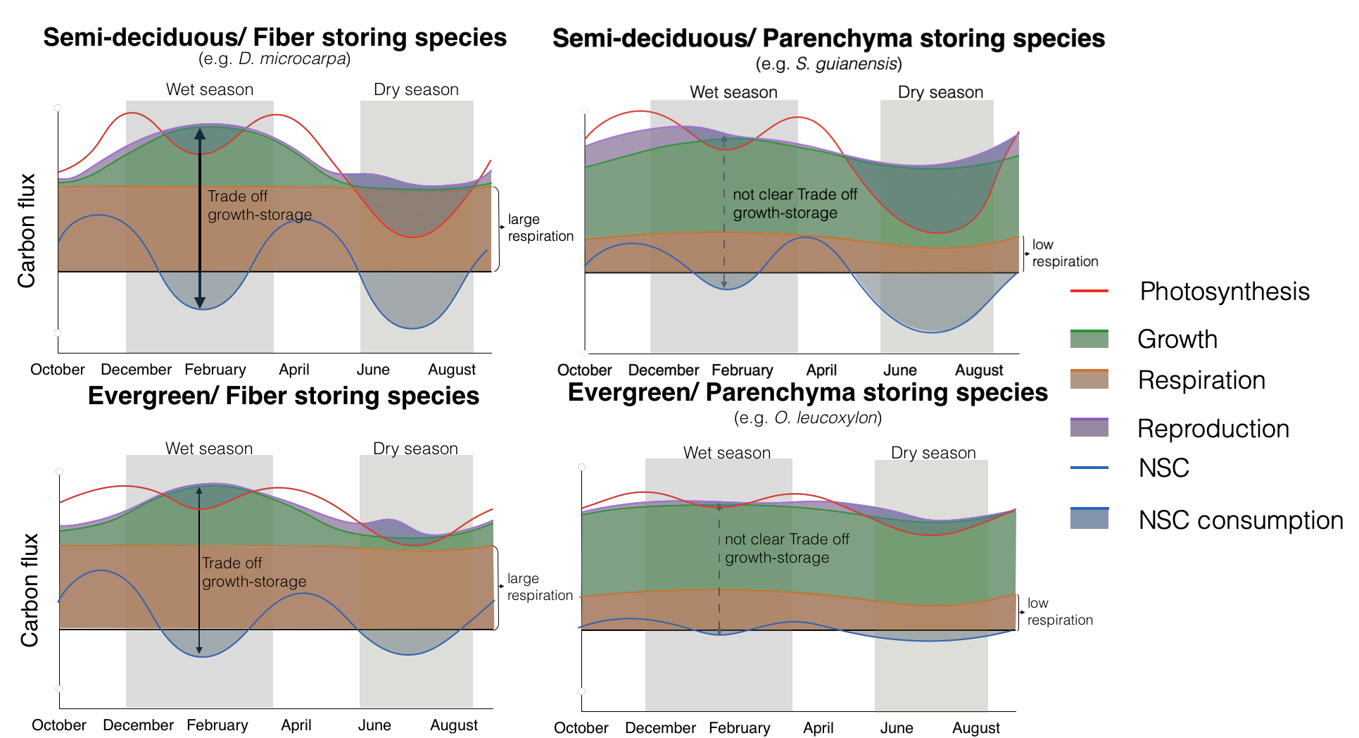

**Figure 1:** Conceptual framework that relates differences in carbon dynamics for trees with different combinations of two functional traits: leaf habit and storage strategy of starch in the stem wood. Here we show the seasonal behavior of carbon sources - photosynthesis (red line)- and carbon sinks - growth (green), respiration (orange), and reproduction (purple) - and their interactions with NSC storage or consumption (blue line). Expected trade-offs between growth and storage are indicated by black arrows and the thickness of the line indicates the strength of the trade-off. Thus, thicker and darker lines indicate strong trade-offs, and dashed and lighter lines indicate weaker or less clear trade-offs. The seasonal patterns of photosynthesis and reproduction are estimated from the phenological observations of mature leaves in the crown for species representative of the different trait combinations, which are named in the respective panels, and are reported in Fig. S3.

# Methods

# 2.1. Site description

This study was conducted in a transitional forest between the Amazon rainforest and the Cerrado, located at Tanguro Ranch, Mato Grosso, Brazil. It is a seasonally dry forest with mean annual precipitation of 1770 mm distributed between the dry season (May to September) with less than 10 mm of precipitation per month and a wet season (October to April) with a mean precipitation of 150 mm per month (Fig. 2). Relative humidity follows a similar seasonal pattern, falling below 60% from June to September and above 80% from December to February (Fig. 2). The mean temperature is 25˚C with almost no seasonal variation throughout the year (data obtained from the local station at Tanguro Ranch, operated by the Instituto de Pesquisa Ambiental da Amazônia, IPAM).

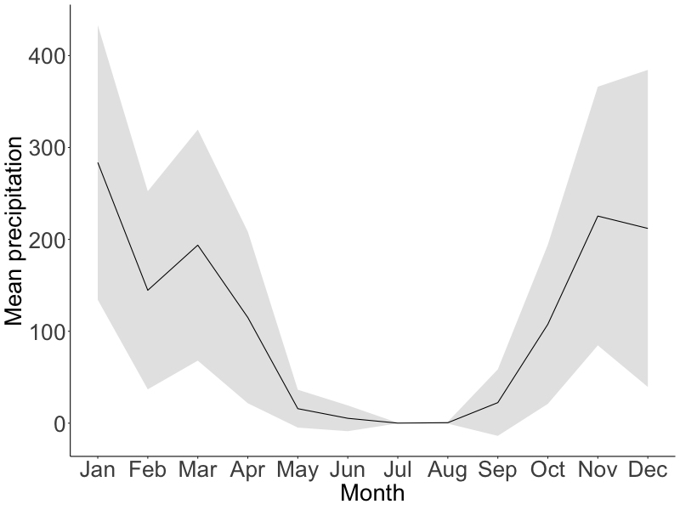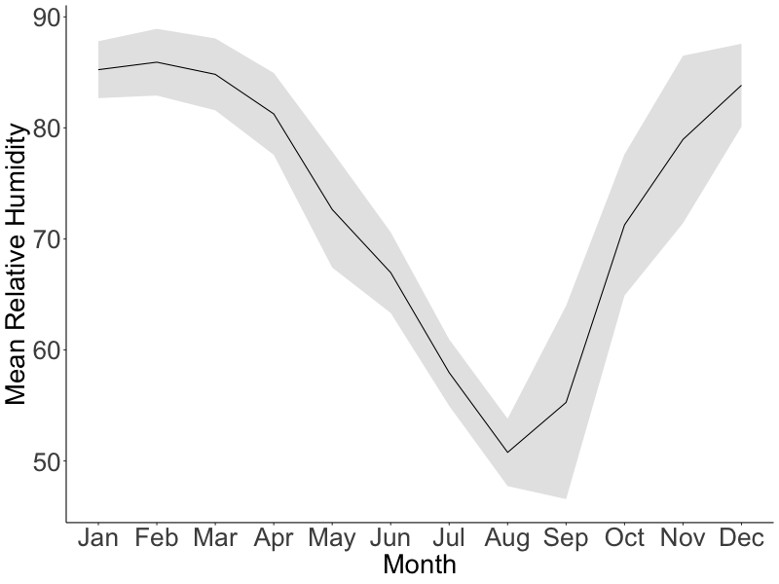

**Figure 2:** Mean seasonal course of monthly total precipitation (mm) and relative humidity (%) during 2016-2020 (black lines). Gray areas correspond to the standard deviation. Data provided by IPAM.

## 2.2. Species description

We selected three tree species previously shown to have contrasting starch storage strategies in wood, parenchyma-storing species and fiber-storing species (Herrera-Ramírez et al., 2021, Fig. S1), different leaf habits (evergreen or semi-deciduous), and different growth and mortality rates (Table 1). Based on inventory data these species are in the top 10 % of the most dominant species in this forest. From each tree species we chose 12 mature and healthy trees reaching the canopy with a diameter at breast height (at 1.3 m, dbh) greater than 20 cm (Table 1).

**Table 1**: Species names and traits: wood storage strategy, growth rates, mortality rates, phenology, and the sampling dates.

|  |  |  |  |  |
| --- | --- | --- | --- | --- |
| Species name | Growth rate  (cm/year) | Mortality rate   (%/year) | Storage strategy | Leaf phenology  (~% of annual leaf loss) |
| *Ocotea leucoxylon* (Sw.) Laness | 0.295 | 5.7 | Parenchyma | Evergreen (~30) |
| *Sacoglottis guianensis* Benth. | 0.72 | 5.0 | Parenchyma | Semi-deciduous (~45) |
| *Dacryodes microcarpa* Cuart. | 0.078 | 1.6 | Fiber | Semi-deciduous (~60) |

*Growth rate, Mortality rates and Leaf phenology were calculated based on inventories conducted between 2004 and 2018 and included more than 100 individuals per species.

## 2.3. Sampling strategy

We sampled the selected 36 trees every three months from May 2019 to February 2020, specifically in May 2019 (transition from wet to dry season), August 2019 (dry season), November 2019 (transition from dry to wet season), and February 2020 (wet season). During each field campaign we took two wood cores (~ 5mm diameter and 20 cm long) approximately 10 cm away from the previous collection point. We used one wood core to quantify starch distribution along the radial axis from bark to pith using the histological quantification method described in Herrera-Ramírez et al. (2021). Wood cores were placed on ice immediately after collection and frozen at -18 ˚C within two hours in order to stop respiration. After freezing, they were dried at 60 ˚C for two days.

The second wood core was used for incubation to estimate wood respiration rates. These cores were placed in a wet tissue immediately after collection and kept away from direct sun exposition. The cores were put in the incubation chambers within the two subsequent hours after collection.

**2.4. NSC seasonality**

We quantified soluble sugars with a High-Performance Anion Exchange Chromatography with Pulsed Amperometric Detection (HPAE-PAD) following the protocols from Landhäusser et al. (2018). We quantified starch based on the histological method proposed by Herrera-Ramirez et al. (2021).

To quantify the starch concentration using the histological method we took 30 m thick slices and mounted them on a glass slide. The wood surface was covered with Lugol’s iodine solution for 3 minutes to stain starch grains and then covered with a coverslip. The stained samples were photographed using an optical digital microscope with a large depth-of-field (Keyence, VHX-6000, USA) within 3 hours. Panoramic images of the sample were taken at 300x magnification.

We quantified the percentage of starch in the samples by repeatedly measuring the areal percentage of starch coverage for each 1 mm2 area over the wood surface using the Image J software (Schneider et al., 2012). We divided the images into radial increments of 5 mm from bark to pith to measure the radial distribution of starch in the wood core. We measured starch in all 5 mm-increment sections until no starch was found in the wood. While doing so, we also manually eliminated artifacts from the images that may have interfered with the quantification. After preparing the images, we ran an automatic script for identifying and quantifying starch grains in multiple 1 mm2 regions of interest (ROI), randomly selected along the images (see supplementary material Methods S2 in Herrera-Ramírez et al. (2021) for details). After identifying all starch grains in a ROI, the script calculates the percentage of the surface area covered by starch. We measured 50 ROIs in each image of 5 mm segments of the stem increment core from bark to pith. We took the average of these 50 ROI measurements as an estimate of the percentage of starch for each of the 5 mm sections of the wood increment core. Measurements of the areal percentage covered by starch closely approximate the concentration of starch per gram of dry wood explaining 80% of the variability of starch concentrations measured by the HPAE-PAD (Herrera-Ramírez et al., 2021). Finally, we estimated the mass of starch per wood core by integrating the starch mass per 5 mm segment based on wood density, segment volume, and the measured percentage of starch per unit of volume along the radial path of the wood core from bark to pith.

To measure the concentration of sucrose, fructose and glucose (soluble sugars), with the HPAE-PAD (Landhäusser et al., 2018), we segmented the wood core in two depth ranges: 0-2 cm and 2-4 cm. These measurements were made only for 5 individuals per species and for samples taken in January (wet season) and July 2018 (dry season). Each wood core segment was ground to a fine powder using a ball mill (Retsch MM 400, Haan, Germany) at 25 Hz for 30 seconds and dried at 60 °C overnight. We weighed 50 mg of wood powder and mixed it with 1.5 ml of 80 % ethanol for 10 minutes at 90 ˚C in order to extract the soluble sugars. After cooling to room temperature, the samples were centrifuged at 13000 g for 2 minutes. The supernatant was recovered in a new vial, diluted, filtered, and then used for measuring three specific sugars (sucrose, fructose and glucose) by HPAE-PAD. For quality control we used blanks, standard solutions with known concentration of glucose, fructose and sucrose and internal standards made of a mix of tree leaf and branch samples as detailed in the protocol “*S3*" of Landhäusser et al. (2018). We estimated the average concentration of soluble sugars per wood core and compared between time points. The concentration of soluble sugars was always very low (up to 2 %) for all species and we did not find significant differences between the wet and dry season of 2018 (Fig. S2). Therefore, soluble sugars were not measured for 2019. For the species we analyzed, starch represented 70, 85 and 90 % of the stored NSC for *D. microcarpa, S. guianensis* and *O. leucoxylon*, respectively. Therefore, we assumed that NSC dynamics are mainly represented by starch changes over time.

We used a Wilcoxon signed-rank test to compare starch and soluble sugar mass and concentration between different sampling dates and different wood depths, in order to evaluate seasonality and differences between wood depths from bark to pith.

We estimated the seasonal changes in the starch mass (mg) between two consecutive sampling periods. For example, the starch change observed in the dry season was the difference in the starch mass between May 2019 and August 2019 and we denominated it May19-Aug19; Similarly, the starch change observed in the transition months from the dry to the wet season was the difference in starch mass between August 2019 and November 2019 (Aug19-Nov19); and the starch change observed during the wet season constituted the difference in starch mass between November 2019 and February 2020 (Nov19-Feb20). Unfortunately, due to the Covid 19 pandemic, we could not travel to the field site in May 2020 to observe the change in starch mass during the transition months from the wet to the dry season (February 2020 to May 2020) and close the year of observations.

We also estimated the relative change of starch mass between the seasons previously described, for that we divided the starch change by the starch mass in the final month (equation 1).

(equation 1)

Where t2 is chronologically the second time point between seasons and t1 is the first time point.

We evaluated the significance of the relative starch change between seasons and we compared these relative changes between seasons and species by building 95% non-parametric confidence intervals for the mean using bootstrapping.

## 2.5. Sink activity measurements

We measured monthly stem growth with manual dendrometer bands (D1, Labcell Ltd, UK). These dendrometers were installed at breast height for each tree in July 2018, and measurements were collected monthly (by manually reading) until July 2020. We used three month moving averages of growth rates, which we calculated to reduce the effect of water dynamics in our growth data, capturing the average intra-annual radial growth variations (Zweifel et al., 2006, 2016). From these data we calculated annual growth for each tree during 2019 and compared it with the mean annual starch mass and the changes in the starch mass every three months. We used Wilcoxon signed-rank tests with 95% significance confidence to compare growth between months and test for significant seasonal changes in growth for each species. We also estimated seasonal accumulated three months growth of the seasons already described. We estimated Pearson’s correlations and linear regressions between the accumulated growth and starch changes in mass for each season in order to estimate seasonal trade-offs between storage and growth. Before doing so, we tested the data for normality and heteroscedasticity.

We measured wood respiration during the wet season (May) and the dry season (August) of 2019 by incubation of stem cores taken from each tree for a period of 36 hours following collection. The wood cores were cut at the depth in the stem we had previously identified where starch is depleted (6 cm for *O. leucoxylon*, 8 cm for *D. microcarpa* and 12 cm for *S. guianensis*). The cores were then sealed in cylindrical chambers and incubated in parallel for 36 hours at ambient temperature (~25 ˚C). The CO2 produced was collected in custom made glass flasks. We purified the total amount of collected CO2 after cryogenic separation on a vacuum line, and the total sample mass by measuring the pressure at room temperature together with the flask volume (calculated individually by filling with water and weighing). Then we calculated the respiration rate for each sample by dividing the total amount of collected CO2 (in mg C) by the incubation time and wood volume of the incubated core segment. We used Wilcoxon rank tests to compare respiration between seasons and between species.

We used previous observations of leaf, flower and fruit phenology patterns to estimate other carbon source and sink fluxes such as photosynthesis and reproduction. These observations were made for each species at this location over the last 8 years. The percentage of crown coverage of young leaves, mature leaves, flowers and fruits have been recorded monthly from selected species. The patterns were classified in 5 categories (0, 25, 50, 75 and 100%). We used these data to estimate seasonal changes in the phenological data by fitting a smoothing spline model to the monthly data (Fig. S3). We used this phenological data to give an idea of the contribution of flowering and fruiting to the seasonal carbon sink fluxes but we did not measure the amount of carbon allocated to these fluxes for individual trees or species. Then in relative terms we expect a higher flux of carbon to reproduction whenever there is more presence of fruiting and flowering. We report these data in Fig. S3.

# Results

## 3.1. Seasonality of starch mass, growth and respiration

Starch concentrations decreased radially across the sapwood from bark to pith for all species for all sampling dates (Fig. 3). We found significant differences in the starch mass of the entire wood core between sampling dates for the semi-deciduous species *D. microcarpa* (*p*=0.01) and marginally significant for the semi-deciduous species *S. guianensis* (*p* = 0.059, Fig. 4), while the evergreen species *O. leucoxylon* did not show significant changes in starch mass in the stem wood during 2019 (p>0.1). Seasonality of starch mass changed at each wood depth (Fig. 3). For instance, *D. microcarpa* and *O. leucoxylon* showed the largest change in starch mass in the first radial 20mm of wood from bark to pith, while *S. guianensis* showed the largest changes in starch mass at around 80mm depth in the wood (Fig. 3). Interestingly, despite the small changes in mass, starch was totally remobilized from the deepest layers of wood during the dry season in all species, showing high metabolic activity of deep sap wood and the capacity of these species to totally remobilize the stored starch from the deepest living layers of wood when it is needed.

We found a marginal significant effect of the storage strategy on the starch seasonality (*p*=0.055, Fig. S4). Seasonal changes in starch mass were stronger for the fiber-storing species *D. microcarpa* (*Fig. S4*) than in the parenchyma-storing species *S. guianensis* and *O. leucoxylon* (*Fig. S4*). *D. microcarpa* trees significantly reduced their starch content during the period May19-Aug19 by around -0.75% (*ci*: -1.15, -0.37, Fig. S4), relative to the starch mass in August 2019 (equation 1), while *S. guianensis* had significant gains in starch content from May 2019 to February 2020 by around 0.25% (*ci*: 0.06, 0.53, Fig. S4), respect to the starch mass in February 2020.

Seasonality in growth rates during 2019 were only significant for the fiber-storing species *D. microcarpa (p<0.05, Fig. 5)*. These trees grew slower during the dry season and faster during the wet season (Fig. 5). The two parenchyma-storing species did not show a clear seasonal pattern (*p*>0.1, for all comparison between all months), although a slight decrease in growth rates during the dry season can be noticed for both species in Fig. 5.

Wood respiration was higher in the fiber-storing species *D. microcarpa* than in the parenchyma-storing species *S. guianensis* and *O. leucoxylon* (*p<0.01, Fig. 6*). Nevertheless, the differences between wet and dry season in 2019 were not statistically significant for any of the species (Fig. 6).

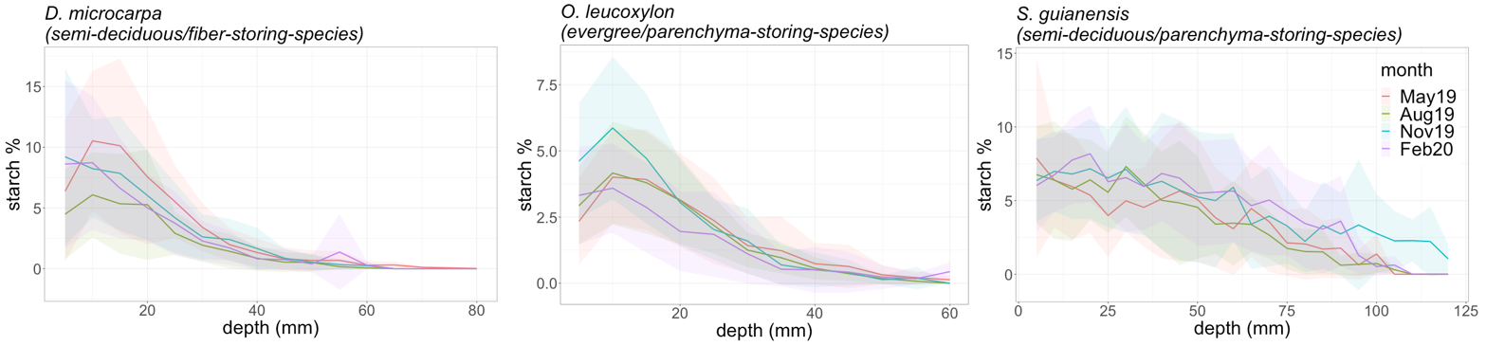

**Figure 3:** Radial distribution of the mean starch concentrations measured in 4 months during 2019. Starch concentrations were measured in the wood core every 5 mm from bark to pith until starch disappeared completely from the wood sample. The shadowed areas correspond to one standard variation around the mean of the measurements at each depth.

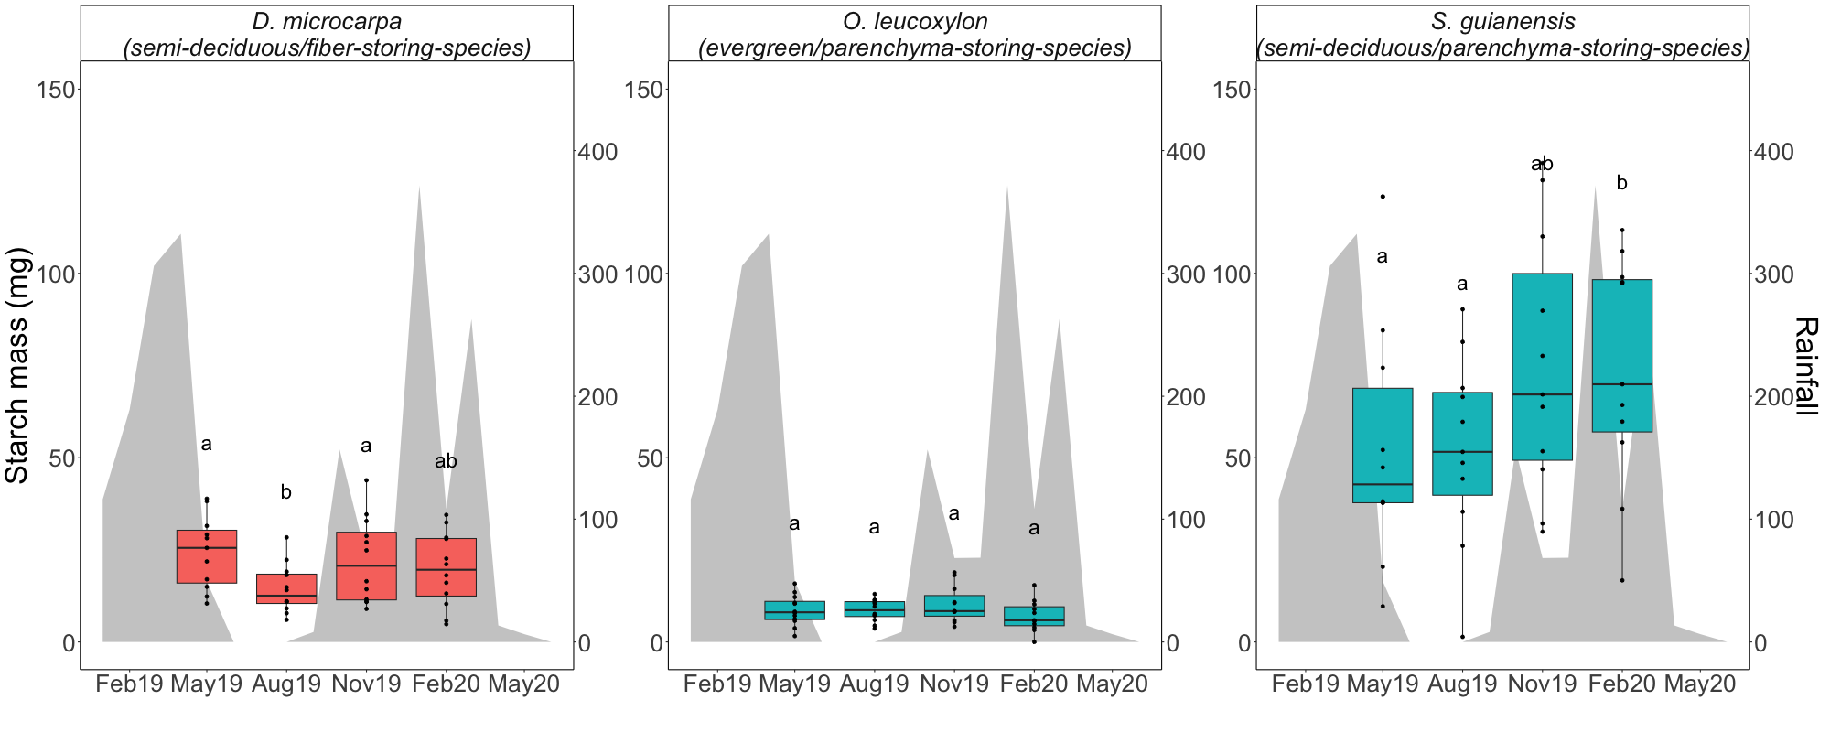

**Figure 4:** Box-plots that show the starch mass measured in the wood cores from trees of each evaluated species at different times/seasons during 2019. Differences between groups are indicated by different letters (with 90% confidence) above the box-plots and were tested with Wilcoxon signed-rank tests. Blue box-plots represent the parenchyma storing species while red box-plots represent fiber storing species. Shaded areas correspond to the precipitation in the corresponding months and its values are shown in the right axis.

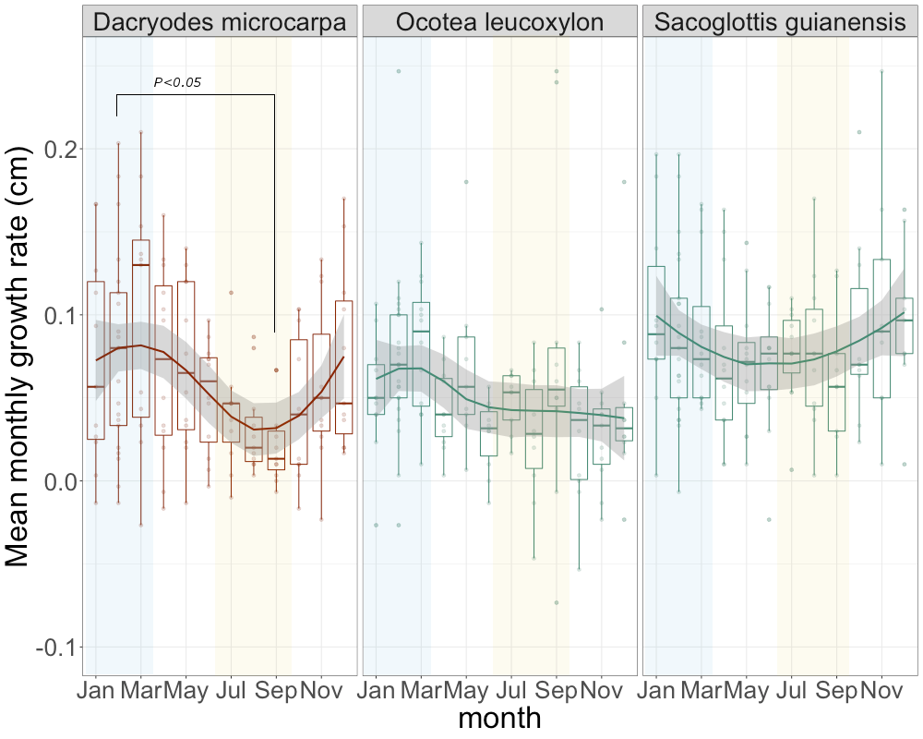

**Figure 5:** Seasonal trend of growth rates for the three species evaluated. Solid lines show the smoothing trends, while the dispersion of the measurements is shown by box-plots. The horizontal lines inside the box-plots show the median of the distribution of the measurements. Yellow shaded areas indicate the dry season and blue shaded areas indicate the wet season. Red colored data indicates fiber storing species while blue colored data indicates parenchyma-storing species.

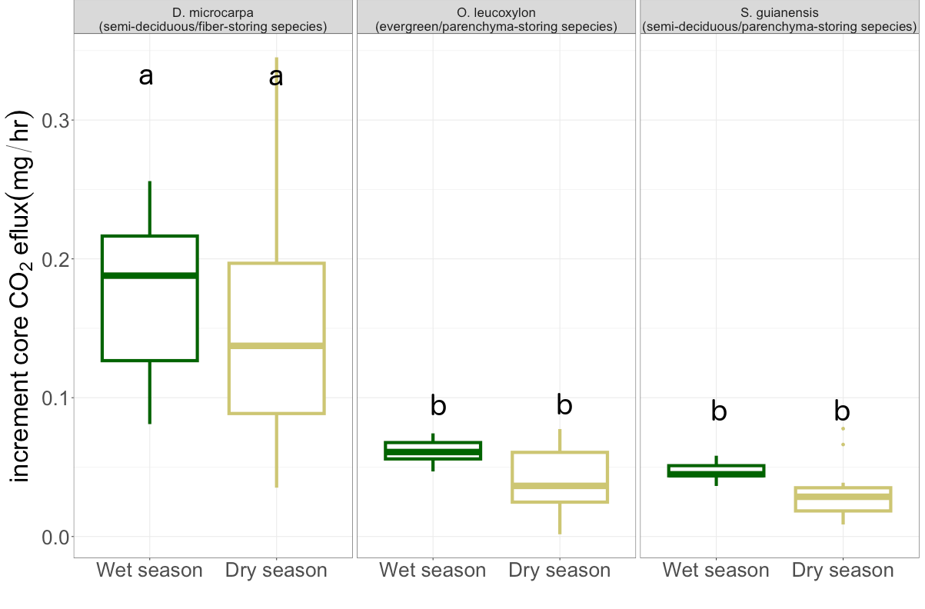

**Figure 6:** Wood respiration of the incubated wood increment cores during the wet and the dry seasons. The dispersion of the data is shown by box-plots. We indicate with different letters statistical differences tested with a Wilcoxson rank test with 95% confidence.

## 3.3. Accumulation and consumption of starch and storage-growth trade-offs

We only observed a strong significant consumption of starch during the dry season for the fiber storing species *D. microcarpa* (Fig. 4 and Fig. S4)*.* The parenchyma-storing species (*S. guianensis* and *O. leucoxylon*) did not show a significant accumulation or consumption of starch during the dry season (Fig. S4). Nevertheless, our data suggest that *S. guianensis* may consume starch during the transition months between the wet and the dry season from February to May (Fig. 4), but, unfortunately, we did not measure this period.

We observed a marginally significant consumption of starch during the wet season for the fiber-storing species *D. microcarpa* (Fig. S4) and a significant consumption for the evergreen/parenchyma-storing species *O. leucoxylon* (Fig. S4). Accumulation of starch happened clearly during the transition from the dry to the wet season August 2019 to November 2020 in the fiber-storing species trees (*D. microcarpa*); The parenchyma-storing species (*S. guianensis*) accumulated starch from May 2019 to February 2020 (Fig. S4).

We observed a negative correlation between the accumulated three months of growth (December, January and February) and changes in starch mass during the wet season between November 2019 and February 2020 (*p* = 0.05, r2 = 0.36, Fig 7), for the fiber-storing species *D. microcarpa*. During this period some trees consumed starch while they grew fast and some other individuals accumulated it instead and had lower growth rates (Fig. 7). For this species most of the individuals consumed large quantities of starch during the dry season (from May 2019 to August 2019), but this was not related to growth (Fig. 7).

For the parenchyma-storing species *O. leucoxylon* and *S. guianensis* the storage-growth trade-offs were less clear or nonexistent. We did not observe any significant correlation when we compared simultaneous growth and starch change during each season. Nevertheless, we found significant correlations when a three-month time lag was considered between growth and starch change for these species (Fig. 7). For instance, we observed a negative correlation between the change in starch mass during the transition months from the dry to the wet season (from August 2019 to November 2019) and the three months of accumulated growth of the wet season (from November 2019 to February 2020), for *O. leucoxylon* (*p*=0.03, r2=0.41, Fig 7). For *S. guianensis* this trend is also noticed but it is not significant (*p*=0.1, r2=0.38, Fig. 7).

We observed that starch mass from the whole tree core was related to annual stem growth, but there were differences between storage strategies. The storage-growth trade-off trend between the starch mass in February 2020 and the annual growth calculated from February 2019 to February 2020 was still distinguishable for the fiber-storing species *D. microcarpa*, although non-significant (*p*=0.11, r2=0.31, Fig. S5). The semi-deciduous/parenchyma-storing species (*S. guianensis*) showed positive correlation between annual growth and starch mass during the dry season (August 2019, *p=0.003,* r2= 0.79, Fig. S5), and it also showed a positive correlation between annual growth and starch mass in the wet season, although it was weaker (February 2020, p=0.05, r2=0.51, Fig. S5). Evergreen/parenchyma-storing species (*O. leucoxylon*) showed a marginal positive relationship between starch mass in May 2019 (transition between the wet and the dry seasons) and the annual stem growth (*p*=0.088, r2=0.4, Fig. S5).

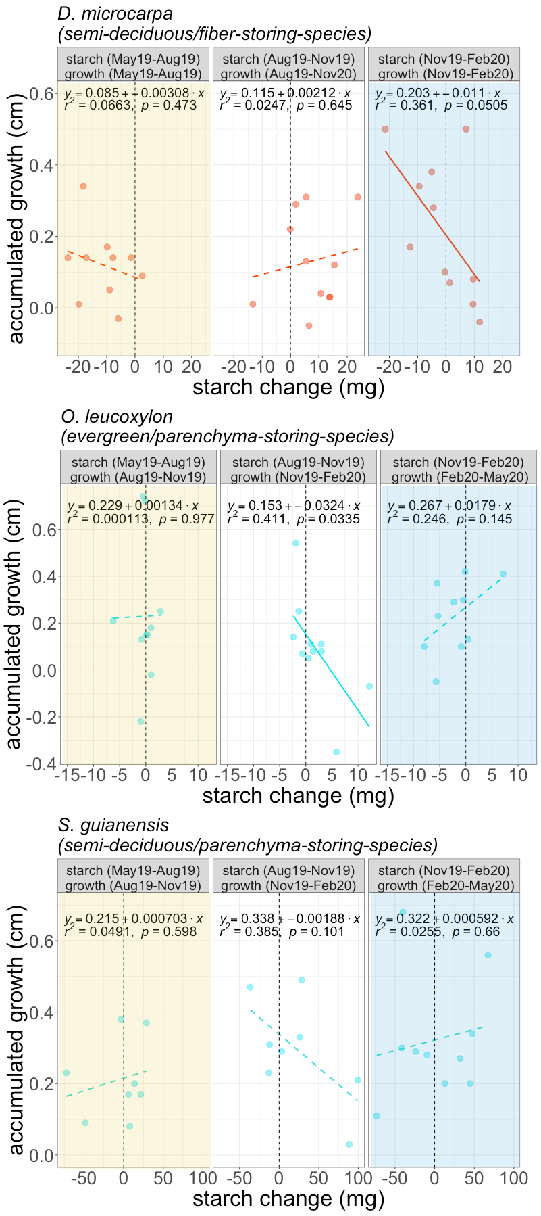

**Figure 7:** Relationship between changes in starch mass (accumulation or consumption of starch) and three-month growth in 2019 for the three species studied. For the fiber-storing species, growth and changes in starch are evaluated for the same months. For the two parenchyma storing species, comparison of growth and starch change did not result in any significant correlations. Instead, for these species, changes in starch storage are correlated with growth in the following 3 months. The comparison periods between starch change and growth for each panel are shown in the panel title. We show the significant correlations with solid lines and the no-significant correlations with a dashed line. The vertical dotted line marks the 0, points on the left indicate starch consumption and those on the right indicate scratch accumulation. The dry season is indicated by shaded yellow areas, while the wet season is indicated by shaded blue areas. 

1. **Discussion**

Our results relate differences in carbon dynamics in mature trees to life history traits such as starch storage strategy and leaf habit and allowed us summarize them in a conceptual framework (Fig. 1). Evergreen trees should not exhibit large seasonal differences in carbon acquisition, while semi-deciduous trees studied here shed between 50 and 70% of their leaves during the dry season (May-Aug) and then invest carbon in new leaves (Fig S3). Eddy covariance data from this forest indicates an overall reduction in canopy photosynthesis during the dry season (Bando et al., 2019). During the wet season (Nov-Feb) a slight reduction in the percentage of mature leaves may also indicate a small reduction in photosynthesis (Fig S3, Fig 1).

The slow growing semi-deciduous/fiber-storing species (*Dacryodes microcarpa*) showed seasonality in radial growth but not in wood respiration. Carbon sources and sinks were balanced by starch and resulted in the largest seasonal amplitude of starch mass among the evaluated species, with greatest starch consumption during the dry season when sources were reduced and almost no radial growth occurred, and a small consumption overall during the wet season when sources but also growth increased (Fig S4). As expected, during the wet season, we observed a strong negative correlation between growth and starch storage change for this species with large reductions in starch with trees growing most rapidly, and increases in starch where radial growth was small (Fig 1; Fig. 7).

The two parenchyma-storing species partially agreed with our hypothesis. Neither showed marked seasonality in radial growth or wood respiration. Starch mass was marginally seasonal in the semi-deciduous/parenchyma storing species (*Sacoglottis guianensis*), with starch accumulated towards the wet season from November to February. Although we did not detect significant starch consumption during the wet or the dry season, lower values of starch mass in May and August 2019 suggest that these trees may consume starch during the dry period. For the evergreen/parenchyma storing species (*Ocotea leucoxylon*) we did not observe seasonality in the starch mass but a significant consumption of starch during the wet season (Fig S4). For these parenchyma-storing species, we did not observe clear seasonal trade-offs (Fig 1).

Although we only evaluated three of the four conceptualized groups of our framework, omitting the evergreen/fiber storing species (Fig. 1), we expect that differences in carbon fluxes between evergreen and semi-deciduous fiber storing species are small because previous analyses indicated little difference in starch storage, mortality, respiration or growth between these groups (Hererra-Ramirez et al., 2021). We included the expected behavior of this group in our conceptual framework for reference, which should be evaluated in future research. Our conceptual framework in conjunction with our results help improve our understanding of the carbon dynamics in mature trees and provides insights into the mechanisms behind starch accumulation and use and its interplay with carbon sources and sinks that can influence plant survival in tropical forests.

**4.1. Semi-deciduous and fiber-storing species have seasonal changes of starch**

As we expected, leaf habit and storage strategy of starch in the wood influence the seasonal fluctuation of starch in the stem wood. Semi-deciduous species showed significant starch seasonality (*p*=0.001), while the evergreen species we analyzed did not. Semi-deciduous trees may experience large imbalances between carbon sources and sinks during the dry season due to the high demand for carbon to rebuild the canopy, therefore showing larger seasonal changes in starch mass than evergreen species (Kozlowski, 1992; Hoch et al., 2003; Würth et al., 2005; Richardson et al., 2013; Furze et al., 2018). This is consistent with studies showing strong NSC seasonality in temperate deciduous species but not in evergreen species (Chapin et al., 1990; Piispanen and Saranpää, 2001; Trumbore et al., 2015; Martínez-Vilalta et al., 2016; Furze et al., 2018). Our results support the idea that semi-deciduous trees are more dependent in NSC storage than evergreen species in seasonally dry tropical forests. Nevertheless, a larger number of species and longer time series of NSC dynamics should be examined to confirm these patterns. Histological methods provide a rapid and convenient method for quantifying starch storage that can support observations in a high number of species over the longer term.

Our results also suggest that starch storage strategy influences the seasonal dynamics of NSC (Fig. S4). In terms of soluble sugars, all species showed very low concentrations with no apparent seasonality. In addition, only one species (*D. microcarpa*) showed accumulation of lipids, also in lower concentrations than starch (Herrera-Ramirez et al., 2021). Therefore, for these species, starch seasonal changes seem to be a good proxy for NSC seasonality. So far, the fiber-storing species (*D. microcarpa*) had larger seasonal changes in starch mass than parenchyma-storing species (Fig. S4). This provides us some insights into the mechanisms behind carbon dynamics. In fiber-storing species, the high seasonal carbon consumption may be caused by the larger proportion of living cells in the stem, which require more carbon for respiration than the smaller proportion of living cells in parenchyma-storing species (Fig. 6). This high metabolic cost may compete for carbon resources with other carbon sinks such as growth during the dry season, probably leading to a seasonal growth and a high reliance on storage to keep cells alive during low photosynthetic periods. Nevertheless, having living fibers allows trees to use a larger wood volume to store starch and cover all metabolic demands, which probably would reduce their vulnerability to starvation. This would likely benefit plant competition/survival and result in low mortality rates (e.g. Table 1).

**4.2. Fiber-storing species have larger plasticity in wood growth rates but not in respiration rates**

Trees growing in a seasonally dry environment should balance their carbon sources and sinks in order to survive recurrent stressful conditions. The fast growing, parenchyma-storing species *S. guianensis* kept radial growth relatively constant throughout the year, whereas the slow-growing, fiber-storing species *D. microcarpa* significantly reduced growth during the dry season. Thus, these trees, with contrasting storage strategies and respiratory demands, differentially adjust their balance between carbon sources and sinks during seasonally dry conditions (Fig. 1). It is important to note that radial growth is not the only form of growth in trees and other types of growth can be differentially adjusted or prioritized. Nevertheless, reducing wood growth rates during low productivity periods may make trees more tolerant to a wider range of environmental conditions.

Contrary to the growth patterns described above, wood respiration showed no seasonal changes for any of the species evaluated during the year of measurements (Fig. 6). A previous study also reported no changes in CO2 efflux between dry and wet seasons in tropical forest trees (Asao et al., 2015). CO2 efflux includes not only wood respiration, but also phloem respiration, CO2 re-fixation and transport of CO2 dissolved in the sap (Helm et al., 2023). Nevertheless, it has been shown that some trees can regulate stem CO2 efflux and growth to adapt to certain environmental conditions such as seasonal changes in precipitation and temperature, releasing resources for other metabolic activities (Teskey et al., 2008; Huang et al., 2019; Sierra et al., 2022). Then, it may also be possible that the dry period of 2019 was not strong enough to induce changes in CO2 efflux, and longer time series of wood respiration are needed to confirm this pattern.

Wood respiration was greatest in the fiber-storing species (*D. microcarpa)*, probably because the proportion of living cells in the wood in these species, which include parenchyma and living fibers, is larger than in parenchyma-storing species (*S. guianensis* and *O. leucoxylon*). Therefore, fiber-storing species may have greater carbon requirements to keep all living wood tissue alive, which may potentially reduce their ability to regulate respiration seasonally. These results suggest that wood anatomical traits such as living fibers may indicate a large carbon demand for respiration that may heavily compete with other carbon sinks such as growth, leading these trees to have a stronger regulation of growth rates and have a high reliance on storage. Thus, the proportion of living wood biomass may have a larger control over wood respiration than environmental conditions.

## 4.3. Starch is consumed during the peak of the dry and the wet season

Our results show that, for most trees, starch seems to be consumed not only during the peak of the dry season but also during the peak of the wet season (Fig 7, Fig S4). This is clear for *D. microcarpa* and *O. leucoxylon* trees but we did not observe starch consumption during the wet season for *S. guianensis* (Fig S4). We would assume that trees may recharge the carbon storage pools during the wet season because of favorable conditions for growth and less photosynthesis limitation (Dietze et al., 2014). Nevertheless, the consumption of starch during the wet season suggests a negative carbon balance in these trees. There could be several reasons for this: For fiber-storing trees (*D. microcarpa*), it is possible that the carbon demand of wood growth and respiration exceeds the supply of new photoassimilates. In addition, some other carbon sinks such as reproduction may also contribute to a greater carbohydrate demand during the wet season (Hartmann and Trumbore, 2016, Fig. S3). For instance, both *D. microcarpa* and *S. guianensis* produced flowers and fruit during the wet season (Fig. 1, Fig. S3), which could constitute a large demand for carbon reserves (Hartmann and Trumbore, 2016; Blumstein et al., 2022). This suggests that for some tree species, flowering and fruiting can be a significant carbon sink that influences seasonal NSC dynamics, probably contributing to depletion of NSC during the wet season. Alternatively, the rainy season comes with its own challenges that put pressure on available NSC. During the rainy season, blowdowns, storms and lightning can cause physical damage to trees, which along with an increase in herbivory or fungal infections, may increase the risk of individual damage or even mortality (Zuleta et al., 2022, Aleixo et al., 2019). Rebuilding the lost tissue during the wet season, or building up defense compounds could represent a large demand of NSC (Huang et al., 2021). Thus, trees that, in the transition months between the wet and the dry seasons, may have not replenished their NSC reserves and repaired damage, may be more vulnerable and susceptible to die when facing stress (Anderegg et al., 2013; Arellano et al., 2019; Aleixo et al., 2019).

## 4.4. Storage-growth trade-offs occur in the fiber-storing species during the wet season

Seasonal patterns in starch mass showed us when trees consumed and accumulated stem NSC. Our results indicate a trade-off between starch consumption/accumulation and growth only during the wet season for the fiber-storing species *D. microcarpa*. For the parenchyma-storing species (*O. leucoxylon* and *S. guianensis*) storage-growth trade-offs were only observed when lagged correlations were considered (Fig 7), probably reflecting the use of reserves for other metabolic needs such as reproduction that are also important for species survival (Fig. S3, Blumstein et al., 2022, Hartmann and Trumbore 2016). Nevertheless, it is important to clarify that these storage-growth trade-offs may change when other forms of growth are considered. At the whole tree level, including other starch storage tissues such as phloem (Rosell et al., 2021) or roots (Hillman et al., 2021) may offer further insights into these trade-offs.

Identifying trade-offs between C sinks with field measurements is challenging (Blumstein et al., 2022). Here we show that annual estimates of starch mass and radial stem growth may hide the seasonal trade-offs between these two variables (Fig. S5). This may be influenced by the fact that a single time point measurement of starch mass will integrate past fluctuations of the carbon balance in the plant and therefore may not reflect the actual current growing conditions of trees. Also, trade-offs may be affected by variations in carbon supply. Individuals with higher carbon acquisition, may have more leverage to invest more in both growth and storage than individuals with lower carbon acquisition (Blumstein et al., 2022), as might have been the case for our parenchyma-storing species. These two parenchyma-storing species grew faster than the fiber-storing species and the correlation between annual growth and starch mass was positive for both species during the dry season (Aug19) for *S. guianenesis* and during the transition months from wet to dry season (May 19) for *O. leucoxylon*. For more conservative species, such as the fiber-storing species, a weak trade-off trend between starch mass and annual growth was still observed during the wet season (Fig. S5). Our results suggest that these trade-offs may not be reflected in the annual carbon balance, but would only be evident on a seasonal basis. Therefore, evaluating seasonal changes in starch mass (rather than mean storage mass per year or max starch storage per year) in relation to seasonal growth can better inform us about when and under what conditions such trade-offs occur, avoiding the influence of some confounding factors when annual averages are used.

Evidence for growth-storage trade-offs is increasing in the literature and has been linked to survival of individuals (Wright et al., 2004; Poorter and Kitajima, 2007; O’Brien et al., 2014, 2015; Klein and Hoch, 2015; D’Andrea et al., 2019, 2020). Studies comparing highly conservative species and highly competitive species in surviving stressful environmental conditions are needed to further understand how variation in storage-growth trade-offs are maintained across space and time. Our results are a good indication that highly conservative, slow-growing, and high-storing species, such as fiber-storing species (e.g., *D. microcarpa*), may have stronger trade-offs between starch storage and growth, indicating a greater plasticity in their sink activity, and/or a higher prioritization of storage, than parenchyma-storing species. Life history traits such as low growth and low mortality rate are associated with highly conservative species and are a good proxy for tree longevity (Wright et al., 2004; Herrera-Ramírez et al., 2021; Piovesan and Biondi, 2021). Therefore, we would expect that as stressors intensify, highly conservative trees, such as fiber-storing species, would have higher survival rates and would become more competitive in seasonally dry forests. Future work should focus on understanding how these storage strategies are distributed in forest communities and how their different storage-growth trade-offs affect productivity and species survival in tropical forests under climate change.

# 5. Acknowledgments

We want to thank the Max Planck Society, the Friedrich-Schiller University and the German Research Foundation (SI 1953/2-1) for the founding of this project. Also, we received funding from the EU, through the German Bundesanstalt für Landwirtschaft und Ernährung FKZ: 2816ERA03W (to S. T.); the Brazilian council for Scientific and Technological Development - CNPq (PELD/CNPq No. 441703/2016-0; No. 441940/2020-0; UNIVERSAL No. 430149/2018-2); and DH and ST acknowledge the support from the Balzan foundation.

**6. Author contributions**

DH-R, CAS, HH, CR, ST, and JM, conceived the idea, conceptualized the hypothesis, and planned the data collection and the experiments. DH, LM and DS collected and analyzed data. DH and IK performed sample analysis and quantification. DH-R wrote the manuscript. DH-R, HH, CR, ST, JM, LM, PB, DS, HJ, IK, and CAS contributed significantly to the writing of the manuscript and gave important and critical input. All authors revised the manuscript.

**7. Data accessibility statement**

The data here presented will be stored in an open GitHub repository once the manuscript is accepted.

# 8. References

Adams, H. D., Zeppel, M. J. B., Anderegg, W. R. L., Hartmann, H., Landhäusser, S. M., Tissue, D. T., et al. (2017). A multi-species synthesis of physiological mechanisms in drought-induced tree mortality. *Nature Ecology & Evolution* 1, 1285–1291. doi:[10.1038/s41559-017-0248-x](https://doi.org/10.1038/s41559-017-0248-x).

Aleixo, I., Norris, D., Hemerik, L., Barbosa, A., Prata, E., Costa, F., et al. (2019). Amazonian rainforest tree mortality driven by climate and functional traits. *Nature Climate Change* 9, 384–388. doi:[10.1038/s41558-019-0458-0](https://doi.org/10.1038/s41558-019-0458-0).

Anderegg, W. R. L., Berry, J. A., Smith, D. D., Sperry, J. S., Anderegg, L. D. L., and Field, C. B. (2012). The roles of hydraulic and carbon stress in a widespread climate-induced forest die-off. *Proceedings of the National Academy of Sciences* 109, 233–237. doi:[10.1073/pnas.1107891109](https://doi.org/10.1073/pnas.1107891109).

Anderegg, W. R. L., Kane, J. M., and Anderegg, L. D. L. (2013). Consequences of widespread tree mortality triggered by drought and temperature stress. *Nature Climate Change* 3, 30–36. doi:[10.1038/nclimate1635](https://doi.org/10.1038/nclimate1635).

Arellano, G., Medina, N. G., Tan, S., Mohamad, M., and Davies, S. J. (2019). Crown damage and the mortality of tropical trees. *New Phytologist* 221, 169–179. doi:[https://doi.org/10.1111/nph.15381](https://doi.org/https:/doi.org/10.1111/nph.15381).

Arx, G. von, Arzac, A., Fonti, P., Frank, D., Zweifel, R., Rigling, A., et al. (2017). Responses of sapwood ray parenchyma and non-structural carbohydrates of pinus sylvestris to drought and long-term irrigation. *Functional Ecology* 31, 1371–1382. doi:[10.1111/1365-2435.12860](https://doi.org/10.1111/1365-2435.12860).

Asao, S., Bedoya-Arrieta, R., and Ryan, M. G. (2015). Variation in foliar respiration and wood CO2 efflux rates among species and canopy layers in a wet tropical forest. *Tree Physiology* 35, 148–159. doi:[10.1093/treephys/tpu107](https://doi.org/10.1093/treephys/tpu107).

Barbaroux, C., and Bréda, N. (2002). Contrasting distribution and seasonal dynamics of carbohydrate reserves in stem wood of adult ring-porous sessile oak and diffuse-porous beech trees. *Tree Physiology* 22, 1201–1210. doi:[10.1093/treephys/22.17.1201](https://doi.org/10.1093/treephys/22.17.1201).

Blumstein, M., Sala, A., Weston, D. J., Holbrook, N. M., and Hopkins, R. (2022). Plant carbohydrate storage: Intra- and inter-specific trade-offs reveal a major life history trait. *New Phytologist* 235, 2211–2222. doi:[https://doi.org/10.1111/nph.18213](https://doi.org/https:/doi.org/10.1111/nph.18213).

Carlquist, S. (2013). Fibre dimorphism: Cell type diversification as an evolutionary strategy in angiosperm woods. *Botanical Journal of the Linnean Society* 174, 44–67. doi:[10.1111/boj.12107](https://doi.org/10.1111/boj.12107).

Chapin, F. S., Schulze, E., and Mooney, H. A. (1990). The ecology and economics of storage in plants. *Annual Review of Ecology and Systematics* 21, 423–447. doi:[10.1146/annurev.es.21.110190.002231](https://doi.org/10.1146/annurev.es.21.110190.002231).

Dietze, M. C., Sala, A., Carbone, M. S., Czimczik, C. I., Mantooth, J. A., Richardson, A. D., et al. (2014). Nonstructural carbon in woody plants. *Annual Review of Plant Biology* 65, 667–687. doi:[10.1146/annurev-arplant-050213-040054](https://doi.org/10.1146/annurev-arplant-050213-040054).

D’Andrea, E., Rezaie, N., Battistelli, A., Gavrichkova, O., Kuhlmann, I., Matteucci, G., et al. (2019). Winter’s bite: Beech trees survive complete defoliation due to spring late-frost damage by mobilizing old c reserves. *New Phytologist* 224, 625–631. doi:[https://doi.org/10.1111/nph.16047](https://doi.org/https:/doi.org/10.1111/nph.16047).

D’Andrea, E., Rezaie, N., Prislan, P., Gričar, J., Collalti, A., Muhr, J., et al. (2020). Frost and drought: Effects of extreme weather events on stem carbon dynamics in a mediterranean beech forest. *Plant, Cell & Environment* 43, 2365–2379. doi:[https://doi.org/10.1111/pce.13858](https://doi.org/https:/doi.org/10.1111/pce.13858).

Furze, M. E., Huggett, B. A., Chamberlain, C. J., Wieringa, M. M., Aubrecht, D. M., Carbone, M. S., et al. (2020). Seasonal fluctuation of nonstructural carbohydrates reveals the metabolic availability of stemwood reserves in temperate trees with contrasting wood anatomy. *Tree Physiology* 40, 1355–1365. doi:[10.1093/treephys/tpaa080](https://doi.org/10.1093/treephys/tpaa080).

Furze, M. E., Trumbore, S., and Hartmann, H. (2018). Detours on the phloem sugar highway: Stem carbon storage and remobilization. *Current Opinion in Plant Biology* 43, 89–95. doi:[https://doi.org/10.1016/j.pbi.2018.02.005](https://doi.org/https:/doi.org/10.1016/j.pbi.2018.02.005).

Galiano, L., Timofeeva, G., Saurer, M., Siegwolf, R., Martínez-Vilalta, J., Hommel, R., et al. (2017). The fate of recently fixed carbon after drought release: Towards unravelling c storage regulation in tilia platyphyllos and pinus sylvestris. *Plant, Cell & Environment* 40, 1711–1724. doi:[https://doi.org/10.1111/pce.12972](https://doi.org/https:/doi.org/10.1111/pce.12972).

Hartmann, H., and Trumbore, S. (2016). Understanding the roles of nonstructural carbohydrates in forest trees from what we can measure to what we want to know. *New Phytologist* 211, 386–403. doi:[10.1111/nph.13955](https://doi.org/10.1111/nph.13955).

Hartmann, H., McDowell, N. G., and Trumbore, S. (2015). Allocation to carbon storage pools in Norway spruce saplings under drought and low CO2. *Tree Physiology* 35, 243–252. doi:[10.1093/treephys/tpv019](https://doi.org/10.1093/treephys/tpv019).

Hartmann, H., Ziegler, W., and Trumbore, S. (2013). Lethal drought leads to reduction in nonstructural carbohydrates in norway spruce tree roots but not in the canopy. *Functional Ecology* 27, 413–427. doi:[https://doi.org/10.1111/1365-2435.12046](https://doi.org/https:/doi.org/10.1111/1365-2435.12046).

Helm, J., Salomón, R.L., Hilman, B., Muhr, J., Knohl, A., Steppe, K. et al. (2023). Differences between tree stem CO2 efflux and O2 influx rates cannot be explained by internal CO2 transport or storage in large beech trees. *Plant, Cell & Environment*, 1– 14. <https://doi.org/10.1111/pce.14614>

Herrera-Ramírez, D., Sierra, C. A., Römermann, C., Muhr, J., Trumbore, S., Silvério, D., et al. (2021). Starch and lipid storage strategies in tropical trees relate to growth and mortality. *New Phytologist* 230, 139–154. doi:[https://doi.org/10.1111/nph.17239](https://doi.org/https:/doi.org/10.1111/nph.17239).

Hilman, B., Muhr, J., Helm, J., Kuhlmann, I., Schulze, E.-D., & Trumbore, S. (2021). The size and the age of the metabolically active carbon in tree roots. *Plant, Cell & Environment* 44( 8), 2522– 2535. <https://doi.org/10.1111/pce.14124>

Hoch, G., Richter, A., and Körner, C. (2003). Non-structural carbon compounds in temperate forest trees. *Plant, Cell & Environment* 26, 1067–1081. doi:[10.1046/j.0016-8025.2003.01032.x](https://doi.org/10.1046/j.0016-8025.2003.01032.x).

Huang, J., Hammerbacher, A., Gershenzon, J., Dam, N. M. van, Sala, A., McDowell, N. G., et al. (2021). Storage of carbon reserves in spruce trees is prioritized over growth in the face of carbon limitation. *Proceedings of the National Academy of Sciences* 118, e2023297118. doi:[10.1073/pnas.2023297118](https://doi.org/10.1073/pnas.2023297118).

Huang, J., Rücker, A., Schmidt, A., Gleixner, G., Gershenzon, J., Trumbore, S., et al. (2020). Production of constitutive and induced secondary metabolites is coordinated with growth and storage in Norway spruce saplings. *Tree Physiology* 40, 928-942. doi:<https://doi.org/10.1093/treephys/tpaa040.>

Huang, J., Hammerbacher, A., Weinhold, A., Reichelt, M., Gleixner, G., Behrendt, T., et al. (2019). Eyes on the future – evidence for trade-offs between growth, storage and defense in norway spruce. *New Phytologist* 222, 144–158. doi:[https://doi.org/10.1111/nph.15522](https://doi.org/https:/doi.org/10.1111/nph.15522).

Klein, T., and Hoch, G. (2015). Tree carbon allocation dynamics determined using a carbon mass balance approach. *New Phytologist* 205, 147–159. doi:[10.1111/nph.12993](https://doi.org/10.1111/nph.12993).

Kozlowski, T. T. (1992). Carbohydrate sources and sinks in woody plants. *The Botanical Review* 58, 107–222. doi:[10.1007/BF02858600](https://doi.org/10.1007/BF02858600).

Körner, C. (2003). Carbon limitation in trees. *Journal of Ecology* 91, 4–17. doi:[https://doi.org/10.1046/j.1365-2745.2003.00742.x](https://doi.org/https:/doi.org/10.1046/j.1365-2745.2003.00742.x).

Landhäusser, S. M., Chow, P. S., Dickman, L. T., Furze, M. E., Kuhlman, I., Schmid, S., et al. (2018). Standardized protocols and procedures can precisely and accurately quantify non-structural carbohydrates. *Tree Physiology* 38, 1764–1778. doi:[10.1093/treephys/tpy118](https://doi.org/10.1093/treephys/tpy118).

Martínez-Vilalta, J. (2014). Carbon storage in trees: pathogens have their say. *Tree Physiology* 34, 215–217. doi:[10.1093/treephys/tpu010](https://doi.org/10.1093/treephys/tpu010).

Martínez-Vilalta, J., Sala, A., Asensio, D., Galiano, L., Hoch, G., Palacio, S., et al. (2016). Dynamics of non-structural carbohydrates in terrestrial plants: A global synthesis. *Ecological Monographs* 86, 495–516. doi:[https://doi.org/10.1002/ecm.1231](https://doi.org/https:/doi.org/10.1002/ecm.1231).

Meir, P., Mencuccini, M., and Coughlin, S. I. (2020). Respiration in wood: Integrating across tissues, functions and scales. *New Phytologist* 225, 1824–1827. doi:[https://doi.org/10.1111/nph.16354](https://doi.org/https:/doi.org/10.1111/nph.16354).

Michelot, A., Simard, S., Rathgeber, C., Dufrêne, E., and Damesin, C. (2012). Comparing the intra-annual wood formation of three European species (Fagus sylvatica, Quercus petraea and Pinus sylvestris) as related to leaf phenology and non-structural carbohydrate dynamics. *Tree Physiology* 32, 1033–1045. doi:[10.1093/treephys/tps052](https://doi.org/10.1093/treephys/tps052).

Newell, E. A., Mulkey, S. S., and Wright, J. S. (2002). Seasonal patterns of carbohydrate storage in four tropical tree species. *Oecologia* 131, 333–342. doi:[10.1007/s00442-002-0888-6](https://doi.org/10.1007/s00442-002-0888-6).

O’Brien, M. J., Burslem, D. F. R. P., Caduff, A., Tay, J., and Hector, A. (2015). Contrasting nonstructural carbohydrate dynamics of tropical tree seedlings under water deficit and variability. *New Phytologist* 205, 1083–1094. doi:[https://doi.org/10.1111/nph.13134](https://doi.org/https:/doi.org/10.1111/nph.13134).

O’Brien, M. J., Leuzinger, S., Philipson, C. D., Tay, J., and Hector, A. (2014). Drought survival of tropical tree seedlings enhanced by non-structural carbohydrate levels. *Nature Climate Change* 4, 710 EP. Available at: <http://dx.doi.org/10.1038/nclimate2281>.

O’Brien, M. J., Valtat, A., Abiven, S., Studer, M. S., Ong, R., and Schmid, B. (2020). The role of soluble sugars during drought in tropical tree seedlings with contrasting tolerances. *Journal of Plant Ecology* 13, 389–397. doi:[10.1093/jpe/rtaa017](https://doi.org/10.1093/jpe/rtaa017).

Palacio, S., Hoch, G., Sala, A., Körner, C., and Millard, P. (2014). Does carbon storage limit tree growth? *New Phytologist* 201, 1096–1100. doi:[10.1111/nph.12602](https://doi.org/10.1111/nph.12602).

Piispanen, R., and Saranpää, P. (2001). Variation of non-structural carbohydrates in silver birch (betula pendula roth) wood. *Trees* 15, 444–451. doi:[10.1007/s004680100125](https://doi.org/10.1007/s004680100125).

Piovesan, G., and Biondi, F. (2021). On tree longevity. *New Phytologist* 231, 1318–1337. doi:[https://doi.org/10.1111/nph.17148](https://doi.org/https:/doi.org/10.1111/nph.17148).

Piper, F. I., and Paula, S. (2020). The role of nonstructural carbohydrates storage in forest resilience under climate change. *Current Forestry Reports* 6, 1–13. doi:[10.1007/s40725-019-00109-z](https://doi.org/10.1007/s40725-019-00109-z).

Piper, F. I., Gundale, M. J., and Fajardo, A. (2015). Extreme defoliation reduces tree growth but not C and N storage in a winter-deciduous species. *Annals of Botany* 115, 1093–1103. doi:[10.1093/aob/mcv038](https://doi.org/10.1093/aob/mcv038).

Plavcová, L., Hoch, G., Morris, H., Ghiasi, S., and Jansen, S. (2016). The amount of parenchyma and living fibers affects storage of nonstructural carbohydrates in young stems and roots of temperate trees. *American Journal of Botany* 103, 603–612. doi:[10.3732/ajb.1500489](https://doi.org/10.3732/ajb.1500489).

Poorter, L., and Kitajima, K. (2007). Carbohydrate storage and light requirements of tropical moist and dry forest tree species. *Ecology* 88, 1000–1011. doi:[https://doi.org/10.1890/06-0984](https://doi.org/https:/doi.org/10.1890/06-0984).

Resco de Dios, V., and Gessler, A. (2021). Sink and source co-limitation in the response of stored non-structural carbohydrates to an intense but short drought. *Trees* 35, 1751–1754. doi:[10.1007/s00468-021-02116-9](https://doi.org/10.1007/s00468-021-02116-9).

Richardson, A. D., Carbone, M. S., Keenan, T. F., Czimczik, C. I., Hollinger, D. Y., Murakami, P., et al. (2013). Seasonal dynamics and age of stemwood nonstructural carbohydrates in temperate forest trees. *New Phytologist* 197, 850–861. doi:[10.1111/nph.12042](https://doi.org/10.1111/nph.12042).

Rosell, J. A., Piper, F. I., Jiménez-Vera, C., Vergílio, P. C.,  Marcati, C. R., et al. (2021). Inner bark as a crucial tissue for non-structural carbohydrate storage across three tropical woody plant communities. *Plant, Cell & Environment*  44, 156– 170. [doi:10.1111/pce.13903](https://doi.org/10.1111/pce.13903)

Sala, A., Woodruff, D. R., and Meinzer, F. C. (2012). Carbon dynamics in trees: Feast or famine? *Tree Physiology* 32, 764–775. doi:[10.1093/treephys/tpr143](https://doi.org/10.1093/treephys/tpr143).

Salleo, S., Lo Gullo, M. A., Trifilò, P., and Nardini, A. (2004). New evidence for a role of vessel-associated cells and phloem in the rapid xylem refilling of cavitated stems of laurus nobilis l. *Plant, Cell & Environment* 27, 1065–1076. doi:[10.1111/j.1365-3040.2004.01211.x](https://doi.org/10.1111/j.1365-3040.2004.01211.x).

Schneider, C. A., Rasband, W. S., and Eliceiri, K. W. (2012). NIH image to imagej: 25 years of image analysis. *Nature Methods* 9, 671–675. doi:[10.1038/nmeth.2089](https://doi.org/10.1038/nmeth.2089).

Sevanto, and M., Sanna, Dickman, L Turin, Pangle, Robert E., and Pockman, W. T. (2014). How do trees die? A test of the hydraulic failure and carbon starvation hypotheses. *Plant, Cell & Environment* 37, 153–161. doi:[10.1111/pce.12141](https://doi.org/10.1111/pce.12141).

Sierra, C. A., Ceballos-Núñez, V., Hartmann, H., Herrera-Ramírez, D., and Metzler, H. (2022). Ideas and perspectives: Allocation of carbon from net primary production in models is inconsistent with observations of the age of respired carbon. *Biogeosciences* 19, 3727–3738. doi:[10.5194/bg-19-3727-2022](https://doi.org/10.5194/bg-19-3727-2022).

Teskey, R. O., Saveyn, A., Steppe, K., and McGuire, M. A. (2008). Origin, fate and significance of CO2 in tree stems. *New Phytologist* 177, 17–32. doi:[https://doi.org/10.1111/j.1469-8137.2007.02286.x](https://doi.org/https:/doi.org/10.1111/j.1469-8137.2007.02286.x).

Trumbore, S., Czimczik, C. I., Sierra, C. A., Muhr, J., and Xu, X. (2015). Non-structural carbon dynamics and allocation relate to growth rate and leaf habit in California oaks. *Tree Physiology* 35, 1206–1222. doi:[10.1093/treephys/tpv097](https://doi.org/10.1093/treephys/tpv097).

Wiley, E., and Helliker, B. (2012). A re-evaluation of carbon storage in trees lends greater support for carbon limitation to growth. *New Phytologist* 195, 285–289. doi:[https://doi.org/10.1111/j.1469-8137.2012.04180.x](https://doi.org/https:/doi.org/10.1111/j.1469-8137.2012.04180.x).

Wiley, E., Casper, B. B., and Helliker, B. R. (2017). Recovery following defoliation involves shifts in allocation that favour storage and reproduction over radial growth in black oak. *Journal of Ecology* 105, 412–424. doi:[https://doi.org/10.1111/1365-2745.12672](https://doi.org/https:/doi.org/10.1111/1365-2745.12672).

Wright, I. J., Reich, P. B., Westoby, M., Ackerly, D. D., Baruch, Z., Bongers, F., et al. (2004). The worldwide leaf economics spectrum. *Nature* 428, 821–827. doi:[10.1038/nature02403](https://doi.org/10.1038/nature02403).

Würth, M. K. R., Peláez-Riedl, S., Wright, S. J., and Körner, C. (2005). Non-structural carbohydrate pools in a tropical forest. *Oecologia* 143, 11–24. doi:[10.1007/s00442-004-1773-2](https://doi.org/10.1007/s00442-004-1773-2).

Zuleta, D., Arellano, G., Muller-Landau, H. C., McMahon, S. M., Aguilar, S., Bunyavejchewin, S., et al. (2022). Individual tree damage dominates mortality risk factors across six tropical forests. *New Phytologist* 233, 705–721. doi:[https://doi.org/10.1111/nph.17832](https://doi.org/https:/doi.org/10.1111/nph.17832).

Zweifel, R., Haeni, M., Buchmann, N., and Eugster, W. (2016). Are trees able to grow in periods of stem shrinkage? *New Phytologist* 211, 839–849. doi:[https://doi.org/10.1111/nph.13995](https://doi.org/https:/doi.org/10.1111/nph.13995).

Zweifel, R., Zimmermann, L., Zeugin, F., and Newbery, D. M. (2006). Intra-annual radial growth and water relations of trees: implications towards a growth mechanism. *Journal of Experimental Botany* 57, 1445–1459. doi:[10.1093/jxb/erj125](https://doi.org/10.1093/jxb/erj125).

**9. Tables**

Table 1: Species names and traits: wood storage strategy, growth rates, mortality rates, phenology, and the sampling dates.

|  |  |  |  |  |
| --- | --- | --- | --- | --- |
| Species name | Growth rate (cm/year) | Mortality rate  (%/year) | Storage strategy | Leaf phenology  (~% of leaf loss) |
| *Ocotea leucoxylon* (Sw.) Laness | 0.295 | 5.7 | Parenchyma | Evergreen (~30) |
| *Sacoglottis guianensis* Benth. | 0.72 | 5.0 | Parenchyma | Semi-deciduous (~45) |
| *Dacryodes microcarpa* Cuart. | 0.078 | 1.6 | Fiber | Semi-deciduous (~60) |

**10. Figure Legends**

**Figure 1:** Conceptual framework that relates differences in carbon dynamics for trees with different combinations of two functional traits: leaf habit and storage strategy of starch in the stem wood. Here we show the seasonal behavior of carbon sources - photosynthesis (red line)- and carbon sinks - growth (green), respiration (orange), and reproduction (purple) - and their interactions with NSC storage or consumption (blue line). Expected trade-offs between growth and storage are indicated by black arrows and the thickness of the line indicates the strength of the trade-off. Thus, thicker and darker lines indicate strong trade-offs, and dashed and lighter lines indicate weaker or less clear trade-offs. The seasonal patterns of photosynthesis and reproduction are estimated from the phenological observations of mature leaves in the crown for species representative of the different trait combinations, which are named in the respective panels, and are reported in Fig. S3.

**Figure 2:** Mean seasonal course of monthly total precipitation (mm) and relative humidity (%) during 2016-2020 (black lines). Gray areas correspond to the standard deviation. Data provided by IPAM.

**Figure 3:** Radial distribution of the mean starch concentrations measured in 4 months during 2019. Starch concentrations were measured in the wood core every 5 mm from bark to pith until starch disappeared completely from the wood sample. The shadowed areas correspond to one standard variation around the mean of the measurements at each depth.

**Figure 4:** Box-plots that show the starch mass measured in the wood cores from trees of each evaluated species at different times/seasons during 2019. Differences between groups are indicated by different letters (with 90% confidence) above the box-plots and were tested with Wilcoxon signed-rank tests. Blue box-plots represent the parenchyma storing species while red box-plots represent fiber storing species. Shaded areas correspond to the precipitation in the corresponding months and its values are shown in the right axis.

**Figure 5:** Seasonal trend of growth rates for the three species evaluated. Solid lines show the smoothing trends, while the dispersion of the measurements is shown by box-plots. The horizontal lines inside the box-plots show the median of the distribution of the measurements. Yellow shaded areas indicate the dry season and blue shaded areas indicate the wet season. Red colored data indicates fiber storing species while blue colored data indicates parenchyma-storing species.

**Figure 6:** Wood respiration of the incubated increment cores during the wet and the dry season. The dispersion of the data is shown by Box-plots. We indicate with different letters statistical differences tested with a Wilcoxson rank test with 95% confidence.

**Figure 7:** Relationship between changes in starch mass (accumulation or consumption of starch) and three-month growth in 2019 for the three species studied. For the fiber-storing species, growth and changes in starch are evaluated for the same months. For the two parenchyma storing species, comparison of growth and starch change did not result in any significant correlations. Instead, for these species, changes in starch storage are correlated with growth in the following 3 month period. The comparison periods between starch change and growth for each panel are shown in the panel title. We show the significant correlations with solid lines and the no-significant correlations with a dashed line. The vertical dotted line marks the 0, points on the left indicate starch consumption and those on the right indicate scratch accumulation. The dry season is indicated by shaded yellow areas, while the wet season is indicated by shaded blue areas.