Graphical abstract: Anatomical distribution of starch in the stemwood influences carbon dynamics and suggests storage-growth trade-offs in some tropical trees

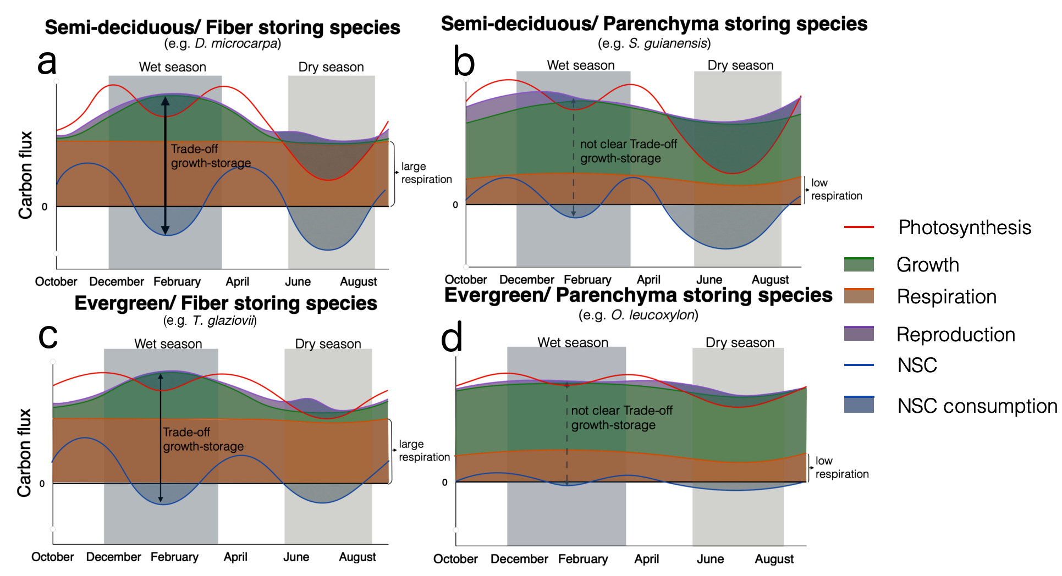

The anatomical distribution of starch in the stem wood (e.g., fiber-storage vs Parenchyma storage) together with leaf habit influences the carbon dynamics of trees in a seasonally dry forest. Semi-deciduous/fiber-storing species have greater temporal variation in carbon sink activity and a more dynamic starch pool. Furthermore, these semi-deciduous/fiber-storing species showed a negative correlation between the starch dynamics and growth during the wet season, suggesting a seasonal trade-off between storage and growth.