**Metabolic safety margin as an indicator of transient state of trees metabolism**

David Herrera-Ramírez1,2, Carlos A. Sierra1, Boaz Hilman1, Susan Trumbore1, and Paulo Brando2

1Max Planck Institute for Biogeochemistry, Hans-Knöll-Str 10, 07745 Jena

2Yale School of the Environment

Journal aim: PNAS

May 28, 2024

# Abstract

Non-structural carbon (NSC) reserves are vital for trees to survive and recover from stress. NSC dynamics leave a footprint in the NSC age and transit time. NSC mean age is the time from carbon fixation to measurement, while NSC transit time is from carbon fixation to allocation for metabolic needs like respiration and growth. These quantities can be modelled or estimated by measuring 14*C* in NSC and respired CO2.We to use the ratio between NSC mean transit time and age to evaluate the metabolic status of trees and NSC turnover, and we called this metroc the metabolic safety margin (MSM).

We modeled the MSM in trees from fast to slow NSC turnover. Our models indicate that trees prioritizing storage have a smaller MSM and take longer to aproximation one under starvation. They also show a slower transient response of the MSM to reduced carbon income.

We estimated the age of soluble carbon and respired CO2 in stem of trees in the Amazon with contrasting storage strategies, and branches and roots in trees in the Swiss Alps, using 14C. Results support our models showing that trees prioritizing storage have a smaller MSM. Additionally, MSM in organs with slower NSC turnover such as stem and roots are smaller and provide more long-term metabolic informatio than in organs with faster NSC turnover such as branches.

The metabolic safety margin helps to assess the metabolic state of mature trees and their resilience to environmental stress, improving estimates of tree vulnerability to climate change.

# Introduction

Trees are long-lived organisms that face and survive multiple and frequent stressors throughout their life spans. Global change is increasing the frequency and severity of stress and disturbances by raising air temperature, vapor pressure deficit (VPD), and shifting precipitation regimes, affecting trees worldwide (1–4). These factors are expected to cause changes in forest demographics with severe consequences for the global carbon cycle and the climate crisis we now face (4). This prompt us to understand the vulnerability of trees and forests to these new conditions, and their ability to survive and recover, is crucial for predicting changes in forest composition and functionality under new global environmental conditions.

Trees' investment in carbon reserves helps them survive and recover from multiple disturbances or stressful changes in environmental conditions (5–15). Carbon reserves in the form of non-structural carbon (NSC) are mainly soluble sugars, starch, and lipids. These reserves can be short-term—cycled very fast with a high turnover—or long-term—cycled slower with lower turnover—depending on tree’s organ and tree species (16–18). Tree species differ in their carbon allocation strategies, and some may prioritize allocation to NSC long-term storage over other alternatives such as growth (19–21). Thus, trees storing long-term NSC may have very old reserves that, if accessible, can buffer metabolism over multiannual or multidecadal time scales, playing a fundamental role in long-term tree survival and recovery.

Under a positive carbon balance, trees’ metabolism is sustained by recent NSC (11, 22–24). However, when trees are in a carbon deficit, they access their reserves to sustain metabolism (11, 13, 25–27). In these conditions, the carbon allocated to metabolism starts reflecting the contribution of old reserves, becoming progressively older. When trees recover or adapt, NSC reserves replenish with new NSC, and allocation to metabolism comes back to younger NSC (28). Thus, the interplay between multiple disturbances along trees’ life spans and trees’ carbon metabolism leaves footprints in the composition of ages of the NSC reserves and the NSC being allocated to metabolism.

Here, we present a new metric to evaluate the status of carbon metabolism of trees and their vulnerability to future stressful conditions. The Metabolic safety margin, as we call it, is the relationship between the age of the NSC mean age and transit time. This metric serves as a proxy to understand the interplay between trees’ carbon balance and changes in environmental conditions. We hypothesize that this relationship integrates the metabolic history of an adult tree over recent years and would indicate how much a tree has been affected by past multiple perturbations and how it will be by future extreme events or changes in growing conditions.

# Metabolic stafety margin: a new metric to evaluate the metabolic status of mature trees

The NSC turnover in trees and organs is determined by NSC pool size and the carbon fluxes towards metabolic needs such as respiration and growth, which may depend on species live history traits (19). These NSC turnover may fluctuate as trees regulate their carbon fluxes in response to environmental conditions (28, 29). The strategy for storing and using long-term reserves impacts trees' carbon fluxes and metabolism, affecting their ability to survive disturbances and recover.

Estimating the age of NSC stored in trees can serve as a proxy for NSC turnover time if trees are in a steady state. NSC age is the time between carbon fixation by photosynthesis and the time of observation. Large carbon allocation to NSC reserves and low allocation to growth, respiration, and reproduction may result in low NSC turnover times. The lower the turnover time, the older the NSC in reserve pools. However, NSC turnover time may vary significantly between species, having a significant impact on trees' resilience to environmental changes.

Since trees are not usually in a steady state, and NSC pool sizes and carbon fluxes may change with environmental conditions (29), the observed NSC age alone may not accurately reflect NSC turnover time. Additionally, NSC ages are not evenly distributed within trees or organs (16, 18). Age distribution depends on the mixing rates between old stored NSC and newly assimilated carbon, influenced by tree life history traits (30). Fluctuations in the carbon balance and mixing rates affect the age composition of NSC reserves, creating transient responses in NSC ages that do not reflect changes in NSC turnover time.

These differences and fluctuations cause the age of carbon allocated to metabolism to differ from the age of stored NSC. NSC transit time is the age of carbon from when it enters the tree until it is allocated to other carbon sinks (e.g., respiration, growth). Thus, the average mean age of NSC in a tree is expected to differ from the average NSC mean transit time (16, 31–33). The transient response of the ratio between the NSC mean age and mean transit time, caused by changes in the age composition of stored and accessed NSC, may integrate the NSC dynamics of trees over time and its responses to multiple stressors.

Under a positive carbon balance, trees allocate younger carbon to metabolism, typically 1 to 5 years old (11, 22, 23, 34). When trees face a negative carbon balance, they access carbon reserves to sutain their metabolism and survive (11, 13). As disturbances or stress progress, the contribution of old reserves to metabolic functions increases, reflected in the NSC transit time (16, 35, 36). NSC transit time would become progresively older as much as the age composition of the available reserves allows it. This progression towards older NSC transit time help us understanding how fast trees can access their reserves and for how long carbon reserves in trees reamain availabe, helping us to better understand transient responses of NSC ages in trees in response to environmental changes.

Then, the ratio between the NSC mean transit time and the NSC mean age at a given time may help us to estimate how much of the long term reserves contribute to trees metabolism, relative to the NSC turnover times of individual trees. For trees with fast NSC turnover, this ratio remains close to 1, indicating that reserves would not last long under stress. When trees have slower NSC turnover time, they may have older reserves and very small values of the NSC age ratio. Under stress, these trees' transit time increase, bringing the ratio closer to 1, indicating reliance on old storage to maintain metabolic functions. When this ration nears 1, it may indicate carbon reserve exhaustion, signaling tree vulnerability to future disturbances.

We call this ration “Metabolic Safety Margin” (MSM), and we propose using it as a metric to evaluate tree vulnerability to stress and recovery capacity (Fig. 1). This metric may serve as a proxy for changes in NSC age composition or turnover time, helping assess the metabolic health of adult trees.

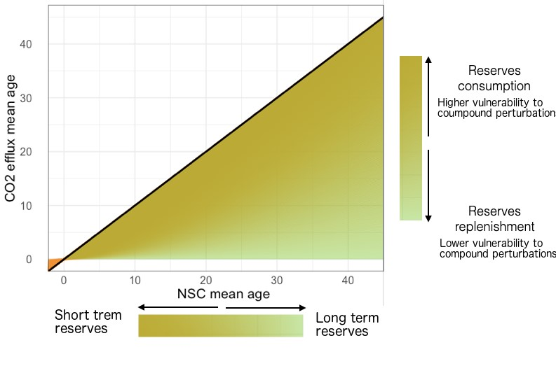

**Figure 1:** Theoretical relationship between the NSC mean age and the NSC transit time. Darker colors show a closer proximity to the 1:1 line which indicates a faster NSC turnover time

# Estimates of the metabolic safety margin

Estimting NSC mean age and transit time for entire mature trees is challenging. However, we can rely on good proxies for these measurements. For insntace, 14*C* measurements in the soluble carbon, starch, respired *CO*2, and new wood formed after cathastrophic events have been used to estimate NSC ages and the allocation of carbon to metabolism during stress (22, 23, 37, 38). Models allow us to estimate the NSC mean ages and transit time in specific organs and the entire tree (16). They also enable us to estimate the distribution of NSC ages and transit time and their variability between tree species and organs. In the following sections, we will ilustrate how both techniques help us estimating and understanding the metabolic safety margin in mature trees.

## Modelling approach

Metzler et al., (2018) developed an innovative mathematical framework to estimate mean ages and mean transit time for compartmental systems. This framework has been used in several studies to estimate differences in the age composition of NSC in trees with different storage strategies or growing under different environmental conditions (16, 28, 29). One way to explain carbon allocation is by dividing NSC into several compartments in trees. Carbon enters the system as sugars fixed from photosynthesis, and it is distributed to compartments such as leaves, stems, and roots. In each organ, it may be allocated to NSC reserves, respiration, biomass, reproduction, defense compounds, or exudates. We use this conceptual compartmentalization of NSC allocation to estimate NSC mean ages and transit times for each defined compartment and the whole tree using the framework proposed by Metzler et al., (2018).

As an example, to estimate the NSC mean age and transit time of mature trees with different allocation strategies and under stress, we used the NSC compartimental model adapted from Herrera-Ramírez et al (2020) and Klein and Hoch (2015) (Fig. 2). This model considers leaves, stems and roots as organ comprtments and, in each, two NSC compartments: stored NSC (slow cycled) and active NSC (fast cycled) (Table 1). For simplicity, only allocation to growth and respiration was considered as the ouflux of carbon from each organ (Fig. 2). With these models we explored the differences in the metabolic safety margin of trees with varying storage strategies and NSC turnover times, and describe their response to stressful conditions such as starvation or reduced photosynthesis.

**Table 1:** Compartments description for the model structure proposed in Fig. 2

|  |  |
| --- | --- |
| Abbreviation | Name |
| E | Transient Carbon Pool |
| FANSC | Foliage Active Non Structural Carbon |
| FSNSC | Foliage Stored Non Structural Carbon |
| SANSC | Stem Active Non Structural Carbon |
| SSNSC | Stem stored Non Structural Carbon |
| RANSC | Fine Root Active Non Structural Carbon |
| RSNSC | Fine Root Stored Non Structural Carbon |

We parametrized these models to simulate trees with different storage strategies (Table 2). Parameters in these models represent the annual fraction of carbon leaving each pool, estimated as the flux of carbon out of the pool divided by the pool size. We simulated a tree with a high NSC turnover time (1 year) where all parameters have a value of 1. Then, we simulated trees with slower NSC turnover times by adjusting the storage allocation parameters relative to the model with a 1-year turnover time (Table 2). This generated four more models with varying NSC turnover times, which we named: 1) allocation to stem storage; we increased allocation to stem storage by a factor of 60; 2) high allocation to stem storage; we increased the allocation stem storage by a fator of 120, 3) high allocation to root storage; we increased allocation stem storage by a factor of 60 and allocation root storage by a factor of 120; and 4) low allocation to stem storage; we increased the allocation stem storage by a factor of 30. These modifications allow us to evaluate NSC mean age and transit time of trees with different storage strategies and NSC turnover times at steady state.

**Table 2:** Annual rates of carbon cycling (year−1) and other parameters for each species from the models in Fig. 2. Pool name abbreviations are defined in the Table 1.



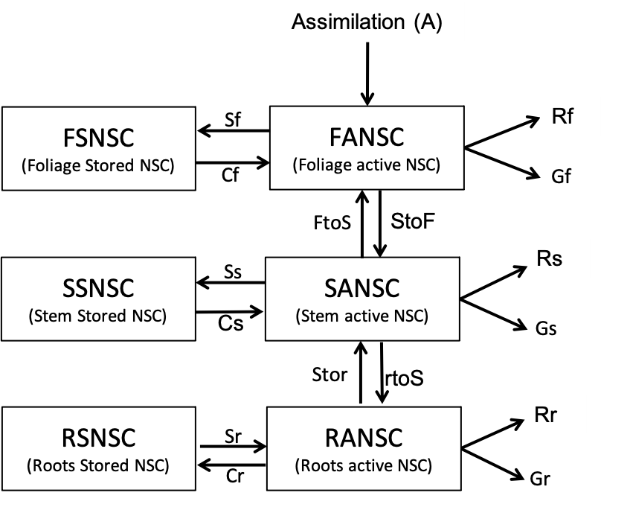

**Figure 2:** NSC allocation compartimental model. This model considers three organs foliage, stem and roots. In each orgar there are two NSC compartments an Active fast cycling compartment and a storage slow cycling compartment. Compartments are indicated by boxes, while fluxes out and into compartments are indicated by arrows. Abreviation names are explained in Table 1 and Table 2

We estimated NSC mean age and transit time at steady state for each of the five modeled tree types (Fig. 3). These points represent the metabolic safety margin of trees with contrasting storage strategies at steady state. We observed that lower NSC turnover times (higher allocation to storage in wood and roots, red and blue points in Fig. 3) resulted in older NSC mean age and, younger NSC mean transit time relative to storage, than trees with faster turnover times (brown and black points, Fig. 3). This indicates that the closer the relationship between NSC mean age and NSC mean transit time (metabolic safety margin ) is to the 1:1 line, the faster the NSC turnover time.

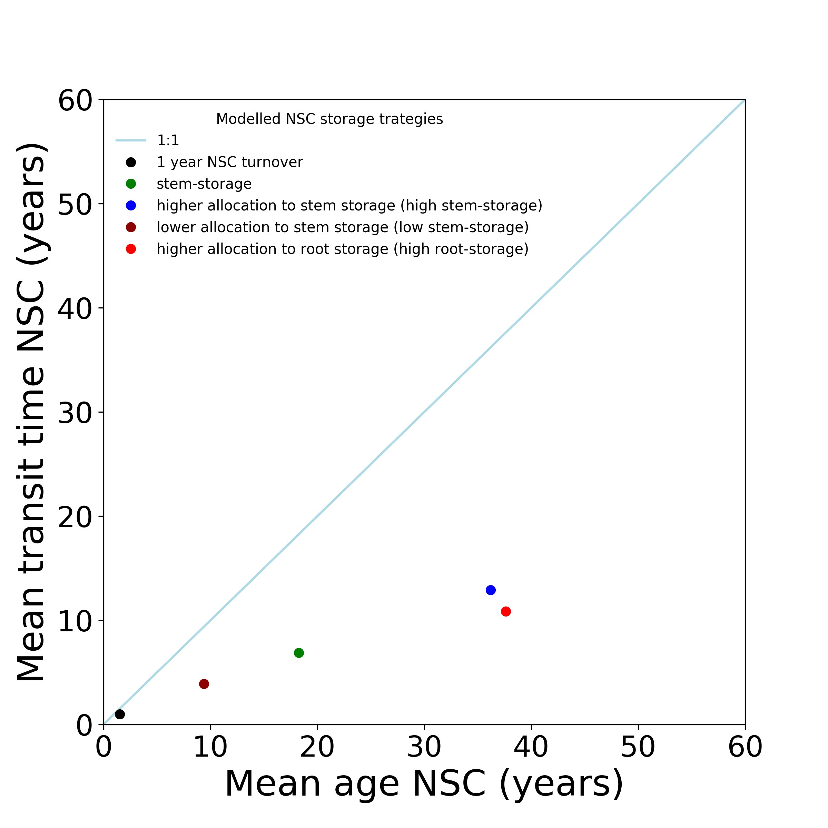

**Figure 3:** Metabolic safety margin simultated for 5 trees with different NSC turnover times using the model structure presented in Fig. 2 and the parameters described in Tale 2 to generate each of the point shown in the model

We estimated the trajectories of the metabolic safety margin as trees with different storage strategies faced starvation. All models showed a trajectory towards the 1:1 line as the system became carbon depleted (Fig. 2). These trajectories approached the 1:1 line differently depending on the NSC allocation strategy. High priority to storage resulted in a slower approach to the 1:1 line, with a longer trajectory for greater allocation to root storage (red line) compared to stem storage (blue line) (Fig. 2). Meanwhile, lower priority to NSC storage and faster NSC turnover resulted in a faster approach to the 1:1 line (green, brown, and black lines in Fig. 2). This progressive approach of each line to the 1:1 line reflects the increasing contribution of stored reserves to respiration and growth.

These models are linear and not time-dependent, therefore NSC turnover time does not change during the simulated starvation. These estimated changes in NSC mean age and transit time are a transient response of the age composition of stored NSC to the sumulated starvation. These changes in the metabolic safety margin provide insights into the ability of trees with different storage strategies to use stored carbon when facing starvation and the time it would take to exhaust NSC reserves. In reallity, changes in NSC turnover time can also occur as trees respond to environmental conditions, reflecting a change in the tree’s carbon allocation strategy. Such changes would alter the metabolic safety margin, accelerating or slowing its progression toward the 1:1 line. Then, changes in MSM may be a mixture of both, a transient change in the age composition of the NSC and a transient change of the NSC turnover time. Progressions toward the 1:1 line appear as an increase in NSC turnover time as trees exhaust their reserves. Thus, MSM inform us abut transient state of NSC reserves and its transient NSC turnover time, shading insights about the use or replenishment of NSC reserves over time in mature trees.

We also modeled the transient changes in the metabolic safety margin when trees experience a limitation in carbon supply. In these simulations, income was kept as in Table 2 for the first 10 years and then reduced to 2300 gC/year for the next 40 years. We compared a fast-cycling tree (black line) with a slower-cycling tree (green line) (Fig. 5). A reduction in carbon income produced a transient response in the metabolic safety margin for both trees (Fig. 5). The metabolic safety margin approached the 1:1 line as trees depleted of carbon and then returned to steady state as all the carbon was replaced by new carbon under the new conditions (Fig. 5). In these new conditions, the size of storage pools and carbon fluxes adapted to the new income, keeping NSC turnover times constant. Depending on NSC turnover, some trees will take longer than others to return to the steady state metabolic safety margin; the transient changes in the metabolic safety margin are faster in trees with faster turnover times (black line) than in trees with slower NSC turnover times (green line).

If a tree experiences increases in NSC turnover times due to environmental changes, we would expect a shift in the transient pathway of the metabolic safety margin from a slower (green line) to a faster (black line) response (Fig. 5). When trees return to steady state, they would be closer to the 1:1 line as NSC turnover time increases. These simulations help us understand the trajectories of the transient response of the metabolic safety margin to stress and perturbations and evaluate how changes in NSC turnover times affect trees' responses to stress. This provides a tool to assess trees' health and their potential ability to survive and recover under stress and perturbations.

## [1]*4C* approach

4*C* have been widely used to estimate the age of NSC such as soluble carbon and starch, the formation of new structural tissues (leaves, wood, roots) and the respired *CO*2 in plants. Using the bomb spike in the 14*C* concentrations in the atmosphere caused by nuclear testing in the 1950’s and 1960’s, 14*C* measurements can be calibrated to calendar dates with only one year of uncertainty (42). Consiering only NSC in plants, we can assume that the age of the NSC can be estimated by the 14*C* signal of the stored NSC (soluble sugars, starch and lipids), while the NSC transit time can be estimated with the 14*C* signal of the carbon allocated new biomass and respiration (*CO*2).

Estimates of the NSC ages based on 14*C* provide an average value of the NSC age distribution in the analyzed sample. However, this may not accurately represent NSC age distribution, as it may be skewed towards younger ages and vary between organs, making it difficult to estimate NSC ages for the entire tree (16). Nevertheless, 14C measurements are currently our best approach to characterize mean NSC ages and transit times in tree organs and compounds, and observe their changes when trees face stress or perturbations. Identifying key organs and compartments where estimates of the metabolic safety margin provide insights into the metabolic state of the whole tree is important for assessing the metabolic vulnerability of trees to future stress.

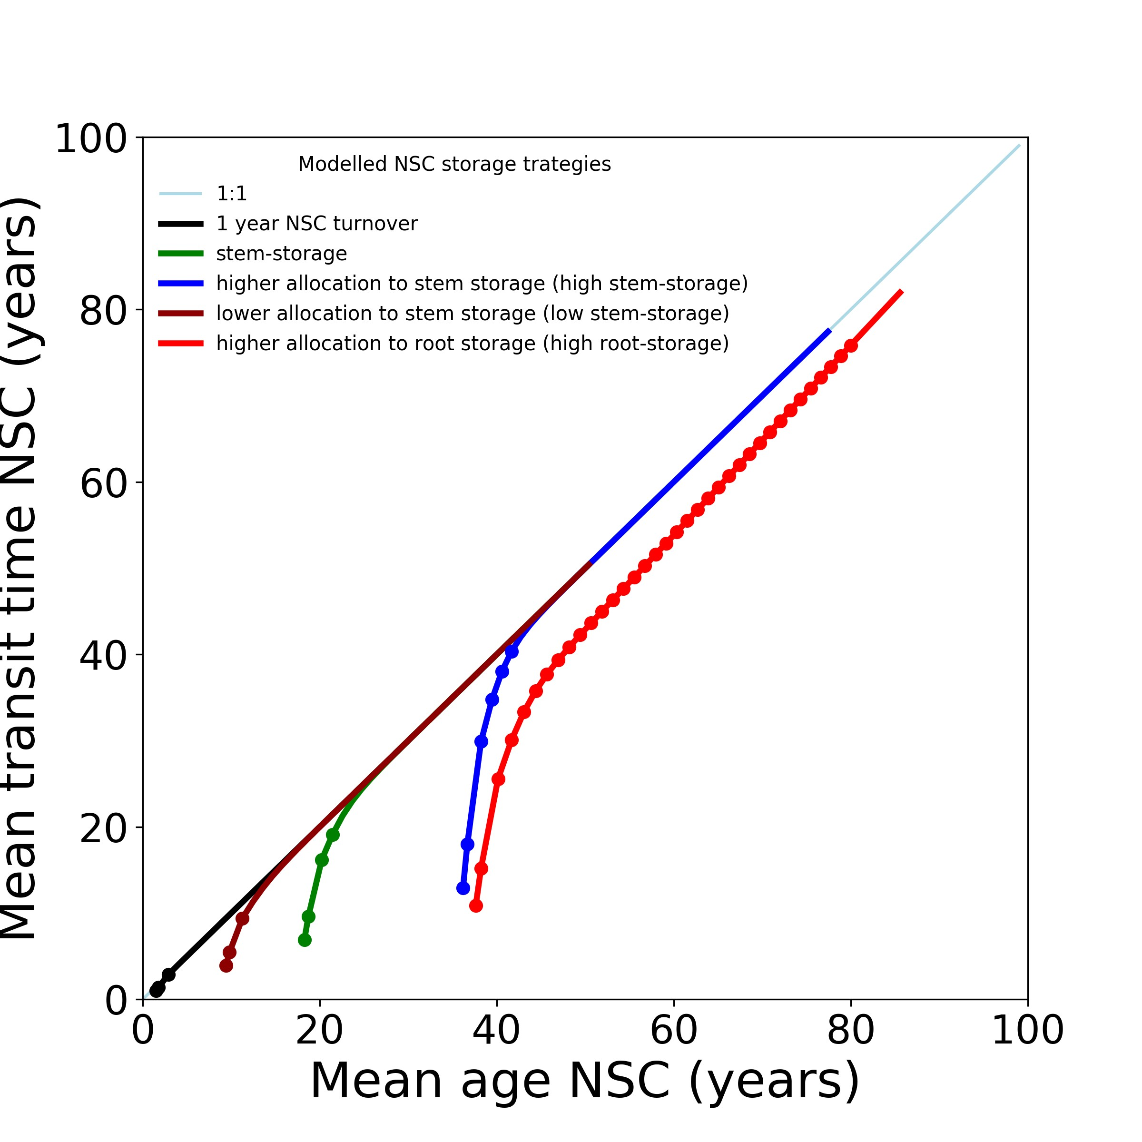

**Figure 4:** Simulation of the pathway that the metabolic safety margin wold follow when trees face starvation for each of the simulated trees specified in the Table2. Each poin in each trend line represents one time step of one year. The amount of point each line has before reaching the 1:1 line shows te amount of years each of those trees would take to exahust their NSC reserves.

**3.2.1 What organs should we measure to estimate trees’ Metablic Safety Margin?**

14*C* ages are not evenly distributed in trees; different organs have different age composition depending on species and organ dynamics (22). For instance, leaves will generally have very young NSC because they cycle it daily, while stemwood and coarse roots would have an age composition with larger proportions of older carbon due to multiannual cycling dynamics (16). If metabolic safety margins inform us about tree preparedness for future uncertain conditions on multiannual scales, mean NSC ages and transit times of long-term reserves such as those in stem wood and roots would provide a good estimate of the metabolic state of trees. 14*C* mean ages of NSC have been reported to be older in stem wood and coarse roots than in any other tree organ, showing large variability depending on species and environmental conditions (13, 22, 26, 30, 43). These olde reserves can be accessed to support metabolism, in this case the 14*C* age of the *CO*2 from stem wood becames progressively older as trees use their stored NSC (11, 44). Trees also used their carbon reserves to rebuild new tissues in order to recover after a cathastrophic event, where 14*C* ages of the carbon use tu build new branches and roots resemble the ages in te NSC pools of stem wood and coarse roots (5, 13, 45). Thus, stem wood and root reserves may serve as an integrator of carbon dynamics in the whole tree (19). Therefore, measuring the 14*C* in the NSC reserves and respired *CO*2 in stem wood or roots can provide a good proxy of the metabolic safety margin of mature trees.

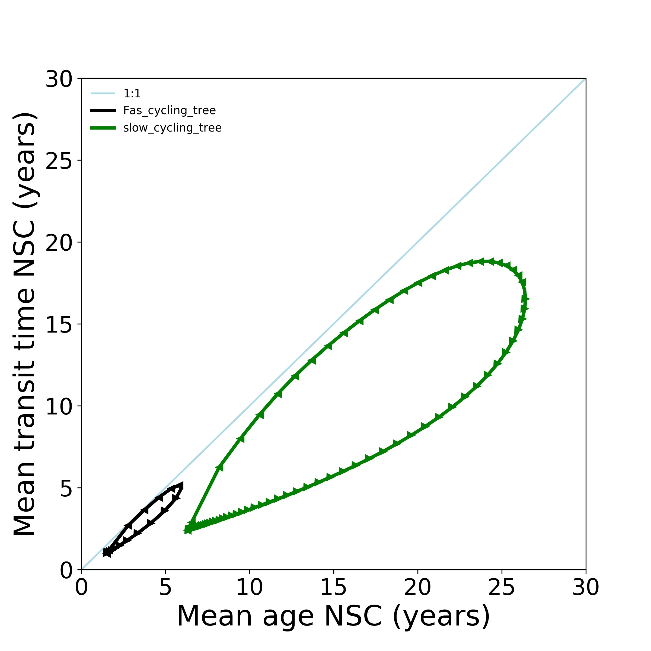

**Figure 5:** Simulation of the pathway that the metabolic safety margin of two trees with contrasting NSC turnover times would follow after facing a reduction in photosynthesis. The black line represents a tree with a fast turnover time, while the green line represents a tree with a slower turnover time. The arrows in the line show the direction of the changes at each time steps. Each arrow represent one time step (1 year)in the simulation.

**3.2.2 What compounds should we measure?**

NSC mainly comprises soluble sugars, starch, and neutral lipids, which all serve as storage reserves but may have different physiological functions. Soluble sugars are involved in osmoregulation, cell signaling, and communication, and can act as hormones, which are vital functions for trees that need to be maintained (15, 27, 46–48). Neutral lipids may be involved in defense, stress responses, hormone signaling pathways, and cellular transport (49, 50). Therefore, a proportion of soluble sugars and neutral lipids may not be accessible to support metabolism and growth in mature trees.

Starch appears to have the sole function of carbon and energy storage, accessible to support other metabolic and physiological functions. While there are uncertainties about the accessibility of all starch reserves for supporting tree metabolism, evidence suggests that trees can remobilize almost all starch reserves in leaves and stem wood at different time scales and in response to perturbations (19, 51, 52). This indicates that most starch pools may be entirely accessible to support metabolism during stressful conditions or recovery from perturbations.

Estimating the age of starch using 14*C* could be the best proxy for the mean age of the NSC to estimate the matabolic safety margin in mature trees. Starch dynamics may serve as a metabolic integrator of the tree's carbon dynamics and overall metabolism (53). It is possible to isolate starch for 14C analysis using enzymatic extraction methods, paying special attention to avoid contamination with exogenous carbon. Alternatively, estimating the age of soluble carbon using 14C may be viable. Soluble carbon is esier to extract than starch, although it may not represent 100% of the accessible reserves, if we assume a fast interchange beteween all soluble carbon (sugars, proteins, tanins, etc) and starch reserves in the sampled organ, the age of soluble carbon would also be a good approximation to the NSC mean age. We propose the use of 14*C* measurements of starch as the best proxy for NSC mean age in storage compartments, but soluble carbon analysis may also provide valuable information if starch isolation is not feasible.

Assuming cell respiration is a priority over growth, changes in the age composition of emitted CO2 would be more sensitive to changes in the metabolic conditions of trees following stress or perturbations than the age composition of carbon allocated to growth. Therefore, 14C analysis of respired CO2 would be a good proxy for the transit time of accessible NSC stored in any tree organ. We hypothesize that the metabolic safety margin for mature trees would be more informative if the mean age of NSC and mean transit times are estimated from stored starch pools and respired CO2, respectively, in stem wood or roots.

**3.2.3 Some examples**

We estimated the metabolic safety margin in different tree organs to test our hypotheses in various tree sets. These measurements were taken on tropical trees growing in a seasonal dry forest in Mato Grosso, Brazil. We measured species with contrasting storage traits (starch storage in parenchyma cells and starch storage in living fibers) to evaluate if differences in storage prioritization can be detected in the metabolic safety margins. Fiber storing species have larger prioritization to storaga than parenchyma storig species (19). Measurements were also taken during the wet and dry seasons to evaluate the impact of seasonal stress on the metabolic safety margin. Additionally, we measured these quantities in the branches and roots of *Larix decidua* and *Pinus mugo* growing in the Swiss Alps to evaluate the representativeness of different storage organs.

Estimates of NSC mean age were based on 14C measurements of soluble carbon extracts from stem wood cores following methods described by Hillman et al 2021 (43). Estimates of CO2 ages were based on 14C measurements of CO2 incubated from stem wood cores, following methods described by (54). Incubations were done for 36 hours to estimate the age of carbon allocated to respiration at the moment of sample collection, avoiding the remobilization of older, long-term reserves.

Our measurements show differences in the metabolic safety margin in stem wood between storage strategies for tropical trees in the Amazon (Fig. 6). Fiber-storing species, which prioritize allocation to NSC storage (19), have lower metabolic safety margins than parenchyma-storing species (Fig. 6), where most trees are far from the 1:1 line in Figure 6. Our results also suggest that, seasonality in precipitation also affects the metabolic safety margin, reflecting the impact of the dry season on tree metabolism and storage reserve use. During the dry season (July 2018), the metabolic safety margin was closer to the 1:1 line for most measured trees, while during the end of the wet season (May 2019), all trees showed a recovery of carbon reserves reflected in younger mean ages and transit times (Fig. 6).

We observed differences in the metabolic safety margins estimated from different tree organs. In our measurements in *L. decidua* and *P. mugo*, branches showed younger mean ages and transit times than 1-2mm roots (Fig. 7), indicating a higher apparent turnover time in NSC in the branches than in the roots. Furthermore, differences in the metabolic safety margin between species were only observable in root samples (Fig. 7), which store older reserves and may better reflect long-term metabolic dynamics of trees. This supports our hypothesis that evaluating metabolic safety margins in roots and stem wood provides more information about the metabolic state of the tree than organs with faster turnover times.

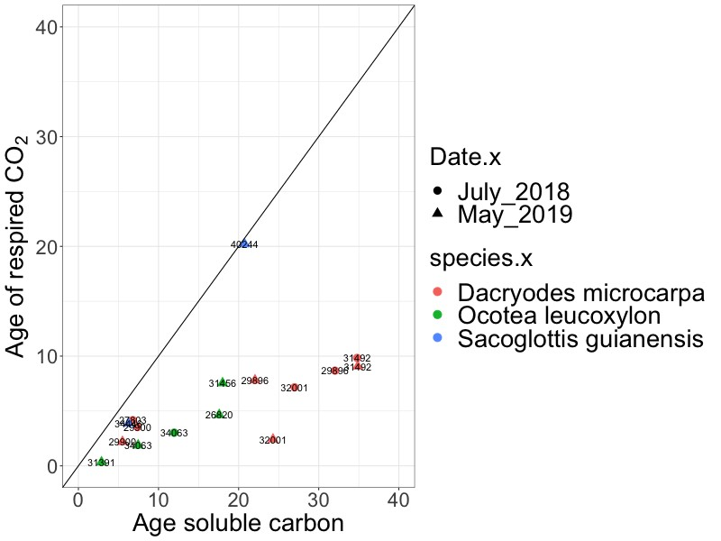

Figure 6: Estimates of the matebolic safety margin for trees measured in a seasonal dry forest in the Amazon during the wet and the dry season. We estimate the age of the soluble carbon and the respired *CO*2 using 14*C* measurements and the bomb spile callibration curve.

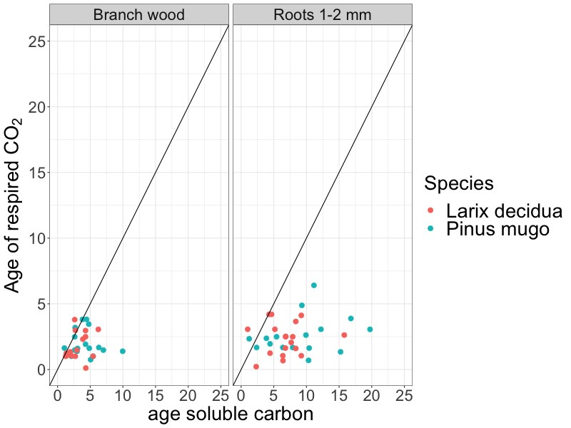

Figure 7: Estimates of the matebolic safety margin for *Larix decidua* and *Pinus mugo* in the swiss alps. We measured branches and roots from the same individuals. We estimate the age of the soluble carbon and the respired *CO*2 using 14*C* measurements and the bomb spile callibration curve.

# Utility of the new hypotheis

We presented a new theoretical framework to evaluate the metabolic vulnerability of trees to multiple future frequent and severe stress or perturbations. This framework helps us evaluate and understand the metabolic status of mature trees at a given time point, integrating the life history traits and storage dynamics of trees. From this metabolic state, we can estimate the potential turnover times of accessible NSC reserves, which influence the time trees can rely on those reserves to survive and recover from stress or perturbations.

This theory also has the potential to help us understand patterns of recovery and adaptation in adult trees. Evaluating how NSC turnover times change in response to stress and perturbation by measuring changes in the metabolic safety margin will help us understand how NSC dynamics are affected by environmental changes and assess the capacity of trees to recover. Information regarding the accessibility of NSC reserves and changes in NSC turnover times in response to environmental changes is still scarce. Our proposed framework offers a viable alternative to evaluate how apparent NSC turnover times change when trees are exposed to environmental changes or face multiple perturbations.

# References

1. C. D. Allen, *et al.*, A global overview of drought and heat-induced tree mortality reveals emerging climate change risks for forests. *Forest Ecology and Management* **259**, 660–684 (2010).

2. H. D. Adams, *et al.*, A multi-species synthesis of physiological mechanisms in drought-induced tree mortality. *Nature Ecology & Evolution* **1**, 1285–1291 (2017).

3. N. G. McDowell, *et al.*, Mechanisms of woody-plant mortality under rising drought, CO2 and vapour pressure deficit. *Nat Rev Earth Environ* **3**, 294–308 (2022).

4. N. G. McDowell, *et al.*, Pervasive shifts in forest dynamics in a changing world. *Science* **368**, eaaz9463 (2020).

5. E. D’Andrea, *et al.*, Winter’s bite: beech trees survive complete defoliation due to spring late-frost damage by mobilizing old C reserves. *New Phytologist* **224**, 625–631 (2019).

6. M. E. Furze, S. Trumbore, H. Hartmann, Detours on the phloem sugar highway: stem carbon storage and remobilization. *Current Opinion in Plant Biology* **43**, 89–95 (2018).

7. L. Galiano, J. Martínez-Vilalta, F. Lloret, Carbon reserves and canopy defoliation determine the recovery of Scots pine 4 yr after a drought episode. *New Phytologist* **190**, 750–759 (2011).

8. N. Guérard, P. Maillard, C. Bréchet, F. Lieutier, E. Dreyer, Do trees use reserve or newly assimilated carbon for their defense reactions? A 13C labeling approach with young Scots pines inoculated with a bark-beetle-associated fungus (Ophiostoma brunneo ciliatum). *Annals of Forest Science* **64**, 601–608 (2007).

9. H. Hartmann, S. Trumbore, Understanding the roles of nonstructural carbohydrates in forest trees – from what we can measure to what we want to know. *New Phytologist* **211**, 386–403 (2016).

10. R. W. Long, H. D. Adams, The osmotic balancing act: When sugars matter for more than metabolism in woody plants. *Global Change Biology* **29**, 1684–1687 (2023).

11. J. Muhr, S. Trumbore, N. Higuchi, N. Kunert, Living on borrowed time – Amazonian trees use decade-old storage carbon to survive for months after complete stem girdling. *New Phytologist* **220**, 111–120 (2018).

12. M. J. O’Brien, S. Leuzinger, C. D. Philipson, J. Tay, A. Hector, Drought survival of tropical tree seedlings enhanced by non-structural carbohydrate levels. *Nature Climate Change* **4**, 710 EP- (2014).

13. D. M. P. Peltier, *et al.*, Old reserves and ancient buds fuel regrowth of coast redwood after catastrophic fire. *Nat. Plants* **9**, 1978–1985 (2023).

14. F. I. Piper, S. Paula, The Role of Nonstructural Carbohydrates Storage in Forest Resilience under Climate Change. *Current Forestry Reports* **6**, 1–13 (2020).

15. C. Signori-Müller, *et al.*, Non-structural carbohydrates mediate seasonal water stress across Amazon forests. *Nat Commun* **12**, 2310 (2021).

16. D. Herrera-Ramírez, *et al.*, Probability distributions of nonstructural carbon ages and transit times provide insights into carbon allocation dynamics of mature trees. *New Phytologist* **226**, 1299–1311 (2020).

17. I. Rog, *et al.*, Increased belowground tree carbon allocation in a mature mixed forest in a dry versus a wet year. *Global Change Biology* **30**, e17172 (2024).

18. S. Trumbore, C. I. Czimczik, C. A. Sierra, J. Muhr, X. Xu, Non-structural carbon dynamics and allocation relate to growth rate and leaf habit in California oaks. *Tree Physiology* **35**, 1206–1222 (2015).

19. D. Herrera‐Ramírez, *et al.*, Anatomical distribution of starch in the stemwood influences carbon dynamics and suggests storage‐growth trade‐offs in some tropical trees. *Journal of Ecology* **111**, 2532–2548 (2023).

20. J. Huang, *et al.*, Storage of carbon reserves in spruce trees is prioritized over growth in the face of carbon limitation. *Proc. Natl. Acad. Sci. U.S.A.* **118**, e2023297118 (2021).

21. M. E. Furze, *et al.*, Whole-tree nonstructural carbohydrate storage and seasonal dynamics in five temperate species. *New Phytologist* **221**, 1466–1477 (2019).

22. M. S. Carbone, *et al.*, Age, allocation and availability of nonstructural carbon in mature red maple trees. *New Phytologist* **200**, 1145–1155 (2013).

23. M. S. Carbone, C. I. Czimczik, K. E. McDuffee, S. E. Trumbore, Allocation and residence time of photosynthetic products in a boreal forest using a low-level 14C pulse-chase labeling technique. *Global Change Biology* **13**, 466–477 (2007).

24. M. S. Carbone, S. E. Trumbore, Contribution of new photosynthetic assimilates to respiration by perennial grasses and shrubs: residence times and allocation patterns. *New Phytologist* **176**, 124–135 (2007).

25. A. D. Richardson, *et al.*, Seasonal dynamics and age of stemwood nonstructural carbohydrates in temperate forest trees. *New Phytologist* **197**, 850–861 (2013).

26. J. B. Gaudinski, *et al.*, Use of stored carbon reserves in growth of temperate tree roots and leaf buds: analyses using radiocarbon measurements and modeling. *Global Change Biology* **15**, 992–1014 (2009).

27. E. D’Andrea, *et al.*, Frost and drought: Effects of extreme weather events on stem carbon dynamics in a Mediterranean beech forest. *Plant, Cell & Environment* **43**, 2365–2379 (2020).

28. D. M. P. Peltier, *et al.*, Carbon starvation following a decade of experimental drought consumes old reserves in *Pinus edulis*. *New Phytologist* **240**, 92–104 (2023).

29. D. M. P. Peltier, *et al.*, Moisture stress limits radial mixing of non-structural carbohydrates in sapwood of trembling aspen. *Tree Physiology* tpad083 (2023). https://doi.org/10.1093/treephys/tpad083.

30. A. D. Richardson, *et al.*, Distribution and mixing of old and new nonstructural carbon in two temperate trees. *New Phytologist* **206**, 590–597 (2015).

31. C. A. Sierra, M. Müller, H. Metzler, S. Manzoni, S. E. Trumbore, The muddle of ages, turnover, transit, and residence times in the carbon cycle. *Global Change Biology* **23**, 1763–1773 (2017).

32. C. A. Sierra, G. R. Quetin, H. Metzler, M. Müller, A decrease in the age of respired carbon from the terrestrial biosphere and increase in the asymmetry of its distribution. *Phil. Trans. R. Soc. A.* **381**, 20220200 (2023).

33. B. Bolin, H. Rodhe, A note on the concepts of age distribution and transit time in natural reservoirs. *Tellus* **25**, 58–62 (1973).

34. C. A. Sierra, V. Ceballos-Núñez, H. Hartmann, D. Herrera-Ramírez, H. Metzler, Ideas and perspectives: Allocation of carbon from net primary production in models is inconsistent with observations of the age of respired carbon. *Biogeosciences* **19**, 3727–3738 (2022).

35. J. Muhr, *et al.*, How fresh is maple syrup? Sugar maple trees mobilize carbon stored several years previously during early springtime sap-ascent. *New Phytologist* **209**, 1410–1416 (2016).

36. J. Muhr, S. Trumbore, N. Higuchi, N. Kunert, Living on borrowed time – Amazonian trees use decade-old storage carbon to survive for months after complete stem girdling. *New Phytologist* **220**, 111–120 (2018).

37. A. Gessler, K. Treydte, The fate and age of carbon – insights into the storage and remobilization dynamics in trees. *New Phytologist* **209**, 1338–1340 (2016).

38. K. A. Prats, M. E. Furze, Tree carbon dynamics: what the age and availability of nonstructural carbohydrates can tell us about forest ecosystem resilience in a changing world. *Tree Physiology* tpad143 (2023). https://doi.org/10.1093/treephys/tpad143.

39. H. Metzler, C. A. Sierra, Linear Autonomous Compartmental Models as Continuous-Time Markov Chains: Transit-Time and Age Distributions. *Math Geosci* **50**, 1–34 (2018).

40. H. Metzler, M. Müller, C. A. Sierra, Transit-time and age distributions for nonlinear time-dependent compartmental systems. *Proc. Natl. Acad. Sci. U.S.A.* **115**, 1150–1155 (2018).

41. T. Klein, G. Hoch, Tree carbon allocation dynamics determined using a carbon mass balance approach. *New Phytologist* **205**, 147–159 (2015).

42. S. E. Trumbore, C. A. Sierra, C. E. Hicks Pries, “Radiocarbon Nomenclature, Theory, Models, and Interpretation: Measuring Age, Determining Cycling Rates, and Tracing Source Pools” in *Radiocarbon and Climate Change: Mechanisms, Applications and Laboratory Techniques*, E. A. G. Schuur, E. Druffel, S. E. Trumbore, Eds. (Springer International Publishing, 2016), pp. 45–82.

43. B. Hilman, *et al.*, The size and the age of the metabolically active carbon in tree roots. *Plant Cell & Environment* **44**, 2522–2535 (2021).

44. J. Helm, *et al.*, Carbon dynamics in long-term starving poplar trees—the importance of older carbohydrates and a shift to lipids during survival. *Tree Physiology* tpad135 (2023). https://doi.org/10.1093/treephys/tpad135.

45. R. Vargas, S. E. Trumbore, M. F. Allen, Evidence of old carbon used to grow new fine roots in a tropical forest. *New Phytologist* **182**, 710–718 (2009).

46. M. Blumstein, J. Gersony, J. Martínez‐Vilalta, A. Sala, Global variation in nonstructural carbohydrate stores in response to climate. *Global Change Biology* **29**, 1854–1869 (2023).

47. M. C. Dietze, *et al.*, Nonstructural Carbon in Woody Plants. *Annual Review of Plant Biology* **65**, 667–687 (2014).

48. J. Martínez-Vilalta, *et al.*, Dynamics of non-structural carbohydrates in terrestrial plants: a global synthesis. *Ecological Monographs* **86**, 495–516 (2016).

49. K. Athenstaedt, G. Daum, The life cycle of neutral lipids: synthesis, storage and degradation. *Cellular and Molecular Life Sciences CMLS* **63**, 1355–1369 (2006).

50. M. A. Welte, A. P. Gould, Lipid droplet functions beyond energy storage. *Biochimica et Biophysica Acta (BBA) - Molecular and Cell Biology of Lipids* **1862**, 1260–1272 (2017).

51. K. A. Prats, A. C. Fanton, C. R. Brodersen, M. E. Furze, Starch depletion in the xylem and phloem ray parenchyma of grapevine stems under drought. *AoB PLANTS* **15**, plad062 (2023).

52. D. M. P. Peltier, *et al.*, An incubation method to determine the age of available nonstructural carbon in woody plant tissues. *Tree Physiology* tpad015 (2023). https://doi.org/10.1093/treephys/tpad015.

53. R. Sulpice, *et al.*, Starch as a major integrator in the regulation of plant growth. *Proc. Natl. Acad. Sci. U.S.A.* **106**, 10348–10353 (2009).

54. J. Muhr, *et al.*, Carbon dioxide emitted from live stems of tropical trees is several years old. *Tree Physiology* **33**, 743–752 (2013).

1.