Supplementary information: starch storage strategy in the stem wood influences carbon dynamics and storage-growth trade-offs in tropical trees

David Herrera-Ramírez1*, Henrik Hartmann1, Christine Römermann2,3, Susan Trumbore1, Jan Muhr1, 4, Leonardo Maracahipes-Santos7, Paulo Brando5, 6,7, Divino Silvério8, Huang Jianbei1, Iris Kuhlmann1 and Carlos A. Sierra1

1Max Planck Institute for Biogeochemistry, Hans-Knöll-Str 10, 07745 Jena

2Friedrich Schiller University Jena, Institute for Ecology and Evolution, Philosophenweg 16, 07743, Jena, Germany

3German Centre for Integrative Biodiversity Research (iDiv) Halle-Jena-Leipzig, D- 04103 Leipzig

4Georg August University Göttingen, Department of Bioclimatology, Büsgenweg 2, 37077 Göttingen, Germany

5Department of Earth System Science, University of California, Irvine, CA 92697, USA

6Yale School of the Environment, Yale University, New Haven, CT, United States.

**7**Instituto de Pesquisa Ambiental da Amazônia, Brasília, DF 70863-520, Brazil

8Department of Biology, Universidade Federal Rural da Amazônia-UFRA, Capitāo Poço 68650-000, Pará, Brazil

*Dacryodes microcarpa* (semi-deciduous/fiber-storing)

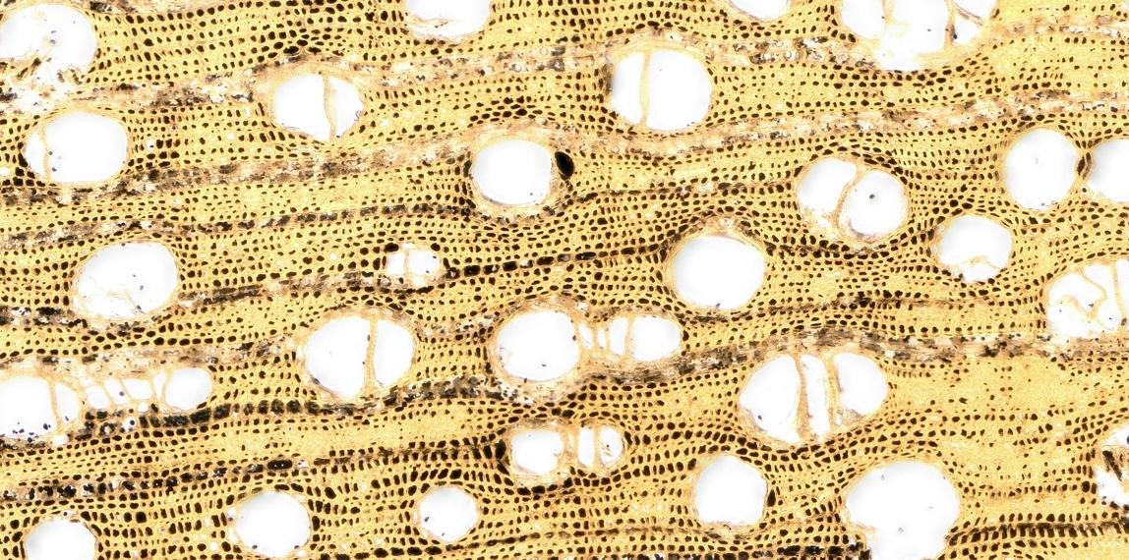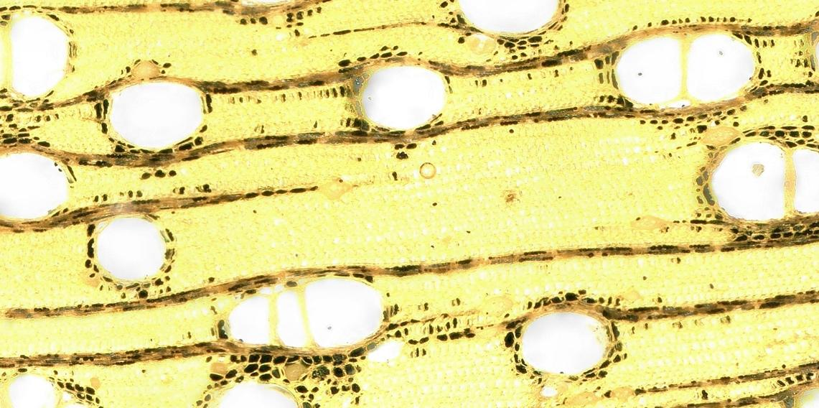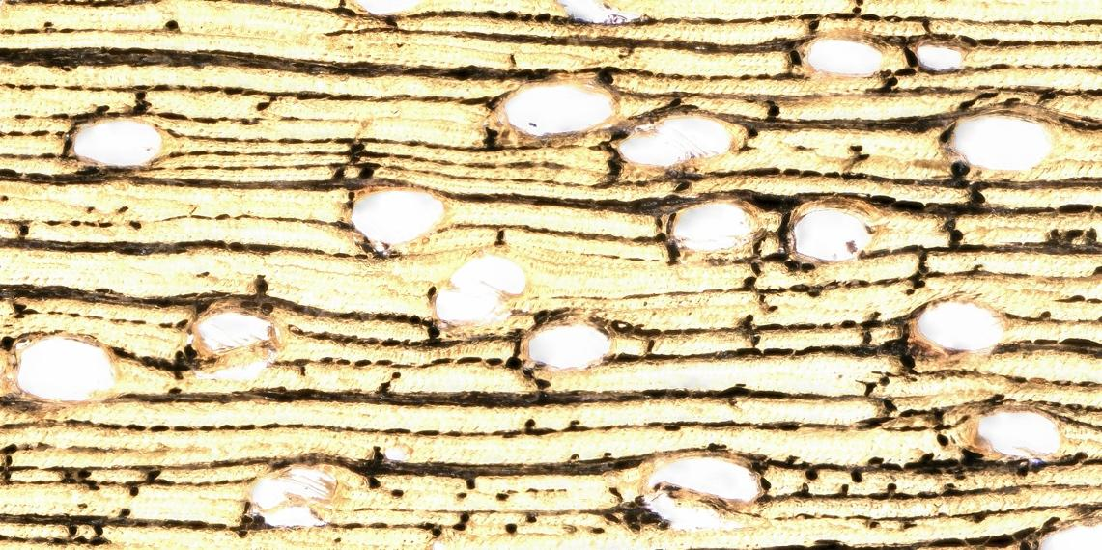

*Sacoglotis guianensis* (semi-deciduous/parenchyma-storing)

*Ocotea leucoxylon* (evergreen/parenchyma-storing)

*Figure S1: Microscopic photos of transversal wood sections from each studied species. The pictures show starch stained black by Lugol’s iodine, which enable us to distinguish the specific cells where starch is stored in the stem-wood of these species. This trait characterizes the starch storage strategy that we use in our study. Each panel is labeled with the name of the species and the specific combination of traits.*

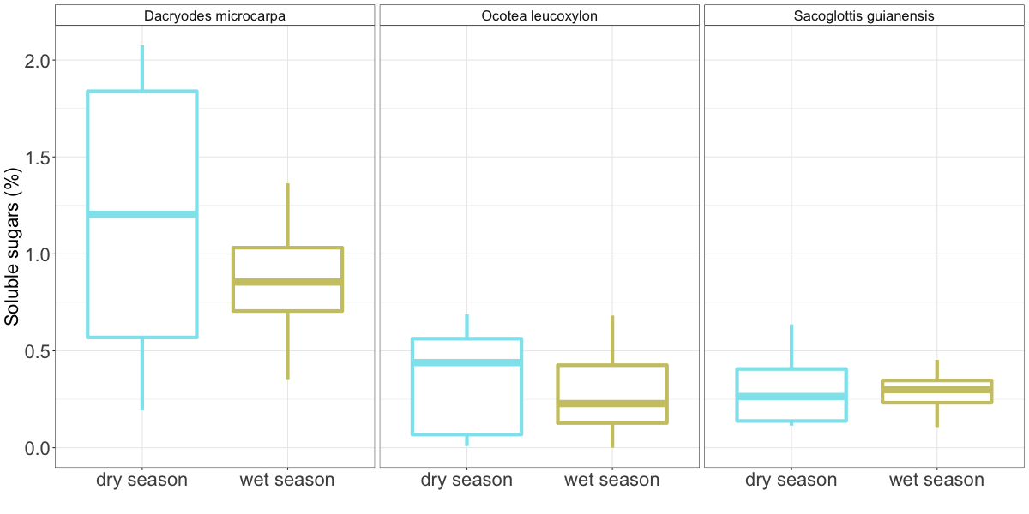

*Figure S2: Soluble sugars concentrations measured in the stem wood of the studied species during the dry and the wet seasons of the year 2018. The dispersion of the measurements is shown by boxplots. Statistical comparisons within species where done using Wilcoxon signed-rank tests and no differences were detected in all the species.*

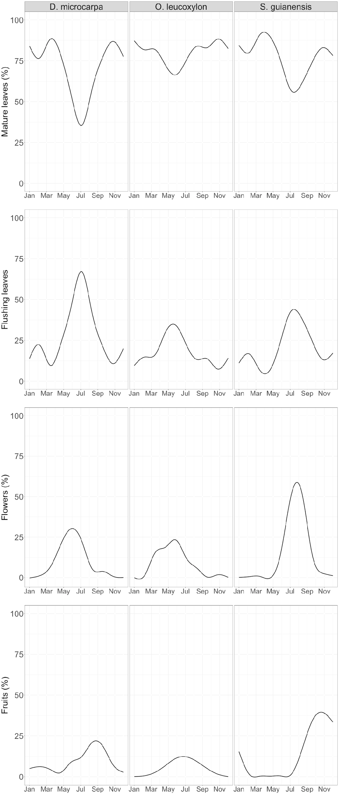

*Figure S3: Seasonal course of the percentage of crown coverage of mature leaves, flushing leaves, flowers and fruits observed during the last 8 years in local trees from the studied species. The lines represent smoothing models from the data that highlight the seasonal trand of each of the evaluated traits.*

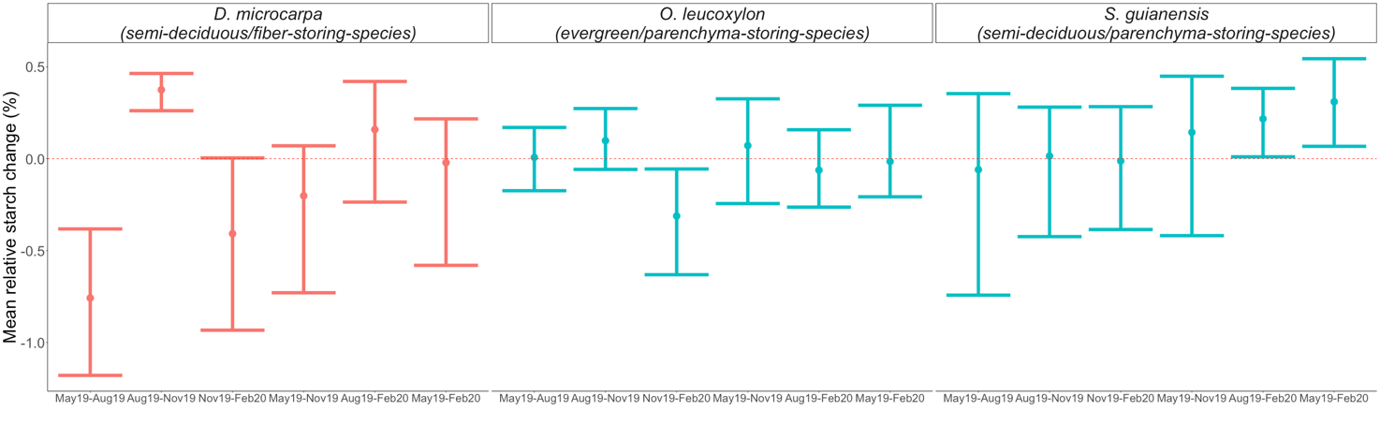

*Figure S4. Non-parametric confidence intervals for the mean of the relative changes of starch content. Relative starch changes where evaluated at distinct time periods, the first three groups for each species are time periods comprising consecutive months of measurements which constitute de defined seasons in our study; the following three groups in each species consist of the other possible time combinations which evaluates changes in starch content across longer time periods. The periods considering for analyzes are denoted in the x-axis indicating the first and the last month of each period in the axis label.*

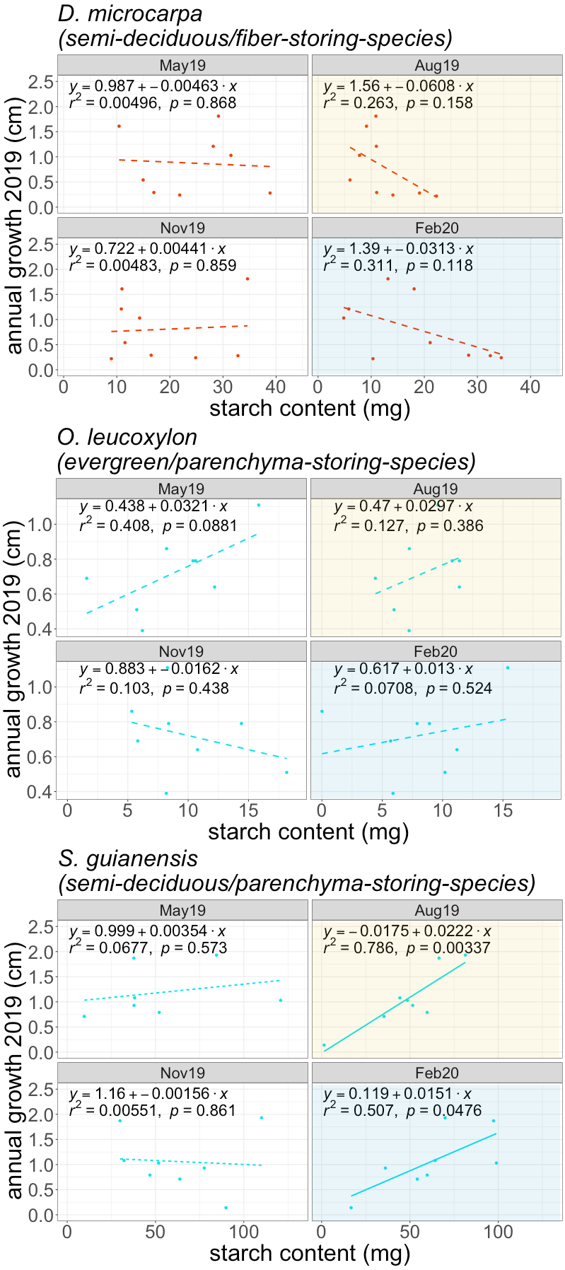

*Figure S5: Correlations between the annual growth rate in 2019 and the starch content at each of the evaluated months of the year for each studied species. The panels show the significant linear regressions with solid lines and the non-significant ones with dashed lines at 95% confidence levels. The panels are grouped in groups of 4 and each group has its respective species name above them. Each panel correspond to one specific month of the year where starch content was measured, and each panel is label with the name of the respective month. Additionally, the months representing the dry and wet season are highlighted with yellow and blue shades respectively.*

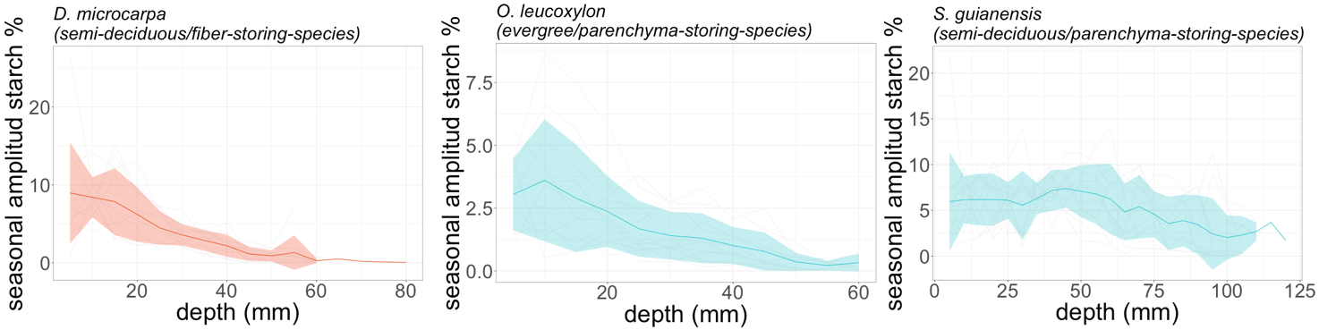

Figure S6. Seasonal amplitude of starch concentrations over the course of the year 2019 at each wood depth measured for each species. The Seasonal amplitude depicted here is the difference between the maximum and the minimal concentration of starch across the year 2019 in each measured individual at different wood depths. The solid lines depict the mean seasona amplitude and the shaded areas are the 1 standard deviation area around the mean. We show the seasonal amplitude at different wood depths until it reached zero, and therefore depth ranges are different for each species. colors denote the storage strategies, red color depicts the fiber storing species, while blue colors depict the paranchyma storing spcies. Note that the scales of the y-axes differ between the species.

Fig S7 Images of the starch content at the deepest layer of wood for one individual of each species between the wet and the dry season. In the images it is shown how the starch grains despite scarce in the wood they are still detectable distinguishable during the wet season, but they are totally indistinguisible during the dry season.



Figure S8: Cumulative mortality of the studied species in the same area of study. The cumulative mortality is shown for the control plot, which is the same forest where we sampled our individuals, and two adjacent plots that were subjected to fires at two distinct intensities: one every year, and the other one every three years, as indicated by the labels. Different species are indicated by distinct dots and line shapes, and are named in the legend along with the specific trait combination. Storage strategy of starch in the stem wood is denoted by different colors: red lines denote the fiber storing species, while the blue lines denote the parenchyma storing species.