**Supplementary information: Carbon dynamics in tropical trees from a seasonal dry forest reveals storage-growth trade-off**

David Herrera-Ramírez1*, Christine Römermann2,3, Henrik Hartmann1, Susan Trumbore1, Jan Muhr1, 4, Leonardo Maracahipes-Santos7, Paulo Brando5, 6,7, Divino Silvério8, Huang Jianbei1, Iris Kuhlmann1 and Carlos A. Sierra1

1Max Planck Institute for Biogeochemistry, Hans-Knöll-Str 10, 07745 Jena

2Friedrich Schiller University Jena, Institute for Ecology and Evolution, Philosophenweg 16, 07743, Jena, Germany

3German Centre for Integrative Biodiversity Research (iDiv) Halle-Jena-Leipzig, D- 04103 Leipzig

4Georg August University Göttingen, Department of Bioclimatology, Büsgenweg 2, 37077 Göttingen, Germany

5Department of Earth System Science, University of California, Irvine, CA 92697, USA

6Yale School of the Environment, Yale University, New Haven, CT, United States.

**7**Instituto de Pesquisa Ambiental da Amazônia, Brasília, DF 70863-520, Brazil

8Department of Biology, Universidade Federal Rural da Amazônia-UFRA, Capitāo Poço 68650-000, Pará, Brazil

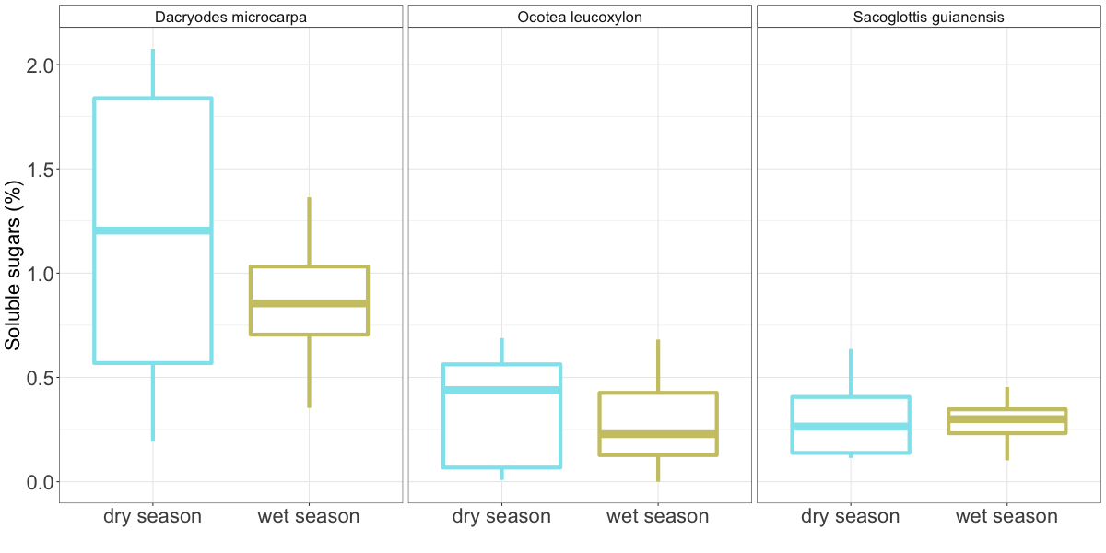

*Figure S1: Boxplots that show the dispersion of the soluble sugar concentration measured in the wood cores from trees of each evaluated species at different seasons during 2018. No difference was detected between seasons for any of the species.*

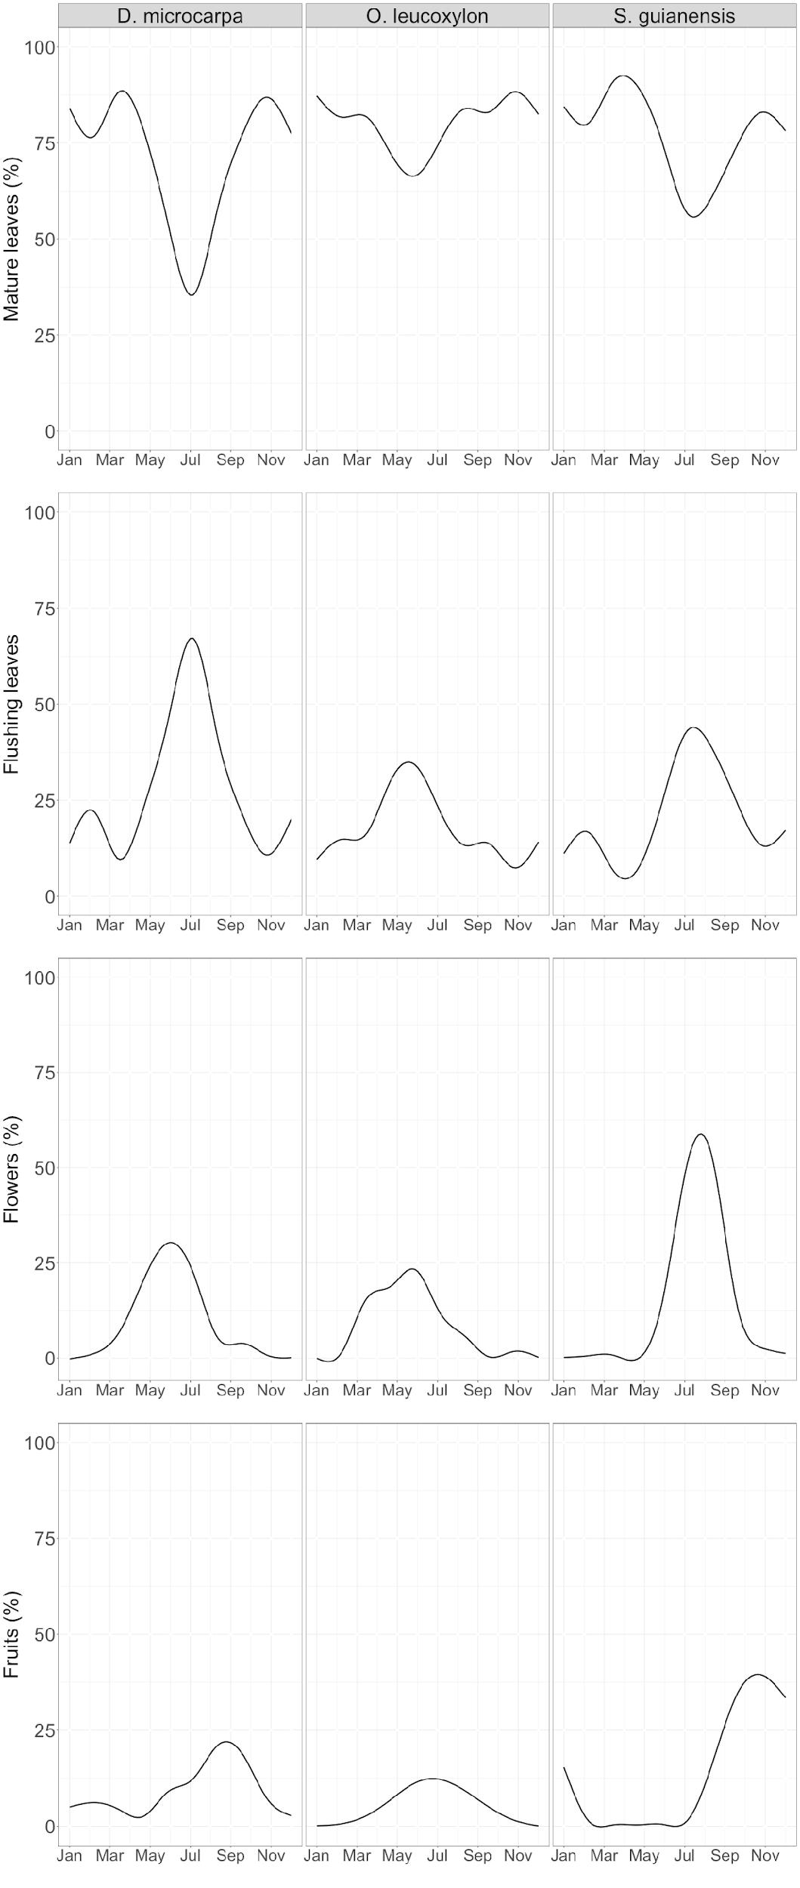

*Figure S2: Seasonality of mature leaves, flushing leaves, flowers and fruits observed during the last 8 years in local trees from the studied species.*