**Laboratory Practical / Experiments Report**

Computer Network (1), CCE 462

Fourth Year

Computer and Control Eng. (CCE) Program

Regulation (2019)

First Semester, 2023/2024

* **Student name:**
* **Student Code: @sha.edu.eg**
* **Section number:**
* **Student number in the registration statement:**

**Experiment (1)**

**Network Components (Devices, Connectors, Cables, and Cards)**

**1.1 Objectives**

Know more about intermediate devices, cards and the connectivity between devices.

**1.2 Equipment / Program Requirements:**

**Devices:**

1- Switch 2- Hub 3- Router

4- Repeater 5- Modem 6- Gateway

7- Access point 8- Controlled WLC

9- Firewall 10- Transceiver Media Converter devices

**Connectors:**

1- Rj45 2- Rj11

3- ST 4- SC

5- LC 6- FC

**Cables:**

1. Copper (UTB, STB)
2. Optical fiber (SMF, MMF)

**Cards:**

1. NIC
2. WIC

**1.3 Experiment Setup:**

First, We Know more information about **intermediate devices**:

**1- Switch:** it is a centralized device to provide physical star topology work in layer 2. It knows next hope but doesn’t know final end.it a hardware support single communication technology.

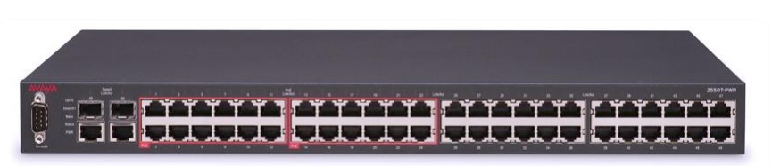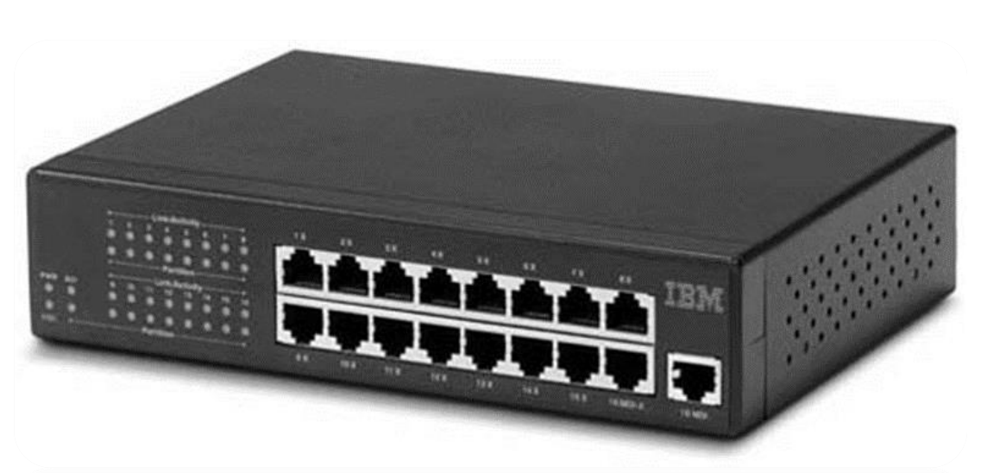

**2- Hub:** it is a centralized device to provide physical star topology work in layer 1 .it doesn’t Know neither final end nor next hope.it used in LAN.

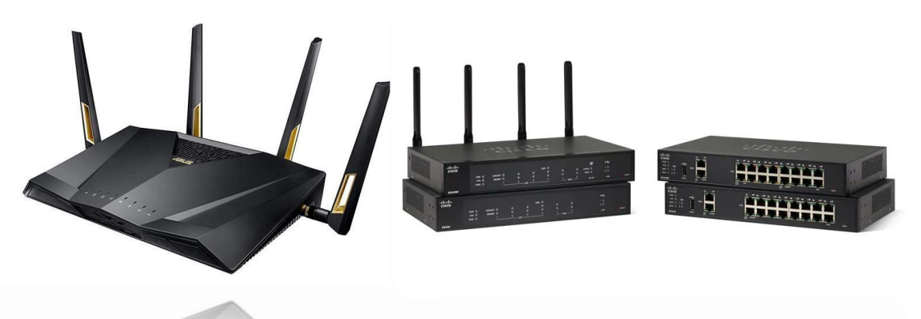

**3- Router:** it is a device that works in layer 3. it is mixed technology. It is by software supporting different technology .it is understanding final end and next hop.

**4- Repeater:** is an electronic device that receives a signal and retransmits it. Repeaters are used to extend transmissions so that the signal can cover longer distances or be received on the other side of an obstruction.

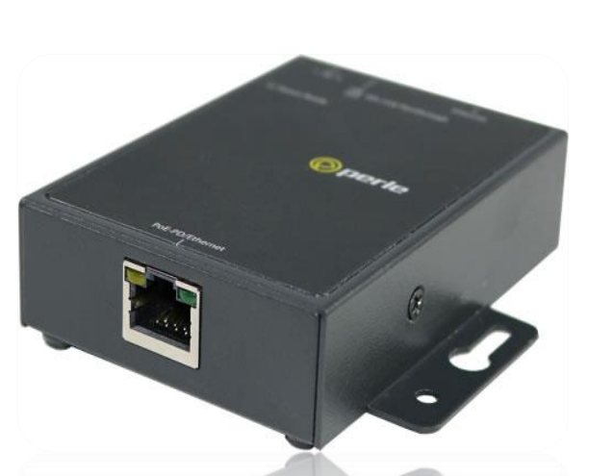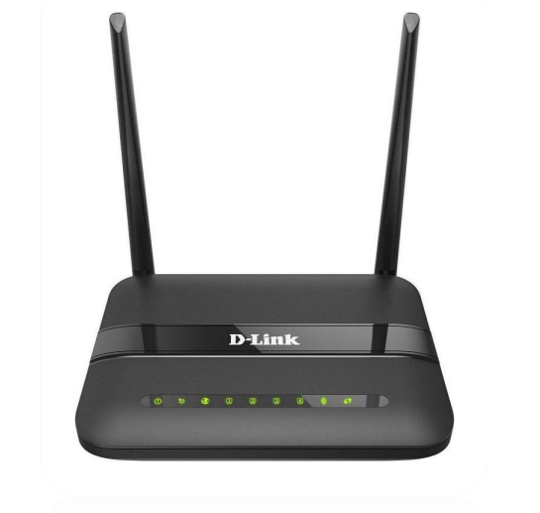

**5- Modem:** is a device that can be internal or external in the network, and without it, the network will not work. This device is installed after every router. Digital modem may be called channelized service unit / data service unit.

**6- Gateway:** is a hardware device that acts as a "gate" between two networks. It may be a router, firewall, server, or other device that enables traffic to flow in and out of the network.

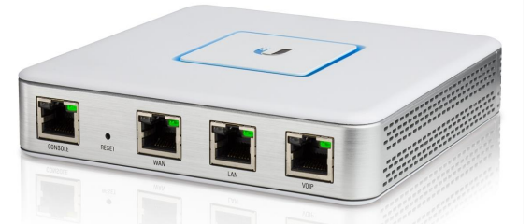

**7- Access point:** is a device that creates a wireless local area network, or WLAN, usually in an office or large building. It connects to a wired router, switch, or hub via an Ethernet cable, and projects a Wi-Fi signal to a designated area.

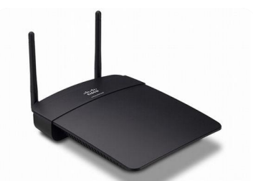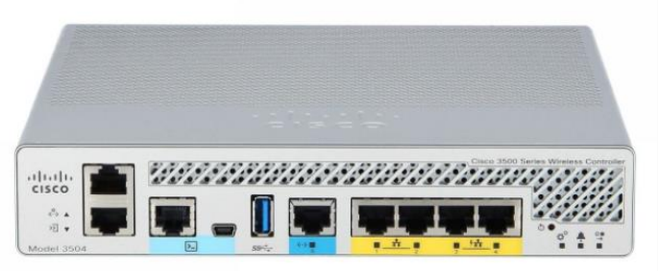

**8- Controlled WLC:** provide a single solution to configure, manage and support corporate wireless networks.

**9- Firewall:** is a network security system that monitors and controls incoming and outgoing traffic based on preset security parameters.

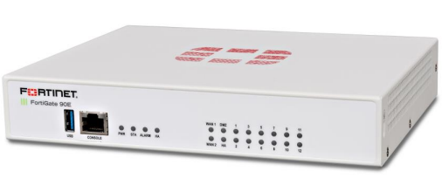

**10- Transceiver Media Converter:** Conversion Method of Fiber Optic line connection to the Fast Ethernet line. Speed Port 10/100/1000 Mbps RJ45

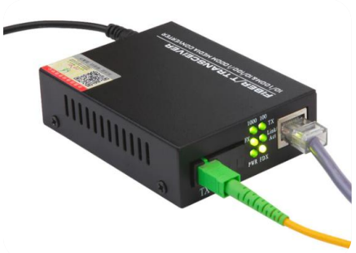

Second, we know information about how to **connect between devices**. The connection divided into two categories (Wire ,wireless):

**Wire**:

**1- Twisted pair:** It can support transmitting 40Gbps in 100m.

**UTP:** it is consisting of 4pair of wire:

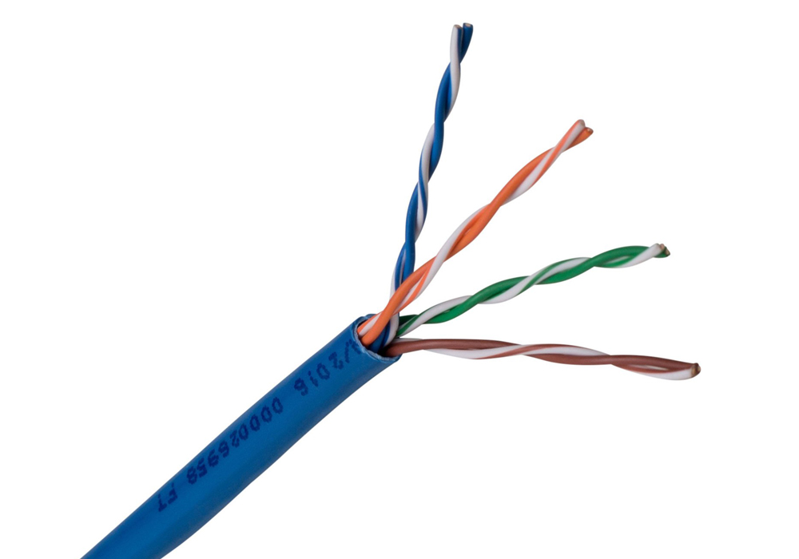

1. Orange, white Orange
2. Green, white Green
3. Blue, white Blue
4. Brown, white Brown

**STB:** it has more advantages than **UTP** that I have immune against electromagnetic wave

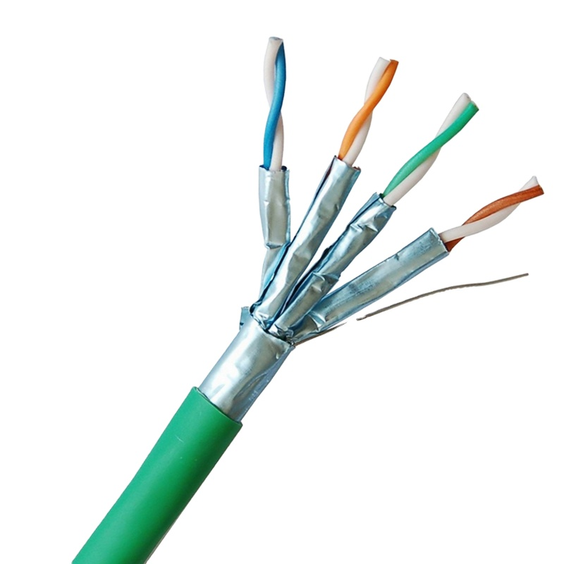

**2- Optical fiber:**

it can support to transmit 100 Gbps in 100Km.

it is consisting of core and cladding.

it may be single mode fiber or multi-mode fiber

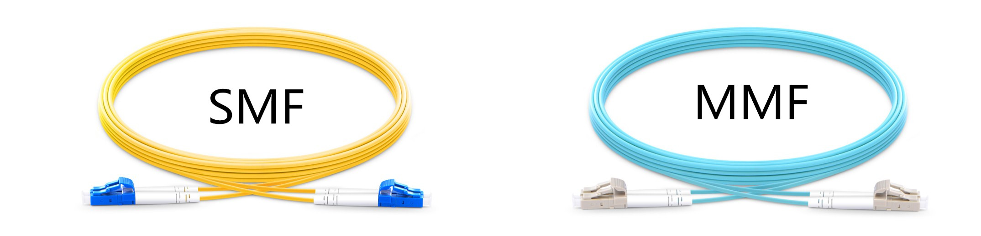

**Connectors:**

if we used twisted pair to connect between devices, we will use RJ45 or Rj11

if we used optical fiber to connect between devices, we will use SC or LC or FC or ST

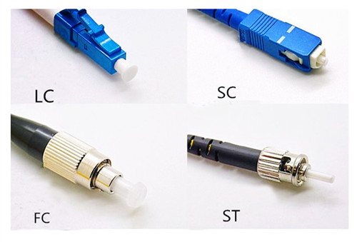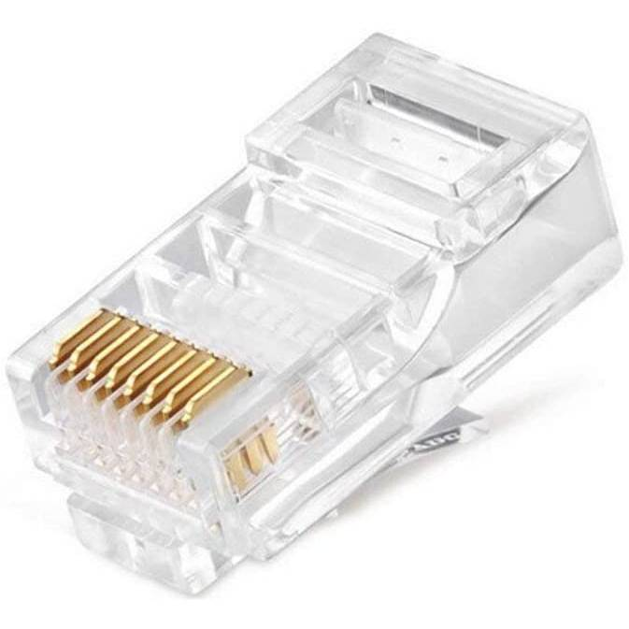

Fiber Connectors RJ45 connector

**Cards:**

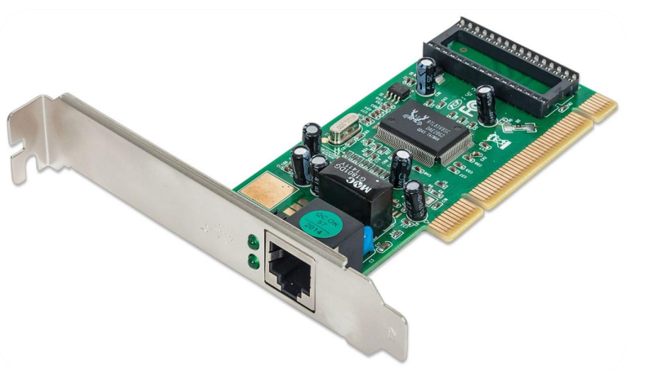

NIC For LAN(ethernet, Wi-Fi)

WIC For WAN