CIS352 Intro to Enterprise Computing

Chapter 1 Assignment
Make the following changes to Chapter’s 1 CALC2000 program
- Add program header documentation
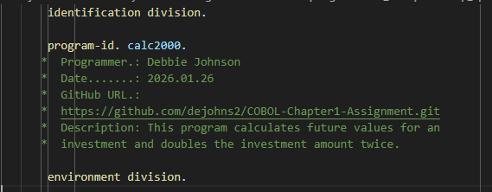
- Instead of using the ACCEPT statement for accepting the user’s input,
rename the user-entries to be input-values, plus assign initial values for all input fields.
- Investment-amount value 1000
- Number-of-years value 10
- Yearly-interest-rate value 5.5
- Delete the edited-future-value data item and replace it with the following two data items that will be used for displaying numeric edit items:
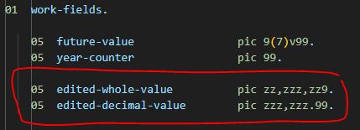
- Remove the unused 110-get-user-values paragraph
Plus, remove the following logic for getting the user’s initial input
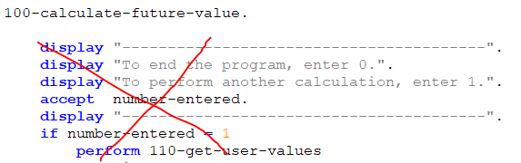
NOTE: Don’t forget to unindent the code that used to be inside the if statement so it’s at the start of Column B.
- Convert the 000-calculate-future-values paragraph to do the following:
  - Display the following program header output
  - Call perform 100-calculate-future-value without using an until clause
  - Then double the investment-amount using a COMPUTE statement and call the 100 paragraph again
  - Plus, it will do this a third time, too
- Add a new paragraph called 140-display-values that will be called at the end of 100-calculate-future-value to produce the following output:
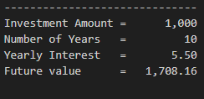
Additional requirements:
- Your goal is to NOT use AI for this assignment, but if you do, use it sparely. If you use AI, you need to document where you used it in your code and justify your reason. I’m okay with you using it to get help, for very specific items, but not to write your code for you.
- Well documented code.
  - https://google.github.io/styleguide/jsguide.html
  - https://gomakethings.com/whats-the-best-way-to-document-javascript/
- Must use GitHub
  - Invite me to your repository (dejohns2)
  - Numerous commits which will prove who did work
  - Balance work across code and README
Repository Structure Example:
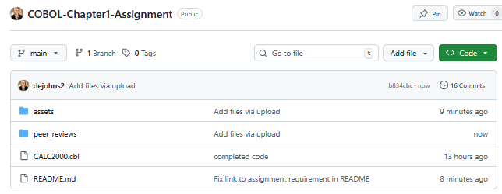
  - Professional README.md
https://github.com/banesullivan/README
https://github.com/matiassingers/awesome-readme?tab=readme-ov-file
    - Fully explain what the program does
    - Embedded screenshots (stored in a subfolder)
    - Bullet point list of what new concepts were used
    - links to the author’s profiles
README.md Example:
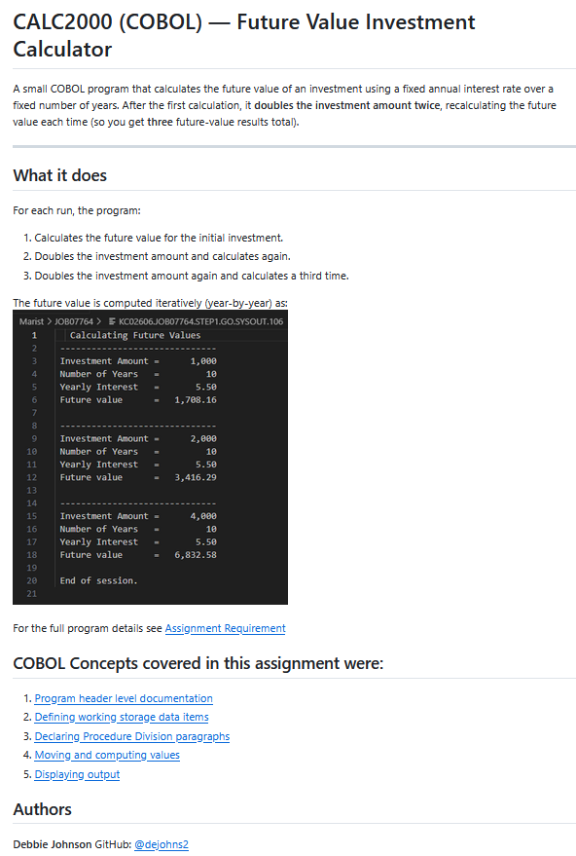
How to embed an image:
![Program Output](assets/CALC2000_Output.png)
How to link to an image:
1. [Program header level documentation](assets/program_header.png)
- PDF Peer review in a subfolder. Use the other person’s name as the file name. A peer review should focus on the person’s strengths and possibly providing helpful suggestions for future group work.
To give a good peer review on a programming assignment, be constructive, focus on learning, and use a positive, clear tone, starting with praise and then suggestions for improvement. Frame feedback as questions or requests, provide code examples, and avoid nitpicking minor issues, ensuring the review is a collaborative effort to improve future code and collaboration.
- Attach your program file to the assignment along with your Good, Bad, and Ugly (GBU) reflection written at a college level. IMPORTANT: Include, your GitHub URL in this document.

