|  |  |
| --- | --- |
| /home/stella/Documents/perso/femmes et sciences/journees scientifiques Yde/2023/logo_short23.pnglogo_short23 | Women in Computer Science Days Cameroon 2023 |

**Program**

**December 12**

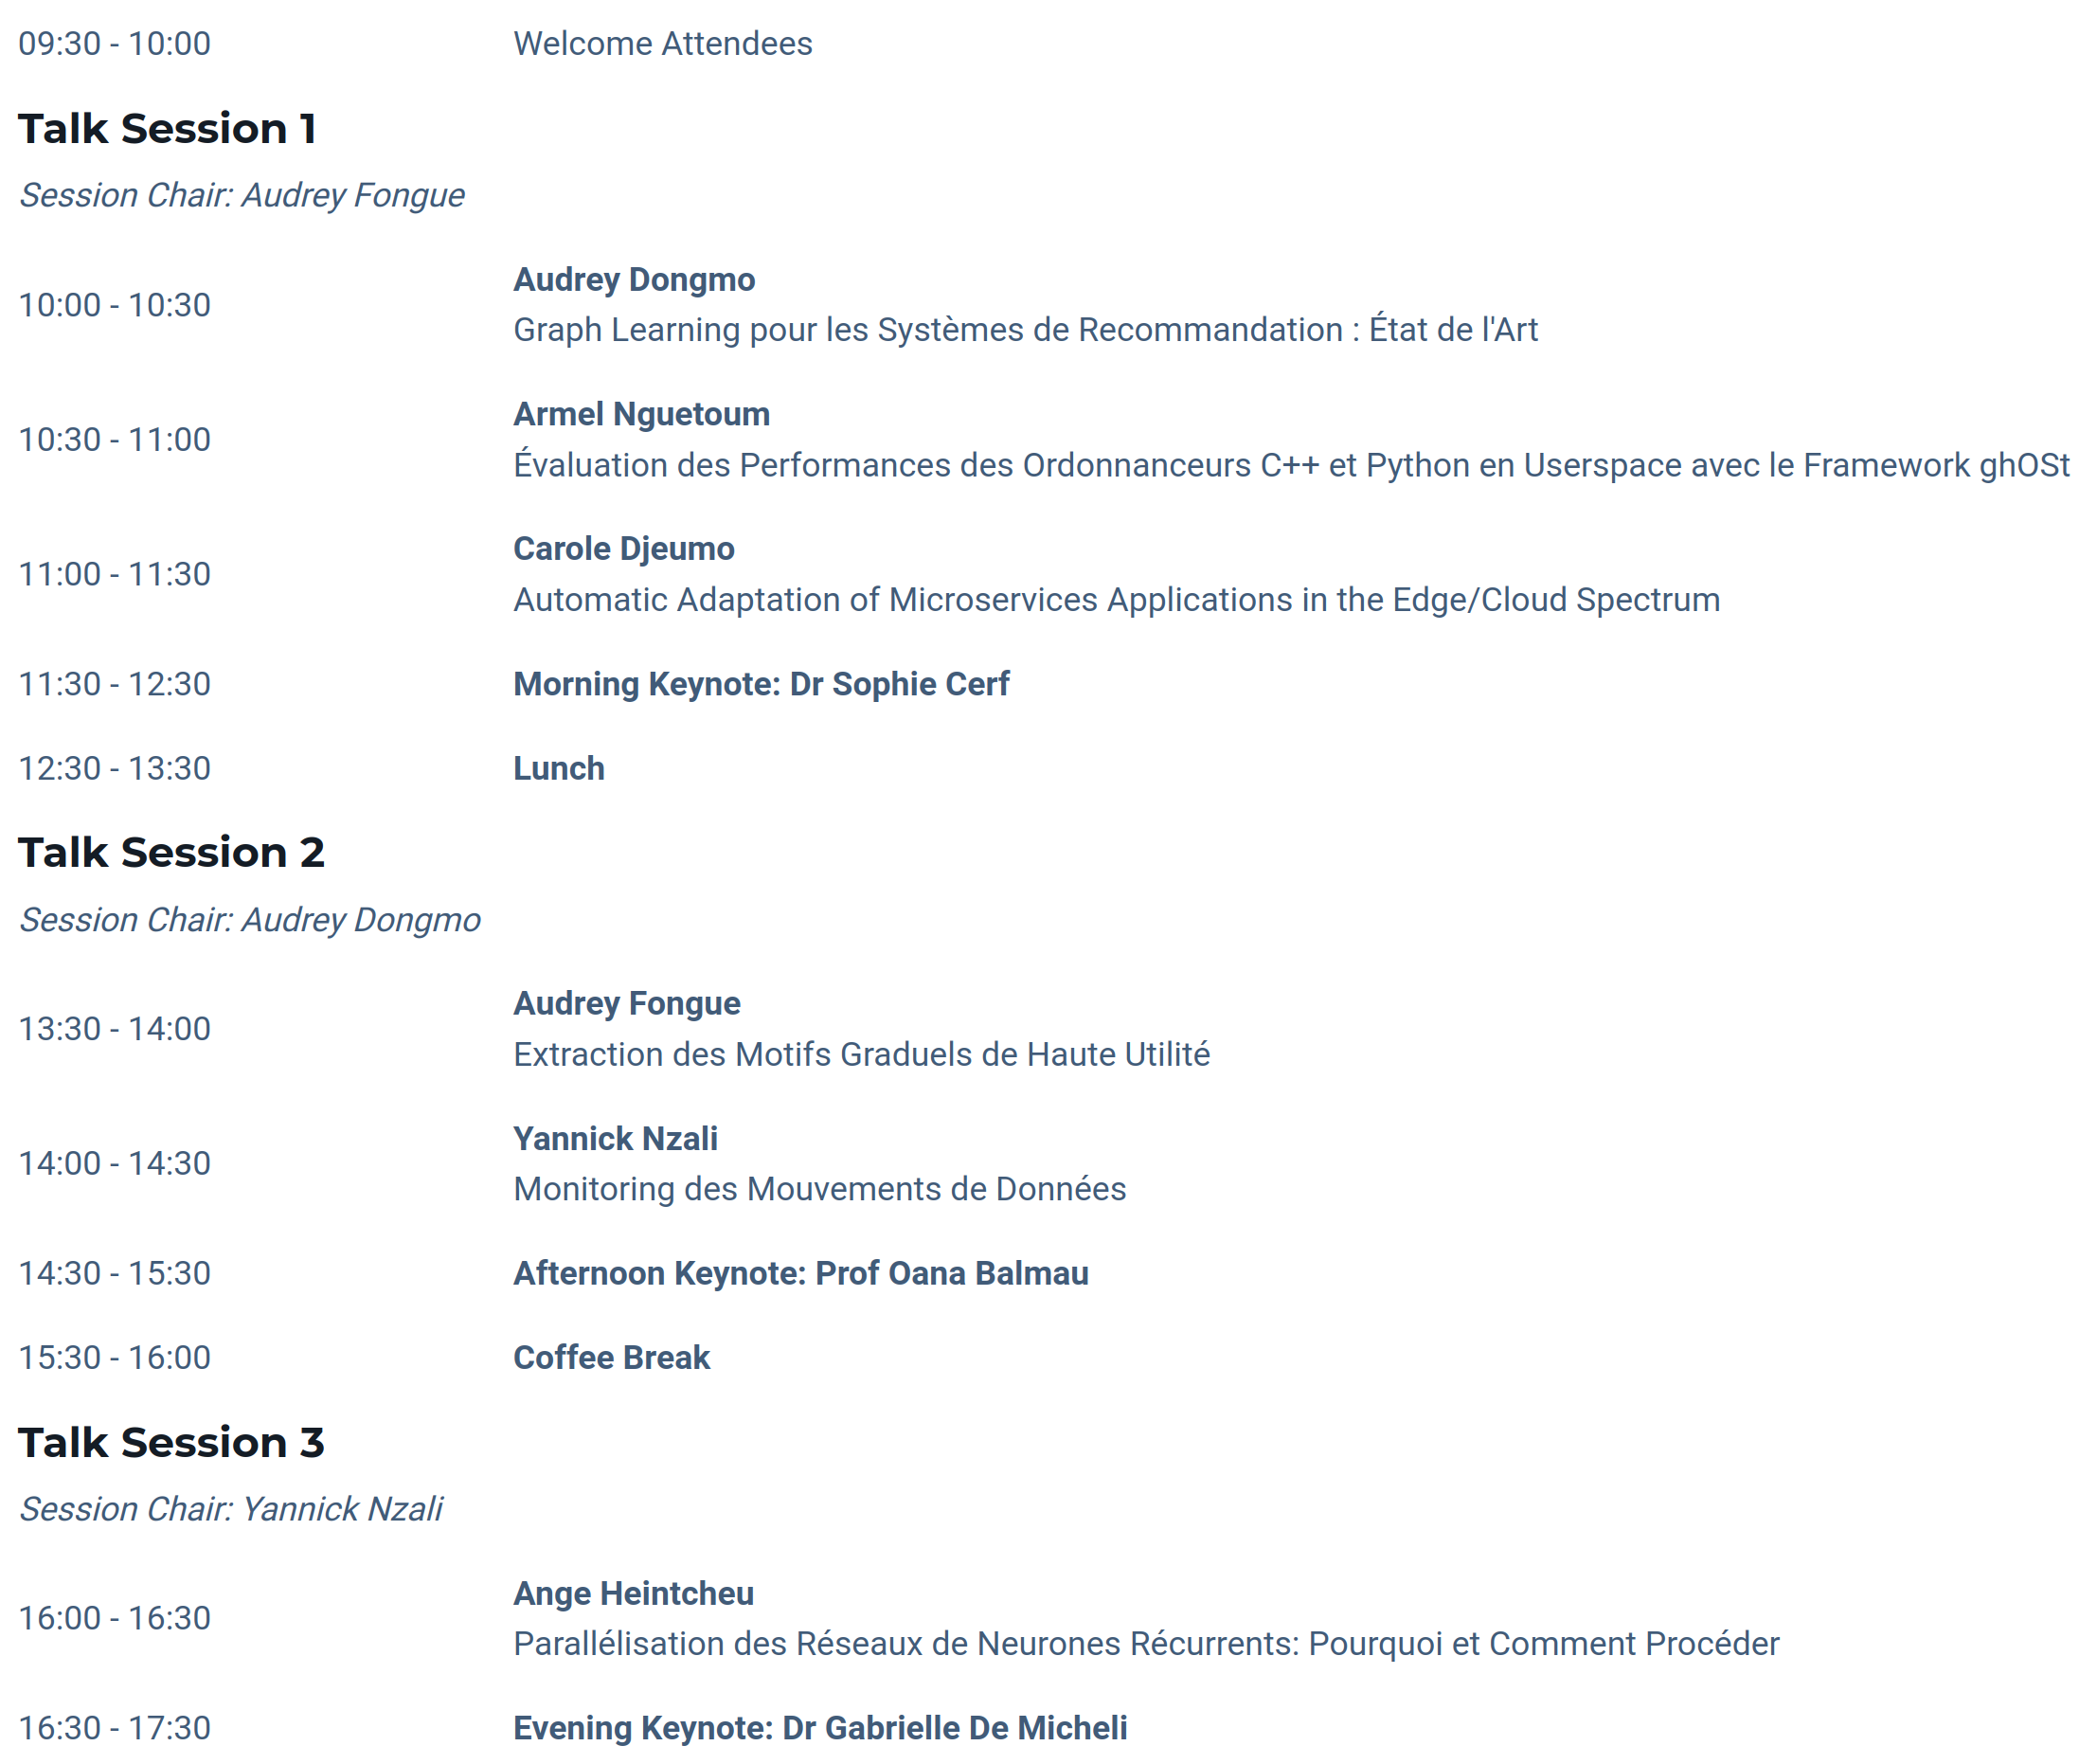

**December 13**

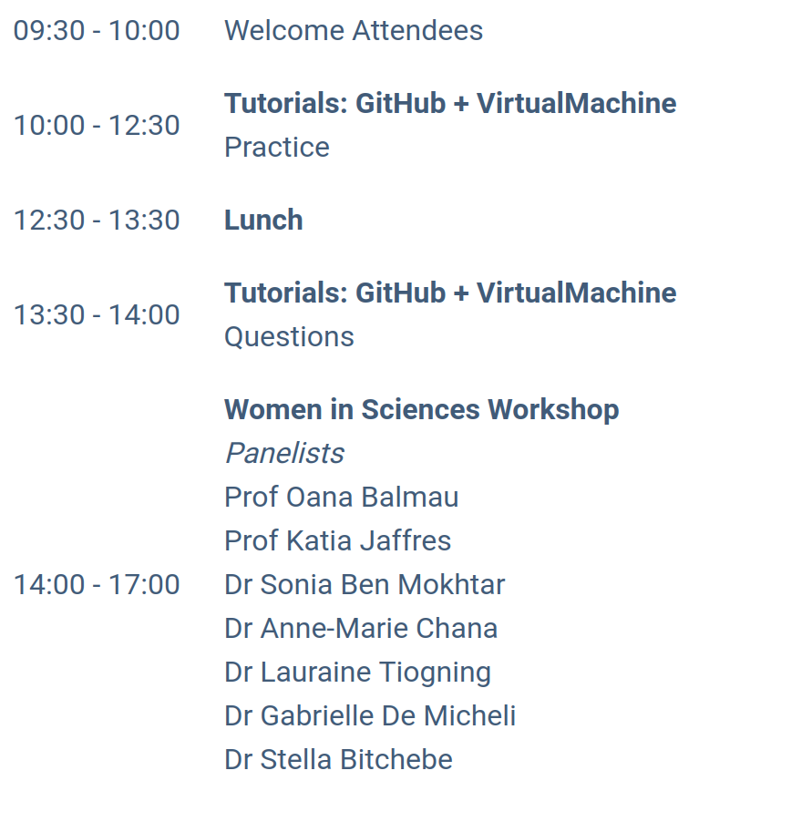

**Description**

**What is WoCC**? An annual seminar we organize in Cameroon (at the Polytechnic School of Yaounde) to share our experience with local researchers and students.

**Aim**: expose aspiring women scientists to women's accomplishments worldwide in System and AI research.

**Who is concerned**? Everyone! WoCC is a hybrid event. It hosts in-person students from all universities of Cameroon and researchers from Cameroon, France, Canada, US. It provides a link for remote attendance to all registered members.

**When?**: 12-13 December 2023, at the Polytechnic Engineering School of Yaounde (https://science-events-cameroon.github.io/2023/).

## **Expected Guests, Keynotes, and Speakers**

* **Mme Libom Li Likeng** (Minister of MINPOSTEL, Yaounde, Cameroon)
* **Prof Marie-Thérèse Abena Ondoa** (Minister of MINPROFF, Yaounde, Cameroon)
* **Prof Oana Balmau** (Assistant Professor, McGill University, Montreal, Canada)
* **Prof Natacha Crooks** (Assistant Professor, UC Berkeley, California, USA)
* **Dr Aline Carneiro** (Research Director at INRIA, Paris, France)
* **Pr Katia Jaffres-Runser** (Full Professor, Toulouse INP, Toulouse, France)
* **Dr Sonia Ben Mokhtar** (Research Director at CNRS, Lyon, France)
* **Dr Anne-Marie Chana** (Senior Lecturer, Polytechnic School, Yaounde, Cameroon)
* **Dr Gabrielle De Michelli** (Postdoctoral Scholar, UC San Diego, California, USA)
* **Dr Stella Bitchebe** (Postdoctoral Researcher, McGill University, Montreal, Canada)
* **Carole Djeumo** (PhD Student, UC Louvain, Louvain, Belgique)

|  |  |
| --- | --- |
| /home/stella/Documents/perso/femmes et sciences/journees scientifiques Yde/2022/logo_short22.pnglogo_short22 | Last Edition Summary |

WoCC’22 (https://science-events-cameroon.github.io/2023/) took place on 20-22 December 2022, at the Polytechnic Engineering School of Yaounde, with the participation of other researchers and PhD students. The program included a lot of in-person and remote speakers and keynotes, student presentations, tutorials, and women in CS workshop. It was colocated with the STEM Bootcamp organized by [Yuhala Peterson](https://yuhala.github.io/).

WoCC’22 had over 70 student and researcher participants from Cameroon, France, and the USA and considerable funding from many sponsors. The following tables recapitulate this first edition.

**Organizers**

[Stella Bitchebe](https://perso.ens-lyon.fr/celestine-stella.ndonga-bitchebe/)

## Participants/Attendees

|  |  |
| --- | --- |
| Student Registrations | **67** |
| Student Attendees | **64** |
| Women | 15 |
| Men | 49 |
| Speakers | **10** |
| In-person | 7 |
| Remote | 3 |
| Msc Students | 2 |
| PhD Students | 4 |
| Senior Researchers/Professors | 4 |
| Student Volunteers | **9** |

## Budget

|  |  |  |  |
| --- | --- | --- | --- |
|  | **Qty** | **Unit** | **Total** |
| Organizer Flights | 3 | 2000 € | 6000 € |
| Conference room rent + Setup | 3 | 250 € | 750 € |
| Coffe breaks | 7 | 150 € | 1050 € |
| Lunch | 3 | 500 € | 1500 € |
| Internt access setup | 3 | 50 € | 150 € |
| Program printing for attendees | 65 | 1 € | 65 € |
| Total | | | **9515 €** |

## Sponsors

|  |  |  |
| --- | --- | --- |
| **Sponsor** | **Funding** | **Cost** |
| University of Neuchatel | 1 Organizer Flight | 2000 € |
| INRIA | 1 Organizer Flight | 2000 € |
| CNRS | 1 Organizer Flight | 2000 € |
| MLNS2 | Coffe Breaks + Lunch + Prints | 2615 € |
| Polytechnic Yaounde | Conference room + Internet access | 900 € |
| Total | | **9515 €** |

**Abbreviations**

* **CNRS**: Centre National de la Recherche Scientifique
* **INRIA**: Institut National de Recherche en Informatique Appliquée
* **MLNS2**: Machine Learning Network Systems Secuity

## **Guests, Keynotes, and Speakers**

* **Dr Aline Carneiro (**Research Director at INRIA, Paris, France)
* **Pr Katia Jaffres-Runser** (Full Professor, Toulouse INP, Toulouse, France)
* **Dr Gabrielle De Michelli** (Postdoctoral Scholar, UC San Diego, California, USA)
* **Dr Anne-Marie Chana** (Senior Lecturer, Polytechnic School, Yaounde, Cameroon)
* **Josiane Kouam** (PhD Candidate, INRIA/Ecole Polytechnique, Paris, France)
* **Prof Batchakui Bernabe** (Associate Professor, Polytechnic School, Yaounde, Cameroon)
* **Nel Tsopgny (**PhD Student, University of Yaounde I, Yaounde, Cameroon)
* **Jordan Ngounou (**PhD Student, University of Yaounde I, Yaounde, Cameroon)
* **Gaëlle Yonga (**Msc Student, University of Douala, Douala, Cameroon)
* **Stella Bitchebe** (PhD Candidate, ENS Lyon, Lyon, France)
* **Yuhala Peterson** (PhD Candidate, University of Neuchatel, Neuchatel, Switzerland)