**Create a service to accept Meter Reads**

Bruno Stuelp Filho – bstuelp@gmail.com

1. Technologies
   1. Java + JAX-RS + Jersey
   2. Gson
   3. Mysql/Workbench
   4. Tomcat 9
   5. Postman
2. Project Structure

package com.bluetel.DAO;

DAO, Interface and Connection

package com.bluetel.entity;

Entities Customer and Read (not used)

package com.bluetel.rest;

Rest Services Methods and Interface

package com.bluetel.testJUnit;

JUnit tests

1. URLs

POST

http://localhost:8080/Bluetel/rest/meter-read/store

* Creates a new reader

Request Body: application/json

{

"customerId": "identifier123",

"serialNumber": "27263927192",

"mpxn": "14582749",

"read": [

{"type": "ANYTIME", "registerId": "387373", "value": "2729"},

{"type": "NIGHT", "registerId": "387373", "value": "2892"}

],

"readDate": "2017-11-20T16:19:48+00:00Z"

}

Responses

* 200 – the register was recorded

Response body: application/json: The register

* 400 – Json invalid

GET

http://localhost:8080/Bluetel/rest/meter-read/present/{ID}

Show user meter stored

Parameters

* Request Body -> customerID

Responses

* 200 – registers

Response body: application/json: A reader

* 400 – ID not found

Examples

* http://localhost:8080/Bluetel/rest/meter-read/present/1 -> (200 – A reader)
* http://localhost:8080/Bluetel/rest/meter-read/present/12 -> (400 - ID not found)

1. Database Diagram

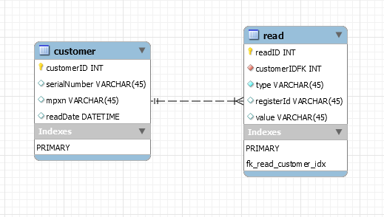

1. Project Decisions

I had some questions about description project. To avoid many question about, I have decided to made some implementations follow my understand.

1. If exists CustomerID, update table register;
2. If not exists CustomerID (sent by json), create a new customer and insert register;
3. Json validation is done at **public** **boolean** validJson(String json)
4. Tests

<http://localhost:8080/Bluetel/rest/meter-read/store> - Invalid Json -> error 400

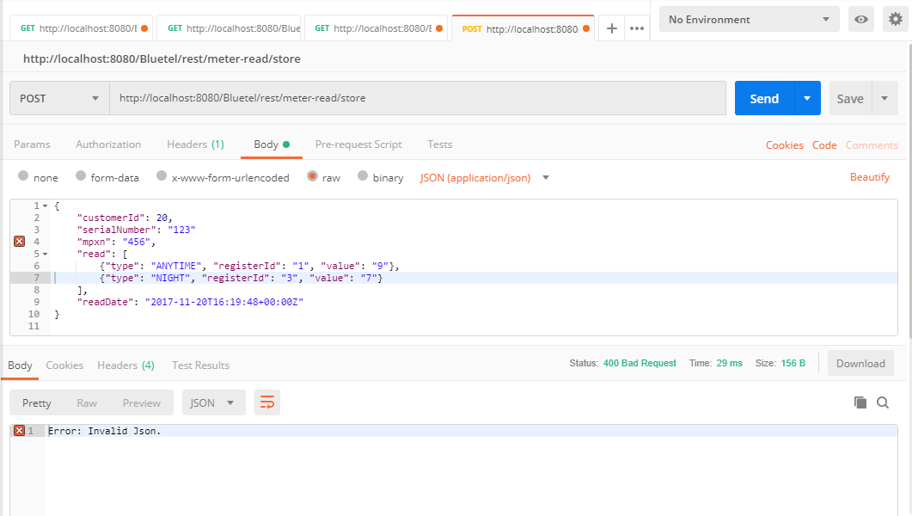

http://localhost:8080/Bluetel/rest/meter-read/store

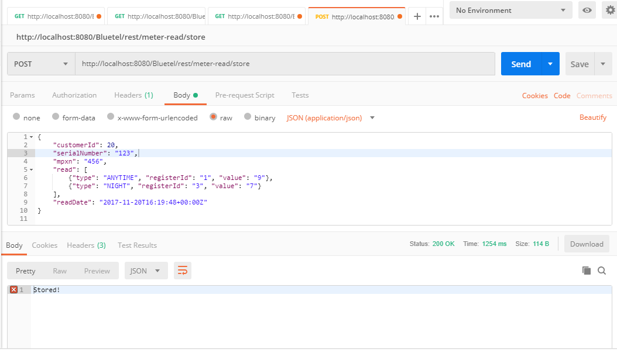

http://localhost:8080/Bluetel/rest/meter-read/present/3

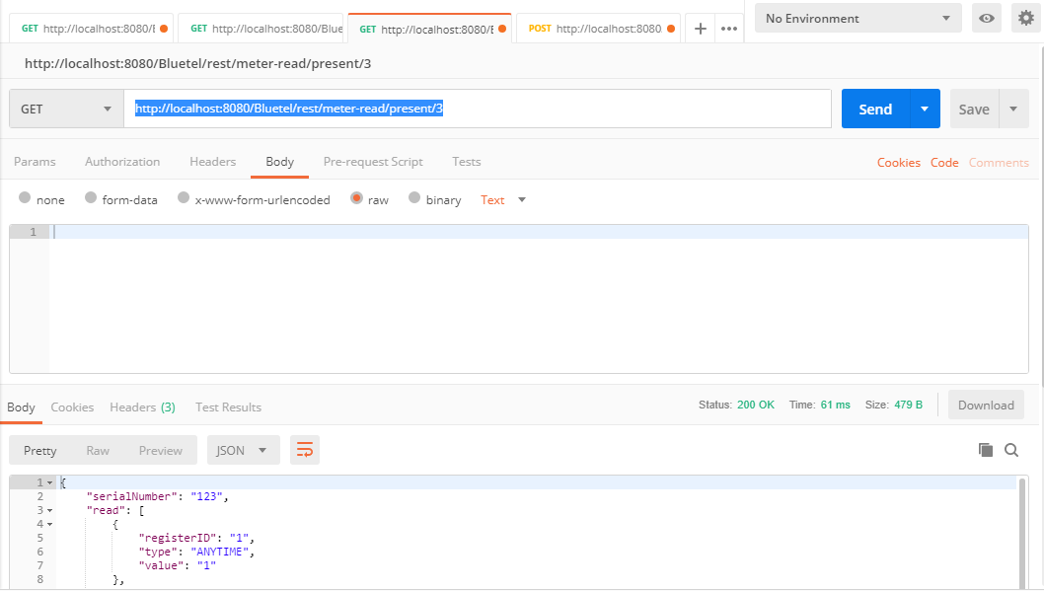

http://localhost:8080/Bluetel/rest/meter-read/present/300

