Concurrent File Sharing System with SDN
SDN-Socket Programming Mini Project (Project 14): TCP sockets + Mininet + OS-Ken controller
Repository: github.com/bsubriyaa/concurrent-file-sharing-sdn

1. Problem statement and objectives
The project builds a multi-user file-sharing service on raw TCP sockets and runs it in a Mininet network whose Open vSwitch is controlled by an OS-Ken (OpenFlow 1.3) controller. The application and the network influence each other: security events produced by the application make the controller change forwarding behaviour.
Objectives from the project brief, and how each is met:
Expectation (Project 14) | Implementation
Concurrent TCP file transfers | Thread-per-client server; 8 parallel downloads and 10 parallel uploads tested
Upload and download | UPLOAD / DOWNLOAD with explicit sizes; SHA-256 verified
File metadata | metadata.json: size, uploader, upload time; shown in LIST
Authenticated access | AUTH with salted PBKDF2 password hashes; 3 failures close the connection
SDN access policies | Controller blocks a host after 3 failed logins with a timed drop flow
Portal API tests (t_api.py, 37 checks) | Roles and permissions (a student cannot see other students submissions or download files the portal did not create), path-traversal and bad-name rejection, late flag, regrade clears marks, material upload and download with matching SHA-256, activity feed visibility by role, unauthenticated access refused. All passed.
Portal in a browser (Playwright, Chromium) | Login, hand-in, download with step tracking, grading, new assignment, slow-motion replay, desktop, 1000 px and phone widths, light and dark; no page errors.
Bandwidth monitoring | Controller polls port statistics every 2 s into stats.csv
Simultaneous-transfer tests | 3 hosts downloading at once; fairness measured
Dynamic bandwidth management (extra) | Optional hog limiter: OpenFlow meter caps a host that monopolises a busy server link
Performance evaluation | SDN vs baseline (no controller), repeated runs, mean and standard deviation

2. System architecture
A star topology: four hosts connect to one Open vSwitch (s1), which connects to a remote OS-Ken controller.
OS-Ken controller c0 (127.0.0.1:6653)
| OpenFlow 1.3
s1 (Open vSwitch)
port1 | port2 | port3 | port4 (capped, 10 Mbit/s)
h1 h2 h3 server
10.0.0.1 10.0.0.2 10.0.0.3 10.0.0.4 : TCP 5000

Component | Role
h1, h2, h3 | Client hosts running client.py / bench.py
server | File server (server.py), thread per connection, port 5000
s1 | Open vSwitch, OpenFlow 1.3, flow tables programmed by the controller
c0 | OS-Ken controller: learning switch, dynamic blocking, bandwidth monitor

3. Socket implementation

3.1 Server and concurrency
The server creates a TCP socket (AF_INET, SOCK_STREAM), binds 0.0.0.0:5000, listens with a backlog of 128, and starts a daemon thread for every accepted connection. Each thread has a 60 s inactivity timeout. A lock protects metadata.json and the event log; metadata is written atomically (temporary file then replace).

3.2 Application protocol
TCP is a byte stream and does not preserve message boundaries, so every control message is one line ending in a newline, and file contents follow an exact byte count. Both sides use a buffered reader that never assumes one recv() equals one message.
C: AUTH <user> <password> S: OK | ERR <reason>
C: LIST S: OK <nbytes> + listing
C: UPLOAD <name> <size> S: READY | ERR ... then <size> bytes, S: OK | ERR
C: DOWNLOAD <name> S: OK <size> + <size> bytes | ERR file not found
C: QUIT S: BYE

3.3 Error handling and safety
- File names are restricted to letters, digits, '.', '_' and '-': no path separators and no '..', which blocks path traversal on both upload and download.
- Uploads are written to a temporary .part file; if the client disconnects mid-transfer the file is deleted and no metadata entry is created.
- Invalid commands, bad sizes, unknown files, failed authentication, timeouts and disconnects each produce an error reply or a clean close.
- Limitations: no TLS; demo accounts (admin, alice, bob) are hard-coded.

4. Mininet and SDN implementation

4.1 Topology
topology.py builds the star with fixed IPs and MACs and TCLink links. The server link is capped (default 10 Mbit/s) so that it is a real bottleneck. --mode sdn attaches the remote controller and pins OpenFlow 1.3; --mode baseline uses the same network with a standalone learning switch and no controller, so the two modes differ only in SDN control.

4.2 Controller (controller.py)
- Learning switch: table-miss rule sends unknown packets to the controller; MAC learning installs priority-1 forwarding flows.
- Dynamic blocking: a priority-200 drop flow matching IPv4 source, destination 10.0.0.4, TCP port 5000, installed with a hard timeout. Priority 200 beats the forwarding flows, so it takes effect even if earlier traffic already created a forwarding path.
- Bandwidth monitor: port statistics requested every 2 s; per-port receive and transmit Mbit/s appended to stats.csv.
- Hog limiter (optional, HOG_LIMIT=1): when one client takes more than 70% of a busy server link for two consecutive polls while another client is active, the controller installs an OpenFlow meter (50% of the link, drop band) and a priority-160 flow for server-to-hog traffic with a 20 s hard timeout. The flow expires on its own and the controller logs HOG_LIMIT and HOG_UNLIMIT. The decision logic is in policy.py (HogPolicy) and is unit-tested.
- Logging: BLOCK, UNBLOCK, HOG_LIMIT, HOG_UNLIMIT and start-up lines are written to controller_events.log.

5. Socket-SDN integration
The server appends a JSON line to events.jsonl for every login, failed login, upload and download. Mininet hosts share the host filesystem with the controller, so the controller tails that file in a green thread. The decision logic is in policy.py and is unit-tested separately: three AUTH_FAIL events from one IP within 60 s trigger a block.
Event flow: client sends wrong password -> server logs AUTH_FAIL -> controller reads it -> after the third failure it sends a FlowMod with a drop action and a 30 s timeout -> the client's packets to the server are dropped at the switch -> the flow expires and the controller logs UNBLOCK.
Design note: a shared file is a deliberate simplification for the emulated network; a deployment would use a network channel (for example a REST call to the controller).

6. Application layer: CampusShare portal
To show the file-sharing system working inside a real-life application, it is used as the storage and transfer engine of CampusShare, a college assignment and course-material portal. Students hand in assignments, faculty publish assignments and course materials and grade work, and an administrator oversees everything. The portal is a standard-library Python HTTP server (webapp.py) with a browser interface. It does not read or write the stored files itself: every upload and download is an ordinary TCP connection to the file server, made with the same client library (fsclient.py). The browser never speaks the socket protocol; it talks HTTP to the portal, which keeps the two layers separate.
Request path: browser, then HTTP to the portal, then a TCP socket through the Open vSwitch (the portal host is attached to the switch as 10.0.0.254 on port 5 when topology.py is started with --web), then the file server on 10.0.0.4:5000. Because the portal traffic crosses the switch, the OS-Ken controller sees it, counts it per port and applies the same block and limit policies.
Role | Demo account | What the portal allows
Student | alice, bob, carol | See assignments and due dates, hand in and resubmit work, see own marks and feedback, download course materials
Faculty | prof | Publish assignments with due dates, upload course materials, download every submission, grade with feedback
Admin | admin | Everything faculty can do

Storage and access rules. Files are stored on the file server as SUB_<assignment>_<student>_<file> for submissions and MAT_<course>_<file> for course materials; assignments, submission records and grades are kept in portal.json, written atomically under a lock. The portal enforces access on every download: a student can fetch only their own submissions and any course material, faculty and administrators can fetch any submission, and files not created by the portal cannot be reached through it. Submissions after the due date are flagged late, and a resubmission replaces the record and clears an earlier grade. Sessions are held in server memory in an HttpOnly, SameSite=Strict cookie, and file names are restricted to letters, digits, dot, underscore and hyphen.
Making the network visible. A Live network panel is shown beside every page. During a hand-in or download it lists each step as it happens (browser to portal, portal to file server over TCP, file server stores or returns the file) with the measured size, time and Mbit/s and, for downloads, the SHA-256 checksum. It also shows the journey of a file, live per-port traffic from the controller's stats.csv (with a 20 s peak hold, because the controller samples every 2 s), and the latest controller events (BLOCK, UNBLOCK, HOG_LIMIT) in plain sentences. A slow-motion replay animates the same steps one at a time with a short explanation of each; it replays the recorded transfer rather than slowing the real one.
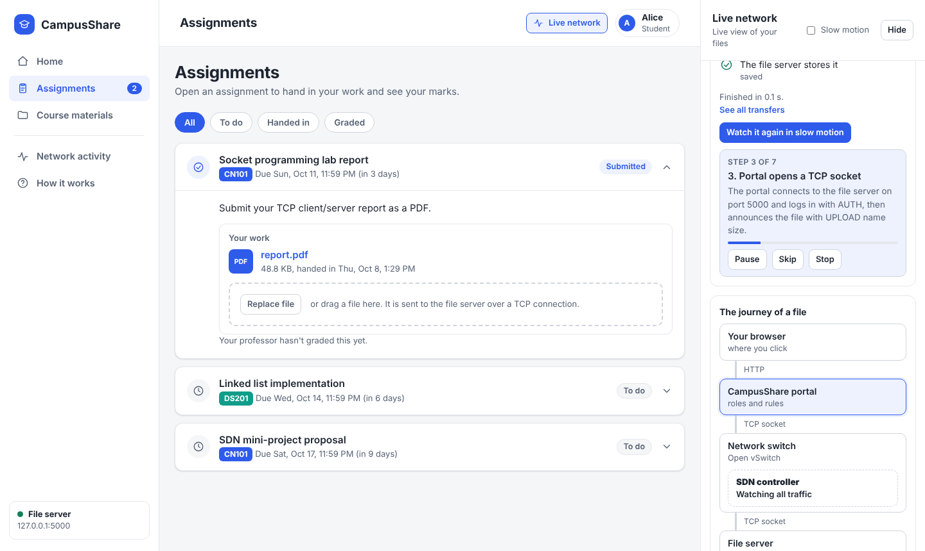
Figure 1. Student view: a submitted assignment, with the Live network panel replaying the transfer step by step.
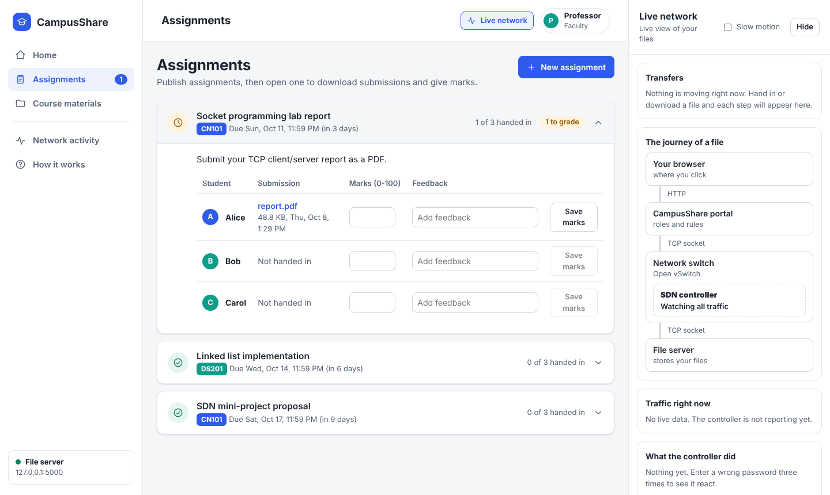
Figure 2. Faculty view: submissions for an assignment, with marks and feedback.
The screenshots were taken on a single test machine without Mininet, so the traffic and controller panels report no live data there; with the network running they fill from stats.csv and controller_events.log.
SDN behaviour through the portal. The portal gateway appears to the switch as one source address, so three failed logins through the portal block 10.0.0.254 for 30 s and every browser user is cut off until the controller logs UNBLOCK. This is the same policy as in section 4, but it also shows a limitation: blocking is per IP address, not per portal user.

7. Testing
Test | Result
selftest.py (loopback, 13 checks) | 5 MB hash match; binary containing the old END marker; missing file then LIST; 5 path-traversal names rejected on download and upload; interrupted upload leaves no file; 3 bad logins close the connection; 8 parallel downloads; 10 parallel uploads all recorded in metadata. All passed.
Mininet connectivity | pingall: 0% dropped (12/12) through the OS-Ken controller
End-to-end transfer in Mininet | 5 MB random file uploaded by h2 (admin) and downloaded by h3 (alice): SHA-256 identical
Dynamic block | h3 failed 3 logins; controller logged BLOCK 10.0.0.3 with response 89.4 ms; h3 with the correct password got no response while blocked; h2 unaffected; UNBLOCK logged about 32 s later; h3 then logged in successfully
Hog limiter | h1 ran 4 parallel downloads while h2 ran one; only 10.0.0.1 was limited (HOG_LIMIT logged, HOG_UNLIMIT after 20 s); see section 8
Bandwidth monitoring | stats.csv received per-port samples every 2 s (2,145 rows during testing)

8. Performance evaluation
Setup: server link capped at 10 Mbit/s, 5 MB file, identical topology and tests in both modes. Single-client: 10 runs. Concurrent and under-attack: 3 runs per client. Values are mean ± standard deviation.
Scenario / metric | Baseline (no SDN) | SDN | Reading
Single client, throughput (Mbit/s) | 9.16 ± 1.19 | 9.64 ± 0.03 | No real difference
3 clients at once, per-client (Mbit/s) | 3.45 ± 1.04 | 3.68 ± 1.98 | Same
3 clients at once, Jain fairness | 0.999 | 0.943 | Baseline slightly fairer; small sample
Brute-force login, 20 s: attempts reaching server | 99 of 99 | 3 of 20 | SDN stops the attacker
h2 download during attack (Mbit/s) | 9.58 ± 0.10 | 9.61 ± 0.06 | No effect either way

Hog limiter experiment. h1 opened four parallel downloads (the hog) while h2 ran one download (the victim), with the controller's limiter off (sdn_nolimit) and on (sdn_limit). Mean ± standard deviation:
Victim h2 | Limiter off | Limiter on | Reading
Throughput (Mbit/s) | 1.72 ± 0.40 (n=7) | 3.47 ± 1.84 (n=6) | About 2x better
Download time, 5 MB (s) | 25.7 ± 7.1 | 14.2 ± 4.8 | About 45% faster

The limiter helps the victim because the hog gets 5 Mbit/s at most for 20 s, leaving room for others. The variance is large because the limit lasts 20 s while a transfer takes 14-26 s, so some runs overlap the limited window more than others. Jain fairness is not reported for this test because the hog is four connections, not one client. n is 7 and 6 rather than 9 because one run was an orphan from an interrupted earlier set (kept, documented) and one run set was invalidated and rerun.
Interpretation. The controller adds no measurable overhead to legitimate transfers, and it does not make them faster; throughput differences are within run-to-run noise. Its benefit is access control: the attacker was cut off after three attempts, within 89 ms of the third failure being logged, and access was restored automatically. The attack uses little bandwidth, so it does not slow h2 in either mode; the block protects the server and its logs rather than the link. Fairness in the plain concurrent test is determined by TCP; the optional limiter is what changes it when one host dominates.
Caveats. Runs are inside WSL2, so occasional slow runs (for example 5.83 Mbit/s in the baseline) are likely scheduling noise. Sample sizes are small. The 89 ms figure measures server log time to controller flow installation, not switch confirmation.

9. Issues found and fixed during development
- The first prototype relied on a single recv() per message, so commands, sizes and file data could merge; it was replaced by the line-based protocol with exact byte counts.
- File names were joined to the shared folder unchecked (path traversal); now validated.
- A failed upload left a partial file; now written to a temporary file and removed on failure.
- Concurrent uploads could corrupt metadata.json; now locked and atomic.
- The first controller blocked a host only when its first TCP packet reached the controller, so the block silently failed once a forwarding flow existed (observed after pingall); blocking is now a higher-priority flow installed on demand.
- The hog limiter first limited the victim as well as the hog (flip-flopping) because its thresholds were too tight; the share threshold was raised to 70% and the cap set to 50%, and the policy was unit-tested before the final runs.
- In the Mininet CLI, several background (&) commands on one host were garbled (for example spython3: command not found), which invalidated a run; the experiment scripts now start the parallel clients with one sh -c command, and the invalid rows were removed.

10. Limitations and future work
- The server-to-controller channel is a shared file; use a REST or socket channel.
- Blocking is per source IP and only for the file-sharing port.
- The limiter applies the meter on the switch output toward the hog, after the bottleneck-side queue, and its 20 s window is fixed; it is a demonstration, not a full QoS scheme.
- Sample sizes are small (3-10 runs), so results show trends, not statistical proof.
- No TLS; credentials are hard-coded demo accounts.
- The portal gateway is a single source address, so a block affects all browser users; per-user blocking would need the server to report user names and the controller to map users to flows.
- The portal enforces access rules, but the raw file server has no access control, so the command-line client can still list and download any file. Portal sessions are in memory and traffic is plain HTTP, which is acceptable only for a local demonstration.
- The portal does not yet support deleting assignments or signing up new users.

11. Reproducing the results
Full steps are in README.md in the repository: start osken-manager controller.py, start sudo python3 topology.py, start the server on the server host, then run source exp_sdn.mn. For the limiter test, run HOG_LIMIT=1 osken-manager controller.py and source exp_hog_limit.mn (exp_hog_nolimit.mn without the variable). For the baseline, stop the controller, start topology.py --mode baseline and run source exp_baseline.mn. python3 analyze.py summarises results.csv. For the portal, start topology.py with --web, start the server inside Mininet, then run python3 webapp.py on the host and open http://localhost:8080.

